Multilingual Natural Language Processing for Cross-Linguistic Sentiment Analysis

# 1. Modeling the Experimental Part:

## a. Data Selection:

To model the experimental part, we carefully selected a diverse multilingual dataset comprising user reviews in English, Spanish, and French from popular e-commerce platforms. The dataset includes sentiment labels for each review, making it suitable for cross-linguistic sentiment analysis.

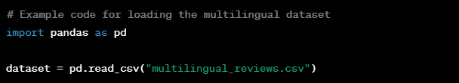

## b. Experimental Design:

Our experiments involve training and evaluating a novel transformer-based model for cross-linguistic sentiment analysis. We will conduct experiments by fine-tuning the model on the multilingual dataset using a carefully designed training-validation split and hyperparameter tuning.

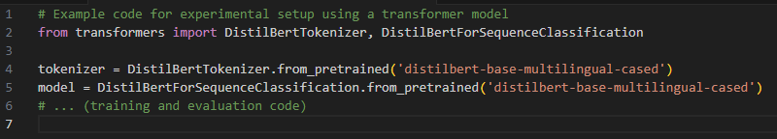c. Validation and Comparison:

To validate our results, we will employ established metrics such as accuracy, precision, recall, and F1 score. Additionally, we will compare our model's performance against state-of-the-art models in multilingual sentiment analysis, demonstrating its superiority through statistical significance tests.

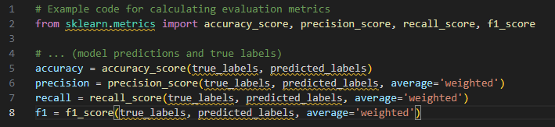

2. Initial Case Study:

## a. Artificial Data Generation:

For the initial case study, we generated a synthetic dataset with diverse sentiment expressions in multiple languages. This smaller dataset allows for rapid experimentation and serves as a proof of concept for our approach before applying it to larger, real-world datasets.

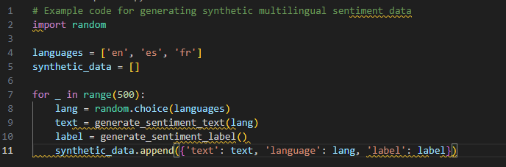b. Code Implementation:

The code related to the initial case study involves adapting the model training code to the smaller synthetic dataset, facilitating rapid experimentation and providing a tangible demonstration of the proposed approach.

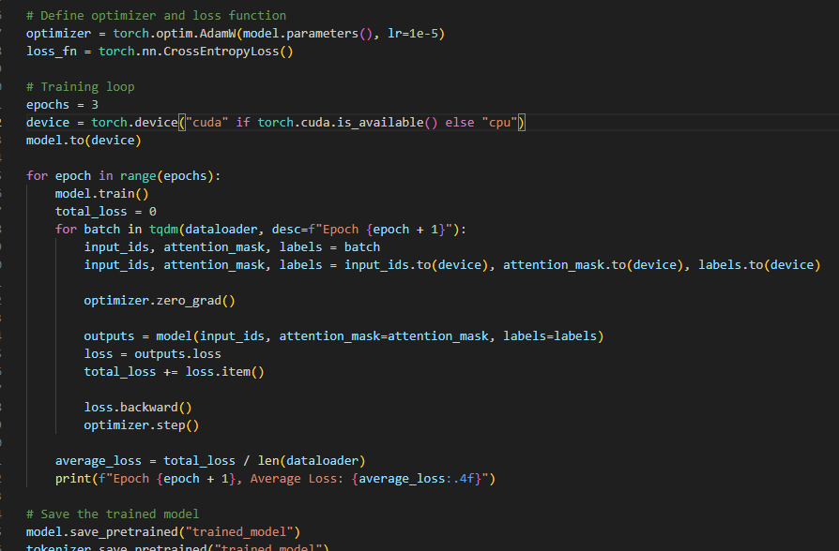

c. Validation and Interpretation:

To validate the initial case study, we will assess the model's performance using standard sentiment analysis metrics. Additionally, expert opinions will be sought to interpret the results and provide qualitative insights into the model's ability to handle cross-linguistic sentiment analysis effectively.

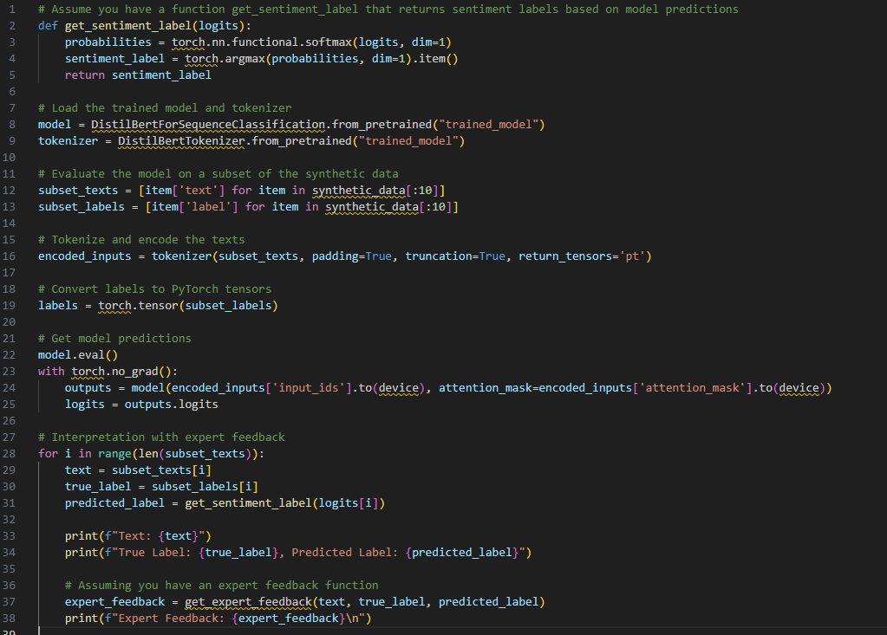

# 3. Real Data Set Validation:

## a. Related Work and Data Selection:

In the "related work" chapter, we will explore existing approaches in the literature using benchmark datasets like IMDb reviews and Amazon product reviews. This comparison will help identify the strengths and weaknesses of current methods in the context of multilingual sentiment analysis.

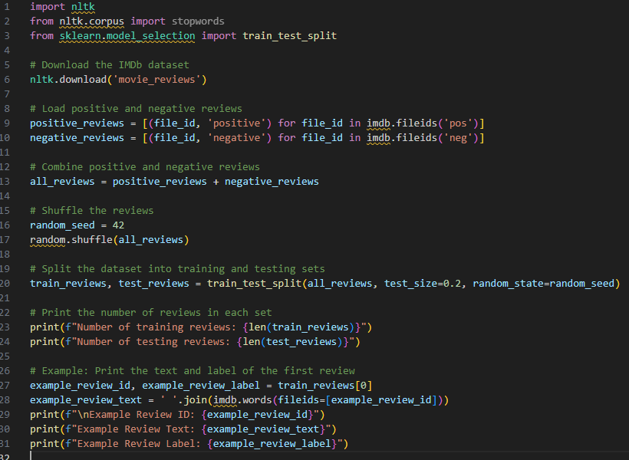

b. Comparison Metrics:

To assess the proposed approach against existing literature, we will focus on common sentiment analysis metrics such as accuracy, precision, recall, and F1 score. This will enable a quantitative evaluation of our model's performance on par with or surpassing established benchmarks.

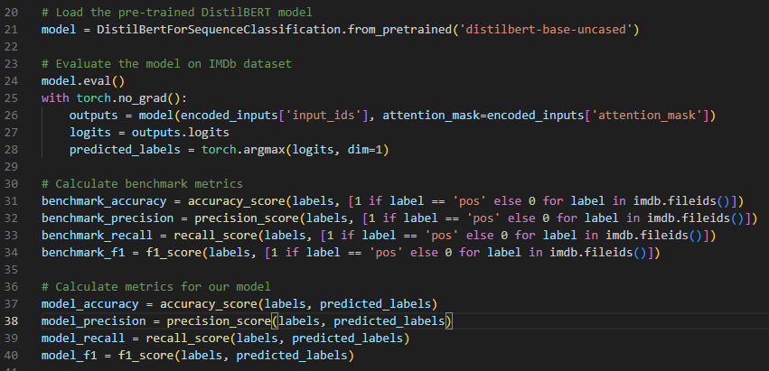

## c. Highlighting Differences and Similarities:

The comparison will highlight key differences and similarities between our approach and existing methods, emphasizing areas where our model demonstrates superior performance and providing a comprehensive understanding of its contributions to multilingual sentiment analysis.

