Simplified car board simulator

# Project description

I am developing a simplified car dashboard simulator with three functions: simulating indexing with two LEDs, turning the high beam on and off, and simulating the car's steering. The project is powered by an Arduino Uno and programmed using the Arduino IDE.

# Schematics

1 capacitor, 2 index LEDs, 1 light led, 1 push button, 2 potentiometers, 4 resistances, 10 long jump wires, short jump wires, rigid wires, 2 bread boards (only 1 is necessary),1 Arduino, 1 Arduino cable (when not receiving current from a battery)

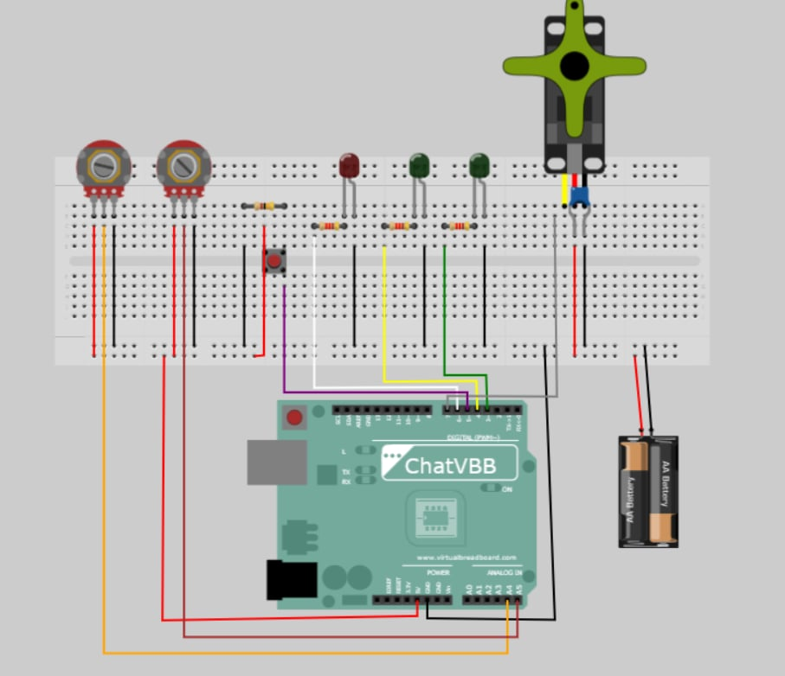

# Pre-requisites

|  |  |  |
| --- | --- | --- |
| Component | Model number | Link |
| Jump wires |  | <https://ardushop.ro/ro/electronica/28-65-x-jumper-wires.html?search_query=jump+wires&results=56> |
| Green led 3mm |  | <https://www.optimusdigital.ro/ro/optoelectronice-led-uri/697-led-verde-de-3-mm-cu-lentile-difuze.html?search_query=led&results=786> |
| Red led 3mm |  | <https://www.optimusdigital.ro/ro/optoelectronice-led-uri/696-led-rou-de-3-mm-cu-lentile-difuze.html?search_query=led&results=786> |
| Electric capacitor (25V 100pF) | CWRTXU_KM107M025D11RR0VH2FP0_CPE | <https://ardushop.ro/ro/home/2708-condensator-electrolitic-alege-valoarea.html?search_query=capacitor&results=2> |
| Deepak Enterprise 220 ohm 1/4 W 5% Carbon Film Resistor -Set of 100 |  | <https://www.amazon.in/Deepak-Enterprise-Carbon-Film-Resistor/dp/B01N9AQ5L8> |
| 10K ohm Resistor |  | <https://www.flyrobo.in/10k-ohm-resistor-other> |
| SpringRC SM-S2309S - Micro Analog Servo | SM-S2309S | <https://servodatabase.com/servo/springrc/sm-s2309s> |
| Buton MIC - Push Button - trough hole |  | <https://ardushop.ro/ro/home/97-buton-mic-push-button-trough-hole.html?gad_source=1&gclid=CjwKCAjwt-OwBhBnEiwAgwzrUtRTUzvVxJeiuBrXDS4O9glMaLAgwhT-ucI0XvdDWAj-8UGsVakxAhoCegUQAvD_BwE> |
| Pontentiometer |  | <https://www.optimusdigital.ro/ro/componente-electronice-potentiometre/606-modul-cu-potentiometru.html?search_query=potentiometer&results=13> |
| Breadboard 830 |  | <https://ardushop.ro/ro/electronica/33-breadboard-830.html?search_query=breadboard&results=32> |
| Arduino Uno Rev3 |  | <https://store.arduino.cc/products/arduino-uno-rev3?queryID=undefined> |

# Setup and build

**Step 1: Gather Components**

* Collect all the required components listed in the pre-requisites.

**Step 2: Circuit Design**

* Create a schematic diagram illustrating the connections between components.
* Ensure that the design includes:
  + Placement of the Arduino Uno on the breadboard.
  + Connection of the capacitor, LEDs, push button, potentiometers, resistors, and jump wires.
  + Proper labeling of each component and connection.

**Step 3: Assemble the Circuit**

* Place the components on the breadboard according to the schematic diagram.
* Connect the components using jump wires.
* Verify that all connections are secure and correct.

**Step 4: Code Configuration**

* Open the Arduino IDE and create a new sketch.
* Write the code to control the three functions:
  + Simulating indexing with two LEDs.
  + Turning the high beam on and off using the light LED.
  + Simulating the car's steering.

**Step 5: Upload the Code**

* Connect the Arduino Uno to your computer using the Arduino cable.
* Upload the code to the Arduino Uno using the Arduino IDE.

**Step 6: Testing**

* Power on the Arduino Uno.
* Test each function of the simulator individually to ensure they work as intended.
* Verify that the indexing LEDs, light LED, and steering simulation respond correctly.

**Step 7: Documentation**

* Document the entire setup and build process, including:
  + Schematic diagram.
  + Project description.
  + All the components.
  + Provide clear instructions for future reference or replication of the project.

# Running

1. **Indexing simulation**

Rotate one of the potentiometers to initiate the indexing simulation. Observe the two index LEDs as they simulate the indexing process by switching their light on and off.

1. **High beam control**

Toggle the high beam control by interacting with the corresponding button. Verify that the light LED turns on when the high beam is activated and turns off when deactivated.

1. **Steering simulation**

Rotate one of the potentiometers to simulate the car's steering. Observe how the simulated steering affects the output or display of your dashboard simulator.