Mock up of the app:

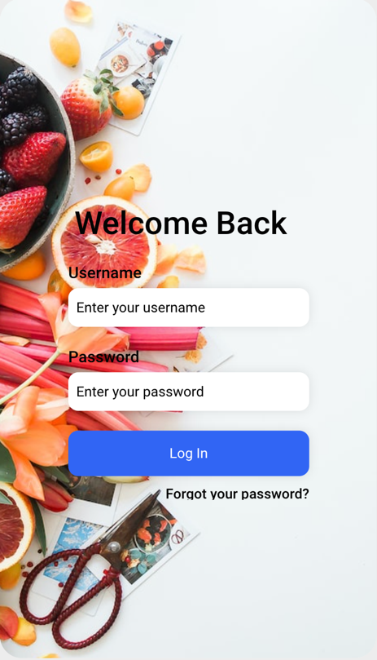 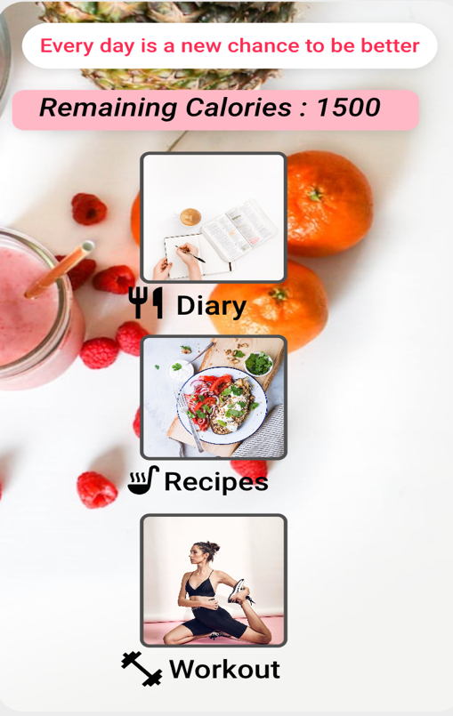 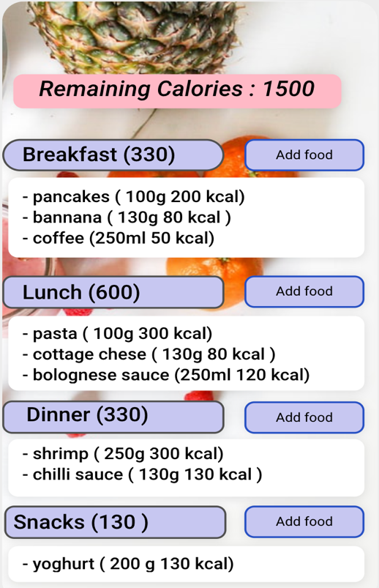

Log in page Home page Diary page

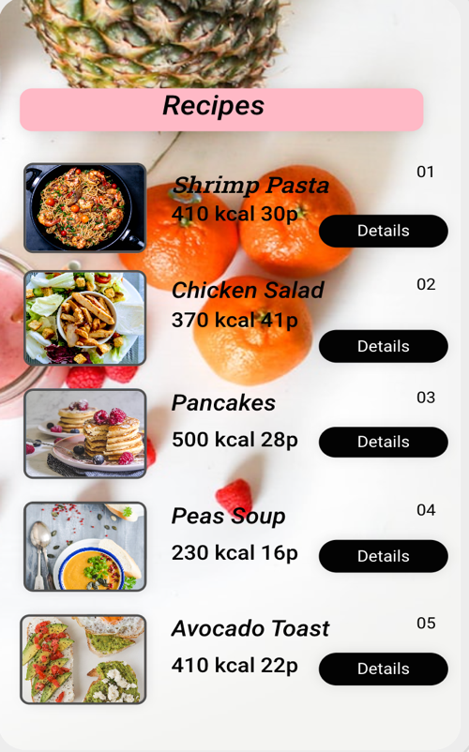

Food List Page. Recipes Page. Workouts Page

First Page :

* La log in : - verifica ca username si parola sa se potriveasca i.e adauga BAZA DE DATE
* La sign up : creeaza pagina de Sign Up
* La forgotten password : creeaza abilitatea sa primeasca mail pt schimbarea parolei

Home Page

* creeaza in backend lista cu quotes
* creeaza in backend caloriile, si abilitatea sa arate caloriile ramase pe ziua de azi

<?xml version="1.0" encoding="utf-8"?>  
<androidx.cardview.widget.CardView xmlns:android="http://schemas.android.com/apk/res/android"  
 android:layout_width="match_parent"  
 android:layout_height="wrap_content"  
 xmlns:app="http://schemas.android.com/apk/res-auto"  
 xmlns:tools="http://schemas.android.com/tools"  
 android:layout_margin="12dp"  
 app:cardCornerRadius="6dp"  
 app:cardElevation="4dp">  
  
 <RelativeLayout  
 android:layout_width="match_parent"  
 android:layout_height="wrap_content">  
 <androidx.cardview.widget.CardView  
 android:id="@+id/card_view_recipe_icon_container"  
 android:layout_width="wrap_content"  
 android:layout_height="wrap_content"  
 android:layout_margin="12dp"  
 app:cardCornerRadius="6dp"  
 app:cardElevation="0dp">  
  
 <ImageView  
 android:id="@+id/image_view_recipe_icon"  
 android:layout_width="80dp"  
 tools:src="@drawable/recipe"  
 android:layout_height="80dp"  
 android:scaleType="centerCrop"  
 />  
 </androidx.cardview.widget.CardView>  
  
 <TextView  
 android:id="@+id/text_view_recipe_title"  
 android:layout_width="match_parent"  
 android:layout_height="wrap_content"  
 android:layout_alignTop="@+id/card_view_recipe_icon_container"  
 android:layout_toEndOf="@+id/card_view_recipe_icon_container"  
 android:fontFamily="sans-serif-medium"  
 android:textColor="#222222"  
 android:textSize="18sp"  
 tools:text="The Recipe Title"  
 />  
  
 <TextView  
 android:id="@+id/text_view_recipe_description"  
 android:layout_width="match_parent"  
 android:layout_height="wrap_content"  
 android:layout_marginTop="4dp"  
 android:textSize="14sp"  
 android:fontFamily="sans-serif-light"  
 tools:text="This will be our description of the project"  
 android:layout_below="@id/text_view_recipe_title"  
 android:layout_toEndOf="@+id/card_view_recipe_icon_container"/>  
  
 <Button  
 android:layout_width="wrap_content"  
 android:layout_height="wrap_content"  
 android:layout_below="@+id/text_view_recipe_description"  
 android:layout_marginLeft="290dp"  
 tools:text="Details"/>  
 </RelativeLayout>  
</androidx.cardview.widget.CardView>

My file of recipe .xml