Phys 135B

Activity 1: Coulomb’s Law: the electrostatic force between two charges

Name:

Partners:

Recall from last semester Newton’s Gravitational Law of Attraction between two massive objects, m1 and m2, separated by a distance r:

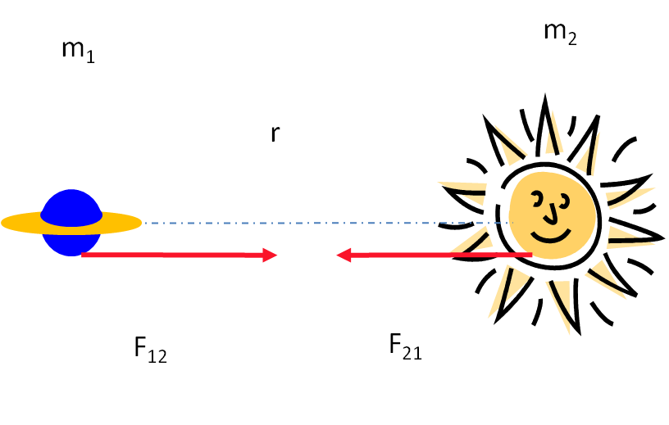

|F12|= |F21|= G m1m2/ r2,

where G =6.67x10-11 Nm2/kg2 is a constant called the gravitational constant. Note that this gravitational force is always attractive.

Because the force decreases, as the distance gets large as 1/r2, this law is one of many such INVERSE SQUARE LAWs encountered in physics. Today, we will learn another such law: the Coulomb’s Law between two electrically charged particles of charges q1 and q2, separated by a distance r as indicated below.

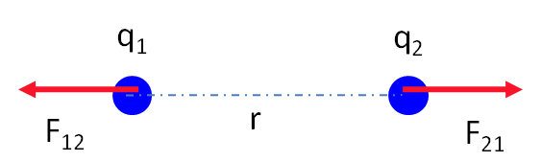

As we learned in our last lecture, the two charges will either attract or repel each other, depending on their signs, with equal-magnitude forces given by the above-mentioned celebrated Coulomb’s law:

|F12|= |F21|= k q1q2/ r2,

where k is a constant called the electrostatic constant, which is approximately 9x109 Nm2/C2.

There is a caveat here: unlike the law of gravitational attraction, the electrostatic force between two charges can be either attractive or repulsive depending on their signs;

Like charges repel

Unlike charges attract.

Visit the following site to get more familiar with charges and electrostatic forces:

<http://phet.colorado.edu/simulations/sims.php?sim=Balloons_and_Static_Electricity>

If there are more forces than just one acting on a particle or object, we add those forces up using vector addition. (This is called the superposition principle)

Now, REMEMBER that a force is a VECTOR quantity, therefore, when we calculate the net force, it must be a VECTOR ADDITION. So please brush up on your vector algebra!!

You cannot just add two vectors like two numbers (unless the vectors are parallel to each other). If one person is pulling you with 10 N-force eastward, and at the same time another person is pulling you with a 10 N-force northward, you will not just go in the east or north directions, rather it will be a direction which is decided by the trigonometry of these involved vectors. Also, you will not just have a net force of 20 N exerted on you, rather it will be 14.2 N. Therefore, the final magnitude and direction are not result of straight addition (or subtraction) of the two numbers.

Let us now do a few hands-on examples on Coulomb’s law:

1-) Calculate the electrostatic force (and indicate both magnitude and direction on the given picture below) the proton (+e) applies on the orbiting electron (-e) in an hydrogen atom. The radius of the electron orbit is 0.53x10-10 m, and the magnitude of the constant e is 1.6x10-19 C.

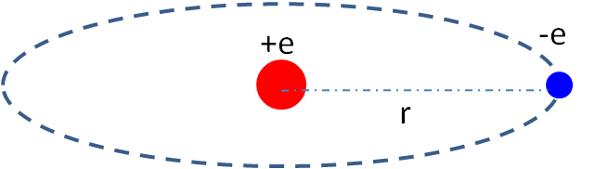

2-) In the above question, calculate the force the electron applies on the proton (both magnitude and direction).

3-) How do these two forces compare? Could you have concluded this using a physical law that you might already know? If yes, what is it?

4-) Calculate, symbolically, the net electrostatic force on q3 due to q1 and q2, as shown in the figure below. Give the answer in terms of the symbols k, e, and d.



5-) Calculate the net electrostatic force on the central charge below due to the other two charges Note: $μ$ is for “micro” and it stands for 10-6.

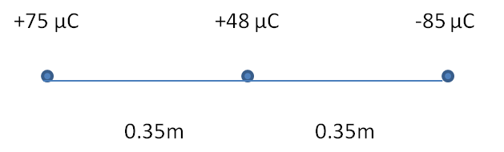

2-Dimensional Examples:

6-) Calculate the net electrostatic force on q3 due to q1 and q2, as shown in the figure below.

e = 1.6x10-19 C and a = 1x10-10 m

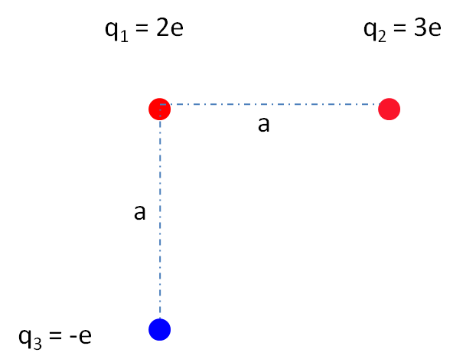

7-) In the above question, calculate the net electrostatic force on q1 due to q2 and q3 (again, both magnitude and direction).

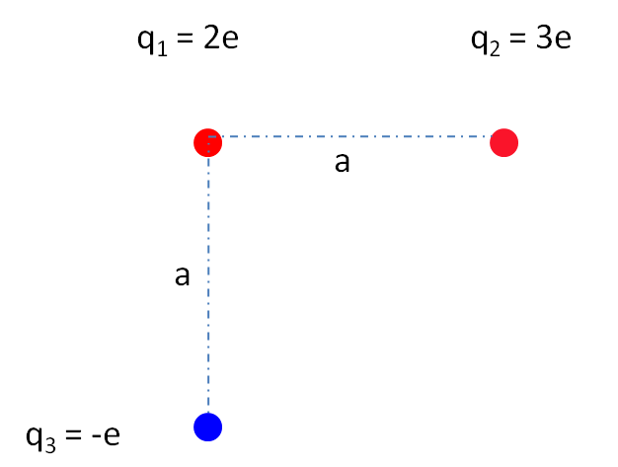

Electric charge and fun: <http://www.youtube.com/watch?v=MKvxbezXNdk>