Phys 135B

Activity 2: Electric Fields and Electric Field Lines

We have learned last semester that the term g in the force formula of mg is called gravitational field of the Earth. This should alert us then toward another way of visualizing the concept of force, whatever type they might be: Force will arise whenever an object is present in a field. The type of the force is determined by the type of the field, and vice versa: gravitational force will be due to a gravitational field acting on a massive object, electric force will be due to an electric field acting on a charged object or particle. Can a gravitational field exert force on a charged but otherwise massless particle (in Newtonian scheme)? **NO!**

What creates the field? What is the origin of a field? It is the same type of particles that a field is allowed to act, normally. I mean, an electric field will act on electric charges and not on chargeless objects even though they might have a nonzero mass. Similarly, a gravitational field will act on massive particles, regardless of what charge it has. In general,

$$Particle↔Field↔Particle$$

In the spirit of this above discussion, we define electric field from our coulomb’s force law. Suppose we are looking at a small “test” charge q in the presence of another charge Q with a distance of separation r. The electric force on our little charge q will be F = k Qq/r2 . Now as we saw, the former equation can be written as F = q E, where E is the electric field created by charge Q at the position of charge q. Electric field then due to a charge Q at a position r is given by

E = kQ/r2.

Since force and electric field are related to each other through a charge which is a scalar quantity, electric field will be a vector quantity like the force. So keep that in mind. The direction of an electric field is from positive charge to a negative charge. If a charge exists by itself we indicate its electric field lines as originating from the charge and pointing outward when the charge is positive, and pointing inward when the charge is negative. If more than one charge exists then the rule in determining the direction of electric field vector is that electric field vector always flows from a positive charge to a negative charge…

The unit of electric field is N/C or V/m, which are equivalent.

By now, you probably see that there are two ways of calculating the electrostatic force on a charge:

i-) Coulomb’s law

ii-) F = qE

If charges are given, then you will use the first one to find the force on any other given charge. If on the other hand, the electric field is given and certain charges are in it, then you will use the second way to figure out the force on any of the given charges. We will encounter both types of scenarios.

**Let us do a few hands-on examples**:

1-) Milikan measured the charge on an electron (charge –e, where $e=1.6x{10}^{-19}C$) by an experiment with falling oil drops in 1909, and got Nobel Prize for it. He essentially suspended the oil drops by balancing the gravitational force on the drops with an electric force he applied on them. Let the average mass of the oil drop be m and its charge be qoil drop. Now, referring to the following picture,

(a) Indicate the electric field lines between the shown electrodes with its direction.

(b) Determine what sign of charge the oil drops should be carrying, if they are to be suspended.

(c) Indicate all the force vectors the oil drop feels on itself.

(d) Calculate the value of the charge q that is on an oil drop in terms of the mass of the drop and electric field applied.

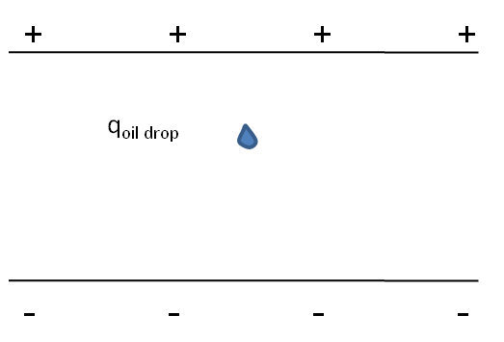

2-) Determine the electric field a proton will create at a distance a = 0.53 Å from it. Indicate its direction.

3-) If an electron (-e) is placed at a distance a = 0.53 Å from the proton, what force will the electron feel due to the electric field of the proton.

4-) The following three charges are located along a line as shown. Given their charges and separation distances as indicated,

1. What electric field vector (not the force!) will the central charge find itself in due to the other two charges? Indicate its direction.
2. Now that you know the electric field at the position of the central charge, find the force (both magnitude and direction) that field applies on the central charge using the formula F = qE.

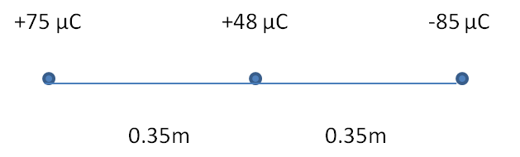

**Electric Field Lines**

Michael Faraday came up with the idea of field lines to visualize what might be going on when charges are in each other’s presence. The field lines indicate both the orientation and intensity of electric field. The field lines are formed of (curved or straight depending on the situation) arrows. The usefulness of it is that if you can map the field lines in space, then you will immediately know what direction a given charge will move when placed in a particular point, because the arrow direction of the line indicates which way the electric field is pointing at that point. The higher the density of field lines, the stronger the electric field. In general, since electric field is proportional with the charge that creates it, the number of field lines is proportional to the charge magnitude. That is a convention, not a hard-and-fast rule, to make our lives easier.

**Draw the electric field lines in the following two situations**:

1-)

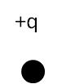

2-)

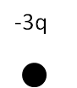

3-)

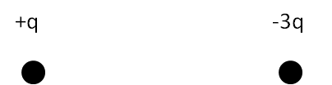

4-)

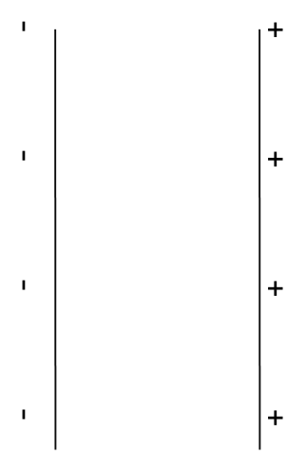

The electric field is $2×{10}^{7}N/C$ in between the above parallel plates, and a charge $q=+6×{10}^{-7}C$ with mass $m=2 kg$ is placed close to the positive plate.

(a) Draw the electric field lines.

(b) What will be the acceleration of the charge?

5-) Two charges are located at the two vertices of an equilateral triangle as shown below.

(a) Determine the electric field at the origin.

(b) Draw the electric field lines for this two charge system.

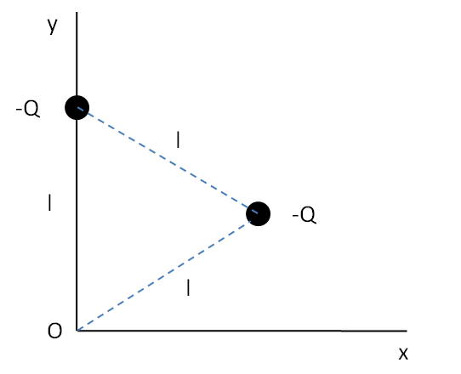

Visit the following websites for a simulation of electric field lines:

<http://www.dgp.toronto.edu/~mjmcguff/research/electrostatic/applet1/main.html>

(Good for comparison between electric field vectors and field lines).

<http://phet.colorado.edu/simulations/sims.php?sim=Charges_and_Fields>

<http://www.its.caltech.edu/~phys1/java/phys1/EField/EField.html>

<http://www.falstad.com/vector3de/>

<http://www.falstad.com/mathphysics.html> (available simulations)