Activity 3: Electric Fields and Conductors in Static Equilibrium

**How do electric fields (electric field lines) behave on the surface of and inside conductors such as metals?**

Investigative Question 1: Suppose you have a free charged particle with mass m present inside a nonzero electric field, what will happen to the particle?

Recall that conductors have “free” electrons moving around the crystal freely. Now, suppose we have a metallic object such a pan sitting by itself, and we would like to ascertain the nature of electric field inside this metal. When we touch the pan, we don’t get electrocuted by it, which means that no electric current (flow of charges in a particular direction) is flowing in it. Therefore, we can safely conclude that there MUST NOT be an electric field inside a conductor.

Investigative Question 2: What if we apply an external electric field to the conductor? Touch your pan in your kitchen when you use your cell phone nearby!

Again, we will measure no current in the conductor, hence there still is not any electric field inside a conductor!

What about right at the boundary? If there is an external field, then there must be some field touching the surface of the conductor. What is the character of that field?

Furthermore, a conductor placed inside an electric field will be polarized, as we, in fact, have seen before in the context of polarization.

**Conclusion**: If an excess charge is placed on a conductor or a static electric field is applied to it, free charges in the conductor will move in such a way as to reach a steady state called **electrostatic equilibrium**.

**Corollary 1**:

**Corollary 2**:

**Corollary 3**:

**Example 1**: A fixed negative charge of magnitude $–q$ is sitting at the center of a “fat” but neutral metallic shell as shown. Draw the electric field lines for all the regions. Indicate the redistribution of charges on the metal.

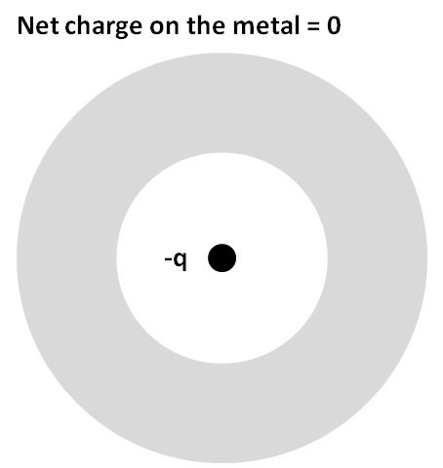

**Example 2**: A fixed positive charge of magnitude $+3q$ is sitting at the center of a “fat” metallic shell with a net charge of $–q$ as shown. Draw the electric field lines for all the regions. Indicate the charge redistribution on the metal.

