Phys 135B

Activity 2: Electric Charges, Electric Fields, and Conductors

Name:

Partners:

Open the following webpage:

<http://www.falstad.com/emstatic/>

**1-)** Create one positive charge and observe its electric field lines and electric field vectors in the surrounding region. Move the charge around and observe the field vectors.

Which way are the field vectors pointing? Draw below.

**2-)** Create one negative charge and observe its electric field lines and electric field vectors in the surrounding region. Move the charge around and observe the field vectors.

Which way are the field vectors pointing? Draw below.

**3a-)** Create two positive charges and position them horizontally. Observe the electric field vectors. Draw the pattern you observe below.

**3b-)** What do you think the electric field will be right at the center of the two charges?

**3c-)** How do the field vectors behave if you bring the two positive particles very close to each other?

**4a-)** Create one positive charge and one negative charge, position them horizontally and observe the electric field vectors. Draw the field vector pattern you observe below.

**4b-)** Will the electric field at the center of the two charges be zero? Why or why not?

**4c-)** Look at the bisecting line passing through the center of the two charges vertically? What is the direction of the electric field at the top portion of the bisecting line? How about at the bottom portion? Does it make sense?

Such a union of a positive charge with an equal magnitude negative charge is called an electric dipole. Electric dipoles are very common in nature and they are very important in various physical, chemical, and biochemical processes.

$$p=\left(charge magnitude in one of the particles\right)*\left(their separation distance\right)=q*d$$

Its unit is coulombs*meters=C*m, which is given the name Debye (D). The electric dipole moment is a vector quantity and its direction is drawn from negative to positive!

The electric field a dipole creates at large distances along the perpendicular line to the axis of the dipole is given by: $E=k\frac{p}{r^{3}}$ (for r>>d).

**5-)** You are encouraged to use this simulation program to check your hw problems asking for the net electric field vector at certain positions due to given charges; just create the same charge configuration in terms of their sign and position and get an approximate idea about the orientation of the net field vector.

Electric Fields and Conductors

Investigative Question 1: Suppose you have a free charged particle with mass m present inside a nonzero electric field, what will happen to the particle?

Recall that conductors have “free” electrons moving around the crystal freely. Now, suppose we have a metallic object such a pan sitting by itself, and we would like to ascertain the nature of electric field inside this metal. When we touch the pan, we don’t get electrocuted by it, which means that no electric current (flow of charges in a particular direction) is flowing in it. Therefore, we can safely conclude that there MUST NOT be an electric field inside a conductor.

Investigative Question 2: What if we apply an external electric field to the conductor? Touch your pan in your kitchen when you use your cell phone nearby! Again, we will measure no current in the conductor, hence there still is not any electric field inside a conductor!

What about right at the boundary? If there is an external field, then there must be some field touching the surface of the conductor. What is the character of that field? Dr. Zorba will show it to you on the board, as well as a demonstration of it in the simulation program.

**Example 1**: A fixed negative charge of magnitude $–q$ is sitting at the center of a “fat” but neutral metallic shell as shown. Draw the electric field lines for all the regions. Indicate the redistribution of charges on the metal.

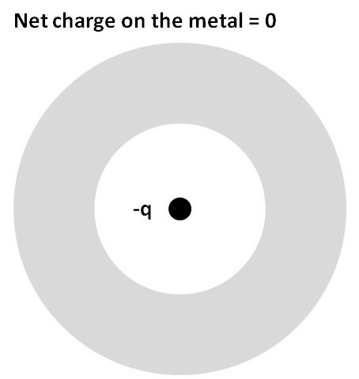

**Example 2**: A fixed positive charge of magnitude $+3q$ is sitting at the center of a “fat” metallic shell with a net charge of $–q$ as shown. Draw the electric field lines for all the regions. Indicate the charge redistribution on the metal.

