Phys 135B Activity 5: Capacitors and Storage of Electric Energy

Name:

Partners:

Capacitors

Capacitors are electrical devices to store electrical energy. Most familiar application of capacitors are in camera flashes. Any object with the capacity to retain charges on it is a capacitor and can store energy. We say such an object has a certain electrical capacitance C on it. Formally, it is the amount of charge that must be added to an object to increase the object’s potential by 1 volt. Its symbol is C. It is related to charge Q and potential V as follows

**C = ∆Q/∆V (1)**

The unit of capacitance is coulombs per volt, but there is a special standard unit for it called farad (F). 1 F = 1 C/V. 1 farad is a very big unit so we usually encounter micro-, nano-, and picofarad.

**Example:** An object acquires 6 $6×{10}^{-12} C$ of charge when it is connected to a 110-volt power supply (battery). Determine the capacitance of this object in farad.

The most typical capacitor example for pedagogical purposes is a pair of metallic parallel plates of the types you have seen before as parallel plates in the context of electric field and potential. The capacitance of such a capacitor is given as

**C = ε0A/d, (2)**

Where = 8.85x10-12 F/m, and is called the electric permittivity of vacuum. A is the plate area, d is the distance of separation between the two plates. Note that the capacitance value depends on the geometry of the system.

**Example:** A pair of metallic parallel plates (in air) has sides $2cm by 3 cm$, and the plate separation is $1 mm$.

1. Determine the capacitance.
2. By what factor would the capacitance change if the separation distance is halved?
3. What if one inserts, in between the plates, a (dielectric) glass slab. Note that the capacitance equation given above needs to be multiplied by the dielectric constant (aka: relative permittivity, $ε_{r}$) $κ$, of the inserted material. See table below.

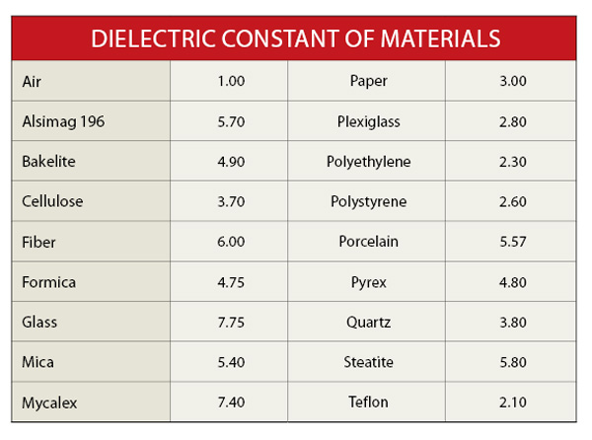

**Energy Storage**:

The function of capacitors is that they can store electrical energy, which is given by the following equivalent formulas:

|  |  |  |
| --- | --- | --- |
| General | Fixed Voltage Case | Fixed Charge Case |
| $U=\frac{1}{2}QV$ (3) | $$U=\frac{1}{2}CV^{2} (4)$$ | $U=\frac{1}{2}\frac{Q^{2}}{C}$ (5) |

**Hint**: For isolated capacitors, it is the charge that will be conserved (fixed), its voltage might change. If on the other hand, a capacitor stays connected to a battery, then its voltage stays fixed, its charge might change.

**Example 1:** If the distance of separation in an isolated capacitor is doubled, how would the stored energy change?

**Example 2:** If the distance of separation in a capacitor that is connected to a battery of potential V is doubled, how would the stored energy change?

Note that while energy changes in these systems, the total energy is still conserved because after all somebody (even the battery) must do work to move the plates toward or away from each other.

Capacitor in Action:

1-) Setup the following circuit diagram:

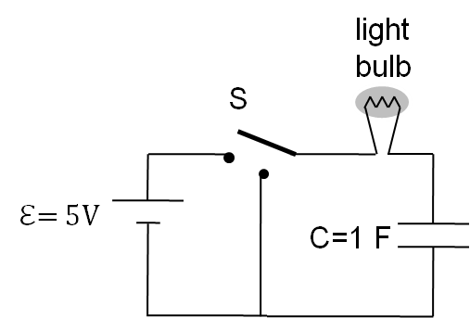

2-) Connect the switch to the battery (top position of the switch). Wait a minute or so. In the mean time, observe whether the light bulb is lit or not. Does the light bulb stay on if one waits enough? Why is this?

3-) And now disconnect the battery from the right circuit without changing the switch position to the bottom position. The switch pole should be floating. Is the light bulb lit? Why or why not? Explain below.

4-) Now bring the switch position to the bottom terminal. Observe the light bulb. Is it lit? Why or why not? Explain below.

5-) How long do you think the light bulb stays on? Try to measure it using your wristwatch.

Compare this value with the $5RC$ (theoretical) value of the circuit.

Capacitors in Parallel and in Series