Physics 135B

**Activity 7**: Kirchhoff’s Circuit Rules, Resistors in Series and Parallel, Electric Power, Alternating Current

**Kirchhoff’s Circuit Rules**

Loop Rule: The algebraic sum of the voltage differences around a closed loop is equal to zero.

Junction Rule: The algebraic sum of all currents meeting at a junction is equal to zero.

Another way of saying the same thing: At any junction (node) in an electrical circuit, the sum of currents entering the node is equal to the sum of currents exiting it.

Note that the following equivalent resistor formulas are derived from the above two rules.

**Resistors in Series**

The equivalent resistance for resistors connected in series:

$$R_{eq}=R_{1}+R_{2}+⋯$$

**Example 1**: Determine $I$, $V_{1}$, $V_{2}$, and $R_{eq}$ in the circuit shown below.

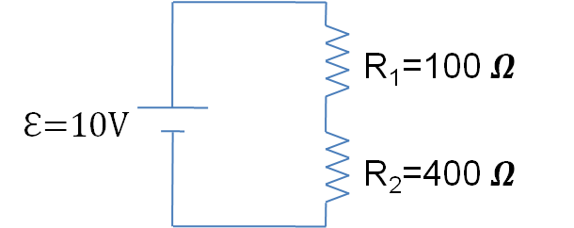

**Resistors in Parallel**

The equivalent resistance for resistors connected in parallel:

$$\frac{1}{R_{eq}}=\frac{1}{R_{1}}+\frac{1}{R_{2}}+⋯$$

**Example 2**: Determine $I$, $I_{1}$, $I_{2}$, $V_{1}$, $V_{2}$, and $R_{eq}$ in the circuit shown below.

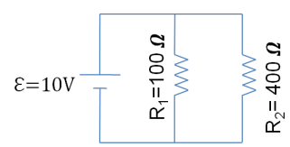

**Electric Power**

Recall that the average value of Power is defined as the rate at which work is done (or energy transferred):

$$\overline{P}=\frac{Work}{Time interval}=\frac{∆W}{∆t},$$

where $∆W$ is the energy transferred during $∆t.$ Then if a force is doing the work on an object we can calculate the average power of that force from

$$\overline{P}=\frac{Work}{Time interval}=\frac{∆W}{∆t}=\frac{F*∆x}{∆t}=F*\frac{∆x}{∆t}=F*v=Force*velocity$$

where $v$ is the velocity of the object on which the force is acting.

**A few remarks on units**

**Watt**:

Work has a unit of Joules, so power must have a unit of $\frac{Joules}{second}=\left(\frac{J}{s}\right)≡watt or W!$

Thus watt is the standard unit for power.

**Horsepower (hp)**:

If one is talking about everyday usage of power, a larger unit is sometimes used. It is the horsepower (hp)! This is a historical unit as people used to use horses to carry heavy objects. The unit stuck with us since then. Arguably, it is a convenient unit of expressing power.

$$1hp≡746 W$$

For example, your car might have around 200 hp of traction power. Please note that, kW is increasingly used as a practical unit instead of hp.

**Kilowatt-hour (kWh)**:

Another unit we need to be familiar with is the kilowatt-hour (kWh). This is not a unit of power, rather it is a unit of energy. Precisely, it is the amount of energy a 1000-W bulb burns if it stays on for 1 hour. This is very practical especially for power-plant companies to calculate how much energy has been used by a particular costumer.

$$1 kWh=\left(1000 W\right)\left(1h\right)=\left(1000\frac{J}{s}\right)\left(3600 s\right)=3,600,000 J=3.6x{10}^{6}J=3.6 MJ$$

**Calories (Scientific)**: 1 calorie (cal) is 4.184 J

**Calories (Dietary)**: 1 Calorie (Cal) $=1kcal=1000 calories$

This is used in the dietary energy-content calculations. For example, when we say an average human being burns 2000 (food) Calories daily, what we mean is that it is $2,000,000$ (scientific) calories per day.

**Example 1**: How many kWh does an average human being consume daily?

**Example 2**: How much energy would a 100-W bulb consume in terms of kWh

(a) in one hour?

(b) in 8 hours?

(c) in 30 days for 8 hours a day?

(d) If 1 kWh costs 10 cents, how much would the above usage in (c) cost per month?

**Power formulas for electric case**:

|  |  |  |
| --- | --- | --- |
| General | Voltage based | Current based |
| $$P=VI$$ | $$P=\frac{V^{2}}{R}$$ | $$P=I^{2}R$$ |

**Example 3:** What is the maximum current that a 1200-W DC motor can handle if its resistance is 3 ohms?

**Example 4**: A 47-ohm resistor has ½ W power rating. If you exceed this rating, the resistor will overheat and burn. What is the maximum voltage you can apply to such a resistor

**Example 5**: Solve symbolically the following Peer Instruction question in detail.

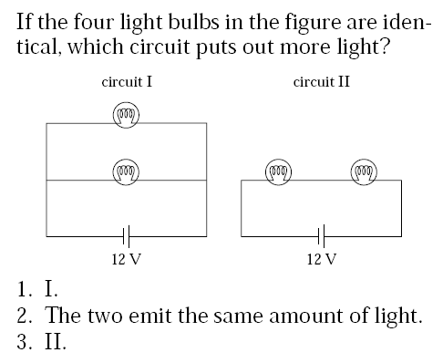

**Non-Ideal Batteries with Internal Resistance and Terminal Voltage**

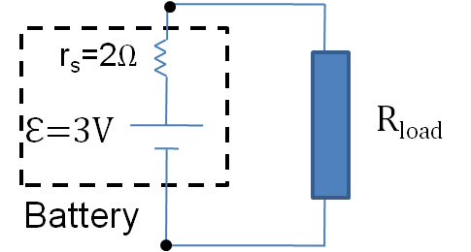

From Ohm’s law, we can write:

$I=\frac{ε}{R_{load}+r_{s}}$ From Ohm’s law.

By Kirchhoff’s loop rule, we can write:

$$V_{terminal}=V_{R_{load}}=ε-Ir_{s}$$

**Direct Current (DC or dc) and Alternating Current (AC or ac)**

|  |  |
| --- | --- |
| DC | AC |
| Current  time  O  I | Current  time  O  Irms  Ipeak=I0 |
| Current and voltage don’t not change  with time. | Current and voltage change with time  For ac signals, one talks about an effective value called rms (root-mean-square).  Device ratings are given in rms. |
|  | $I_{rms}=\frac{I_{0}}{\sqrt{2}} ;$ $V_{rms}=\frac{V_{0}}{\sqrt{2}}$ |
| Power  time  O  P  Power relation: $P=VI$ | Power  time  O  Ppeak=P0  Pavg=P0/2  Power relations: $P_{0}=V_{0} I_{0}$ Peak (maximum) power $P_{Avg}=V_{rms}I_{rms}$ Average power $P_{Avg}=\frac{P_{0}}{2}$ Average power in terms  of peak power |

**Demo of AC signals with an LED**

Explain your observation of the demonstration utilizing two light emitting diodes (one, red, and one green) with DC and AC power supplies.

**Circuit Protection Element: Fuse operation demonstration**

Explain your observation of the demonstration with a power strip (which has an internal 15 Amp rates “fuse”) and wire loop. What happens as the instructor increases the voltage to the wire loop? Why?