Physics 135B

**Activity 7**: Setting up Circuits, Performing Current and Voltage Measurements

**A fun experiment: Can graphite (as in lead-pencil) conduct electricity?**

Your prediction:

Now, do the following experiment to check your prediction: You will be given one light-emitting diode (LED) and a 9 V battery. Using a paper and pencil construct a circuit where LED is connected to the battery with (not wires but) pathways made from lead-pencil traces. Draw the circuit you came up with below.

Note that **graphene,** a recently discovered and much-touted material for its favorable electrical and heat conduction in nanoscience circles, is obtained from graphite by peeling off its layers until a single layer is isolated. It is hoped that graphene is going to supersede silicon in computers.

|  |  |
| --- | --- |
| graphite  graphene |  |

**Circuit with Resistors in Series:**

Recall that the equivalent resistance for resistors connected in series:

$$R_{eq}=R_{1}+R_{2}+⋯$$

Calculate $I$, $V_{1}$, $V_{2}$, and $R_{eq}$ in the circuit shown below.

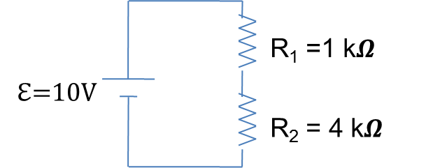

Now, **set up the circuit**, and measure these parameters to see if your above results make sense.

**Circuit with Resistors in Parallel**

Recall that the equivalent resistance for resistors connected in parallel:

$$\frac{1}{R_{eq}}=\frac{1}{R_{1}}+\frac{1}{R_{2}}+⋯$$

Calculate $I$, $I_{1}$, $I_{2}$, $V_{1}$, $V_{2}$, and $R_{eq}$ in the circuit shown below.

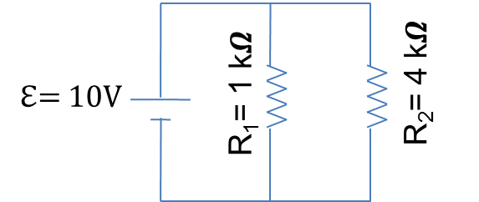

Now, **set this circuit up** and measure these parameters to compare with your calculations.