Physics 135B
Activity 10: Magnetic Levitation

Investigation 1: Like poles repel, unlike poles attract

1- Play with the two pieces of metals given to you. Do they attract each other? Do they repel each other? What do you think are these metal pieces?

2- Connect the given solenoid (cylindrical wound wire) to the DC power supply. Place the solenoid horizontally. Place the small magnet on the table very close to the solenoid’s opening perpendicularly. Don’t turn on the power supply yet. Bring the two knobs on the supply to the maximum setting. Now, without touching any wire or solenoid, turn on the power supply. Explain what you observe.

3- Discuss with your partners as to why this might be happening. Record your conclusion below.

Investigation 2: Magnetic Levitation

Demonstration 1: Flying spinning-top

4- Explain what you observe.

5- Remembering your observation with the two small magnets, and with the solenoid and a small magnet at the beginning of this activity, can you guess why the spinning top levitates?

Demonstration 2: A wire loop on a metal slab
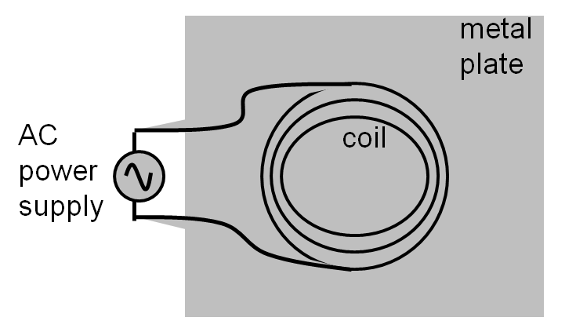

6- Explain what you observe once Dr. Zorba turns on the AC power supply.

7- Remembering your observation with the two small magnets, and with the solenoid and a small magnet at the beginning of this activity, can you guess why the wire loop levitates with the application of current?

8- Did the coil levitate when the current used was DC?

9- Did the coil levitate when the coil was placed on top of a wooden table (instead of the metal plate)?

