Physics background Survey.

PLEASE: Do not write anything on this exam!
Mark all answers on your bubble sheet. (If you need scratch paper, we will provide it.)

Be sure to write and bubble in your name and student ID on your bubble sheet!
(Do this before you begin)

Please answer all questions, and mark only one answer per question.

You will NOT be graded on this, but please avoid guessing.
Your answers should reflect what you personally think.

Plan to take less than 35 minutes.
Thanks!

This survey is double sided, question 1 begins on the back side of this page! (There are 47 questions)

A sled on ice moves in the ways described in questions 1-7 below. Friction is so small that it can be ignored. A person wearing spiked shoes standing on the ice can apply a force to the sled and push it along the ice. Choose the one force (A through G) which would keep the sled moving as described in each statement below.
You may use a choice more than once or not at all but choose only one answer for each blank. If you think that none is correct, answer choice J.
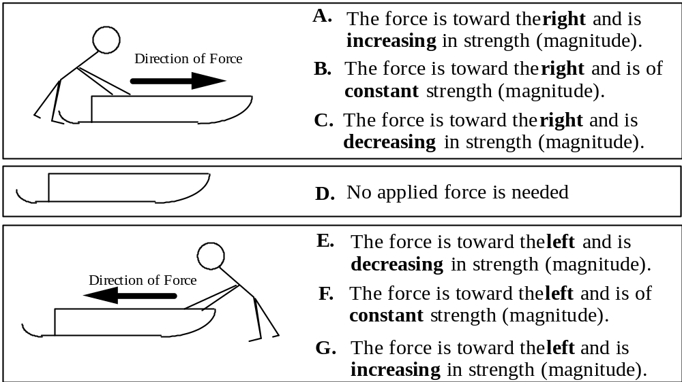
1. Which force would keep the sled moving toward the right and speeding up at a steady rate (constant acceleration)?
2. Which force would keep the sled moving toward the right at a steady (constant) velocity?
3. The sled is moving toward the right. Which force would slow it down at a steady rate (constant acceleration)?
4. Which force would keep the sled moving toward the left and speeding up at a steady rate (constant acceleration)?
5. The sled was started from rest and pushed until it reached a steady (constant) velocity toward the right. Which force would keep the sled moving at this velocity?
6. The sled is slowing down at a steady rate and has an acceleration to the right. Which force would account for this motion?
7. The sled is moving toward the left. Which force would slow it down at a steady rate (constant acceleration)?

(Did you notice questions 1-7 were on the back of the previous page?)
Questions 8-10 refer to a toy car which is given a quick push so that it rolls up an inclined ramp. After it is released, it rolls up, reaches its highest point and rolls back down again. Friction is so small it can be ignored.

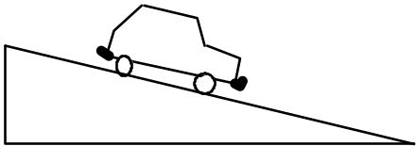

Use one of the following choices (A through G) to indicate the net force acting on the car for each of the cases described below. Answer choice J if you think that none is correct.

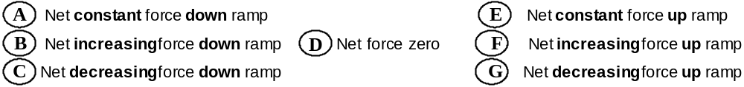

8. The car is moving up the ramp after it is released.
9. The car is at its highest point.
10. The car is moving down the ramp.

Questions 11-13 refer to a coin which is tossed straight up into the air. After it is released it moves upward, reaches its highest point and falls back down again. Use one of the following choices (A through G) to indicate the force acting on the coin for each of the cases described below. Answer choice J if you think that none is correct. Ignore any effects of air resistance.
A. The force is down and constant.
B. The force is down and increasing
C. The force is down and decreasing
D. The force is zero.
E. The force is up and constant.
F. The force is up and increasing
G. The force is up and decreasing
11. The coin is moving upward after it is released.
12. The coin is at its highest point.
13. The coin is moving downward.
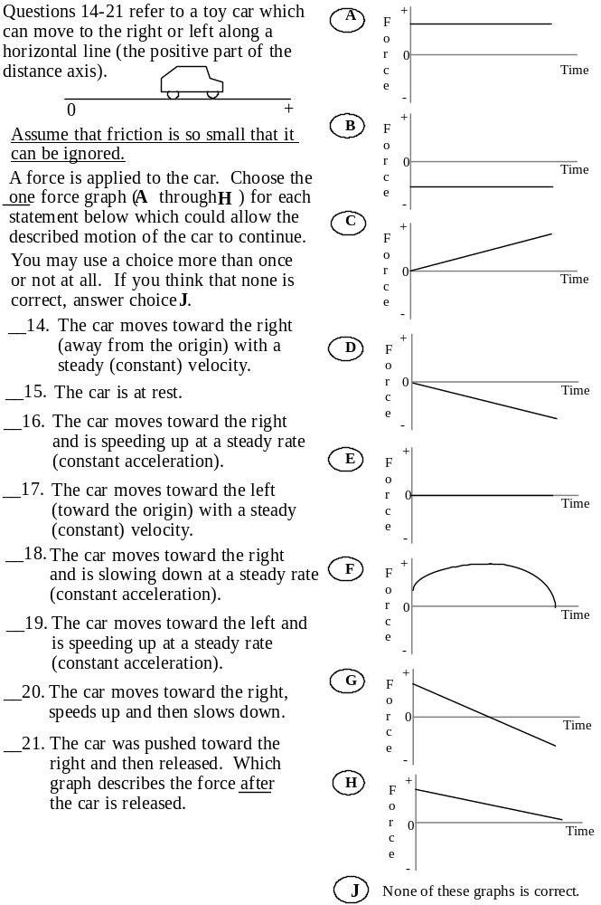
Questions 22-26 refer to a toy car which can move to the right or left on a horizontal surface along a straight line (the + distance axis). The positive direction is to the right.
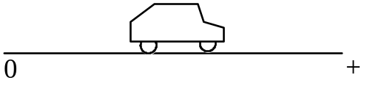
Different motions of the car are described below. Choose the letter (A to G) of the acceleration-time graph which corresponds to the motion of the car described in each statement.
You may use a choice more than once or not at all. If you think that none is correct, answer choice J.
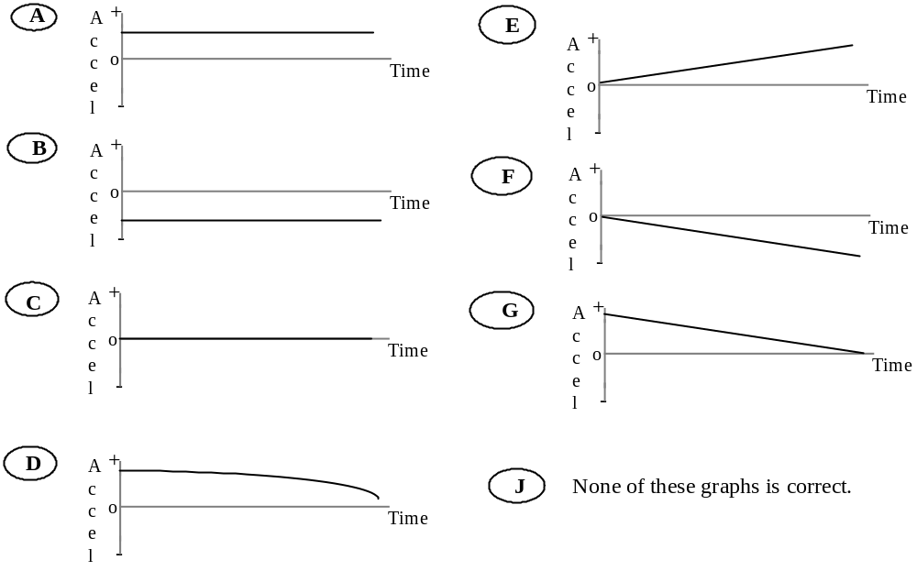
_____22. The car moves toward the right (away from the origin), speeding up at a steady rate.
_____23. The car moves toward the right, slowing down at a steady rate.
_____24. The car moves toward the left (toward the origin) at a constant velocity.
_____25. The car moves toward the left, speeding up at a steady rate.
_____26. The car moves toward the right at a constant velocity.
Questions 27-29 refer to a coin which is tossed straight up into the air. After it is released it moves upward, reaches its highest point and falls back down again. Use one of the following choices (A through G) to indicate the acceleration of the coin during each of the stages of the coin's motion described below. Take up to be the positive direction. Answer choice J if you think that none is correct.
A. The acceleration is in the negative direction and constant.
B. The acceleration is in the negative direction and increasing
C. The acceleration is in the negative direction and decreasing
D. The acceleration is zero.
E. The acceleration is in the positive direction and constant.
F. The acceleration is in the positive direction and increasing
G. The acceleration is in the positive direction and decreasing
___27. The coin is moving upward after it is released.
___28. The coin is at its highest point.
___29. The coin is moving downward.

Questions 30-34 refer to collisions between a car and trucks. For each description of a collision (30-34) below, choose the one answer from the possibilities A though J that best describes the forces between the car and the truck.
A. The truck exerts a greater amount of force on the car than the car exerts on the truck.
B. The car exerts a greater amount of force on the truck than the truck exerts on the car.
C. Neither exerts a force on the other; the car gets smashed simply because it is in the way of the truck.
D. The truck exerts a force on the car but the car doesn't exert a force on the truck.
E. The truck exerts the same amount of force on the car as the car exerts on the truck.
F. Not enough information is given to pick one of the answers above.
J. None of the answers above describes the situation correctly.
In questions 30 through 32 the truck is much heavier than the car . | 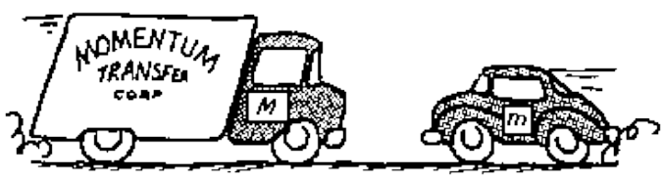
30. They are both moving at the same speed when they collide. Which choice describes the forces?
31. The car is moving much faster than the heavier truck when they collide. Which choice describes the forces?
32. The heavier truck is standing still when the car hits it. Which choice describes the forces?

In questions 33 and 34 the truck is a small pickup and is the same weight as the car. | 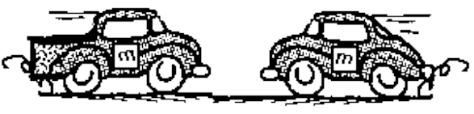
33. Both the truck and the car are moving at the same speed when they collide. Which choice describes the forces?
34. The truck is standing still when the car hits it. Which choice describes the forces?

Questions 35-38 refer to a large truck which breaks down out on the road and receives a push back to town by a small compact car. | 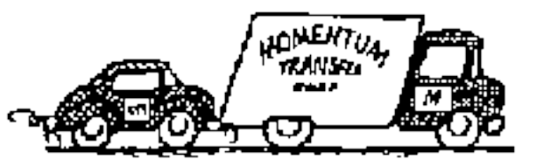
Pick one of the choices A through J below which correctly describes the forces between the car and the truck for each of the descriptions (35-38).
A. The force of the car pushing against the truck is equal to that of the truck pushing back against the car.
B. The force of the car pushing against the truck is less than that of the truck pushing back against the car.
C. The force of the car pushing against the truck is greater than that of the truck pushing back against the car.
D. The car's engine is running so it applies a force as it pushes against the truck, but the truck's engine isn't running so it can't push back with a force against the car.
E. Neither the car nor the truck exert any force on each other. The truck is pushed forward simply because it is in the way of the car.
J. None of these descriptions is correct.
35. The car is pushing on the truck, but not hard enough to make the truck move.
36. The car, still pushing the truck, is speeding up to get to cruising speed.
37. The car, still pushing the truck, is at cruising speed and continues to travel at the same speed.
38. The car, still pushing the truck, is at cruising speed when the truck puts on its brakes and causes the car to slow down.

____39. Two students sit in identical office chairs facing each other. Bob has a mass of 95 kg, while Jim has a mass of 77 kg. Bob places his bare feet on Jim's knees, as shown to the right. Bob then suddenly pushes outward with his feet, causing both chairs to move. In this situation, while Bob's feet are in contact with Jim's knees, | 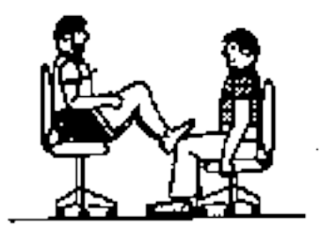
A. Neither student exerts a force on the other. Bob Jim
B. Bob exerts a force on Jim, but Jim doesn't exert any force on Bob.
C. Each student exerts a force on the other, but Jim exerts the larger force.
D. Each student exerts a force on the other, but Bob exerts the larger force.
E. Each student exerts the same amount of force on the other.
J. None of these answers is correct.

Questions 40-43 refer to a toy car which can move to the right or left along a horizontal line (the positive portion of the distance axis). The positive direction is to the right.
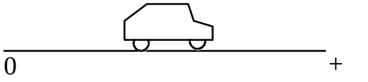
Choose the correct velocity-time graph (A - G) for each of the following questions. You may use a graph more than once or not at all. If you think that none is correct, answer choice J.

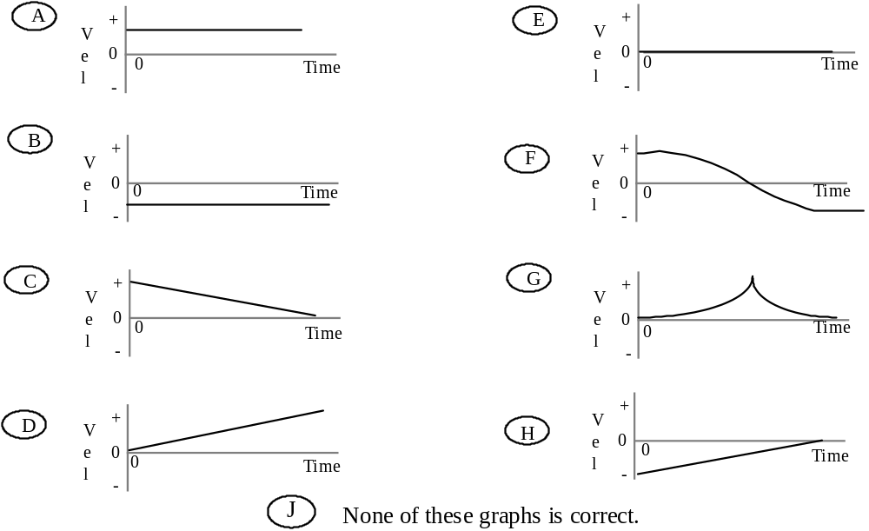

___40. Which velocity graph shows the car moving toward the right (away from the origin) at a steady (constant) velocity?
___41. Which velocity graph shows the car reversing direction?
___42. Which velocity graph shows the car moving toward the left (toward the origin)
at a steady (constant) velocity?
___43. Which velocity graph shows the car increasing its speed at a steady (constant)
rate?
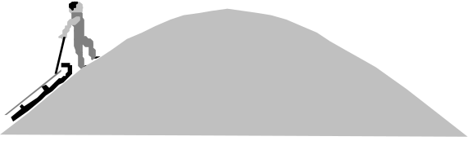

A sled is pulled up to the top of a hill. The sketch above indicates the shape of the hill. At the top of the hill the sled is released from rest and allowed to coast down the hill. At the bottom of the hill the sled has a speed v and a kinetic energy E (the energy due to the sled's motion). Answer the following questions. In every case friction and air resistance are so small they can be ignored.
44. The sled is pulled up a steeper hill of the same height as the hill described above. How will the velocity of the sled at the bottom of the hill (after it has slid down) compare to that of the sled at the bottom of the original hill? Choose the best answer below.
A. The speed at the bottom is greater for the steeper hill.
B. The speed at the bottom is the same for both hills.
C. The speed at the bottom is greater for the original hill because the sled travels further.
D. There is not enough information given to say which speed at the bottom is faster.
J. None of these descriptions is correct.
45. Compare the kinetic energy (energy of motion) of the sled at the bottom for the original hill and the steeper hill in the previous problem. Choose the best answer below.
A. The kinetic energy of the sled at the bottom is greater for the steeper hill.
B. The kinetic energy of the sled at the bottom is the same for both hills.
C. The kinetic energy at the bottom is greater for the original hill.
D. There is not enough information given to say which kinetic energy is greater.
J. None of these descriptions is correct.
46. The sled is pulled up a higher hill that is less steep than the original hill described before question 44. How does the speed of the sled at the bottom of the hill (after it has slid down) compare to that of the sled at the bottom of the original hill?
A. The speed at the bottom is greater for the higher but less steep hill than for the original.
B. The speed at the bottom is the same for both hills.
C. The speed at the bottom is greater for the original hill.
D. There is not enough information given to say which speed at the bottom is faster.
J. None of these descriptions is correct.
_47. For the higher hill that is less steep, how does the kinetic energy of the sled at the bottom of the hill after it has slid down compare to that of the original hill?
A. The kinetic energy of the sled at the bottom is greater for the higher but less steep hill.
B. The kinetic energy of the sled at the bottom is the same for both hills.
C. The kinetic energy at the bottom is greater for the original hill.
D. There is not enough information given to say which kinetic energy is greater.
J. None of these descriptions is correct.

