Asynchronous Activity: Practicing Spatial Description
College Writing Seminar: INTD100-21
Prof. Jordan Hanson, jhanson2@whittier.edu
September 28th, 2020

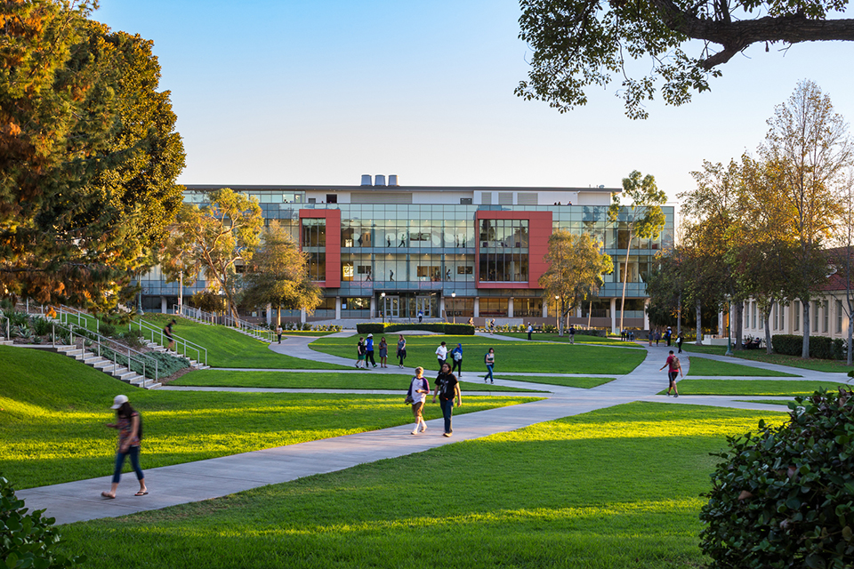

Figure 1. The Science and Learning Center (SLC) at the campus of Whittier College.

1. In Fig. 1, we see a picture of the Science and Learning Center at Whittier College. Because we are undergoing a period of remote instruction, most of us have not seen inside this facility. Imagine, therefore, a laboratory inside the SLC in which you would like to perform scientific research. Using spatially descriptive detail, explain how you would proceed there from the entrance shown in Fig. 1. Give one example of experimentation being done inside this lab that you find interesting.

2. Main Exercise: Imagine you had the resources and space available to construct your own laboratory facility. Using spatial detail, describe exactly how it would be constructed and how it would function. 200-300 words.

