Prof. Jordan C. Hanson
INTD100 Midterm 1 Solutions (my version)
November 12th, 2022

Unit 1: Concise Writing 1

1. Using the delete button. For the sentences below, re-write them more concisely.

(a) The orbits of the starts near the galactic center are used to show that the mass of the object they orbit is so large it must be a black hole.

(b) The reproduction parameter, R0, is defined by epidemiologists to be the number of new infections stemming from one infected person.

(c) Newton’s Laws of motion dictate that objects with different masses and shapes accelerate at the same rate when dropped.

2. Creating an outline. Create an outline of the following set of ideas, such that it describes how to determine optimal tomato growing conditions. Use the outline to write a well-organized paragraph describing the experiment. Submit both the paragraph and the outline.

- Ten tomato seedlings are obtained
- A patch in the garden is reserved with space for all ten
- A photo-sensor can be used to determine the light level at each spot in the patch
- Each tomato plant is given a different amount of water per day
- This whole process is done during the Summer when the amount of sunshine is maximized.

Outline:

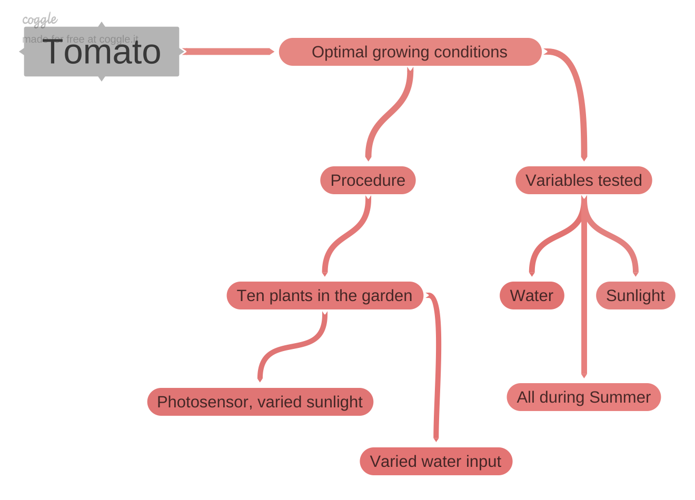

Paragraph:

The optimal Summer growing conditions for tomatoes were determined by varying sunlight and water intake. The experiment was conducted during Summer to maximize average sunlight and avoid frost. Ten tomato plants were planted in a garden adjacent to photo-sensors. The sensors measured solar intensity throughout the day. Each plant received a different amount of sunlight and water per day. The height of each plant and number of tomatoes produced was checked against sunlight and water conditions to locate an optimum.
Unit 2: Concise Writing 2

1. Hierarchy of detail and outlines. Choose from any of the 4 topics from slide 4 of the Week 2 Lecture Notes. Select 3-4 sources online and use them to create an outline with the appropriate hierarchy of details covering the subject. Submit the outline and a 200 word summary of the subject, written concisely and without ambiguous words or phrasing. Properly cite your sources.

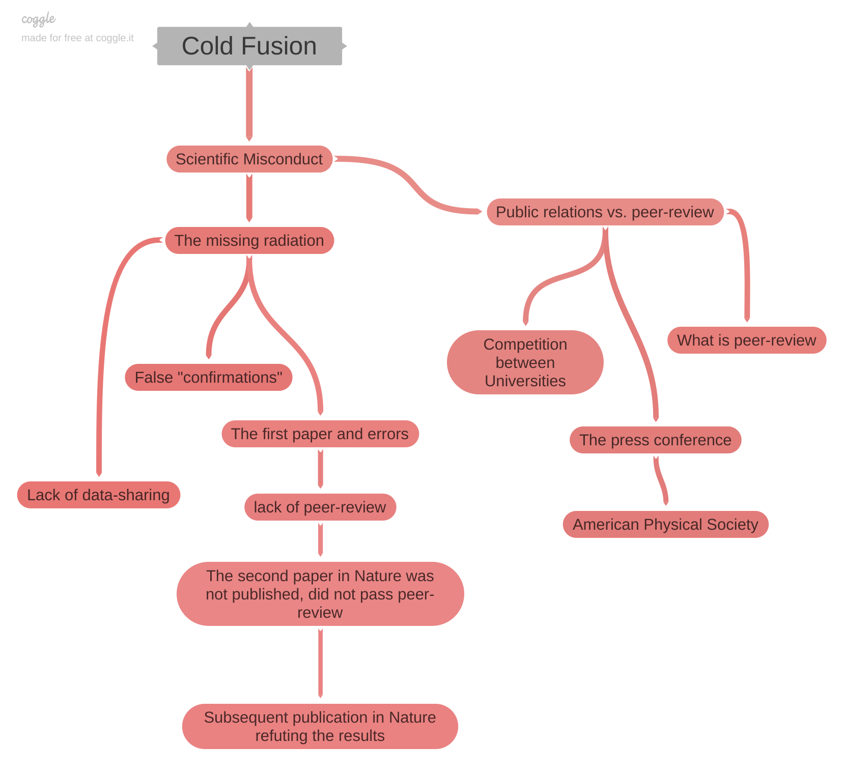

Paragraph:

Scientific misconduct surrounding the announcement of the observation of cold fusion occurred in two forms. First, scientific protocols dealing with data-sharing and reporting of results were not followed. Second, controls within the original experiment were withheld, and removal of errors by peer-review was not performed. Peer-review is the controlled sharing of scientific results with anonymous scholarly peers who critique results from a technical perspective. Profs. Pons and Fleischmann bypassed peer-review to share a positive detection of cold fusion via a press conference. The press-conference was motivated by competition between their home institution, The University of Utah, and rival Brigham Young University. Later, researchers from MIT and CalTech published peer-reviewed articles that refuted the cold-fusion results. These results were shared at the American Physical Society and the journal Nature. The original publication by Pons and Fleischmann in the Journal of Electro-analytical Chemistry was not peer-reviewed, and a more detailed version submitted to Nature never passed peer-review. Experimental controls and other data were not shared initially, leading to false confirmations in the two months between the press conference and the refutation of the initial experiment. The key piece of evidence, a lack of gamma radiation, indicated that fusion was most likely not occurring. This result would have halted the process sooner had it been more widely shared.

Word count: 215

Unit 3: Technical Description 1

1. Removing ambiguous words. In the following sentences, remove or replace ambiguous words.

- “When born, the baby was fairly heavy and really long.” The baby was 48 centimeters long and weighed 3300 grams.
- “The baby grew really fast, by the time she was 1 year old, she was a lot longer.” The baby grew by 40 percent by the time she was 1 year old.
- “Radio transmission took a long while between the Earth and the Moon.” Radio communication was delayed by two seconds between the Earth and the Moon.
- “A hiker walked the full 60 km trail in 4 days, making her average speed moderate.” A hiker walked the trail at 15 km per day for 4 days.

2. Spatial and temporal detail, perspective. Recall the exercise we performed in class, in which we wrote our favorite recipe. In this exercise, explain to the reader from where you are gathering the ingredients, and the recipe. Thus, the result should be a tract of writing that would enable someone to prepare the dish using your kitchen and pantry. Notice how this requires you to pay attention to both time and space.

To prepare salsa roja in our kitchen, first gather the ingredients. From the vegetable rack to the left of the window as one enters the kitchen, take two Roma tomatoes, a head of garlic, two serrano chiles, and four small tomatillos. From the cabinet above the cutting board that is to the left of the refrigerator, take three dried California chiles from the plastic bag. Place the ingredients on the cutting board, and take cumin seeds, black peppercorns, and sea salt from the same cabinet. On the stove to the left of the cutting board, there is a cast-iron pan with a non-stick surface. Place the spices in the pan in desired amounts, and light the flame beneath the pan. With the wooden spoon behind the cutting board, stir the spices until fragrant. To the right of the cutting board, next to the refrigerator, there is a stone molcajete. Leaving the stove flame on, pour the spices from the pan into the molcajete. Return the empty pan to the flame, and grind the spices to a powder using the molcajete. Take the chef’s knife from the second drawer to the right of the sink. Slice the stems from the dried chiles, and toast them in the pan until fragrant. Pour hot water from the sink into the pan, but not enough to cover the chiles. Sprinkle additional salt into the water. Slice the fresh vegetables in half, and add them to the hot water. Boil the vegetables until they are loose. Take the blender from the window sill behind the sink, and place it on the cutting board. Using tongs from behind the cutting board, transfer the vegetables from the pan to the blender. After adding the spices from the molcajete to the blender, pour several tablespoons of the pan water into the blender. Close the lid of the blender, and connect the power chord to the port behind the cutting board. Blend the salsa until it reaches desired consistency. Allow the salsa to cool to room temperature before serving.

Unit 4: Technical Description 2

1. Convert to passive voice.

The acceleration due to Earth’s gravity, g, was measured with a pendulum. The length of the pendulum was measured at 20 cm. The pendulum was hung straight down. The bob was displaced 5 cm to the right, and released. The number of times it returned to the same position as it swung back and forth was recorded during one minute. The pendulum period was measured at 0.90 seconds. The period result was inserted into a formula, predicted by Newton’s Laws, relating period to g. The result for g was 9.81 meters per second squared.

2. Rearrange the sentences to have the proper hierarchy of detail.

The average horizontal distance bacteria travel after a person sneezes was measured. The trials were conducted in a room with no air conditioning, and therefore no air flow. First, a sample of 20 infected people was gathered. The height of each subject was required to be within 6 inches of 5 feet 6 inches tall. Second, petri dishes were arranged in 0.5 meter intervals out to 10.0 meters on the floor in front of the subject. Third, once each subject felt the urge to sneeze, the subject was required to aim the sneeze down the line without covering their mouth. Fourth, bacterial colonies were allowed to grow in the dishes for one week under ideal conditions. The category of dishes with the largest colonies were the ones corresponding to 8.0 meters. The results show that when a person sneezes, it is possible to spread infection to someone who happens to be 8.0 meters away. These results inform the epidemiology of spreading bacteria.

3. Rearrange the sentences to have the proper hierarchy of detail, and convert to passive voice. Remove ambiguous words, and make the writing more concise.

An eraser was placed on a meter stick. The angle between the meter stick and the table was increased, and was measured with a protractor. The angle at which the eraser slides from the ruler is recorded. Using a diagram of the forces, it may be shown that the tangent of the angle is the friction coefficient. The tangent of the angle was measured repeatedly. The average friction coefficient was 0.095, with a standard deviation of 0.05. The temperature of the eraser could be altered in subsequent experiments to determine if the friction coefficient depends on temperature.

