Research Application: Exploration of Antarctic Ice Sheets with Drones

A gap exists in Askaryan-based UHE-ν science. We have made detailed measurements of the RF attenuation length in ice, a critical parameter in our detector designs. However, we cannot currently repeat this measurement throughout detector ice volumes, which would cover kilometers of ice in every direction away from the center of IceCube-Gen2 at the South Pole. Though measurements from aircraft have been collected elsewhere, there is very little aircraft data near the South Pole.

The Open Polar Server Data Gaps, and Drones

The Open Polar Server (OPS) is a service provided by CReSIS at the University of Kansas (KU). Researchers may download data from Greenland and Antarctica. The data are recorded from aircraft over the ice, and the RF attenuation length can be extracted from radar echoes. There are three disadvantages to flight data. First, there may not be a flight near the detector. Second, flights only give a snapshot of the ice at the time. Third, the bandwidth of CReSIS radar does not always overlap with the proposed IceCube-Gen2 bandwidth. There is a trade-off between spatial and temporal data in radio sounding. A plane flight covers hundreds of kilometers, once. Conversely, an embedded station records data over time, but only at one location.

A dedicated drone could constrain the attenuation length in both regimes. In my machine shop and RF design lab, a student and I constructed a 3D printed drone, with 1 kg payload, powered by LiPo batteries. Before the pandemic hit, we had plans to equip it with solar charging and cold-temperature components. A similar effort is underway at CReSIS at KU: Prof. Emily Arnold of the KU Dept. of Aerospace Engineering has begun an NSF CAREER grant to utilize RC military drones to study the Jakobshavn glacier in Greenland. Thus, there is a potential for collaboration between CReSIS and IceCube-Gen2 and PUEO to solve a common problem: the rechargable ice attenuation length measurement system. Our drone design can be 3D printed and assembled from commercial parts for < $1k.

Connection to Whittier Scholars Program, Office of Naval Research, and Climate Science

This research ties together several aspects of our other research programs at Whittier College, connecting climate science, neutrino physics research, and RF engineering. Wee seek to mount RF transmitting antennas to the drone, along with a transceiver payload. We need a lightweight, broadband RF antenna suited to the task. Thus, our ONR research into 3D printing RF antennas designed with the MIT Electromagnetic Equation Propagation (MEEP) package connects to the drone research. We are currently working on 3D printed RF antennas designed with MEEP that will serve IceCube Gen2 and the Navy in a variety of ways. By constructing a drone capable of landing and recharging in a polar environment, we would unlock a new regime of climate-related measurements by improving the time and spatial resolution of glaciological measurements.

Two undergraduate researchers have helped with this research. The first was a physics and business double major, who helped design and 3D-print the drone, which has autonomous flight capability. The second is a Whittier Scholars Program major who graduated after completing several expeditions to Iceland, Alaska, and Montana to study glaciers. The hope was that he could have performed test flights in Antarctica with the drone, however that expedition was impeded by the pandemic. This student helped further design and test the drone. Finally, we wrote a Whittier Scholars Program thesis exploring the evolution of glaciers within a climate science context, and the connection between glaciers and culture. The work was informed by data collected from our student’s expeditions, my past glaciological research, and work connected to the drone (Fig. 1). A copy of the Whittier Scholars Program Thesis has been included in this dossier.

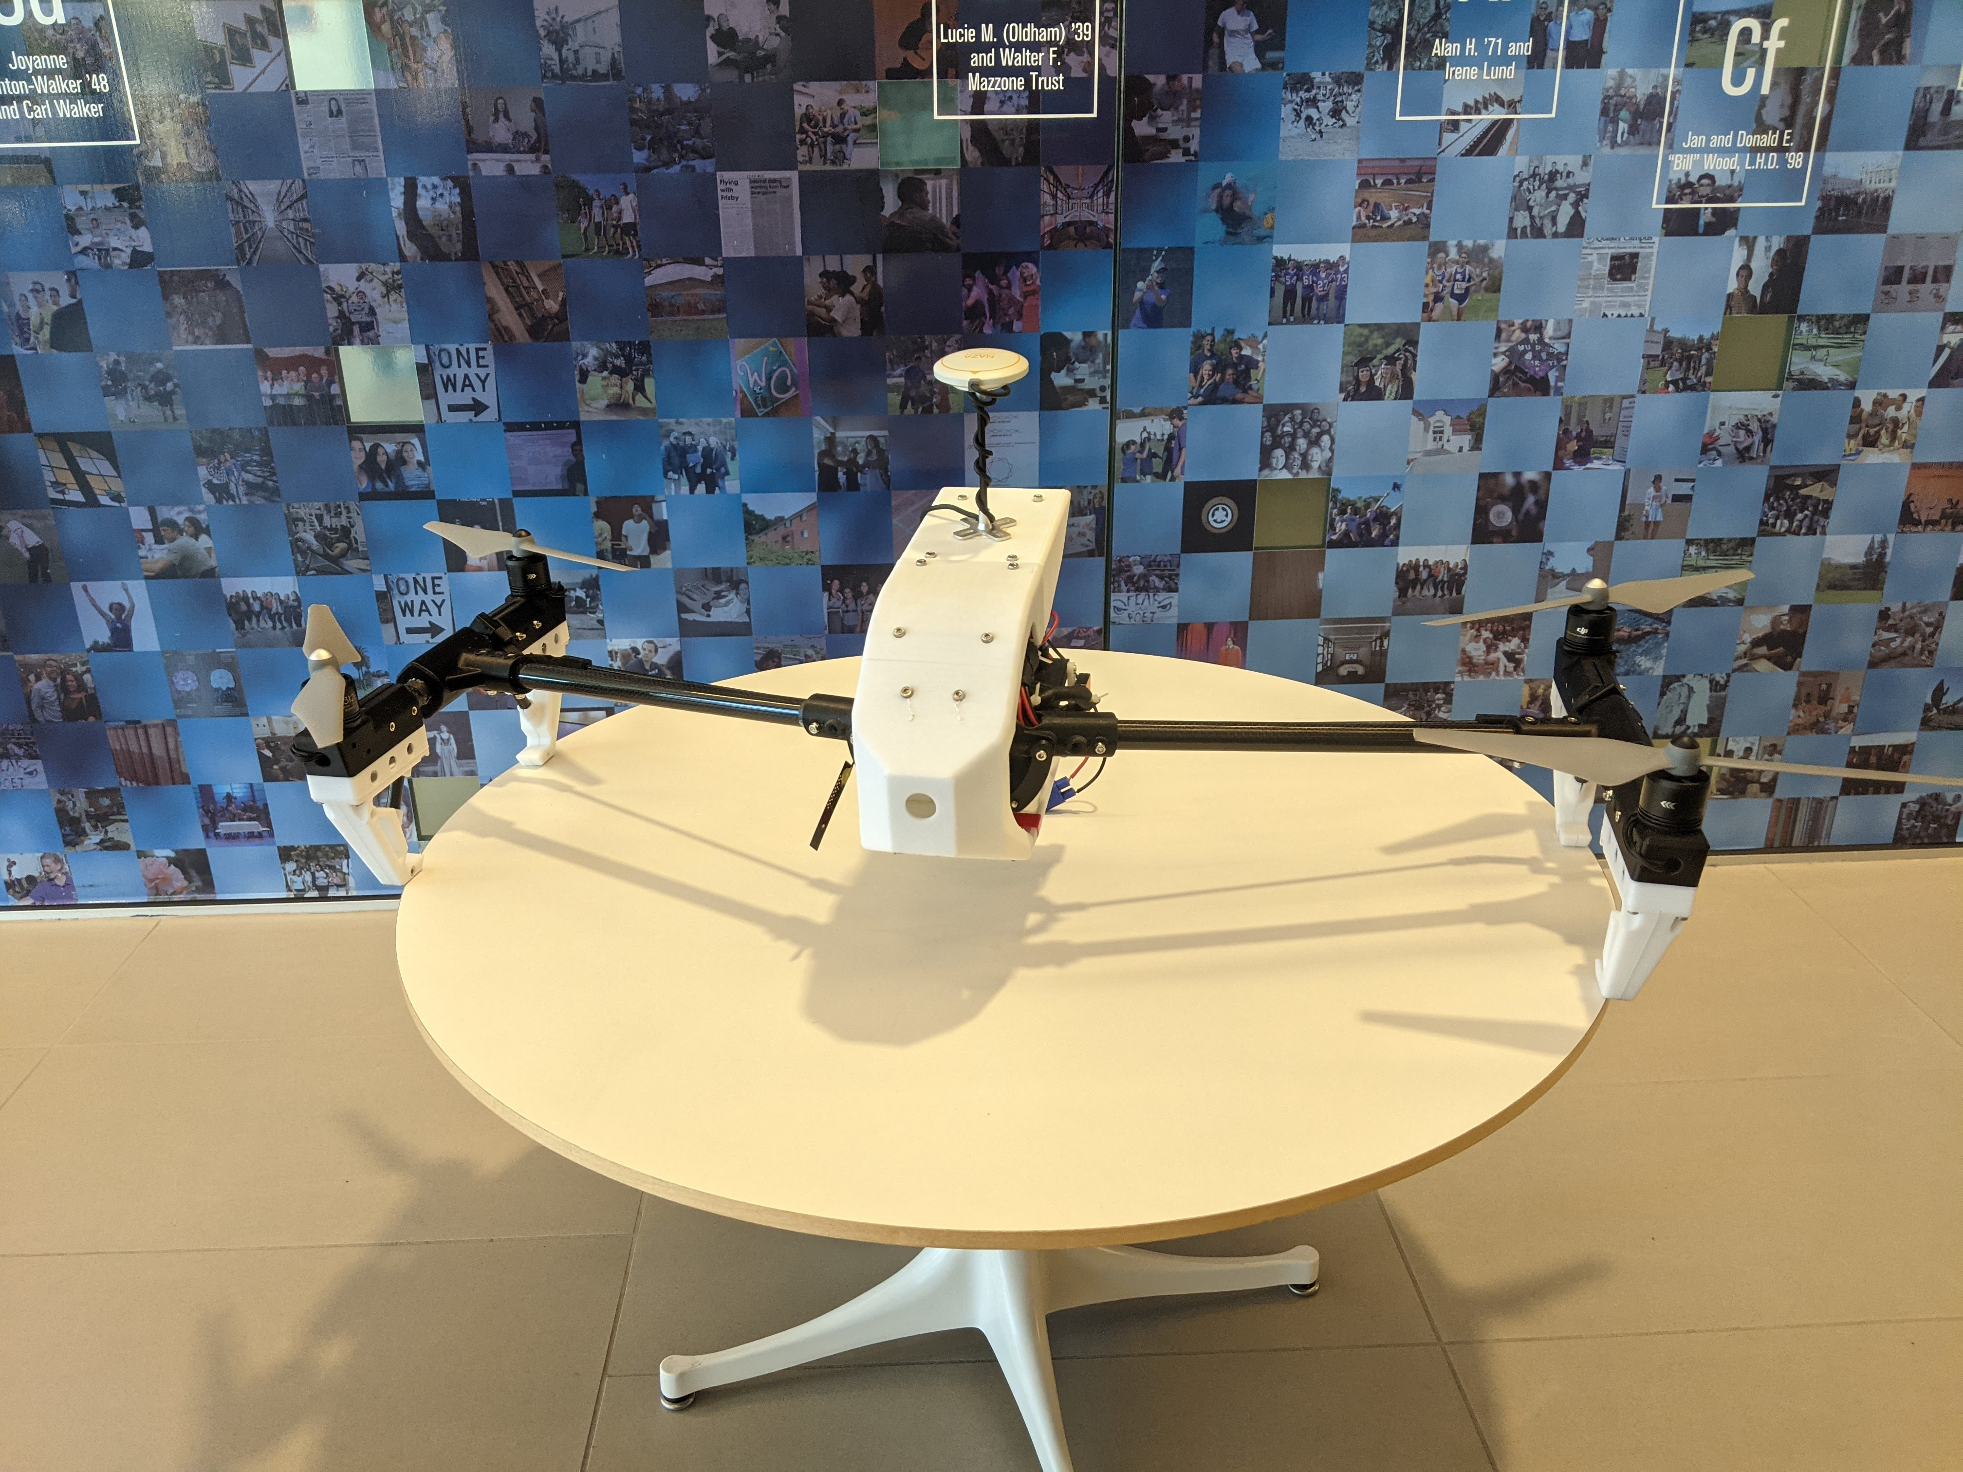

Figure 1. Our custom designed, 3D printed quad-rotor drone with autonomous flight capability. The communications antenna is visible atop the hull. The four engines are mounted on carbon fiber arms, within 3D printed housing components. The guidance, power, and communications electronics are all contained within the hull.

Research Application: Workforce Development for Naval Surface Warfare Systems (NSWC), Corona Division

In the Summers of 2020, 2021, and 2022, I have received Summer Faculty Research Fellowship grants from the Office of Naval Research (ONR). One of my tasks given by ONR was to develop online interactive engineering courses for new personnel. New personnel often join Navy operations, either as civilians or soldiers, with a need for customized training in fields like radar or digital signal processing (DSP).

As a STEM educator at a liberal arts institution, I have a unique set of skills that is highly valued by the Navy. I continue to create interactive engineering courses designed for a diverse audience that has a varying level of expertise in the RF engineering field. Course audiences have been new sailors or field engineers tasked with radar or RF equipment maintenance on aircraft carriers and other warships, and acquisition personnel tasked with purchasing and overseeing new surveillance, GPS, and weapons systems. These diverse personnel need to understand relevant engineering topics quickly, at the right level of detail, and at their own pace.

Luckily, my research often involves synthesizing concepts from RF, radar, DSP, and mathematical physics. I have been able to leverage my knowledge and research experiences in these areas to deliver two summer online courses for the Navy. The first was a general introduction to RF Field Engineering. The second, currently in progress, is an Introduction to GPS M-Code signals for On-boarding of Navy Personnel. Examples of content from each course are included in this dossier.

