July 5th, 2023

To Whom It May Concern:

If the proposal submitted by Dr. Jordan Hanson entitled “CAREER: Translation, Acceleration, and Diversification of Science and Engineering with Open-Source Computational Electromagnetism and Additive Manufacturing” is selected for funding by the NSF, it is my intent to collaborate and/or commit resources as detailed in the Project Description or the Facilities, Equipment or Other Resources section of the proposal.

Sincerely,

Fredrick Park

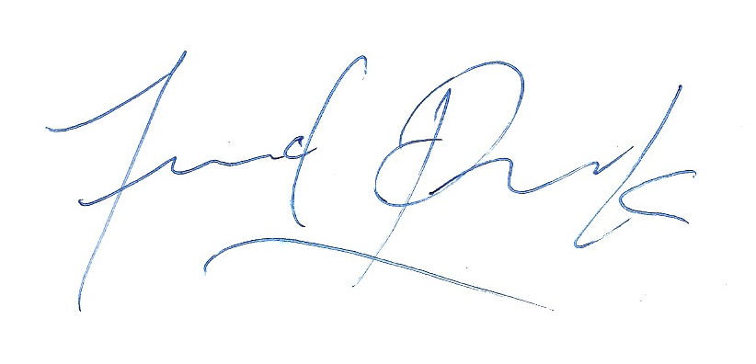

Dr. Fredrick Park

Chair and Associate Professor

Department of Mathematics & Computer Science

Whittier College

fpark@whittier.edu

310-922-7518