E-commerce Website Report

Website description

As we decided to base our website on yoga products it became a necessity that the overall design of the website looked calming, and relaxed to the users. The colour scheme was kept simple by using one main colour across the entire website, which we decided would be turquoise. To make it more appealing to the eye we decided to use a header that would melt into the background image; the back ground image starts off as a cool shade and gradually changes into darker shades, this allows a smooth flow throughout the page rather than looking blocked. The header is very basic; it consists of the navigation bar, that is laid out so that the users would be able to clearly view it and be able to move to other pages without any difficulty. There is also a search bar; users can use this to search for specific products by typing in keywords that relate to what they are looking for; this creates ease of use for the customers. On the top left corner of the navigation bar is our logo, it is very simple and the point is to represent yoga. The top right corner has the shopping basket icon, users are able to click on this to view what is in their basket and also to quickly purchase their products by clicking onto the checkout button. Our website is very customer friendly as users prefer to have everything directed to them, keeping this in mind we decided to keep the navigation bar identical on every page. further on, the content on each page is very minimal and straight to the point, this allows customer to freely check the pages out without getting overwhelmed or confused.

**Database design**

**The layout of the database:**

//Product document

{

Id : object id (".....")

Name: "plain mat"

Description : "plain and blue"

image_url : ""

Height: "150cm"

Width : "50cm"

Price : "£25.99"

Stock_avalibilty : "20"

}

//Customer document

{

Id : object id ("....")

FirstName: "Saibah"

LastName: "Akhtar"

Adress: "32 Albert st, london, N1 PT"

TelephoneNum: "07109823788"

Email: "saibah@yahoo.com"

}

{

Id : object id ("....")

FirstName: "david"

LastName: "Akhtar"

Adress: "19 beechwood st, london, N1 FK"

TelephoneNum: "07467992871"

Email: "David@hotmaail.com"

}

//Order Document

{

Id : Object id("...")

customer_Id:Object id("...")

Shipping Adress: "32 Albert st, london, N1 PT"

Date : "12/03/18"

Time : "12:35"

cost : 25.99

Products: [

{ Id : object id("...")

count : 1 }]

}

//Cart Document

{

Id : Object id("...")

customer_Id:Object id("...")

session_Id : "ljdfksljnbjkfjdhd"

Date : "12/03/18"

Time : "12:35"

cost : 25.99

Products: [

{ Id : object id("...")

count : 1 }]

}

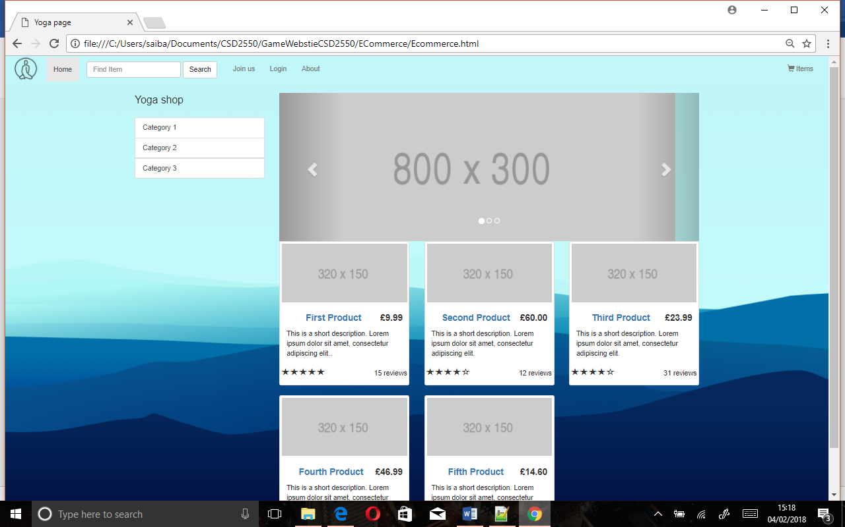

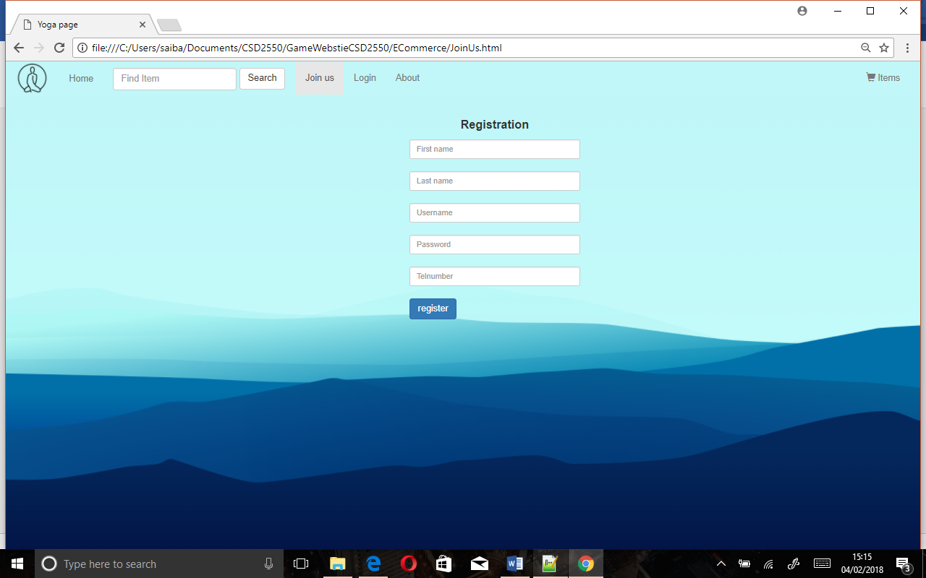

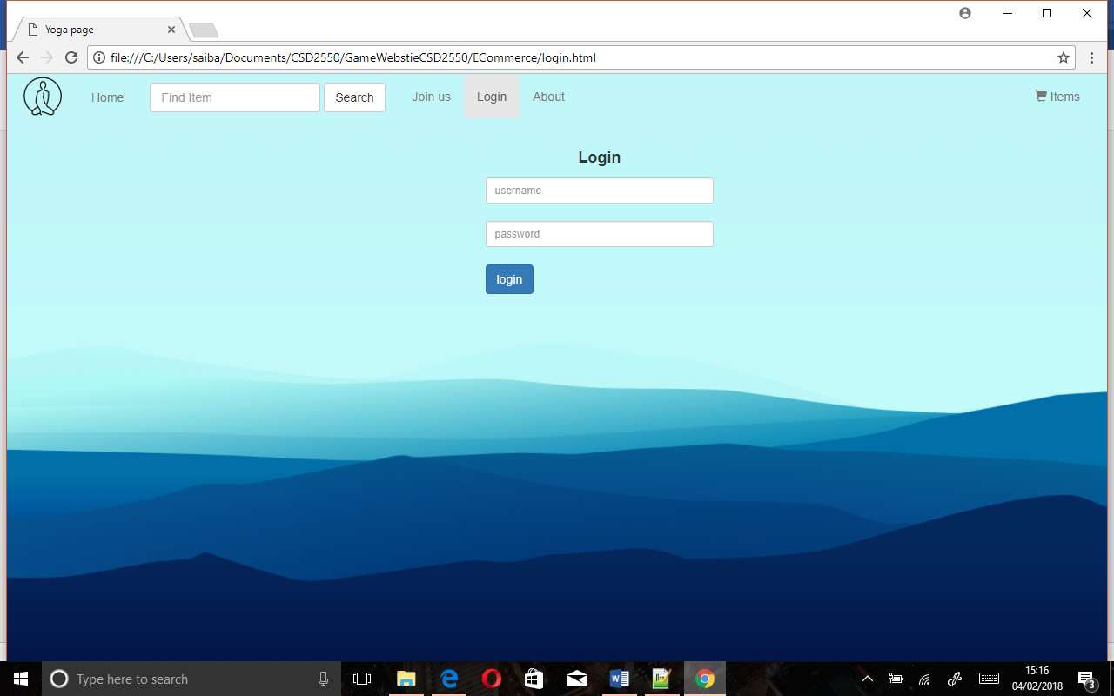

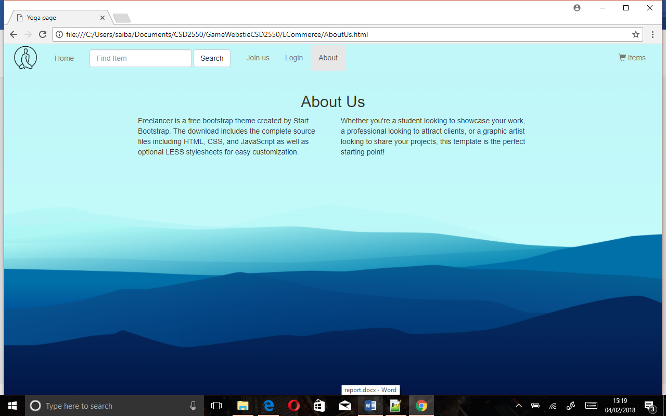

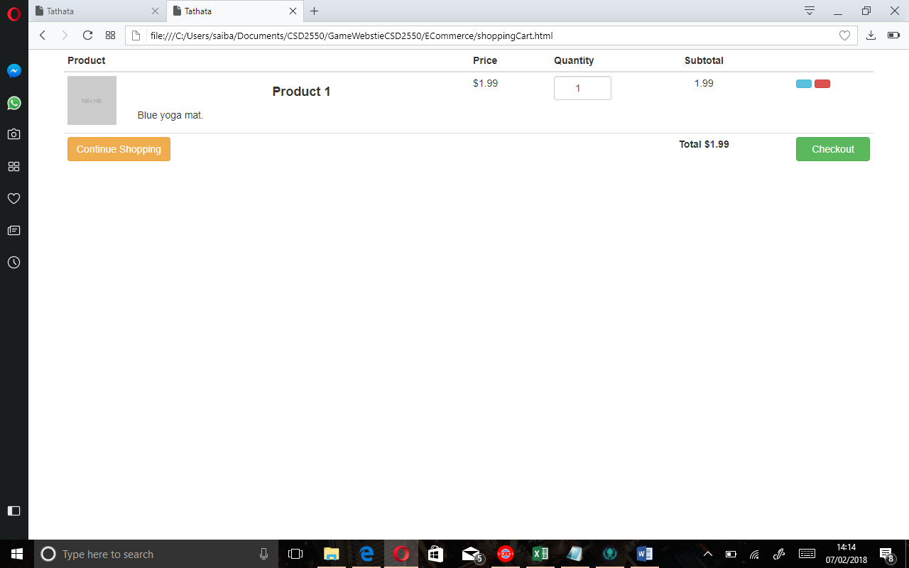

Summary of current stage of project

At this stage in the project we have completed all the requirement that’s been mentioned on the marking page so we have finished:

-front end of the website this includes HTML and corresponding CSS. (since we’ve used Bootstrap and other CSS file has been included for code quality)

-database layout to satisfy our Ecommerce website database requirements and these databases consist of :

List of third party use