Graph documentation(PW2): x2 manual executions

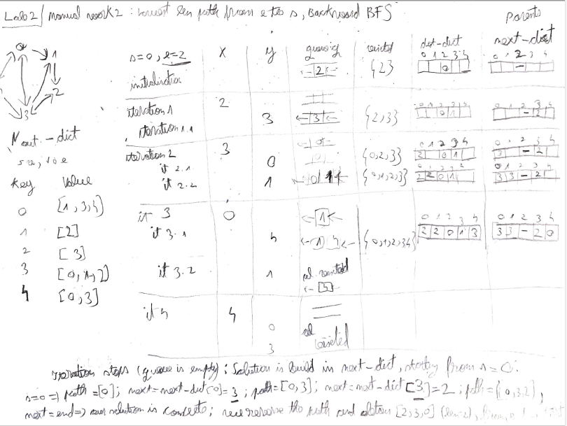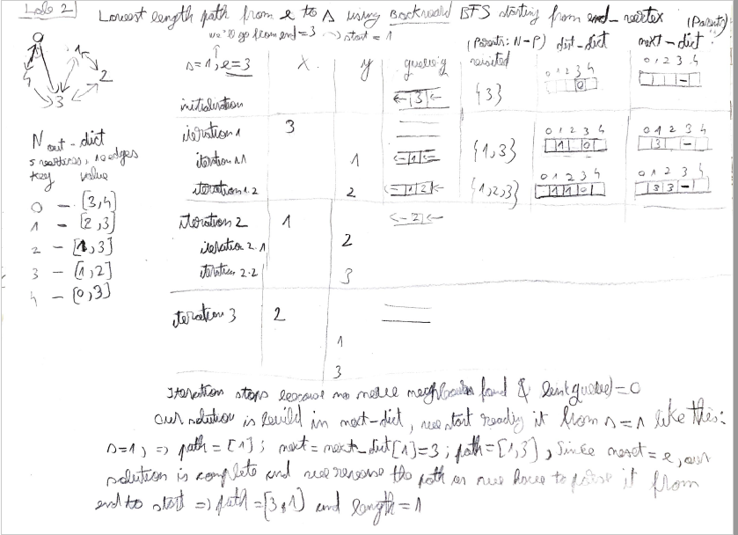

Min length paths (from vertex 1->100, 100->1, graph1k, graph10k, graph100k)

