**Assignment-2**

**Excel :**

**Question 1**

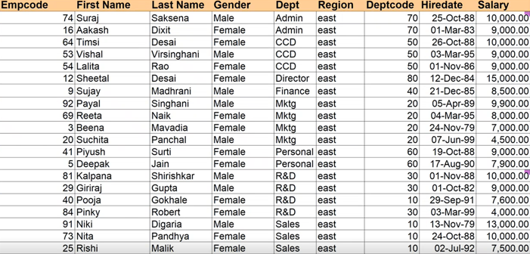

1.Using the above employee table find

a)Bonus column where if salary >10000--- bonus is 3000

salary >8000--- bonus is 2500

salary >6000--- bonus is 2000

Salary >4000---bonus is 1000

2.count the total employee whose salary is 8000 and belongs Finance department

3.find the sum of salary of the employee who belongs to east region and department Marketing

3. find the average of salary of the employee who belongs to north region and department CCD and gender Female

4.find the following for the above table

5.Find the “Allowance” column which is 10% of the salary

6.Fing the “ Gross tax “ column ---if salary >5000 then 10% else 3%

7.Find the “Travel fund “ column ---if dept is CCD and marketing then 1000 else 500

8.Find the “Hike “ column ---if dept is Finance or R& D and region is south then 2000 else 1000

9.Find the name of 5 employee with employee code as per your choice

10.Find the Number of Region and Dept column with match function

11. 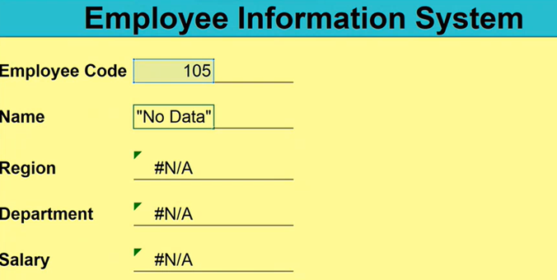

Find the emplyee table like above for both with Data and No data condition

**Question 2**

2)take the similar table as below for the product like Book ,Table ,Chair, pen and find the region wise sales accordingly

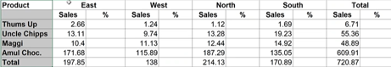

3. 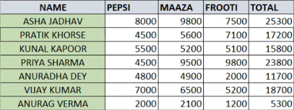

**Implement the the concept of IF , AND , OR for the above table**

**4.** 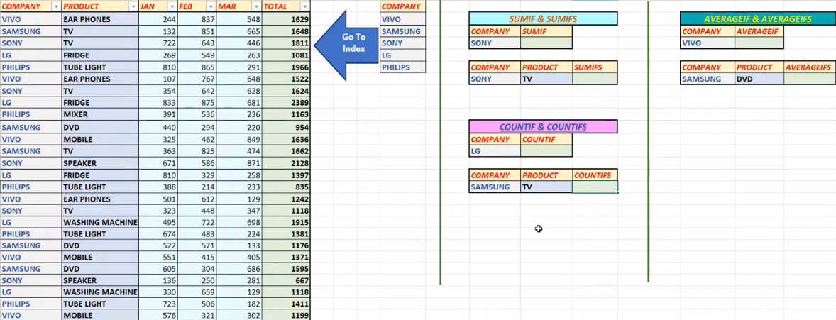

**SQl questions**

1. Write A SQL query to join 2 tables

SELECT customers.customer_id, customers.first_name, orders.item

FROM Customers

Join orders

on customers.customer_id=orders.customer_id

1. Write a SQL query to create student table with 5 basic details and insert the values in it
2. create table prac (age int, name varchar(20), major varchar(20));
3. insert into prac values(20,'sd','science'),(30,'sfds','football'),(33,'rs','football'),(33,'sts','football'),(34,'pjs','football')
4. select * from prac;

3. Write a SQL query to update a student Address from USA to UK

update prac

set address='USA'

where address='UK' and name=’Thomas’;

4. Write a SQL query to finf all the NULL values in Email column

Select email from student where email is Null;

5.Write a SQL query to finf the list of all customers with the value in address field

SELECT * FROM Customers  
WHERE Address IS NOT NULL;

1. Write a SQL query to use UNION operator

select age as Age

from customers

union

select amount

from orders;

7. Write a SQL query to list the number of customer in each country .only include countries with more than 10 customers using having clause.

**SELECT Country, COUNT(*) as NumberOfCustomers**

**FROM Customers**

**GROUP BY Country**

**HAVING COUNT(*) > 10;**

**Python questions**

1.Write a python code to Find whether the person is eligible to vote or not

2. Write a python code to Find whether a Character is vowel or consonant

3. Write a python code to Find the sum of first 5 integer numbers

4. Write a python code to Find the 10 multiple for 5 using while loop

Eg : 5 , 10 ,15, 20 ,25, 30 ,35, 40, 45, 50

5. Write a python code to find the 1st 10 odd numbers using range function

6. Write a python code to check whether the grade of student

>90 ---A Grade

>80----B Grade

>70----C Grade

>60----D Grade

<50----fail

7. Write a python code to loop through string using for loop