rpm -qa | grep docker – – 列出包含docker字段的软件的信息

**使用yum remove卸载docker字段软件**

安装docker

# yum install -y yum-utils device-mapper-persistent-data lvm2

# yum-config-manager --add-repo https://download.docker.com/linux/centos/docker-ce.repo

# yum install -y docker-ce

安装epel-release

#yum -y install epel-release

安装docker-compose

yum install python-pip;pip install docker-compose

下载Harbor离线包

wget <https://github.com/vmware/harbor/releases>

tar -xvf harbor-online-installer-v1.1.1.tgz ; cd harbor

修改配置文件

vim harbor.cfg

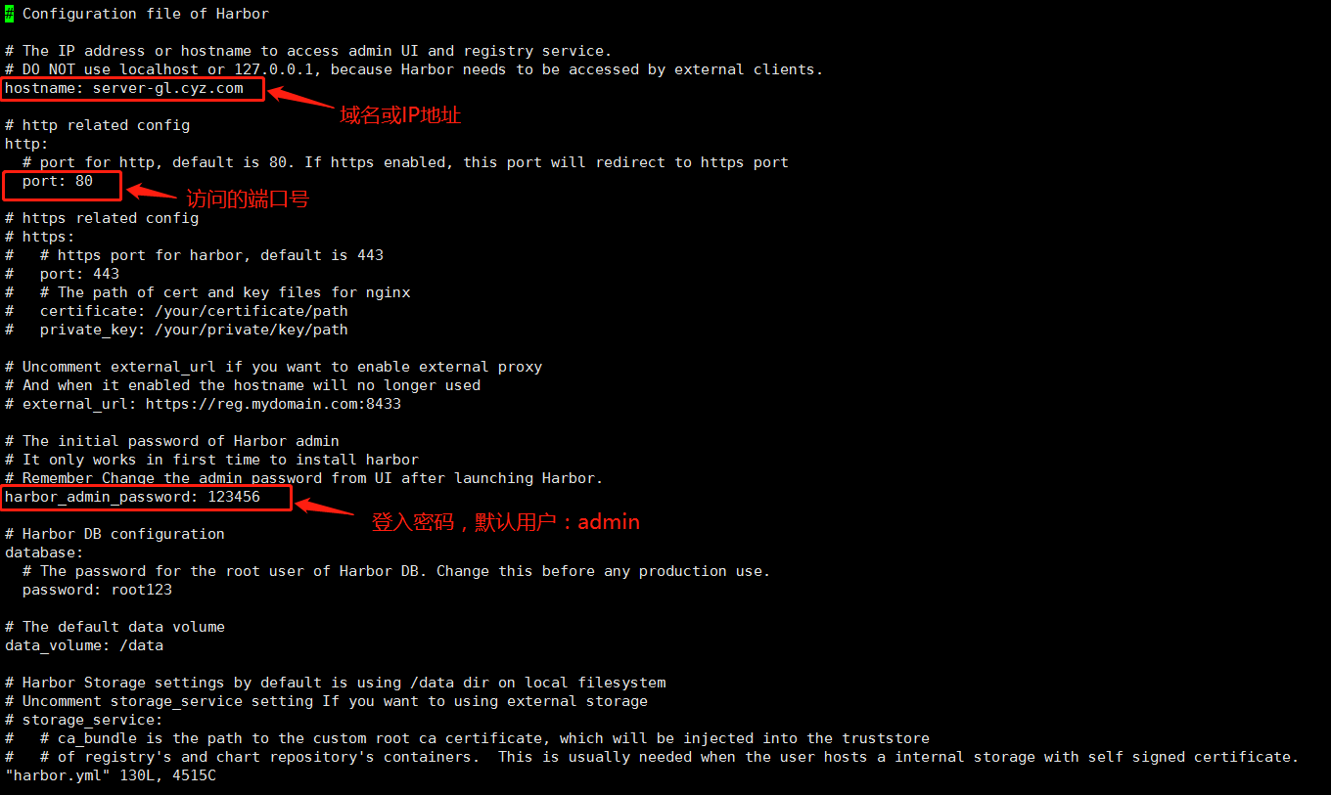

执行./prepare,更新一下配置文件

./prepare

执行./install.sh，开始安装并启动

 ./install.sh

harbor登入报错Error response from daemon

vim /etc/docker/daemon.json

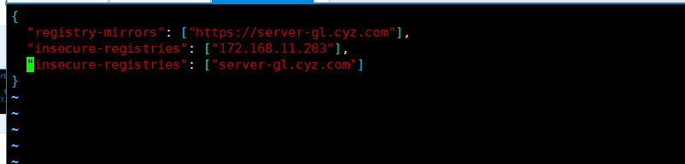

添加信任：

  {

"registry-mirrors": ["https://server-gl.cyz.com"],

"insecure-registries": ["172.168.11.203"],

"insecure-registries": ["server-gl.cyz.com"]

}

systemctl daemon-reload

systemctl restart docker

停止Harbor命令：

docker-compose down -v

启动Harbor

docker-compose up -d

harbor修改配置文件后重启

# docker-compose down

# ./prepare

#  docker-compose up –d

错误：

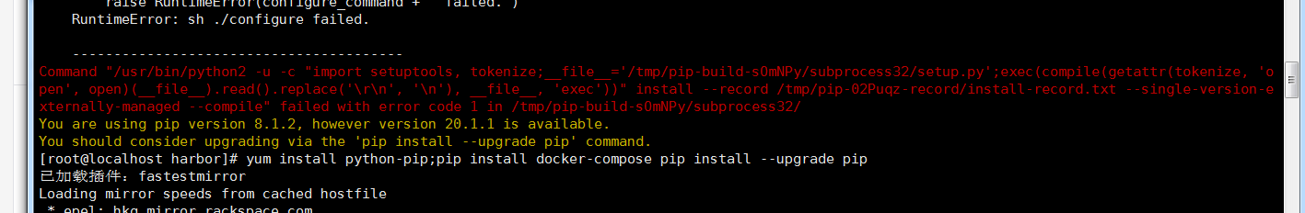

yum install python-devel

推送镜像

docker tag jenkins/jenkins:latest 192.168.14.18/demo/jenkins:v1

docker push 192.168.14.18/demo/jenkins:v1

下载镜像

docker pull 192.168.14.18/demo/jenkins:v1