Whether Weather
Members: Alexander Pham, Jack Larsen, Glen Larsen
Project Description:
Event API with weather API cross reference. User input of events in area code. Output of events near user, indoor/outdoor, expected weather at time of event. Possible google map with events listed on map.
Sketch:
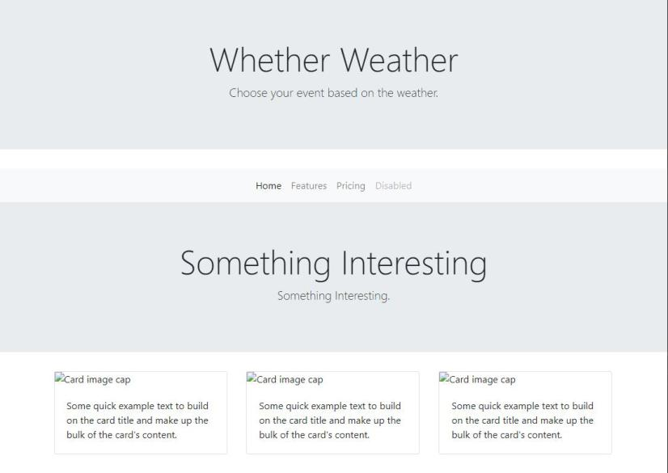
APIs to be Used:
    - PredictHQ API
    - Google Maps API
    - Open Weather Map API
Breakdown of Tasks:
Alexander Pham: Project Leader;
        - Backend
a. API focused backend
b. Firebase storage
1. local storage for last searched event
2. firebase storage for most liked events in area code

Jack Larsen: QA;
        - Frontend
a. Create HTML framework
b. Create CSS styling
        - QA;
a. Check for merge conflicts
b. Communicate compatibility
Glen Larsen:
1.Backend
          - Grab front end user input
          - Work with frontend to create dynamic fields that push to HTML

