**Milestone 2:**

Step 1: Enter code in the terminal: git clone <https://github.com/929583249/7421ICT_Milestone2.git>

Step 2: Enter code in the terminal: cd .\hello-world\\

Step 3: Enter code in the terminal:

1. npm i
2. npm install @react-navigation/native
3. npm install react-native-screens react-native-safe-area-context
4. npm install @react-navigation/native-stack

Step 4: open this folder in android studio

Step 5 :Run the virtual machine of Android Studio.

Step 6: Enter code in the terminal: npm start(first time open this object you need to run the code npx expo start to set up expo first)

Step 7: Scan the QR code with a physical device, or enter 'a' to open the virtual machine.

Step 8: you will see the object looks like this:

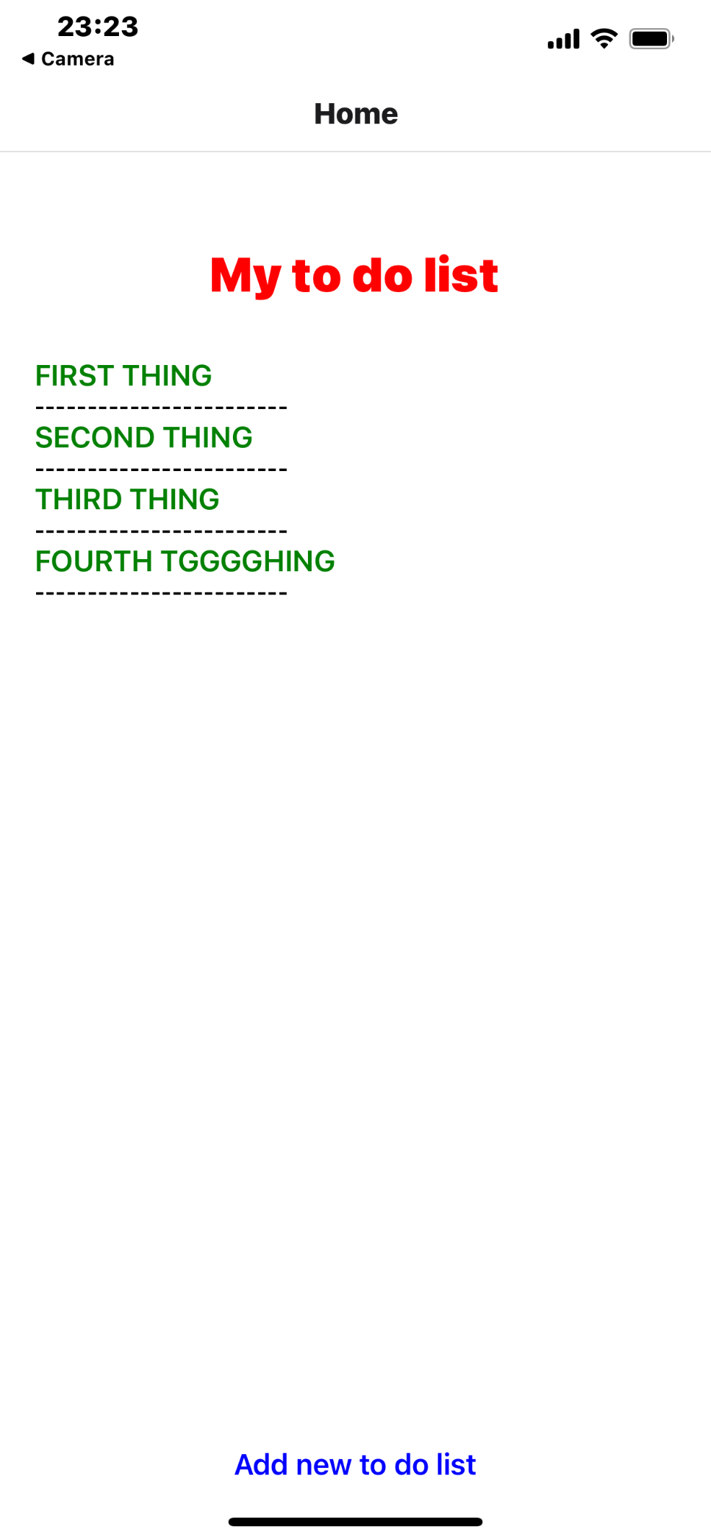

When we click on "Add new to do list," we enter the next screen, named "NewToDo."

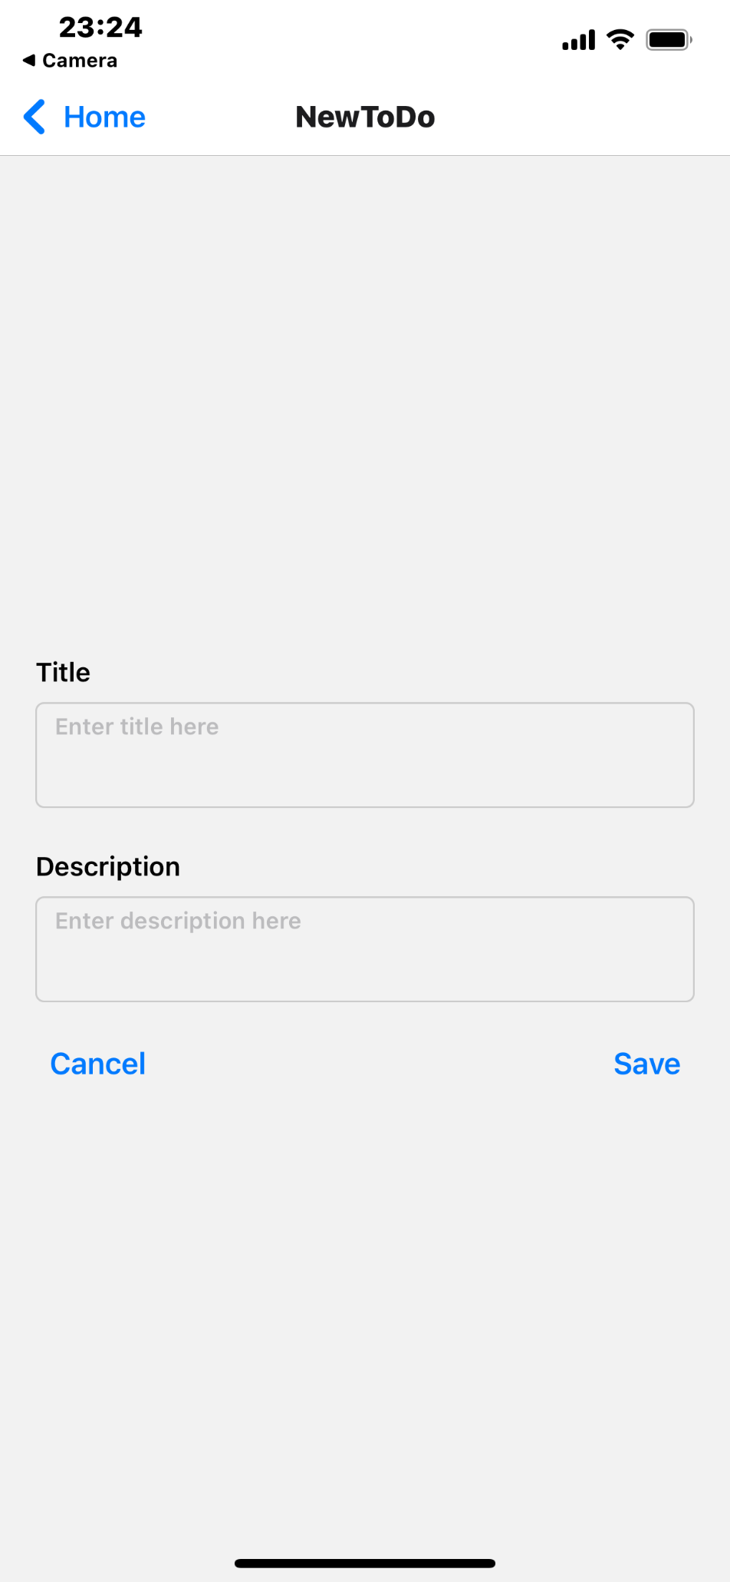

Title and description support multi-line input, while both the cancel button and the top left home button allow returning to the home page.

