Smart Lost & Found System
Project Report
CP3407 Advanced Software Engineering / Projects
Group 6 · James Cook University Singapore
Team | Yuvraj Dave · João Gabriel Costa · Chiranjeeb Satpathy
Milestone | 1 — three iterations, released as v1.0, v2.0 and v3.0
Repository | https://github.com/929919/Smart-Lost-and-Found-System
Deployed application | https://smart-lost-and-found-system-virid.vercel.app (see the notice below)
Demo video | Silent walkthrough, 3 min 41 s — section 5.7
Interactive prototype | Figma — section 4.4
Documentation | 17 pages and 20 user-story pages, in docs/
Delivered | 18 of 20 user stories · 67 of 71 estimated days

Please read before opening the deployed application
Chrome currently shows a full-screen “Dangerous site” warning for the deployed URL. The application is not compromised. Google Safe Browsing classifies it as phishing because it combines three signals that do genuinely describe a phishing site: authentic James Cook University branding, a sign-in form asking for a university ID and password, and a free vercel.app subdomain.
The cause has been addressed — a permanent student-project disclaimer appears at the top of every page and the demonstration accounts are published openly on the sign-in screen — but clearing the classification requires Google to re-review the site. That review has been requested and was still pending at the time of submission. It is tracked as defect D-03 and is the only defect in this project that is not closed (section 6.6).
To see the working system without waiting on Google: watch the demo video (section 5.7), or run the application locally — no install and no build step, against the same live database. To reach the deployed site anyway, Chrome allows it via Details → visit this unsafe site. Only sample data and the three published demonstration accounts exist there; no real credentials are involved and none should be entered.

Contents
Contents 2
1. Executive summary 4
Headline results 4
2. Introduction 5
2.1 The problem 5
2.2 Vision 5
2.3 Objectives 5
2.4 Scope 5
3. Requirements 6
3.1 Elicitation 6
3.2 Personas 6
3.3 Prioritisation 6
3.4 Product backlog — 20 stories, 71 days 6
3.5 Iteration allocation 7
3.6 A gap in elicitation, recorded honestly 7
3.7 Story identifiers in the commit history 7
4. Design 8
4.1 Architectural design 8
4.2 Domain model 8
4.3 Database design 9
4.4 Interface design 10
4.5 Interaction design — claim and approval flow 11
5. Implementation 12
5.1 Technology 12
5.2 Repository structure 12
5.3 What each iteration delivered 12
5.4 Notable implementation decisions 12
5.5 The delivered system 14
5.6 Deployment 18
5.7 Demonstration and client feedback 18
6. Testing 20
6.1 Strategy 20
6.2 Test-driven development 20
6.3 Mock objects 20
6.4 Acceptance testing 20
6.5 System testing 21
6.6 Defect log 21
7. Code quality — SRP and DRY review 22
7.1 Module inventory 22
7.2 Findings 22
7.3 What already held up 22
8. Version control and development tools 24
8.1 Repository and workflow 24
8.2 Issues, milestones and the project board 24
8.3 Continuous integration 24
8.4 Tools and libraries 25
9. Agile process 26
9.1 Velocity 26
9.2 Burn-down charts 26
9.3 Iteration log 27
9.4 Roles and collaboration 28
10. Results and evaluation 29
10.1 Against the plan 29
10.2 What was not delivered 29
10.3 Against the project requirements 29
11. Reflection and future work 30
11.1 What worked 30
11.2 What the team would do differently 30
11.3 Future work 30
12. Appendices 31
A. Demonstration accounts 31
B. Documentation index 31
C. Source documents 31
D. Team contributions 31
E. Links 32

1. Executive summary
The Smart Lost & Found System is a web application that centralises the reporting, searching and recovery of lost property on the JCU Singapore campus. It replaces the current arrangement — a physical logbook at the security office and scattered social media posts — with a searchable register, a verified claims process, and automatic matching between what students report lost and what is handed in.
The system was built over three iterations against a backlog of 20 user stories totalling 71 estimated days, gathered by interviewing target users. Eighteen stories (94% of the estimated effort) were delivered. The two that were not are the two lowest-priority stories in the backlog; no must-have or should-have story was dropped.
The delivered system is a browser client backed by a managed PostgreSQL database, deployed publicly over HTTPS. It provides role-based access for students and campus administrators, camera capture for logging found items, an interactive campus map for recording locations, and a matching engine that explains why it believes two items are the same. Quality is supported by 53 automated unit tests, 34 documented acceptance scenarios, a system test procedure, an SRP/DRY code review, and continuous integration on every push.

Headline results
Measure | Result
Stories delivered | 18 of 20 (90%)
Estimated effort delivered | 67 of 71 days (94%)
Must-have (P10) stories | 8 of 8
Should-have (P20) stories | 6 of 6
Deferred | 2 — both P30/P40
Automated unit tests | 53, all passing, run in CI
Acceptance scenarios | 34 across four epics, all passing
Defects | 10 logged — 9 closed, 1 open (D-03, awaiting Google review)
Application source | ~1,500 lines of JavaScript across 17 modules, 11 pages
Documentation | 17 pages + 20 user-story pages

2. Introduction

2.1 The problem
Items are lost on campus daily. At present a student who loses something must visit the security office in person and describe it, while security keeps a paper log. There is no way to search from outside the office, no record that survives staff turnover, and no way to be told when a lost item is handed in. Students frequently give up; items go unclaimed and are eventually discarded.

2.2 Vision
For JCU Singapore students and campus administrators who need to report and recover lost property, the Smart Lost & Found System is a web application that centralises found-item listings, an interactive campus map and a verified claims process — delivering what is needed, on time and on budget.

2.3 Objectives
- A searchable, filterable register of items handed in, usable from any device
- A structured way for students to report losses and claim items, with evidence of ownership
- Tools for campus security to log items with photographs and physical storage locations
- Automatic matching between lost reports and found items
- A modern relational database with integrity enforced at the data tier
- Access control so that administrative functions are restricted to staff

2.4 Scope
In scope: the item register, the claims workflow, role-based access, the campus map location picker, camera capture, matching and a rule-based assistant.
Out of scope for this milestone: integration with JCU's identity provider, email or push notification delivery, and a native mobile application. The assistant is rule-based rather than a language model.

3. Requirements

3.1 Elicitation
Requirements were gathered by interviewing target users in two groups — students who lose and search for items, and campus security staff who log items and manage claims. Findings were converted into user stories with a title, a short description, a priority on the 10–50 scale and an effort estimate in days. The source document, User_Stories.docx, is committed to the repository, as is the iteration-planning document Practical_Week3_Iteration1.docx. An earlier brainstorm is preserved as Initial Backlog Ideas.md.

3.2 Personas
Persona | Role | Primary need
Jack | Student, searching | Browse and filter what has been handed in
Sarah | Student, lost an item | Report a loss, ask questions, be told when a match appears
Ethan | Campus security, logging | Record found items quickly and store them traceably
Peter | Administrator, claims | Verify ownership and manage the item lifecycle

3.3 Prioritisation
Tier | Meaning
P10 | Must have — the core system cannot function without it
P20 | Should have — works, but feels incomplete without it
P30 | Could have — significant value-add
P40 | Low priority — useful enhancement
P50 | Not scheduled for this milestone

3.4 Product backlog — 20 stories, 71 days
ID | Story | Epic | Pri | Effort | Iter. | Status
1.1 | Found-item dashboard | 1 | P10 | 5 d | 1 | Delivered
1.2 | Search & filter engine | 1 | P10 | 5 d | 1 | Delivered
1.3 | Photo display for items | 1 | P20 | 3 d | 2 | Delivered
1.4 | Responsive design | 1 | P20 | 3 d | 2 | Delivered
1.5 | Clean grid (status filter) | 1 | P30 | 1 d | 3 | Delivered
2.1 | Intelligent chatbot | 2 | P10 | 7 d | 1 | Delivered
2.2 | Real-time database querying | 2 | P10 | 7 d | 1 | Delivered
2.3 | Lost-item reporting form | 2 | P20 | 4 d | 2 | Delivered
2.4 | Match notifications | 2 | P30 | 2 d | 3 | Delivered
2.5 | User accounts & authentication | 2 | P40 | 1 d | 3 | Delivered
3.1 | Found-item logging form | 3 | P10 | 5 d | 1 | Delivered
3.2 | Storage location tagging | 3 | P10 | 4 d | 1 | Delivered
3.3 | Required vs optional fields | 3 | P20 | 2 d | 2 | Delivered
3.4 | Photo upload for items | 3 | P20 | 2 d | 2 | Delivered
3.5 | Duplicate detection | 3 | P30 | 2 d | 3 | Not delivered
4.1 | Claim verification & approval | 4 | P10 | 5 d | 1 | Delivered
4.2 | Status lifecycle management | 4 | P10 | 5 d | 1 | Delivered
4.3 | Claim request & proof of ownership | 4 | P20 | 4 d | 2 | Delivered
4.4 | Admin roles & access control | 4 | P30 | 2 d | 3 | Delivered
4.5 | Audit trail | 4 | P40 | 2 d | 3 | Not delivered

Epics: 1 — Browse & search (Jack) · 2 — Assistance & notification (Sarah) · 3 — Logging found items (Ethan) · 4 — Claims & administration (Peter). Each story has its own page in docs/user-stories/ carrying acceptance criteria, a task breakdown with estimates, the implementation notes and the tests that cover it.

3.5 Iteration allocation
Iteration | Stories | Effort | Focus
1 | 8 | 43 d | P10 — dashboard, search, chatbot, found-item logging, claim workflow
2 | 6 | 18 d | P20 — photographs, responsive design, lost reporting, proof of ownership
3 | 6 | 10 d | P30–P40 — notifications, accounts, access control, duplicate detection, audit trail
Total | 20 | 71 d

Every P10 story was placed in Iteration 1 so that the first demonstration showed a usable system rather than fragments. The lowest-priority work was scheduled last, so that if the budget ran out the least valuable work would be what was lost. That is precisely what happened.

3.6 A gap in elicitation, recorded honestly
User_Stories.docx records 21 requirements. The backlog carries 20 stories. Two requirements gathered from users — performance and reliability — were never carried into the backlog, because the team's story format assumed a user-facing feature and neither fitted that shape. Nothing was built specifically to satisfy them and nothing measured whether they were met. Extended lifecycle states (Disposed / Donated / Archived) were excluded deliberately as P50, which is out of scope for this milestone by definition.
In practice both were addressed incidentally: search filters an in-memory cache so results are immediate, and integrity constraints plus row-level security underpin the accuracy of the listings. That is a happy accident, not a tracked requirement. It is recorded here rather than quietly renumbered, because it is the most useful lesson the project produced, and it recurs in section 11.

3.7 Story identifiers in the commit history
Iteration 1 commits reference the backlog directly. During Iterations 2 and 3 an interim numbering was briefly used in commit messages before being reconciled back to the backlog. Where a commit message is ambiguous, docs/requirements.md is authoritative and carries the full mapping. This is a known inconsistency, recorded rather than hidden.

4. Design
Design covers all major components: architecture, the domain model, the database and the interface. All three principal diagrams were produced in draw.io, an online diagramming tool, with the editable sources committed under docs/diagrams/ as .drawio files that can be reopened and edited at app.diagrams.net. The interface was additionally prototyped interactively in Figma. Class and sequence diagrams are maintained as Mermaid diagrams-as-code inside the documentation, and exported copies are kept in docs/diagrams/ as standalone HTML.

4.1 Architectural design
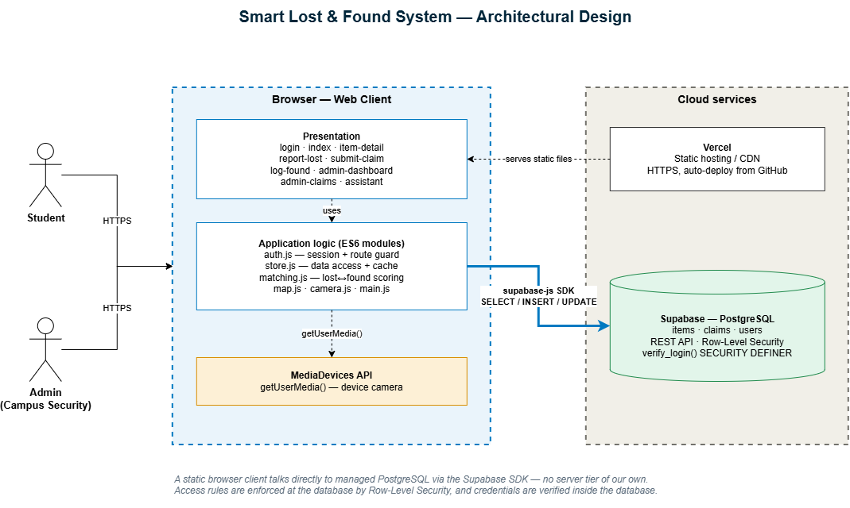
Figure 1 — Architectural design — UML component and deployment view, produced in draw.io
The system is a static browser client that talks directly to a managed PostgreSQL database, with no server tier of the team's own. The client is served as static files from a CDN; data access goes through the Supabase JavaScript SDK, which exposes PostgreSQL over HTTPS.
Why this shape. The project began as a Flask API with a React front end. That stack never reached a demonstrable state and required three deployable parts for what is fundamentally a form-and-list application. Removing the middle tier eliminated an entire class of failure without giving up the relational database — access rules moved into the database itself as row-level security policies, which is a stronger place for them than application code. Both prototypes are preserved in the repository under backend/ and frontend/, each with a README explaining what it was and why it was replaced.
Layering. Presentation is eleven HTML pages plus styles.css. Application logic is seventeen JavaScript modules. The data tier is PostgreSQL with row-level security.

4.2 Domain model
The domain is three entities. An Item receives zero or more Claims; a User submits zero or more Claims.
Class | Attributes | Relationships
Item | id, name, category, location, item_type, status, photo_url, created_at | 1 → 0..* Claim (receives)
Claim | id, item_id, claimant_jcu_id, proof, status, created_at | belongs to one Item; submitted by one User
User | jcu_id, role | 1 → 0..* Claim (submits)

The class diagram is maintained as Mermaid in docs/design.md, with an exported copy at docs/diagrams/class_diagram_smart_lost_found.html.

4.3 Database design
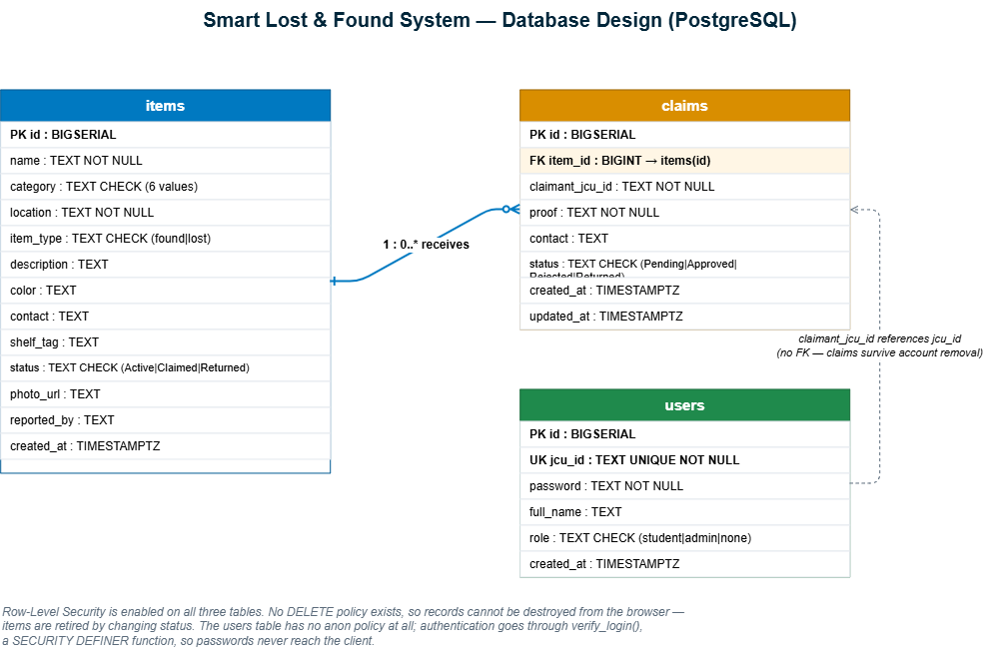
Figure 2 — Entity-relationship model — items, claims and users
Three tables in PostgreSQL. items holds both found items and lost reports, separated by item_type, so one query serves the dashboard and one engine serves matching. claims references items by foreign key, which is what allows approving a claim to transition the item in the same action. users holds accounts and roles.
Table | Key columns | Constrained values
items | id PK, name, category, location, item_type, description, colour, contact, shelf_tag, status, photo_url, created_at | category: Electronics | Accessories | Clothing | Documents | Keys | Other · item_type: found | lost · status: Active | Claimed | Returned
claims | id PK, item_id FK → items, claimant_jcu_id, proof, contact, status, created_at, updated_at | status: Pending | Approved | Rejected | Returned
users | id PK, jcu_id UK, password, full_name, role, created_at | role: student | admin | none

- One table for lost and found. Both report types live in items, distinguished by item_type — simpler queries, one dashboard, one matching engine.
- Claims reference items by foreign key, so approving a claim can transition the item's status in the same action.
- users is deliberately not linked by a foreign key to claims. Claims store the claimant's JCU ID as text, so a claim survives an account being removed.
- Integrity is enforced at the database, not only in the client. CHECK constraints restrict category, item type, status and role to their valid values, so invalid data cannot be stored even if the client is bypassed.
- Row-level security is enabled with no DELETE policy on either table. Reads, inserts and updates are permitted; deletes issued from the browser are silently rejected, so item and claim history cannot be destroyed by a client. Records are retired by changing status, never removed.
- The browser holds only the anon/publishable key. The privileged service_role key is never shipped to the client, and continuous integration decodes every JWT in the repository to prove it was not committed.
- Passwords never reach the browser. The users table has no policy for the browser role at all; authentication goes through verify_login(), a SECURITY DEFINER function that checks credentials inside the database and returns only the identifier, name and role.
The authoritative SQL is in iteration 3/db/: schema.sql (items and claims), users.sql (accounts and the verify_login function), and migration-add-reported-by.sql. An earlier draft at backend/supabase_schema.sql is kept for history and should not be run.

4.4 Interface design
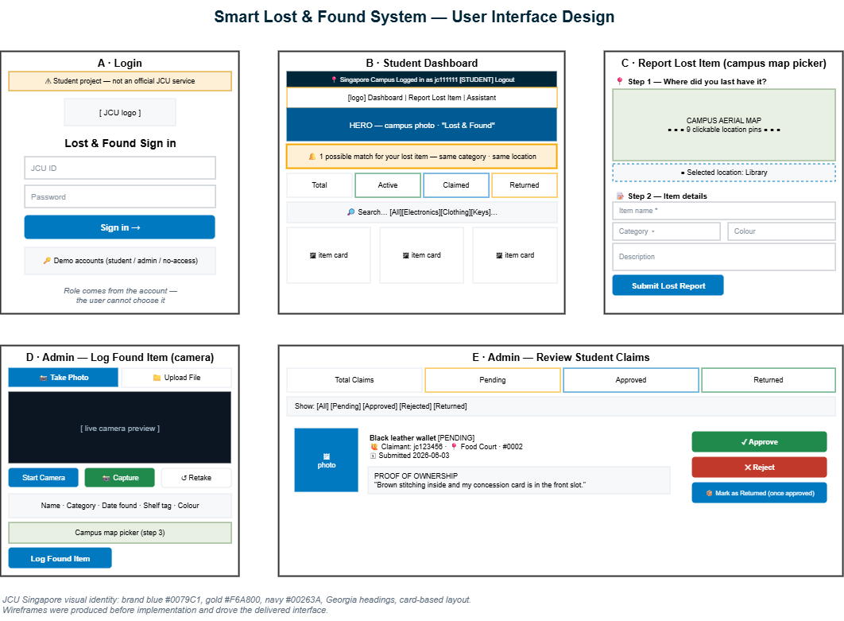
Figure 3 — Wireframes for the five key screens, produced before implementation
The interface follows the JCU Singapore visual identity — brand blue #0079C1, gold #F6A800, navy #00263A, Georgia headings and card-based layouts — so that it reads as a campus service.
Key screens: Login · Dashboard (search and filter grid with auto-match alerts) · Report Lost (campus map picker) · Log Found (camera and upload) · Item Detail · Submit Claim · Admin Dashboard · Review Claims · Access Denied.
The interface design exists in two forms. Wireframes were produced in draw.io before implementation and set the layout and component structure. An interactive prototype was then built in Figma from the delivered screens, assembled as navigable frames covering both the student and the administrator journeys, so a reviewer can move between screens rather than read a static wireframe.
Figma interactive prototype: https://www.figma.com/design/fwFGTc5C5OJuHIAH0ncKvS/Untitled?node-id=0-1
Two interactions received particular attention. Location is captured by clicking a pin on an aerial photograph of the campus rather than typing free text, which makes location a consistent, filterable value. Photographs are captured directly from the device camera, because an officer logging an item has a phone in hand and a photograph is the single most useful field for recognition.

4.5 Interaction design — claim and approval flow
The sequence below is the core transaction of the system. It is maintained as a Mermaid sequence diagram in docs/design.md, with an exported copy at docs/diagrams/sequence_diagram_chatbot_flow.html.
# | Actor | Action | Effect in the database
1 | Student | Submits a claim with proof of ownership | INSERT claim, status = Pending
2 | Admin | Opens Review Claims | SELECT claims
3 | Admin | Approves the claim | UPDATE claim = Approved, item = Claimed
4 | Admin | Marks the item as returned | UPDATE claim = Returned, item = Returned

Rejecting a claim is the alternative path at step 3: the claim becomes Rejected and the item remains Active, so it stays on the register for another claimant. This is the path shown in the demo video.

5. Implementation

5.1 Technology
Layer | Choice | Rationale
Client | HTML5, CSS3, vanilla JavaScript | No build step; effort went into features, testing and documentation rather than tooling
Database | Supabase (PostgreSQL) | Managed relational database with a REST interface and row-level security
Hosting | Vercel | Static hosting with HTTPS and automatic deployment from the repository
Media | MediaDevices API | Camera capture without a third-party dependency
CI | GitHub Actions with Playwright | Runs the browser test suite on every push

5.2 Repository structure
Path | Contents
iteration 1/ | Iteration 1 as delivered at tag v1.0 — preserved unchanged
iteration 2/ | Iteration 2 as delivered at tag v2.0 — preserved unchanged
iteration 3/ | **The current application** — 11 pages, 17 JS modules, db/ and tests/
backend/ | Superseded Flask API prototype, kept for history with a README explaining why
frontend/ | Superseded React + Vite prototype, kept for history with a README explaining why
docs/ | 17 documentation pages, 20 user-story pages, diagrams and images
tools/ | check_links.py, check_repo.py and run_tests.mjs — the CI checks, runnable locally
.github/workflows/ | ci.yml — three jobs, run on every push and pull request

Keeping each iteration as its own folder means incremental progress is directly comparable rather than only visible in the git history, and continuous integration asserts that the earlier snapshots have not been modified.

5.3 What each iteration delivered
Iteration 1 — core. The found-items dashboard with live statistics, the search and filter engine, the assistant with live record querying, the found-item logging form with storage tagging, claim verification and the status lifecycle. All eight planned stories delivered.
Iteration 2 — usability and trust. Photographs displayed and uploaded, responsive layout, the lost-item reporting form with the campus map picker, required-field rules, and claims carrying proof of ownership. All six planned stories delivered, plus role-based access brought forward from Iteration 3 because the claims workflow could not be demonstrated safely without it.
Iteration 3 — persistence, deployment and matching. Stories 1.5, 2.4, 2.5 and 4.4 delivered; 3.5 and 4.5 deferred. Iteration 3 also absorbed four items of unplanned work: the PostgreSQL migration, the automated test suite, public deployment and an accessibility pass.

5.4 Notable implementation decisions
- Load-once-then-cache. Moving to a database introduced asynchronous data access, while every rendering function was synchronous. Rather than rewrite every page, the data layer loads items and claims once on startup and caches them; reads stay synchronous and writes are applied optimistically then persisted in the background. No rendering code changed.
- Graceful degradation. If the database cannot be reached the application falls back to local demonstration data and displays a warning banner instead of failing. This was proven in practice: during deployment the schema had not yet been created, and the application remained usable throughout.
- Explainable matching. The matching engine scores a lost report against every active found item — category +3, location +2, colour +2, each shared keyword +2, date proximity +1 — reports matches at 4 or above, and returns the reasons alongside the score, so a student sees why two items were matched rather than being asked to trust a number.
- Accessibility. Keyboard navigation with visible focus, a skip link, ARIA live regions for dynamic content, role="alert" on validation messages, and prefers-reduced-motion support.

5.5 The delivered system
Screenshots of the running application, captured against the live database.
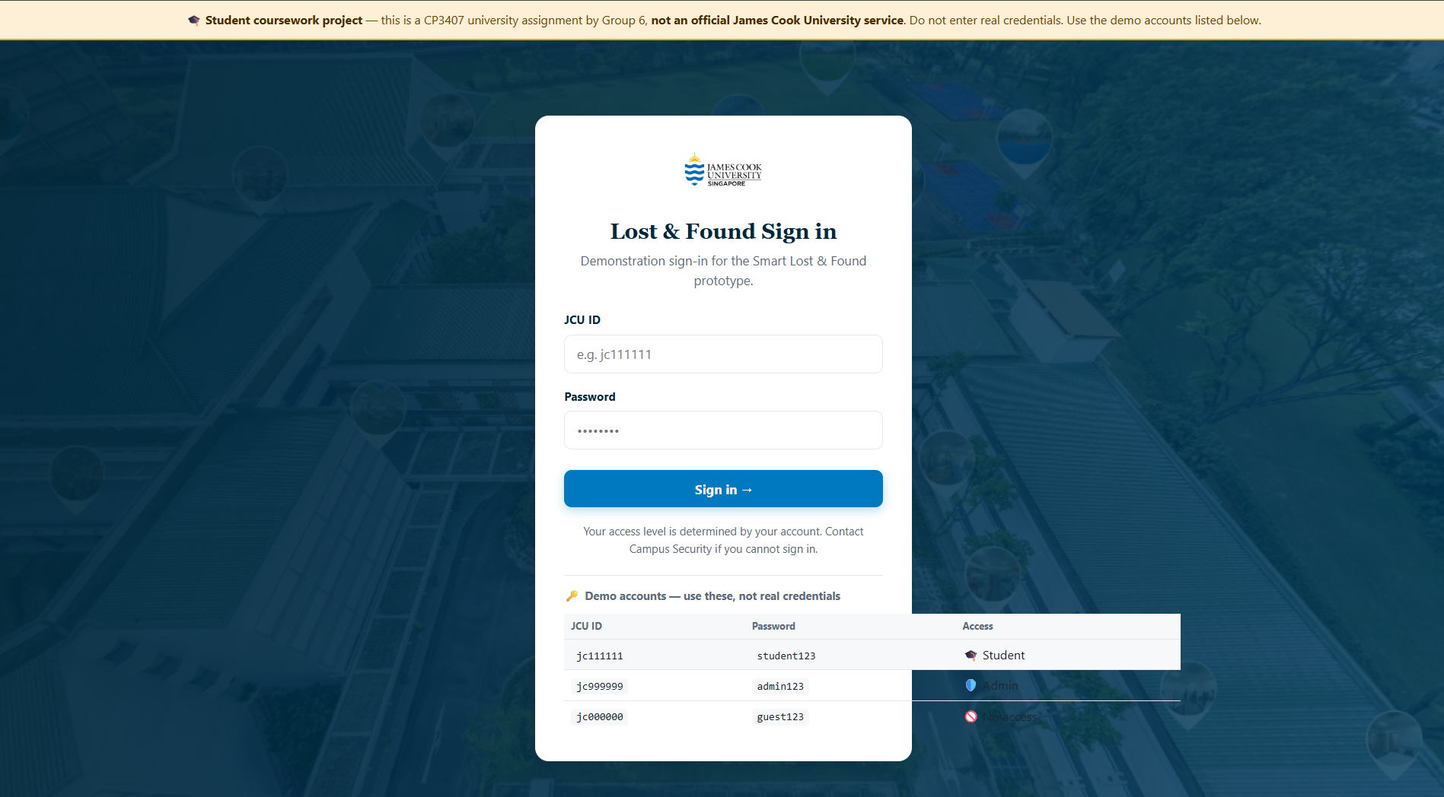
Figure 4 — Sign-in. Access level is determined by the account; the banner marks the site as student coursework.
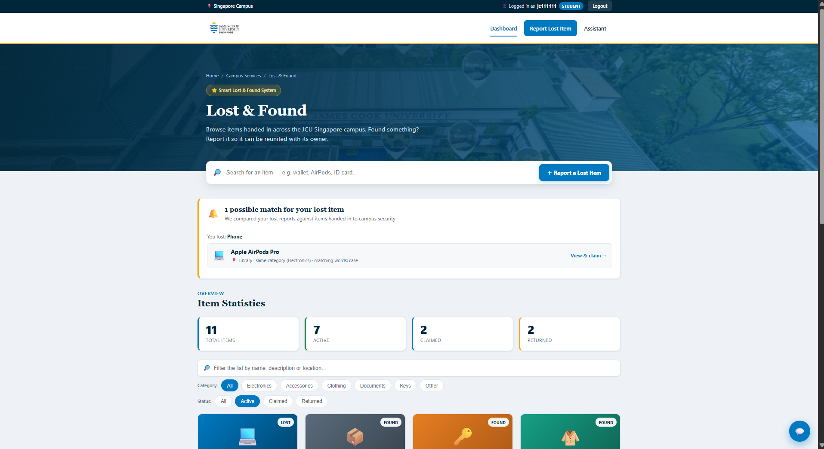
Figure 5 — Student dashboard: live counts, search, category and status filters, and the match alert.

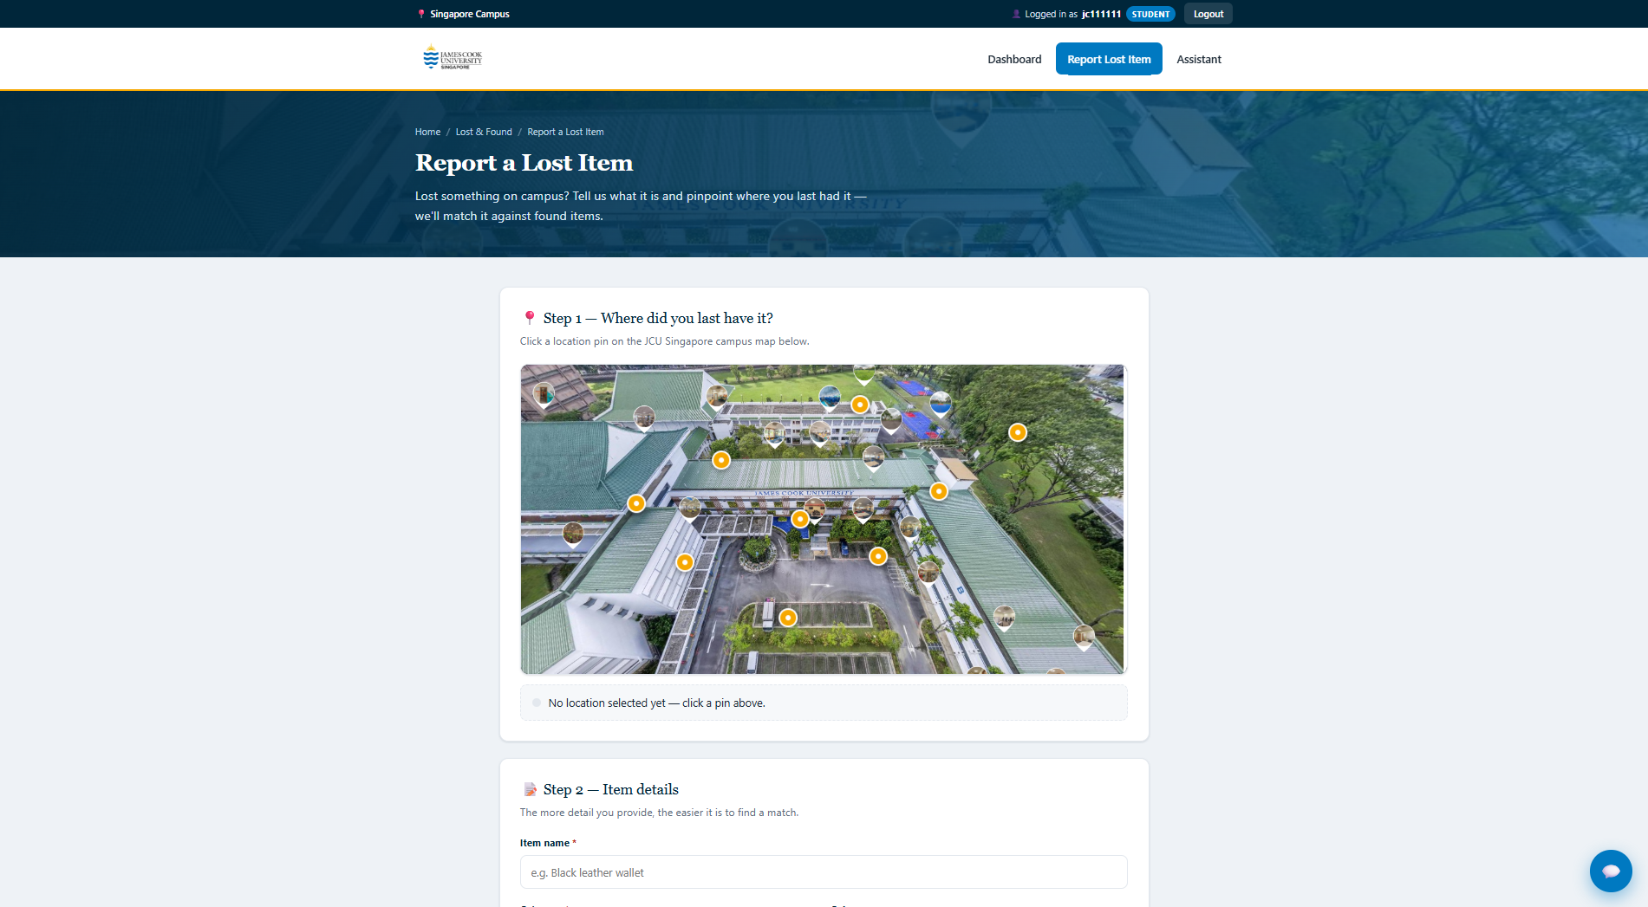
Figure 6 — Reporting a lost item. Location is chosen by clicking a pin on the campus map.
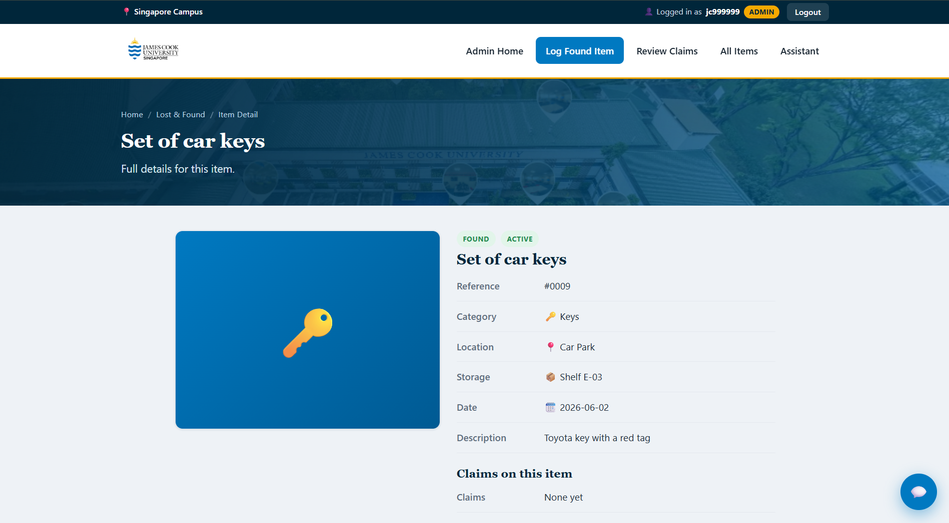
Figure 7 — Item detail, showing category, location, storage shelf, date and description.

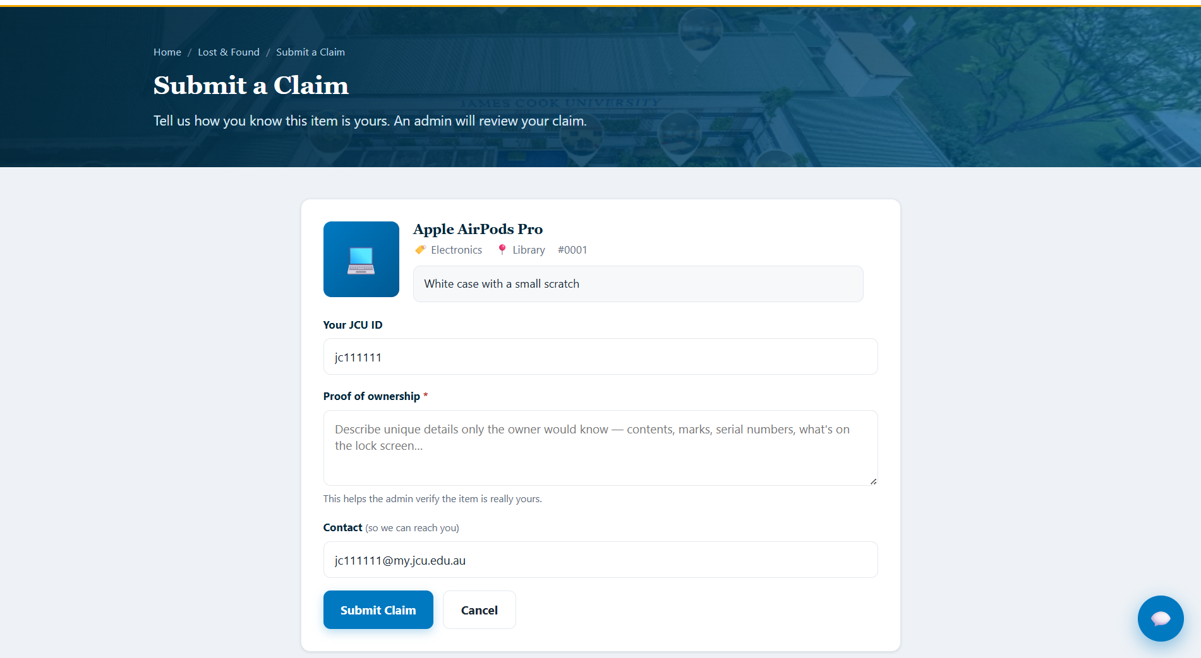
Figure 8 — Submitting a claim. Proof of ownership is required before the form will submit.
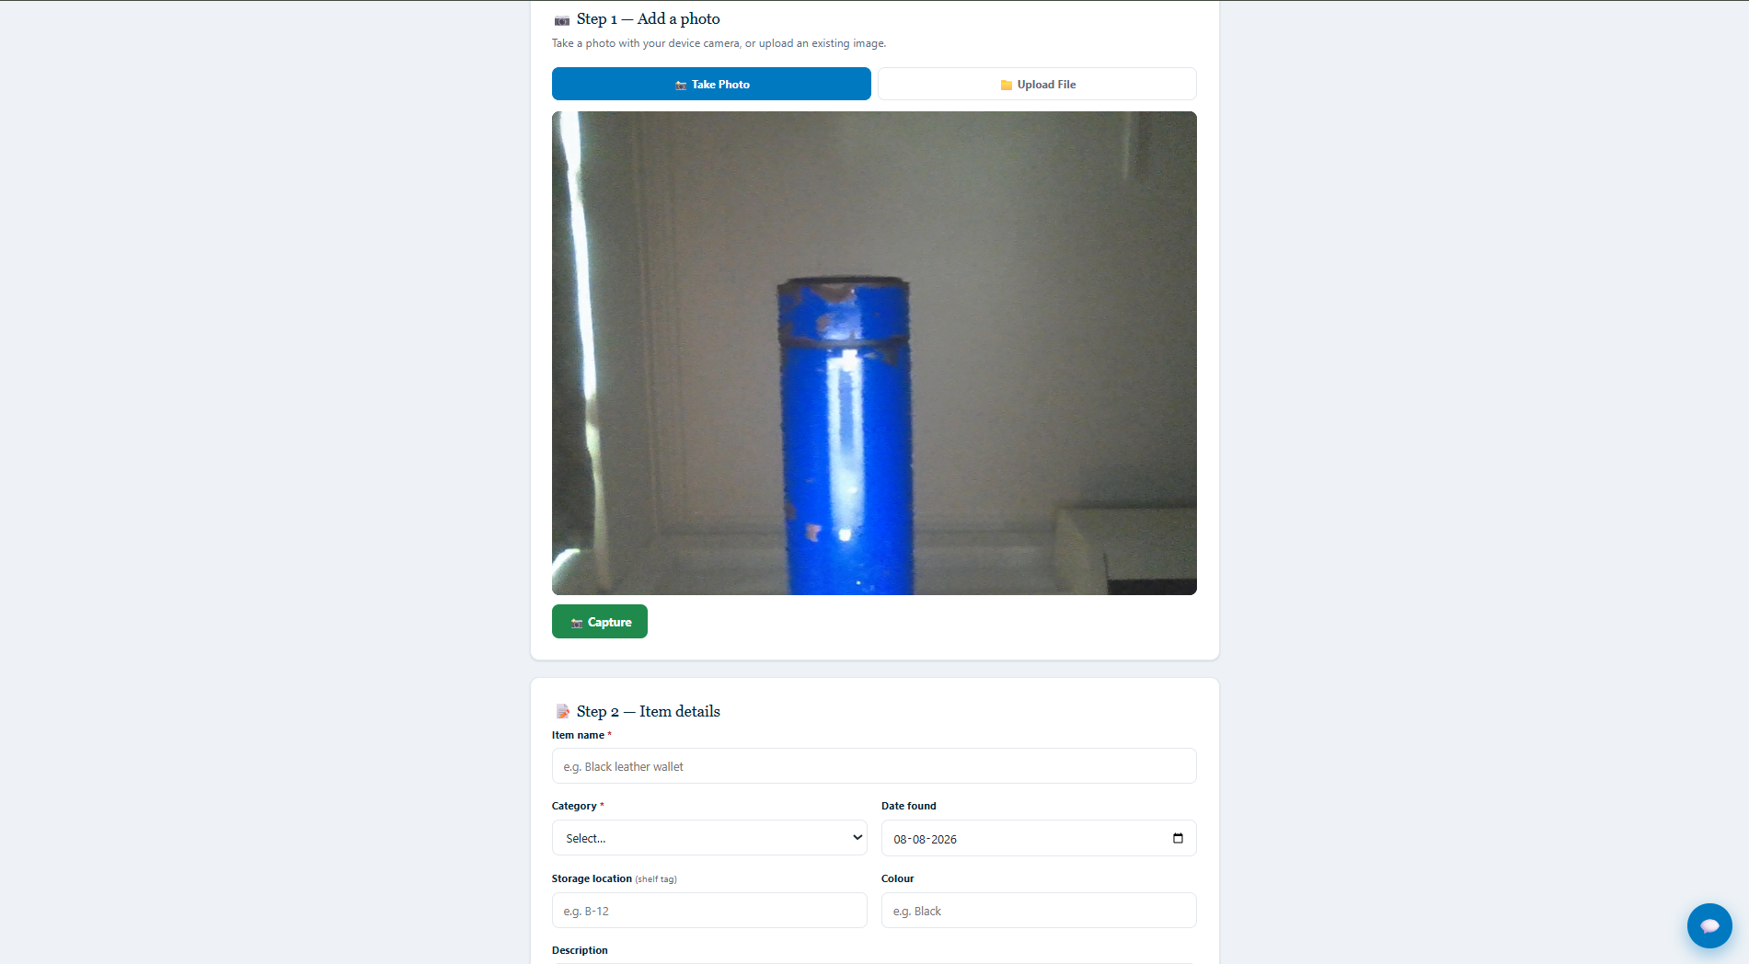
Figure 9 — Logging a found item, with capture from the device camera.

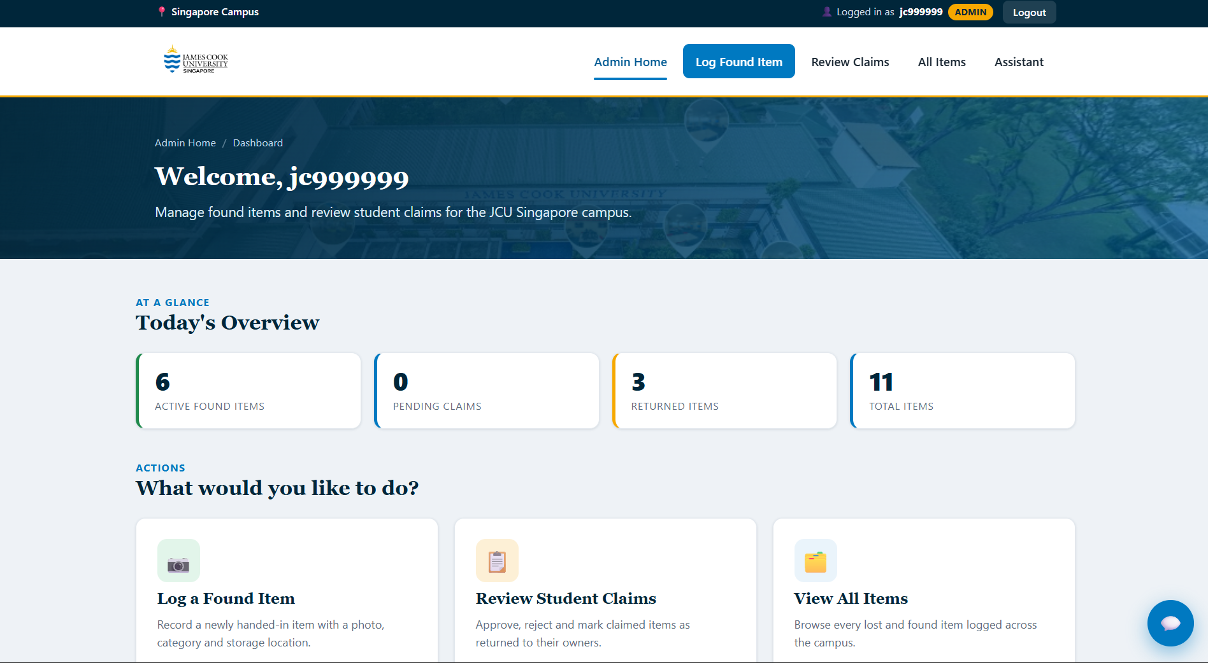
Figure 10 — Administrator home, with the pending claims badge and register statistics.
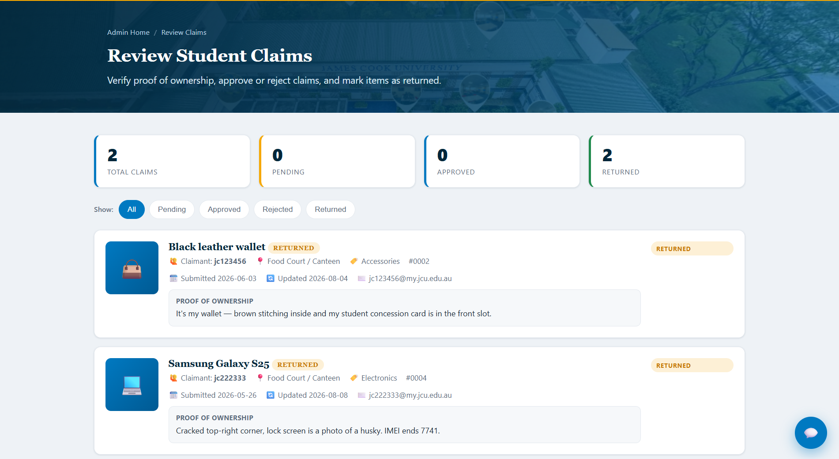
Figure 11 — Reviewing claims: the proof of ownership is read, then the claim is approved or rejected.

5.6 Deployment
The application is deployed as static files on Vercel at https://smart-lost-and-found-system-virid.vercel.app, redeployed automatically on every push to main. HTTPS is required for the camera to work on real mobile devices, so deployment is a functional requirement of the system rather than only a convenience.
Deployment is also where the project's one outstanding defect sits. Google Safe Browsing classifies the deployed URL as phishing, so Chrome shows a warning before the site loads. The combination that triggered it — genuine university branding, a credential form, and a free subdomain — is exactly the pattern the classifier is built to catch, and on the evidence available to an automated scanner the classification is reasonable. A disclaimer was added to remove the cause and a re-review has been requested; the outcome rests with Google. This is recorded as D-03 in section 6.6 and, deliberately, as open rather than closed.

5.7 Demonstration and client feedback
The client for this project is the course lecturer, who reviews the delivered increment at the end of each iteration.
Iteration | Demonstrated | Feedback | Action
1 | Dashboard, search and filtering, the assistant, found-item logging, claim workflow | Well received; no issues raised | None required
2 | Photographs, responsive layout, lost-item reporting with the campus map, proof of ownership | Well received; no issues raised | None required
3 | Both roles, access control, map picker, camera capture, claims, database, tests, repository | Two defects raised | Both fixed and committed the same day (D-04, D-05)

A recorded walkthrough of the delivered system is available. It is a silent screen recording of 3 minutes 41 seconds; the running order below is its commentary.
Demo video: https://drive.google.com/file/d/1BMMGsTkiHfR5UGWSQg3bmyD5pLkSfZZr/view?usp=sharing
Time | What is demonstrated | Story
0:00 | Sign-in page, coursework disclaimer, demo accounts | 2.5
0:18 | Student dashboard, counts read live from PostgreSQL | 1.1
0:22 | Automatic lost↔found match alert, with the reason for the match | 2.4
0:30 | Search and category/status filters on the item grid | 1.2, 1.5
0:40 | Reporting a lost item, location pinned on the campus map | 2.3, 3.2
1:02 | Help assistant answering retention and collection questions | 2.1
1:17 | Item detail — reference, category, location, storage shelf | 1.1, 1.3
1:25 | Claim submission blocked until proof of ownership is given | 3.3, 4.3
1:47 | Administrator sign-in — different navigation, same system | 4.4
1:55 | Logging a found item with live camera capture | 3.1, 3.4
2:36 | The new item in the register with its photograph and shelf tag | 1.3, 3.2
2:46 | Claim review — proof contradicts the description, claim rejected | 4.1
3:10 | An earlier claim at the end of its lifecycle: Returned | 4.2
3:14 | Assistant responses branch by role (defect D-05) | 2.1, 4.4
3:24 | Valid account without permission is refused access | 4.4

The rejection at 2:46 is the intended outcome, not a failure: the item is recorded as “Toyota key with a red tag” while the claimant's stated proof is “has 5 keys and one blue keychain”. Proof of ownership is what gates the handover, and here it did not hold up.

6. Testing

6.1 Strategy
Level | Coverage | Evidence
Unit | Data layer, claims workflow, matching engine, authentication | 53 automated assertions
Integration | Client to PostgreSQL; claim approval across two tables | Verified in the database
System | Whole journeys for both roles | Procedure ST-1 to ST-6
Acceptance | One or more scenarios per story | **34 scenarios**, all passing
Non-functional | Responsive, keyboard, screen reader, offline | Documented checks

The unit suite runs by opening iteration 3/tests/tests.html in a browser — no installation — and is also driven headlessly in continuous integration via Playwright, so the automated and manual runs cannot diverge. The runner snapshots and restores localStorage, so it never disturbs application data.

6.2 Test-driven development
The claims workflow was written test-first: the assertions that approving a claim must set the claim to Approved and its item to Claimed were written before the implementation, watched to fail, and drove the design of Claims.approve(), reject() and markReturned().

6.3 Mock objects
Authentication calls verify_login() inside PostgreSQL. Testing it against the live database would be slow, network-dependent, and — most importantly — unable to exercise failure paths on demand.
Jest, Sinon and Vitest were considered and rejected: each would have introduced Node, npm and a bundler purely for testing, and the suite would have stopped being runnable by opening a file. A 60-line mock framework was written instead in tests/mocks.js, providing a spy that records calls, a fake Supabase client with swappable responses, and canned replies for success, no match, RPC error and network failure.
This made testable what previously was not: that verify_login was called exactly once with the credentials as named parameters (an interaction assertion), that a database outage falls back to local accounts, and — the case that matters most — that the fallback still rejects a wrong password. A fallback that accepted anything would be an authentication bypass, and it is only reachable when the database is down, so without a mock it would realistically never have been tested.

6.4 Acceptance testing
Thirty-four Given/When/Then scenarios cover the delivered stories, organised into four epics and traced back to the backlog.
Epic | Scenarios | Covers
1 — Accounts & Access | AT-1.1 … AT-1.7 (8) | Valid and invalid sign-in, role determines landing page, no-access account, navigation filtered by role, restricted pages unreachable by URL, redirect when signed out, logout clears the session
2 — Search, Browse & Claim | AT-2.1 … AT-2.7 (7) | Dashboard filtering, empty results, item detail, claims requiring proof, valid claim submission, unclaimable items, assistant answers
3 — Reporting & Logging | AT-3.1 … (several) | Lost report requires a map location, selecting a campus location, submitting a report, capturing a photo with the camera
4 — Administration | AT-4.x | Claim review, approval, rejection and the return lifecycle

Test environment and data
Application | iteration 3/ served over HTTP (python -m http.server 8124)
Database | Supabase PostgreSQL (live) — falls back to local demo data if unreachable
Browsers | Chrome / Edge (primary), Firefox, mobile Safari
Test accounts | jc111111/student123 · jc999999/admin123 · jc000000/guest123
Reset between runs | Admin → Manage item statuses → Reset demo data
Seed data | 10 items covering every category — Active (7), Claimed (2), Returned (1); 2 claims (1 Pending, 1 Approved)
Edge cases in the seed | Item with no photo, item with no shelf tag, item with an empty colour

6.5 System testing
A documented system test procedure, ST-1 to ST-6, exercises whole journeys for both roles, with defect severities S1–S4 making the fix-now-or-defer decision explicit rather than implicit. The full procedure is in docs/system-testing-plan.md.

6.6 Defect log
Ten defects were recorded and classified. Nine are closed. D-03 — the Safe Browsing classification of the deployed site — remains open at the time of submission: the cause has been removed, but clearing the flag depends on a Google re-review that had not returned a verdict. Reporting it as closed because the code changed would misrepresent what a reviewer will actually experience, so it is reported as open. See the notice on the title page.
ID | Summary | Sev | Found by | Status
D-01 | “Reset demo data” did not fully reset within a session | S2 | Automated unit test | Closed
D-02 | Sign-in fell back to hard-coded accounts on the deployed site | S2 | Deployment verification | Closed
D-03 | Chrome flags the deployed site as “Dangerous” | S2 | Deployment verification | OPEN
D-04 | Footer links did nothing | S3 | Client demonstration | Closed
D-05 | Assistant gave identical answers to students and administrators | S3 | Client demonstration | Closed
D-06 | schema.sql failed on a second run | S3 | Database rebuild | Closed
D-07 | Re-running the schema would have duplicated all seed items | S2 | Review while fixing D-06 | Closed
D-08 | Statistics markup duplicated across four call sites | S4 | SRP/DRY review | Closed
D-09 | Documentation contradicted the delivered system | S4 | Repository audit | Closed
D-10 | Clipped text in the ER diagram | S4 | Diagram review | Closed

What the log shows:
- Two were raised by the client during the Iteration 3 demonstration (D-04, D-05). Both were fixed and committed the same day.
- One was found by the automated tests (D-01) — the seed data was being mutated in memory, so “reset demo data” did not fully reset. Manual testing had missed it; a regression test now guards it.
- Two were only exposed by deploying (D-02, D-03). Neither was reproducible locally, which is the argument for deploying early rather than at the end.
- One was found by inspection while fixing another (D-07) — the more damaging of the pair, and it had never actually fired.

7. Code quality — SRP and DRY review
The codebase was reviewed against the Single Responsibility Principle and Don't Repeat Yourself. The application is written in modular JavaScript rather than classes, so each module and the object it exports is treated as the unit of responsibility. The full review is in docs/code-quality.md.

7.1 Module inventory
Module | Lines | Responsibility | SRP
store.js | 291 | Data access, database bootstrap, row mapping, view helpers | Violation
assistant.js | 151 | Rule-based assistant | OK
main.js | 150 | Shared header, navigation, footer, logout, chat widget | Partial
dashboard.js | 126 | Dashboard rendering and filtering | OK
auth.js | 121 | Session handling and the route guard | Partial
camera.js | 95 | Photo capture and file upload | OK
admin-claims.js | 90 | Claims review interface | OK
matching.js | 89 | Scoring lost reports against found items | OK
submit-claim.js | 78 | Claim submission | OK
item-detail.js | 65 | Single item view | OK
log-found.js | 56 | Found item form | OK
report-lost.js | 49 | Lost item form | OK
login.js | 41 | Sign-in form handling | OK
admin.js | 40 | Item status table | OK
map.js | 36 | Campus map location picker | OK
config.js | 19 | Connection settings | OK
admin-dashboard.js | 18 | Admin landing figures | OK

7.2 Findings
# | Finding | Principle | Outcome
1 | store.js mixes data access, bootstrap, row mapping and view helpers | SRP | Documented; split into db.js / store.js / ui.js recommended, deferred as too risky after deployment
2 | auth.js combines the session API with the route guard | SRP | Accepted trade-off — a single script in <head> guarantees the guard runs before the page renders
3 | main.js assembles several page regions | SRP | Acceptable at 150 lines; would warrant splitting if it grew
4 | renderStats() duplicated byte-for-byte across four call sites | DRY | **Fixed** — extracted statsCards() and itemStatusCards(); verified against all four pages with the suite still green
5 | Status values repeated as string literals | DRY | Mitigated by database CHECK constraints, which fail loudly on a bad value; a shared constants object is recommended future work

7.3 What already held up
- The feature modules are genuinely single-purpose. matching.js only scores similarity — it does not render, does not touch the DOM, and does not know where items come from. That is precisely why ten assertions could cover it without a browser page.
- Shared components exist once. The campus map picker (map.js) is used by both the report and log forms; the camera tool by the log form; header, navigation and footer are generated once in main.js rather than repeated across eleven HTML files. That is what made role-aware navigation and the site-wide disclaimer single-line changes.
- Output encoding is consistent, because escapeHTML(), icon() and itemMedia() were defined once and shared.
- Seed data is defined once and shared by the application and the test suite.
The one clear violation found by the review was fixed and verified. The remaining findings are recorded with reasoning rather than quietly ignored — the largest, splitting store.js, is deliberately deferred because the system is deployed and the refactor would touch every page.

8. Version control and development tools

8.1 Repository and workflow
- One repository. main is always demonstrable; feature work is done on branches and merged by pull request.
- Story-tagged commit messages, so history maps to the backlog. Where identifiers became ambiguous between iterations, the mapping is documented rather than left unexplained.
- Release tags v1.0, v2.0 and v3.0 marking each iteration, with each iteration also preserved as its own folder so incremental progress is directly comparable.
- Definition of Done: the story is demonstrable, its acceptance criteria pass, there are no console errors, the unit suite is green, and the change is committed with a message naming the story.

8.2 Issues, milestones and the project board
The backlog is mirrored into GitHub's own planning tools, where the same information is live, assignable and filterable rather than being a status column in a Markdown table.
Mechanism | Purpose | State
Issues | One per backlog story, assigned and closed on delivery | 22 issues — 20 closed, 2 open
Milestones | Group issues by iteration | Iteration 1 (10), 2 (6), 3 (6)
Labels | Epic, priority P10–P40, iteration, user-story, process | Applied to every issue
Project board | Todo / In Progress / Done | Done 20 · Todo 2 · In Progress 0
Actions | CI on every push and pull request | Passing

The two open issues are stories 3.5 Duplicate detection and 4.5 Audit trail. Two further issues record the requirements-gathering and iteration-planning work of Practicals 2 and 3, which produced documents rather than application code and so are not among the 20 stories.
Stated plainly: the issues, milestones and board were created at the close of Iteration 3 and were not maintained live across the three iterations — the issue timestamps show this. During the iterations themselves, tracking was the status labels on the story pages together with the Kanban board in Practical_Week3_Iteration1.docx. Nothing sits in In Progress because no work is currently underway; an empty column is the honest state.
Project board: https://github.com/users/uv-22/projects/1

8.3 Continuous integration
Every push and pull request runs GitHub Actions. The application has no build step, so the workflow does not compile anything — it guards the failures this project actually had.
Job | What it does | Why
Repository & documentation checks | Resolves every relative link and image; verifies required files, the 20 story pages, that all 11 pages declare PAGE_REQUIRES and load the route guard, that the documented test count matches the suite, that the iteration snapshots are unmodified, and that no privileged database key is committed | Documentation drifting out of step with the code was a repeated defect (D-09)
JavaScript syntax | node --check on every application and test script | Catches a syntax error before it reaches a demonstration
Unit tests (headless browser) | Serves the app and drives tests.html with headless Chromium via Playwright; fails on any failing assertion or any console error | Runs exactly what a person runs, so CI cannot drift from the local suite

The privileged-key check decodes any JWT found in the repository and inspects its role claim rather than searching for the word, because config.js legitimately mentions service_role in a comment warning against committing it. Both Python checks are runnable locally as tools/check_links.py and tools/check_repo.py.

8.4 Tools and libraries
Tool | How it was used
Supabase / supabase-js | Cloud PostgreSQL, queried from the browser via the SDK
Vercel | Static hosting; auto-deploys from GitHub on every push
draw.io / diagrams.net | Architecture UML, database ER model and UI wireframes; .drawio sources committed
Figma | Interactive prototype of the delivered screens
Mermaid | Diagrams-as-code (class, ER and sequence) inside the documentation
Playwright | Drives headless Chromium so CI runs the same suite a developer runs
MediaDevices API | Camera capture via getUserMedia and canvas
Git + GitHub | Version control, branches, pull requests, tags, issues, milestones, board, Actions
Python 3 | tools/check_links.py and tools/check_repo.py; local static server
VS Code, Chrome DevTools | Editing, debugging, responsive checks, console-error sweeps

Why no framework: for a small team on a tight timeline, vanilla JavaScript removed build and tooling overhead so effort went into features, testing and documentation. Shared behaviour is still modularised across seventeen modules, giving most of the maintainability benefit without a bundler.

9. Agile process

9.1 Velocity
Iteration | Planned | Delivered | Velocity | Against plan
1 | 43 d | 43 d | 43 | On plan — all 8 P10 stories
2 | 18 d | 18 d | 18 | On plan — all 6 P20 stories
3 | 10 d | 6 d planned + 7 d unplanned | 13 | 2 stories deferred; unplanned work absorbed
Total | 71 d | 67 d of backlog |  | 18 of 20 stories (94%)

Velocity was used to adjust the plan. Iteration 1 delivered its full 43 story-days but tracked behind the ideal line for the entire sprint, indicating over-commitment. Iterations 2 and 3 were therefore deliberately committed at 18 and 10 story-days. Iteration 2 then landed exactly on plan, confirming the correction.

9.2 Burn-down charts
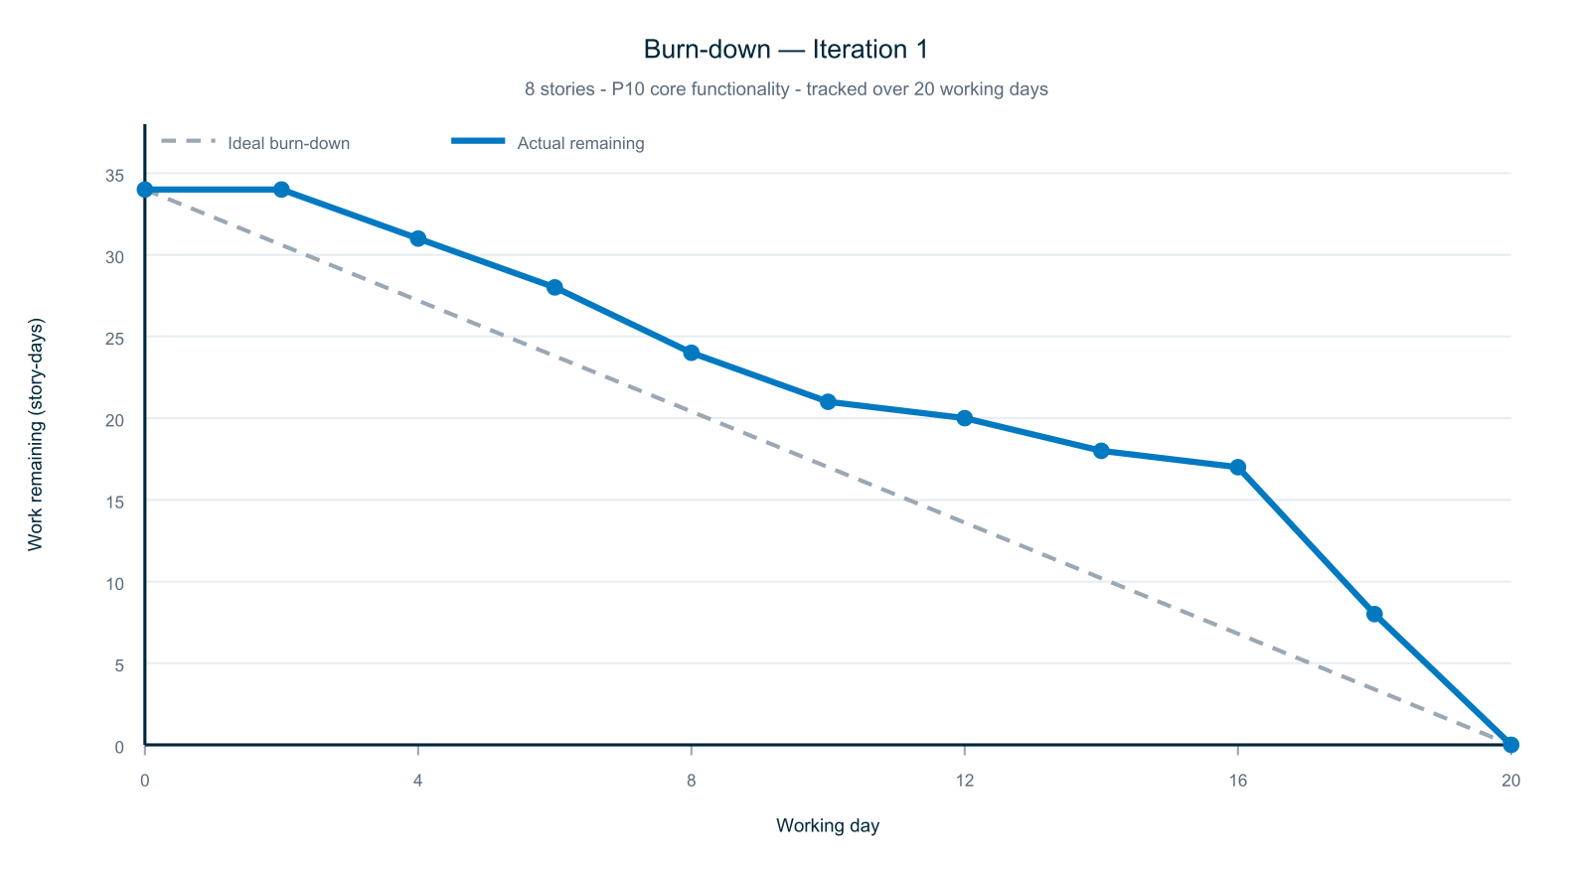
Figure 12 — Burn-down, Iteration 1
Data points 0-16 as recorded in Practical_Week3_Iteration1.docx; the final two points record completion. The team tracked behind the ideal line for most of the iteration and closed the gap late. Note: the Practical 3 burn-down was baselined at 34 story-days; the eight stories sum to 43 days (see agile.md).
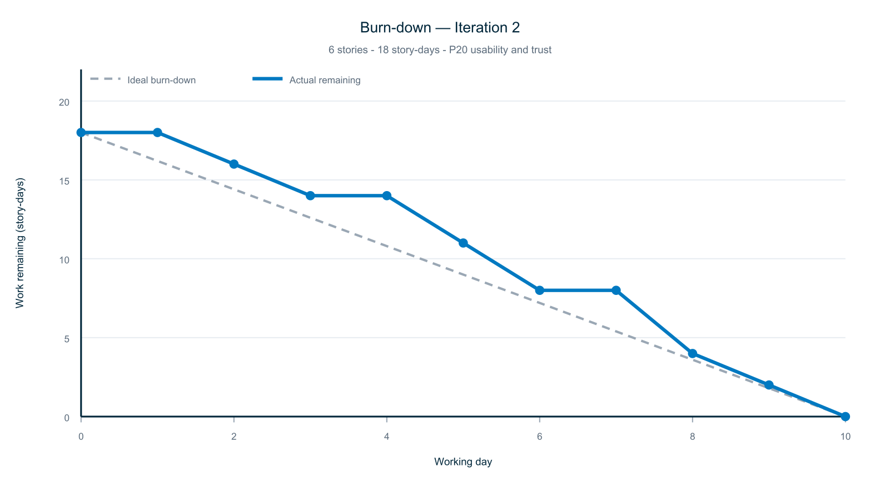
Figure 13 — Burn-down, Iteration 2
Steps mark story completion. The team committed in batches rather than daily, so points record when a story met its acceptance criteria rather than a daily measurement. All six stories delivered: velocity 18 story-days, matching the plan.
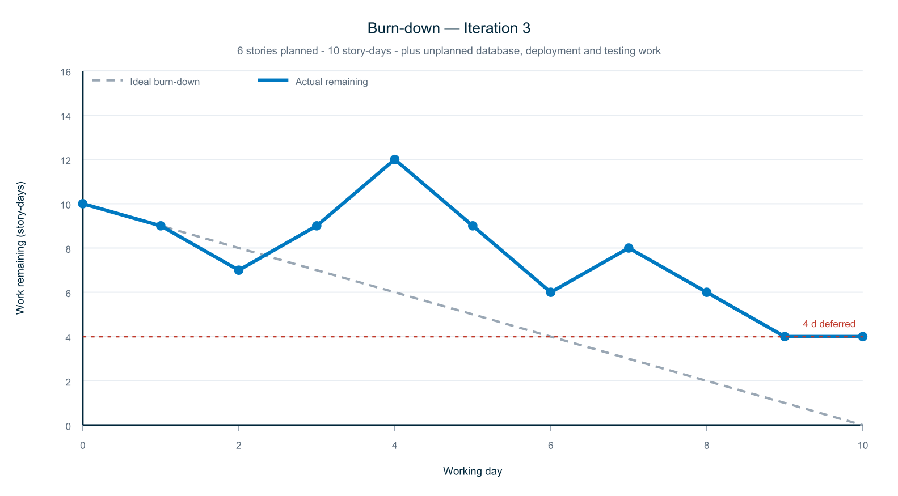
Figure 14 — Burn-down, Iteration 3
The line rises where unplanned work was added: the Supabase migration (3 d), the automated test suite (2 d), deployment (1 d) and the accessibility pass (1 d) - 7 story-days not in the interview-derived backlog. 4 story-days remain: stories 3.5 Duplicate detection (P30) and 4.5 Audit trail (P40), the two lowest priorities.
The Iteration 3 chart is the most informative of the three. The line rises twice, where unplanned work was taken on, and it ends with four story-days outstanding — the two deferred stories. It is an honest record of a plan meeting reality.

9.3 Iteration log

Iteration 1 — Core functionality (8 stories, 43 d, all P10)
- Delivered: all eight stories.
- Review: demonstrated to the client in the practical class; well received, no issues raised.
- Observed: prioritising every P10 story into one iteration meant the first increment was a usable system rather than fragments.
- Observed: work was committed in large batches — 71 commits fall on only eight distinct days — which is why the burn-down had to be reconstructed from story completion rather than daily measurement.
- Action: the next commitment was reduced from 43 to 18 story-days, so the over-commitment was recognised and acted on.

Iteration 2 — Usability and trust (6 stories, 18 d, all P20)
- Delivered: all six stories, plus role-based access brought forward from Iteration 3.
- Review: demonstrated to the client; again well received, no issues raised.
- Observed: extracting shared components meant each later page reused existing work rather than repeating it.
- Observed: no automated tests existed at this point; defects were caught only by manual checking. The suite arrived in Iteration 3.

Iteration 3 — Persistence, deployment and matching (6 planned, 10 d)
- Delivered: 1.5, 2.4, 2.5 and 4.4, plus four unplanned items. 3.5 and 4.5 deferred.
- Review: demonstrated to the client on the team's laptop in the week 10 practical. Two defects raised — inoperative footer links, and the assistant returning identical answers to both roles. Both fixed and committed the same day as D-04 and D-05.
- Went well: the automated tests caught a real defect during development, and graceful degradation meant the database being unavailable never blocked a demonstration.
- Improve: the unplanned work was foreseeable. The database migration was implied by the project requirements from the start and should have been a backlog story with an estimate in Iteration 1.
- Action: recorded 3.5 and 4.5 with the reasoning for deferral and what remains.

9.4 Roles and collaboration
- Work split by epic across the three members, with pairing on the claims workflow.
- Asynchronous stand-ups in the team chat: done / next / blockers.
- Definition of Done: demonstrable, acceptance criteria pass, no console errors, unit suite green, committed with a message naming the story.

10. Results and evaluation

10.1 Against the plan
Measure | Result
Stories delivered | 18 of 20 (90%)
Estimated effort delivered | 67 of 71 days (94%)
Must-have (P10) stories | 8 of 8
Should-have (P20) stories | 6 of 6
Deferred | 2 — both P30/P40

10.2 What was not delivered
Story | Priority | Reason
3.5 Duplicate detection | P30 | Iteration 3 absorbed the unplanned database and deployment work. The matching engine built for story 2.4 already provides the similarity comparison, so what remains is a warning interface at logging time.
4.5 Audit trail | P40 | The lowest-priority story in the backlog. Partially mitigated: claim decisions already carry created_at and updated_at timestamps, and row-level security prevents records being deleted from the client. A full trail needs a separate table recording actor, action and target.

Both were could-have and low-priority. The prioritisation scheme existed precisely so that, under pressure, the least valuable work would be what was lost — and that is what occurred.

10.3 Against the project requirements
Requirement | Met
A software development project requiring source code | Yes — approximately 2,500 lines of HTML, CSS, JavaScript and SQL
Use of productivity tools and libraries | Yes — Supabase, supabase-js, Vercel, Playwright, MediaDevices, draw.io, Figma
A modern relational database | Yes — PostgreSQL: three tables, foreign key, CHECK constraints, row-level security
A modern graphical user interface | Yes — eleven responsive pages

11. Reflection and future work

11.1 What worked
- Prioritising ruthlessly. Placing every must-have story in the first iteration meant the first demonstration showed something usable. When effort ran short in the final iteration, the decision about what to cut had already been made.
- Extracting shared components. The campus map picker, camera tool and shared page chrome were each written once and reused. Each new page cost less than the last, and late changes — role-aware navigation, a site-wide disclaimer — were single-line edits rather than eleven.
- Automated tests earning their keep. The suite found a real defect that manual testing had missed, and the mock-based tests proved a security property that could not otherwise have been checked.

11.2 What the team would do differently
- Estimate non-functional work. The project's most consistent weakness, and it appeared twice. At elicitation, performance and reliability never became stories. Later, the database migration, deployment, test suite and accessibility pass amounted to seven story-days that were equally absent from the backlog and therefore had no budget; they displaced two features. The common cause is a story format that assumed every requirement is a user-facing feature.
- Commit in smaller increments. Work was committed in large batches — 71 commits on only eight distinct days — which is why progress had to be reconstructed for the burn-down charts rather than read directly from the history.
- Deploy earlier. Two defects were only discoverable once deployed. Deploying in Iteration 1, even with an incomplete application, would have surfaced them when there was time to respond calmly.
- Track work in issues from the start. The GitHub issues and project board were created at the close of Iteration 3. They record the backlog accurately, but they cannot evidence how the work was tracked while it was being done.

11.3 Future work
Priority | Item
High | Complete stories 3.5 Duplicate detection and 4.5 Audit trail
High | Replace the credential table with Supabase Auth, using hashed passwords and session tokens; integrate with JCU identity
Medium | Deliver match notifications by email rather than only on the dashboard
Medium | Move photographs to object storage rather than storing them in the row
Medium | Replace the rule-based assistant with a language model
Low | Split store.js into db.js, store.js and ui.js, per finding 1 of the code-quality review
Low | Introduce a shared status-constants object, per finding 5

12. Appendices

A. Demonstration accounts
JCU ID | Password | Access
jc111111 | student123 | Student
jc999999 | admin123 | Administrator
jc000000 | guest123 | No access — used to demonstrate the refusal page

These are demonstration credentials for a coursework prototype. Passwords are stored unhashed in the users table; this is documented as prototype-grade — credentials are checked by a SECURITY DEFINER function so they never reach the browser, and row-level security blocks the client from reading the table — and the production path is identified in section 11.3.

B. Documentation index
Page | Contents
README.md | Repository front page, quick start, demo video running order
docs/README.md | Documentation home and rubric coverage map
requirements.md | Backlog, personas, priorities, estimates, completed vs unfinished
user-stories/ | 20 pages: acceptance criteria, task breakdown, implementation, tests
design.md | Architecture, domain model, database, interface, sequence diagram
diagram-specs.md | draw.io sources, how to open, edit and export them
implementation.md | Delivery per iteration, screenshots, demo video running order
testing.md | Strategy, TDD, mock objects, accessibility
acceptance-tests.md | 34 Given/When/Then scenarios and traceability matrix
system-testing-plan.md | Test procedure ST-1…ST-6, defect management, defect log
code-quality.md | SRP and DRY review, module inventory, five findings
agile.md | Velocity, burn-down charts, iteration log, reviews, retrospectives, task tracking
version-control.md | Branching, commit conventions, releases, issues and board
tools.md | Tools, libraries, continuous integration
HOW-TO-TEST.md | Walkthrough for a reviewer
DEPLOYMENT.md | Publishing procedure
DEMO-SCRIPT.md | 15-minute live presentation running order
DEMO-VIDEO-SCRIPT.md | 5-minute recording script
PROJECT-REPORT.md | The Markdown counterpart of this report

C. Source documents
- User_Stories.docx — interview findings and priority ranking (Practical 2)
- Practical_Week3_Iteration1.docx — iteration allocation, Kanban board and burn-down (Practical 3)
- Initial Backlog Ideas.md — the earlier brainstorm the backlog was refined from
- Members.md — team roster, dated 19 May 2026

D. Team contributions
Member | Contribution
Yuvraj Dave | Application development across all three iterations — the data layer, authentication and access control, the claims workflow, camera capture, the campus map picker and the matching engine. Database design and the Supabase migration. Deployment, the test suite and continuous integration. All diagrams.
João Gabriel Costa | Repository administration and the GitHub workflow. Requirements gathering and the user-story documents. Practical submissions, including the iteration planning document. Page layout and ongoing maintenance of the project materials.
Chiranjeeb Satpathy | Limited contribution to the delivered work.

The distribution of work was uneven. It is recorded accurately here rather than averaged, so that the effort behind the delivered system is clear.

E. Links
Resource | URL
Repository | https://github.com/929919/Smart-Lost-and-Found-System
Deployed application | https://smart-lost-and-found-system-virid.vercel.app
Demo video | https://drive.google.com/file/d/1BMMGsTkiHfR5UGWSQg3bmyD5pLkSfZZr/view?usp=sharing
Figma interactive prototype | https://www.figma.com/design/fwFGTc5C5OJuHIAH0ncKvS/Untitled?node-id=0-1
Project board | https://github.com/users/uv-22/projects/1
Issues (user stories) | https://github.com/929919/Smart-Lost-and-Found-System/issues?q=label%3Auser-story
Milestones | https://github.com/929919/Smart-Lost-and-Found-System/milestones
Continuous integration | https://github.com/929919/Smart-Lost-and-Found-System/actions
Releases (v1.0, v2.0, v3.0) | https://github.com/929919/Smart-Lost-and-Found-System/tags

