Smart Lost & Found System
Practical Week 3 — Part 2: Iteration 1
Milestone 1 Sprint Planning & Monitoring
Based on User_Stories.docx · 20 Stories · 71 Days Total

Task 1 — Iteration Allocation (Milestone 1)
All 20 user stories from the official User_Stories.docx have been allocated across three iterations of Milestone 1. Stories are ranked by priority (P10 = must have, P20 = should have, P30–40 = nice to have) and grouped by effort estimate.

Priority Key
- P10 (red) — Must have: core system cannot function without it
- P20 (yellow) — Should have: system works but feels incomplete without it
- P30 (blue) — Could have: significant value-add
- P40 (gray) — Low priority: useful enhancement, lowest urgency

Full Story Allocation Table
Story ID | Title | Persona | Priority | Effort (days) | Iteration
1.1 | Found-item dashboard | Jack | P10 | 5 | Iteration 1
1.2 | Search & filter engine | Jack | P10 | 5 | Iteration 1
2.1 | Intelligent chatbot | Sarah | P10 | 7 | Iteration 1
2.2 | Real-time DB querying | Sarah | P10 | 7 | Iteration 1
3.1 | Found-item logging form | Ethan | P10 | 5 | Iteration 1
3.2 | Storage location tagging | Ethan | P10 | 4 | Iteration 1
4.1 | Claim verification & approval | Peter | P10 | 5 | Iteration 1
4.2 | Status lifecycle management | Peter | P10 | 5 | Iteration 1
1.3 | Photo display for items | Jack | P20 | 3 | Iteration 2
1.4 | Responsive design | Jack | P20 | 3 | Iteration 2
2.3 | Lost-item reporting form | Sarah | P20 | 4 | Iteration 2
3.3 | Required vs. optional fields | Ethan | P20 | 2 | Iteration 2
3.4 | Photo upload for items | Ethan | P20 | 2 | Iteration 2
4.3 | Claim request & proof upload | Peter | P20 | 4 | Iteration 2
1.5 | Clean grid (status filter) | Jack | P30 | 1 | Iteration 3
2.4 | Match notifications | Sarah | P30 | 2 | Iteration 3
2.5 | User accounts & auth | Sarah | P40 | 1 | Iteration 3
3.5 | Duplicate detection | Ethan | P30 | 2 | Iteration 3
4.4 | Admin roles & access control | Peter | P30 | 2 | Iteration 3
4.5 | Audit trail | Peter | P40 | 2 | Iteration 3

Iteration Summary
Iteration | Stories | Effort | Focus
Iteration 1 | 8 stories | 43 days | P10 — Core functionality: dashboard, search, chatbot, admin logging, claim workflow
Iteration 2 | 6 stories | 18 days | P20 — Usability & trust: photos, responsive design, reporting form, proof upload
Iteration 3 | 6 stories | 10 days | P30–40 — Enhancements: notifications, auth, duplicate detection, audit trail

Task 2 — Iteration 1 Big Board (Kanban)
The table below monitors all 8 user stories of Iteration 1 with labels: Todo, In Progress, and Done.

📋 Todo (6) | ⚙ In Progress (1) | ✓ Done (1)
2.1 — Intelligent chatbot (Sarah · P10 · 7d) | 1.2 — Search & filter engine (Jack · P10 · 5d) | 1.1 — Found-item dashboard (Jack · P10 · 5d)
2.2 — Real-time DB querying (Sarah · P10 · 7d)
3.1 — Found-item logging form (Ethan · P10 · 5d)
3.2 — Storage location tagging (Ethan · P10 · 4d)
4.1 — Claim verification & approval (Peter · P10 · 5d)
4.2 — Status lifecycle management (Peter · P10 · 5d)

Current sprint status: 1 story completed (Done), 1 story actively being developed (In Progress), 6 stories queued (Todo). The team is working through the P10 foundation stories in sequence.

Task 3 — User Stories Implemented
At least two user stories from Iteration 1 have been implemented as required by the practical activity.

Story 1.1 — Found-item dashboard [DONE]
- As a student, I want to browse a visual grid of found items so I can quickly see what has been handed in.
Implementation: React frontend renders a card-based grid (CSS Grid, responsive) pulling item data from a Python/Flask REST endpoint GET /items. Each card displays item category, description, date logged, and campus location. Items with status Claimed or Returned are filtered out server-side — only Active items appear in the public grid. Photo thumbnails are displayed when available.
- Acceptance criteria met: dashboard loads Active items only, cards show photo + metadata, grid layout adapts to screen width.

Story 1.2 — Search & filter engine [IN PROGRESS]
- As a student, I want to filter items by category, location, and date so I can narrow results without reloading the page.
Implementation in progress: Filter panel built in React with controlled components (select dropdowns for category and location, date-range pickers). On filter change, the app fires a new fetch to GET /items?category=&location=&date_from=&date_to= and re-renders the grid without a full page reload. Backend query builder in Flask uses dynamic WHERE clauses on the MySQL items table. Filters can be combined.
- Acceptance criteria in progress: combined filters work, results update dynamically. Pending: date-range validation and empty-state messaging.

Task 4 — Burn Down Graph · Iteration 1
The burn down chart tracks the remaining work (story days) for Iteration 1 over the sprint timeline. The X-axis shows Days Left (counting down from 20 to 0), and the Y-axis shows Work Left in story-day units, following the Head First Agile format.

Chart interpretation
- The dashed gray line is the ideal burn-down rate: 34 story-days divided evenly across 20 working days (~1.7 pts/day).
- The solid blue line is the actual remaining work, plotted at each measured checkpoint.
- Points plotted above the ideal line indicate the team is slightly behind schedule.
- Points below the ideal line indicate the team is ahead of schedule.
- The line stops at Day 16 (4 days left) — today's position. 17 story-days remain vs. the ideal of 6.8 — the team is behind and needs to accelerate.

Data points — Iteration 1
Days Left | Working Day | Ideal (pts) | Actual (pts)
20 | Day 0 | 34 | 34
18 | Day 2 | 30.6 | 34
16 | Day 4 | 27.2 | 31
14 | Day 6 | 23.8 | 28
12 | Day 8 | 20.4 | 24
10 | Day 10 | 17.0 | 21
8 | Day 12 | 13.6 | 20
6 | Day 14 | 10.2 | 18
4 | Day 16 (Today) | 6.8 | 17
2 | Day 18 | 3.4 | —
0 | Day 20 | 0 | —

BURN DOWN GRAPH
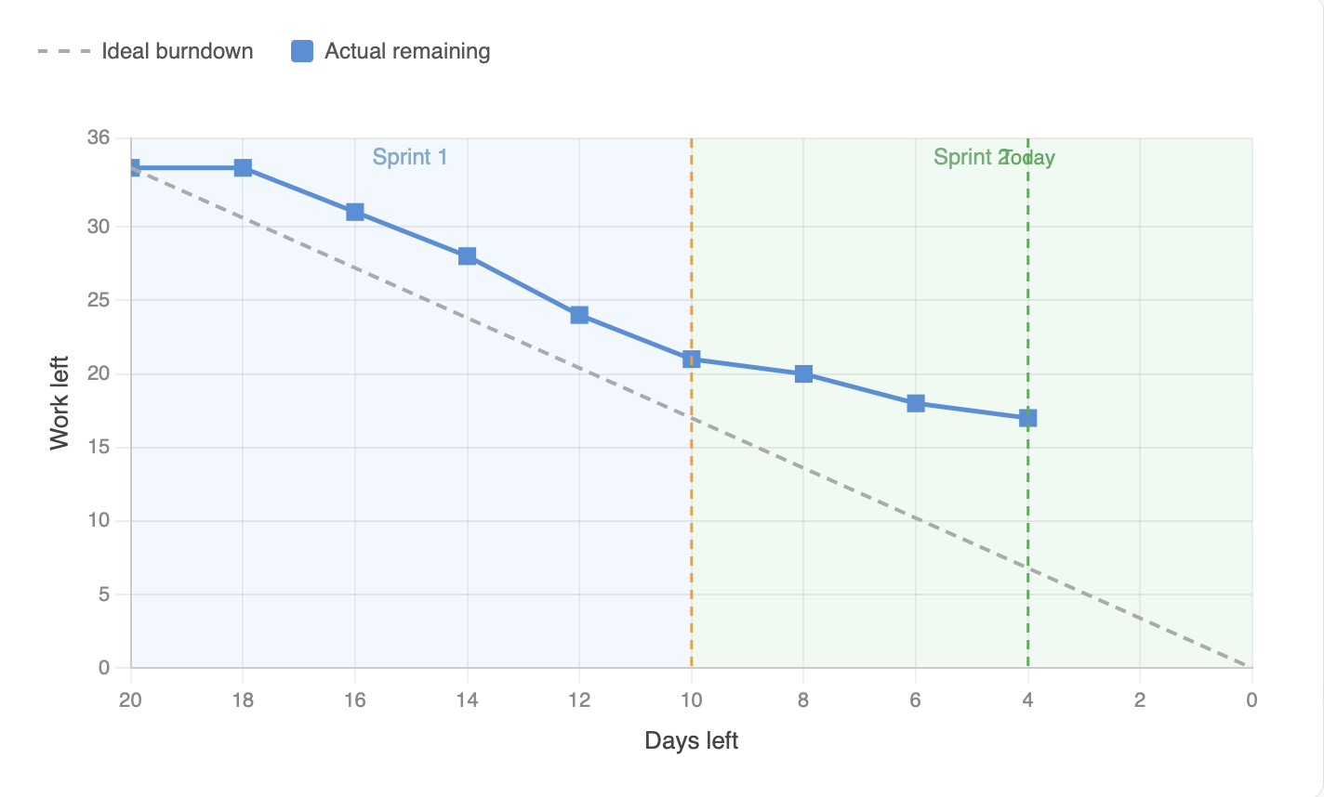
Note: Story 1.1 (Found-item dashboard, 5 days) was completed between Day 16 and Day 18 of the countdown (working days 4–6). Story 1.2 (Search & filter engine, 5 days) is currently in progress. The 17-point gap at Day 16 reflects stories 2.1, 2.2, 3.1, 3.2, 4.1, and 4.2 still queued in Todo, plus the 5 days remaining on 1.2.

Smart Lost & Found System · Practical Week 3 · Milestone 1 Iteration 1

