**Lesson 03 Demo 06**

**Reverting to the Previous Commit**

**Objective:** To demonstrate reverting to the previous commit to undo changes and restore the project to a previous state

**Tools required:** Git and GitHub

**Prerequisites:** None

Steps to be followed:

1. Create a new GitHub repository
2. Clone the GitHub repository
3. Revert to the previous commit

**Step 1: Create a new GitHub repository**

1. Open the browser in your lab, go to **github.com**, and log in to your account

**Note:** If you do not have a GitHub account, visit the official website at **https://github.com /signup** and create a new account

1. Click on the **+** icon from the upper-right corner of the page and select **New repository** from the drop-down menu

1. Enter the repository nameand description as shown in the below screenshot:

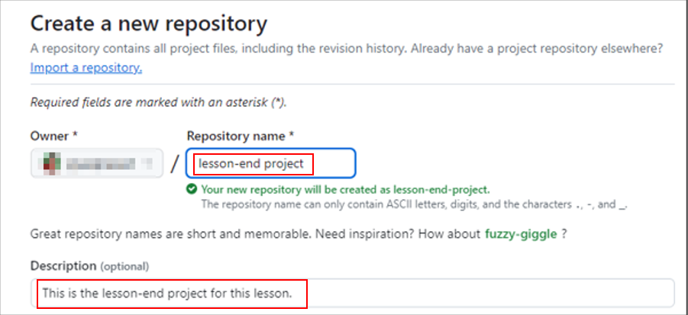

1. Choose **Public** for the repository type

1. Select **Add a README file** to initialize this repository with a README file

1. Click on the **Create repository** button

The remote GitHub repository is created.

**Step 2: Clone the GitHub repository**

1. Open the created repository and click on the **Code** button to copy the URL provided under HTTPS to clone the repository

1. Open the terminal tab on your lab and use the following command to clone the repository:

**git clone <URL>**

**Note:** Replace the URL with the copied URL from the repository

1. Navigate to the cloned repository using the following command:

**cd lesson-end-project**



**Step 3: Revert to the previous commit**

1. Use the command below to create and switch to a new branch:

**git checkout -b feature-branch**

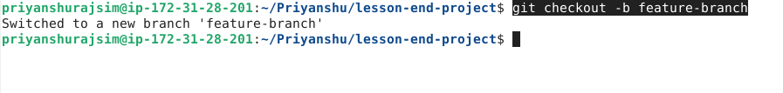

1. Execute the following commands to create a new file and modify it:

**touch example.txt**

**echo "Hello, this is an example file." > example.txt**



1. Run the following commands to add and commit the changes:

**git add example.txt**

**git commit -m "Add example file"**

1. Run the following command to push the changes to the **feature-branch** of the remote repository:

**git push origin feature-branch**

1. Run the following commands to further modify the **example.txt**:

**touch example.txt**

**echo "Hello, I am hard coder" > example.txt**



1. Run the following commands to add and commit the changes:

**git add example.txt**

**git commit -m "Modify example file"**

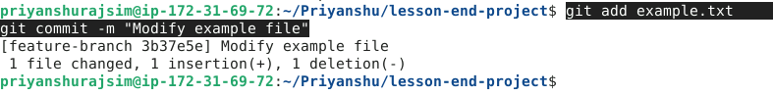

1. Execute the following command to inspect the commit history and identify the commit for reversal:

**git log --oneline**

1. Run the given command to revert to the preceding commit:

**git reset HEAD-1**



1. Run the provided command to verify the commit history and confirm the successful reversal:

**git log --oneline**

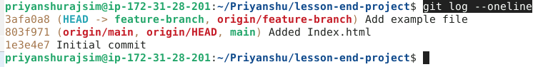

By following these steps, you have successfully demonstrated reverting to the previous commit to undo changes and restore the project to a previous state.