**Lesson 05 Demo 01**

**Implementing Job Import Plugin**

**Objective:** To install the job import plugin for importing jobs from an existing Jenkins instance, streamlining job management, and enhancing productivity

**Tools required:** Jenkins

**Prerequisites:** Jenkins must be operational.

Steps to be followed:

1. Install the job import plugin in Jenkins
2. Configure the job import plugin
3. Access the job import plugin

**Step 1:** **Install the job import plugin in Jenkins**

1. Sign in to the **Jenkins** platform

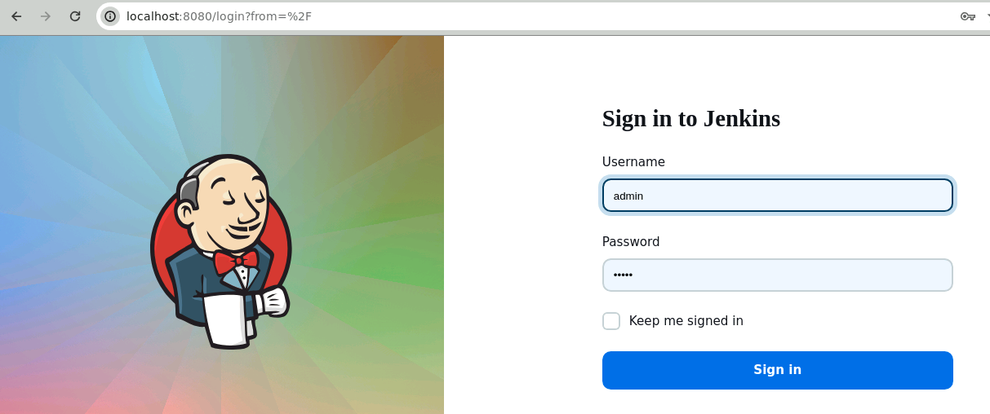

**Note:** The credentials for accessing Jenkins in the lab are Username: **admin** and Password: **admin**.

1. Select **Manage Jenkins**

1. Now, click on **Plugins** under **System Configuration**

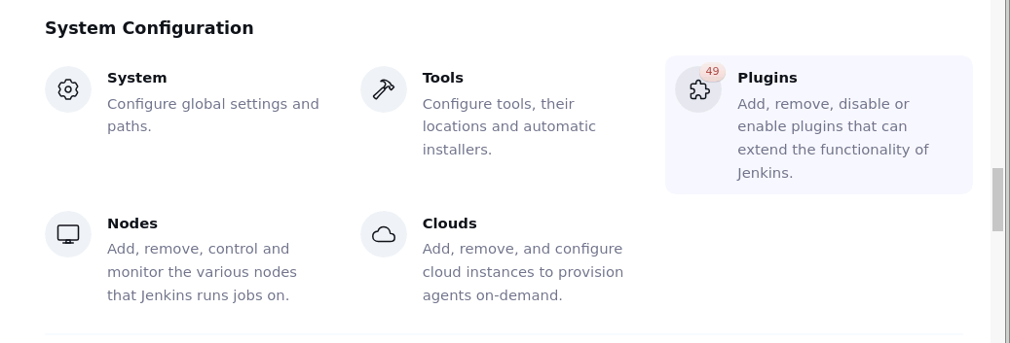

1. In the **Available plugins** tab, search for the **Job import plugin**

1. Select it and click on **Install**

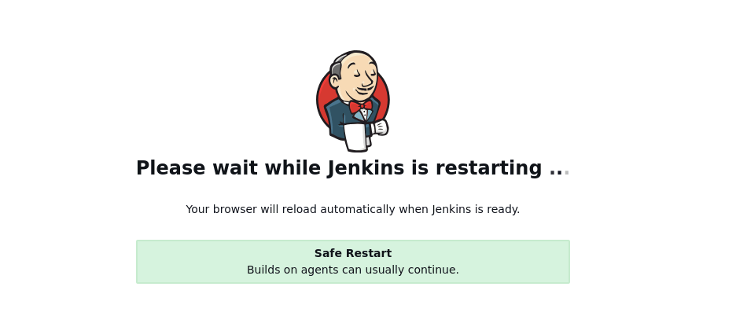

Once the plugin is installed, restart Jenkins to activate the plugin in Jenkins.

**Step 2:** **Configure the job import plugin**

* 1. Navigate to the Jenkins dashboard and select the **Job Import Plugin** option to access the plugin

Before using this feature, configure the source Jenkins server from which you can import the Jenkins job.

* 1. Now, navigate to **Manage Jenkins** and click on **System** under **System Configuration**

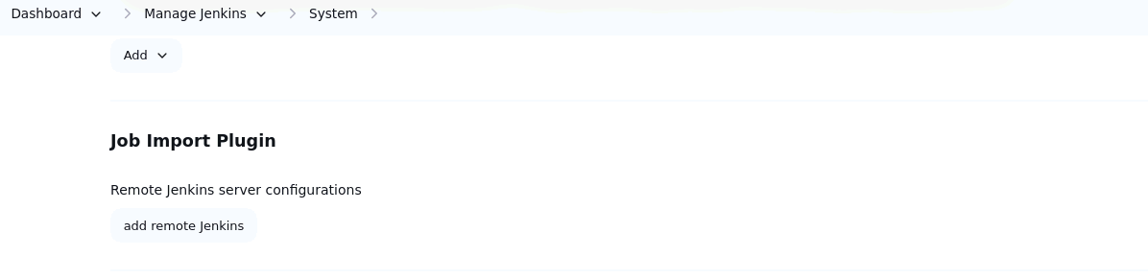

You can see a **Job Import Plugin** section for configuration.

* 1. Now, navigate back to **Manage Jenkins** in the Jenkins dashboard

* 1. Select **Credentials** under the **Security** section

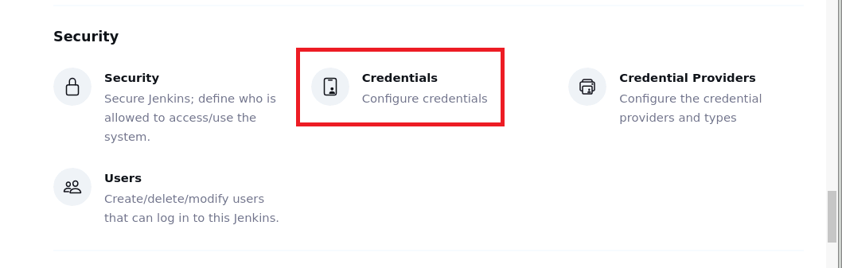

* 1. Select the Jenkins job scope as **global** to create global credentials for the Jenkins job

* 1. Click on **Add credentials** to add new Jenkins credentials

* 1. Provide the details like username and password and click on **Create**

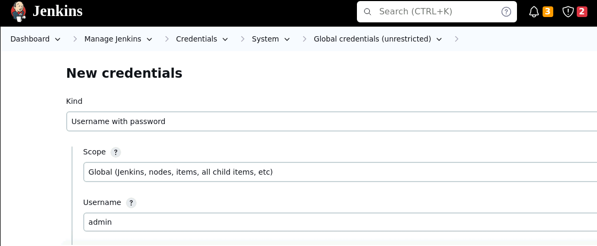

* 1. Now navigate back to the **Manage Jenkins** page and click on **System** under **System Configuration**

* 1. Scroll down to the **Job Import Plugin** section, provide the **Jenkins server name**, **URL,** and **credentials** to connect with the existing Jenkins job, and click on **Save**

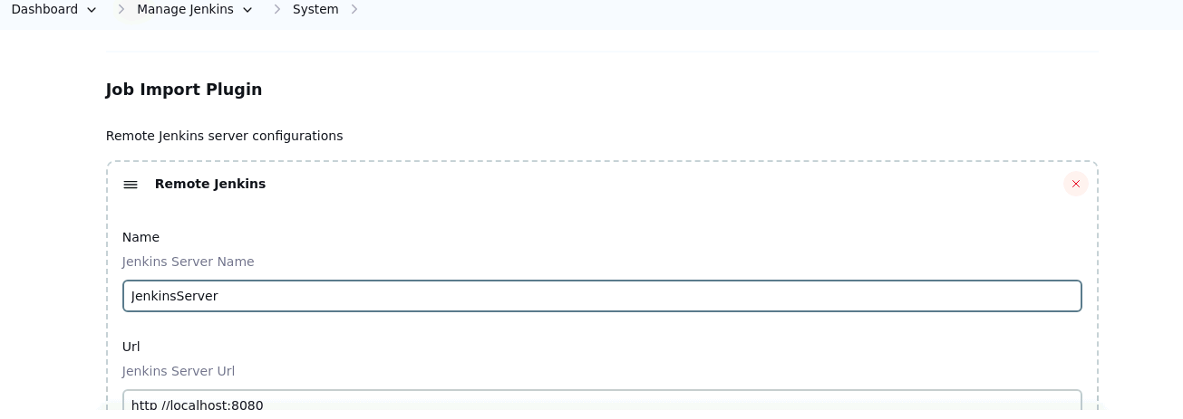

**Step 3:** **Access the job import plugin**

* 1. Once the remote Jenkins job is configured, click on the **Job Import Plugin** option to import the Jenkins job from the source Jenkins job

By following these steps, you have successfully installed the job import plugin for importing jobs from an existing Jenkins instance, streamlining job management, and enhancing productivity.