Name: Younus Jamal, PSID: 1372957

1. Given 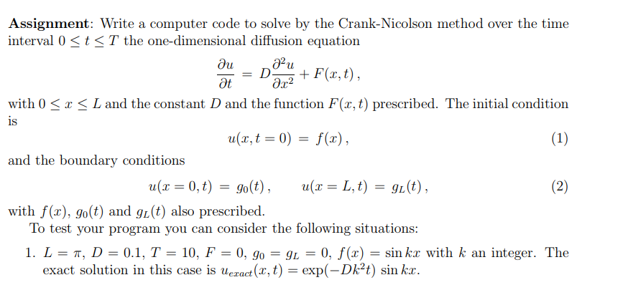

% Solution of the Heat Equation Using a Forward Difference Scheme

% Initialize Data

% Length of Rod, Time Interval

% Number of Points in Space, Number of Time Steps

L=3.14; / This is the length given

T=10; / Time max to be considered

D=0.1; / Diffusion constant

N=10; / Grid points taken

dx=L/N; / step size of x…

dt=T/N; / step size of t,…

lambda=D*dt/dx^2 / constant required for discretization

% Position

for i=1: N+1 / looping for grid points

x(i)=(i-1) *dx;

end

% Initial Condition

for i=1: N+1 / looping for grid points to put in applied function

u0(i)=sin(k*x(i)); */ where k = 1 (taken as integer)

end

% Partial Difference Equation (Numerical Scheme)

for j=1: N

for i=2: N

(-lambda/2) *(u1(j-1)) + (1-lambda) *(u1(j)) – (lambda/2) *(u1(j-1)) = (lambda/2) *(u0(j-1)) + (1-lambda) *(u0(j)) – (lambda/2) *(u0(j+1))

end

u1(1) =0;

u1(j+1) =0;

u0=u1;

u_exact = e^(-D*(t^2) *k) *Sin(Kx);

Error = (1/N) *(u (i, j) – (e^(-D*(t^2) *k) *Sin(k(i))/((e^(-D*((j)^2) *k) *Sin(k(i));

end

|  |  |  |  |  |  |  |  |  |  |  |
| --- | --- | --- | --- | --- | --- | --- | --- | --- | --- | --- |
|  |  | **T/5** | | | **T/2** | | | **T** | | |
| **Iteration Number** | **X (I = 1 to 10)** | **Exact** | **Approximate** | **Error** | **Exact** | **Approximate** | **Error** | **Exact** | **Approximate** | **Error** |
| **1** | 0.314 | 0.2528777 | 0.25793525 | 0.02 | 0.18733641 | 0.191083136 | 0.02 | 0.113625275 | 0.11589778 | 0.02 |
| **2** | 0.628 | 0.48102685 | 0.49064739 | 0.02 | 0.35635346 | 0.370607596 | 0.04 | 0.216139298 | 0.22478487 | 0.04 |
| **3** | 0.942 | 0.66213708 | 0.67537983 | 0.02 | 0.49052322 | 0.519954609 | 0.06 | 0.29751737 | 0.315368412 | 0.06 |
| **4** | 1.256 | 0.77849788 | 0.79406784 | 0.02 | 0.57672542 | 0.622863449 | 0.08 | 0.349801647 | 0.377785779 | 0.08 |
| **5** | 1.57 | 0.81873049 | 0.8351051 | 0.02 | 0.60653047 | 0.667183514 | 0.1 | 0.367879325 | 0.404667257 | 0.1 |
| **6** | 1.884 | 0.77890063 | 0.79447864 | 0.02 | 0.57702378 | 0.646266631 | 0.12 | 0.349982613 | 0.391980526 | 0.12 |
| **7** | 2.198 | 0.66290319 | 0.67616126 | 0.02 | 0.49109076 | 0.559843471 | 0.14 | 0.297861605 | 0.33956223 | 0.14 |
| **8** | 2.512 | 0.48208141 | 0.49172304 | 0.02 | 0.35713469 | 0.414276242 | 0.16 | 0.21661314 | 0.251271242 | 0.16 |
| **9** | 2.826 | 0.25411758 | 0.25919993 | 0.02 | 0.18825493 | 0.222140819 | 0.18 | 0.114182388 | 0.134735218 | 0.18 |
| **10** | 3.14 | 0.00130395 | 0.00133003 | 0.02 | 0.00096599 | 0.001159191 | 0.2 | 0.000585904 | 0.000703085 | 0.2 |
| **Average Error =** |  | 0.02 | |  | 0.11 | |  | 0.11 | |  |

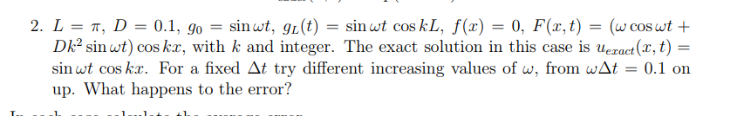

% Solution of the Heat Equation Using a Forward Difference Scheme

% Initialize Data

% Length of Rod, Time Interval

% Number of Points in Space, Number of Time Steps

L=3.14; / length of the rod

W = 0.05; / constant

D=0.1; / diffusion constant

N=10; / grid points

dx=L/N;

dt= T/N

alpha=D*dt/dx^2;

% Position

for i=1: N+1

x(i)=(i-1) *dx;

end

% Initial Condition

for i=1: N+1

u0(i)=0

end

% Partial Difference Equation (Numerical Scheme)

for j=1: M

for i=2: N

for t: 2 = 10;

(-lambda/2) *(u1(j-1)) + (1-lambda) *(u1(j)) – (lambda/2) *(u1(j-1)) = (lambda/2) *(u0(j-1)) + (1-lambda) *(u0(j)) – (lambda/2) *(u0(j+1)) + (w*cos(w(i)) + D*(k^2) *sin(w(i)) *cos(k(j)) / applying the discretization scheme

end

u1(1) =sin(wt.);

u1(N+1) =sin(wt.) (cos(kl))

u0=u1;

u_exact = sin((w(t(i)) *cos(k(x(i))

Error = (1/N) *(u (xi, Ti) – sin((w(t(i)) *cos(k(x(i))/ sin((w(t(i)) *cos(k(x(i)) / Applying the error scheme

end



**CONCLUSIONS DRAWN FROM THE DESCRITIZATION SCHEME AND WHAT I DID**

* We find that Crank-Nicholson scheme is good for solving problems involving heat transfer conditions.
* We figured out that explicit schemes carry limitations, while this scheme is far better as far as convergence and stability is concerned