**系統程式設計**

**Lab7 setjmp/longjmp**

**學號:411410005**

**姓名:**

1. **Where are the errors located?** 
   * 1. [spta@embedded.cs.ccu.edu.tw](mailto:spta@embedded.cs.ccu.edu.tw) no error
     2. twetrewt.terthbbb.com.tw there’s no @
     3. [spta@embed@ded.cs.cc@u.edu.tw](mailto:spta@embed@ded.cs.cc@u.edu.tw) several @
     4. [pv#pig@hot#mail.com](mailto:pv#pig@hot#mail.com) # at 2
     5. [pvpig@hot*mail.com](mailto:pvpig@hot*mail.com) * at 9
     6. [aaawww@ccu.cs..edu.tw](mailto:aaawww@ccu.cs..edu.tw) .. at 13
     7. [EA.EA@ccucsedutw](mailto:EA.EA@ccucsedutw) no . after @
2. **What is the error message format?  
   (you must not print any message after you print error message)**

1. **How did you use the setjmp/longjmp function?**

Use longjmp to jump to the place of setjmp and print the error message according to the return value of the longjmp.

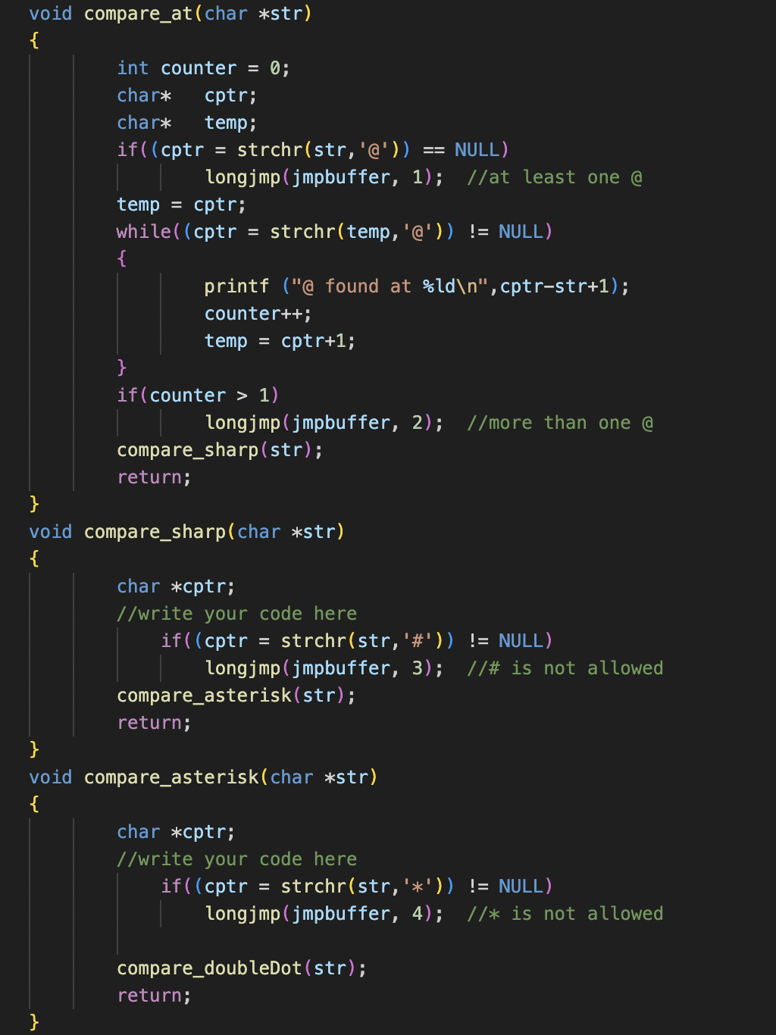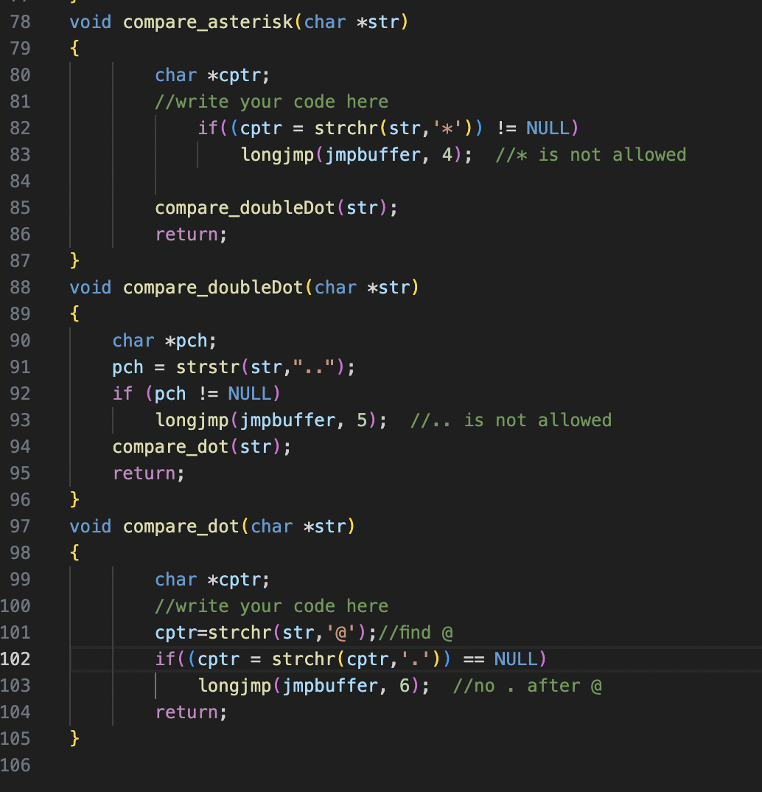

1. **Final result.  
   Please attach screenshot !** **A screenshot of a computer program

   Description automatically generated with medium confidence**