**系統程式設計**

**Lab8 Race condition**

**學號:411410005**

**姓名:莊翔鈞**

1. **How did you implement the processes?  
   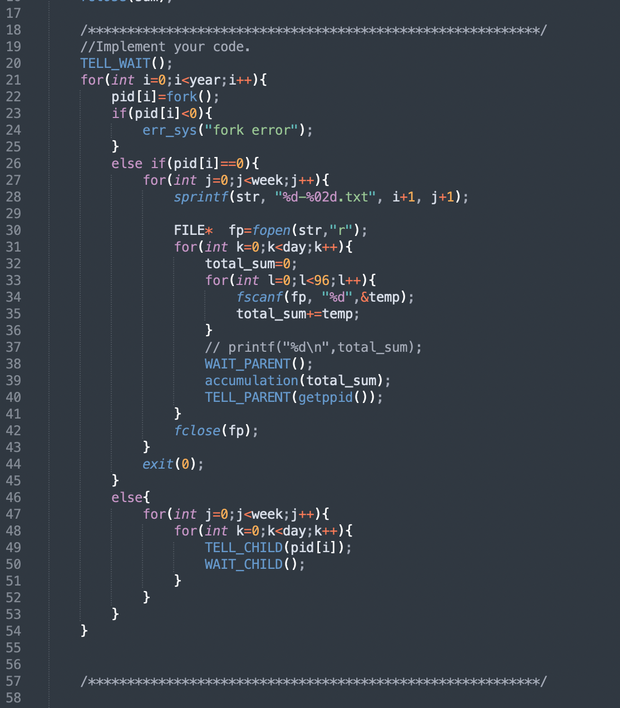**
2. **How did you update the file "sum.txt"?**

**By calling accumudation()  
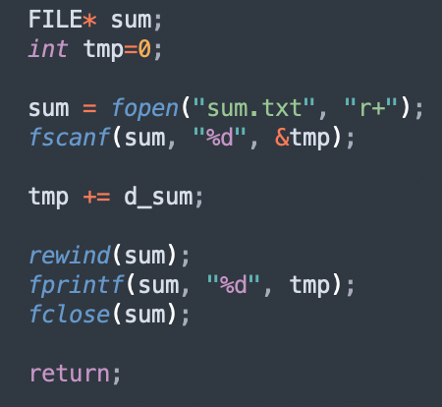**

1. **How did you solve the race condition?  
   by using tell_parent, tell_child, wait_parent, wait_child()**
2. **What is the average daily power consumption over the 5 years? (daily means for one day)  
   Please attach screenshot !**

