**SHUBHI TARAN**

**CODING CHALLENGE NO 4:**

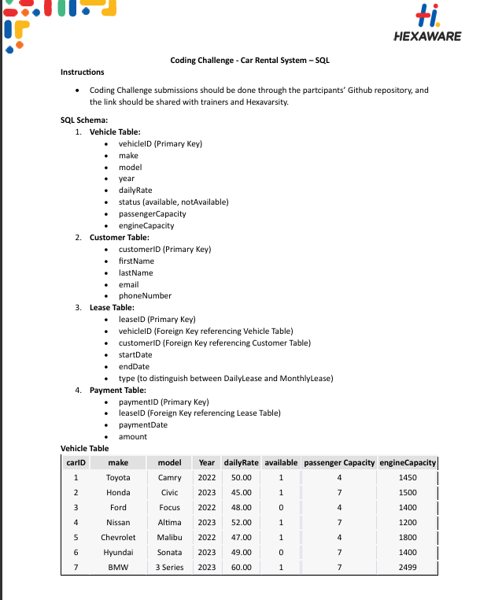

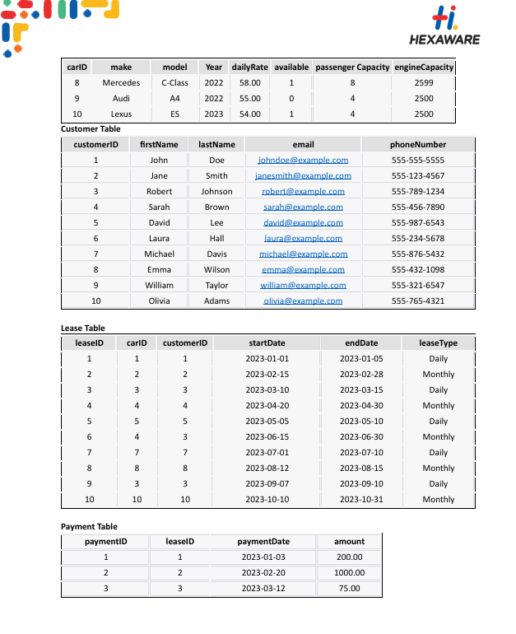

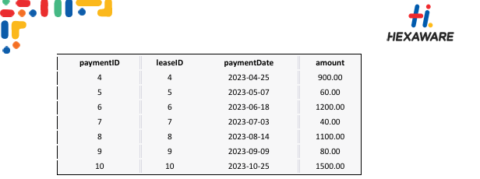

**QUERIES:**

**CREATING DATABASE + TABLES AND INSERTING VALUES:**

**-- coding challenge file 4 shubhi taran**

*CREATE DATABASE CarRental;*

*Use CarRental;*

*create table vehicle(*

*vehicleID int primary key,*

*make varchar(50),*

*model varchar(50),*

*year int,*

*dailyrate decimal(10,2),*

*status varchar(50),*

*passengercapacity int,*

*enginecapacity int*

*);*

*create table customer (*

*customerID int primary key,*

*firstname varchar(50),*

*lastname varchar (50),*

*email varchar(50),*

*phonenumber varchar(50)*

*);*

*create table lease (*

*leaseID int primary key,*

*carID int,*

*customerID int,*

*startdate date,*

*enddate date,*

*leasetype varchar(20),*

*foreign key (carID) references vehicle(vehicleID),*

*foreign key (customerID) references customer(customerID)*

*);*

*create table payment (*

*paymentID int primary key,*

*leaseID int,*

*paymentdate date,*

*amount decimal(10,2),*

*foreign key (leaseID) references lease(leaseID)*

*);*

*insert into vehicle values*

*(1, 'Toyota', 'Camry', 2022, 50.00, 'available', 4, 1450),*

*(2, 'Honda', 'Civic', 2023, 45.00, 'available', 7, 1500),*

*(3, 'Ford', 'Focus', 2022, 48.00, 'notAvailable', 4, 1400),*

*(4, 'Nissan', 'Altima', 2023, 52.00, 'available', 7, 1200),*

*(5, 'Chevrolet', 'Malibu', 2022, 47.00, 'available', 4, 1800),*

*(6, 'Hyundai', 'Sonata', 2023, 49.00, 'notAvailable', 7, 1400),*

*(7, 'BMW', '3 Series', 2023, 60.00, 'available', 7, 2499),*

*(8, 'Mercedes', 'C-Class', 2022, 58.00, 'available', 8, 2599),*

*(9, 'Audi', 'A4', 2022, 55.00, 'notAvailable', 4, 2500),*

*(10, 'Lexus', 'ES', 2023, 54.00, 'available', 4, 2500);*

*insert into customer values*

*(1, 'John', 'Doe', 'johndoe@example.com', '555-555-5555'),*

*(2, 'Jane', 'Smith', 'janesmith@example.com', '555-123-4567'),*

*(3, 'Robert', 'Johnson', 'robert@example.com', '555-789-1234'),*

*(4, 'Sarah', 'Brown', 'sarah@example.com', '555-456-7890'),*

*(5, 'David', 'Lee', 'david@example.com', '555-987-6543'),*

*(6, 'Laura', 'Hall', 'laura@example.com', '555-234-5678'),*

*(7, 'Michael', 'Davis', 'michael@example.com', '555-876-5432'),*

*(8, 'Emma', 'Wilson', 'emma@example.com', '555-432-1098'),*

*(9, 'William', 'Taylor', 'william@example.com', '555-321-6547'),*

*(10, 'Olivia', 'Adams', 'olivia@example.com', '555-765-4321');*

*insert into lease values*

*(1, 1, 1, '2023-01-01', '2023-01-05', 'Daily'),*

*(2, 2, 2, '2023-02-15', '2023-02-28', 'Monthly'),*

*(3, 3, 3, '2023-03-10', '2023-03-15', 'Daily'),*

*(4, 4, 4, '2023-04-20', '2023-04-30', 'Monthly'),*

*(5, 5, 5, '2023-05-05', '2023-05-10', 'Daily'),*

*(6, 4, 3, '2023-06-15', '2023-06-30', 'Monthly'),*

*(7, 7, 7, '2023-07-01', '2023-07-10', 'Daily'),*

*(8, 8, 8, '2023-08-12', '2023-08-15', 'Monthly'),*

*(9, 3, 3, '2023-09-07', '2023-09-10', 'Daily'),*

*(10, 10, 10, '2023-10-10', '2023-10-31', 'Monthly');*

*insert into payment values*

*(1, 1, '2023-01-03', 200.00),*

*(2, 2, '2023-02-20', 1000.00),*

*(3, 3, '2023-03-12', 75.00),*

*(4, 4, '2023-04-25', 900.00),*

*(5, 5, '2023-05-07', 60.00),*

*(6, 6, '2023-06-18', 1200.00),*

*(7, 7, '2023-07-03', 40.00),*

*(8, 8, '2023-08-14', 1100.00),*

*(9, 9, '2023-09-09', 80.00),*

*(10, 10, '2023-10-25', 1500.00);*

**DISPLAYING TABLES: VEHICLE TABLE**

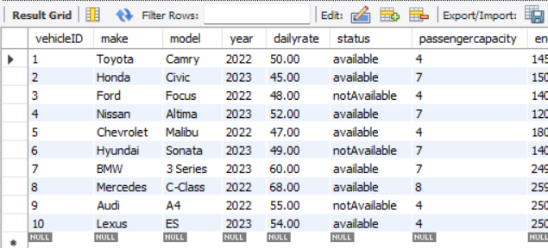

**CUSTOMER TABLE:**

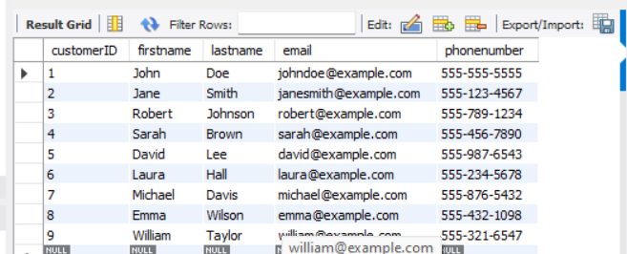

**LEASE TABLE:**

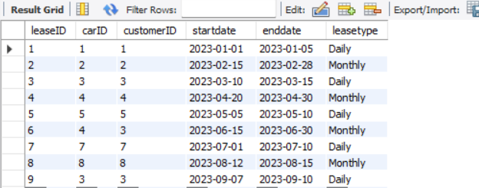

**PAYMENT TABLE:**

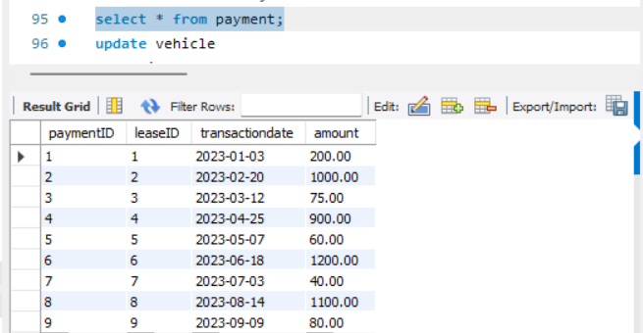

**1. Update the daily rate for a Mercedes car to 68.**

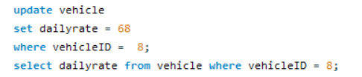

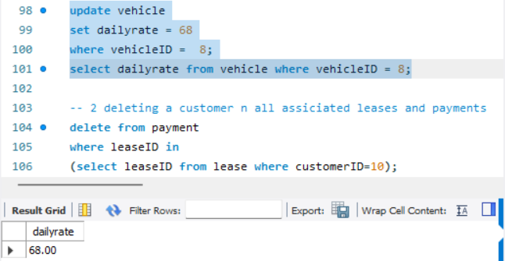

**2. Delete a specific customer and all associated leases and payments.**

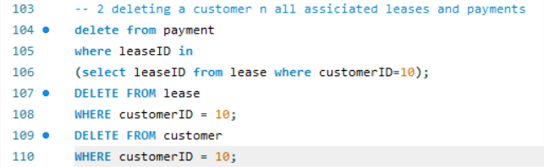

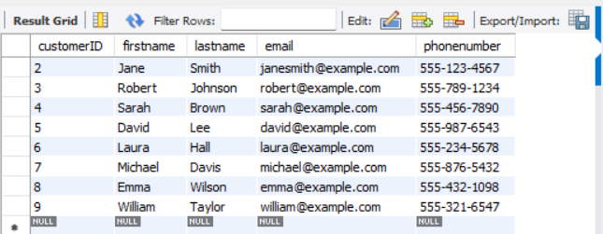

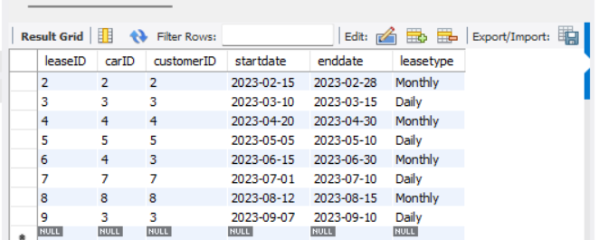

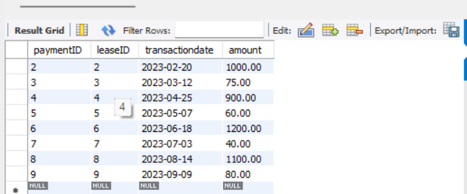

**3. Rename the "paymentDate" column in the Payment table to "transactionDate"**





**. 4. Find a specific customer by email.**

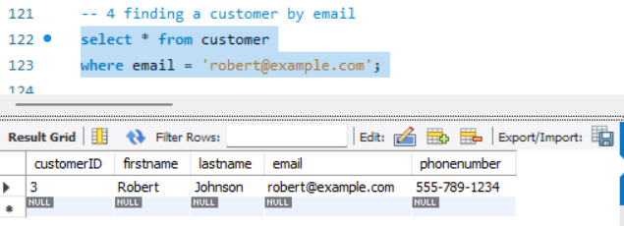

**5. Get active leases for a specific customer.**

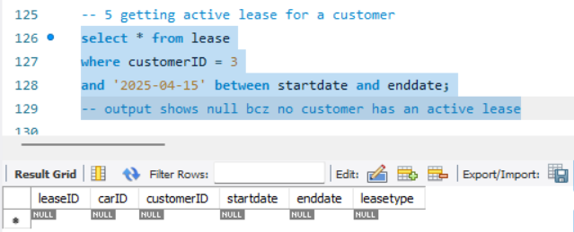

**6. Find all payments made by a customer with a specific phone number.**

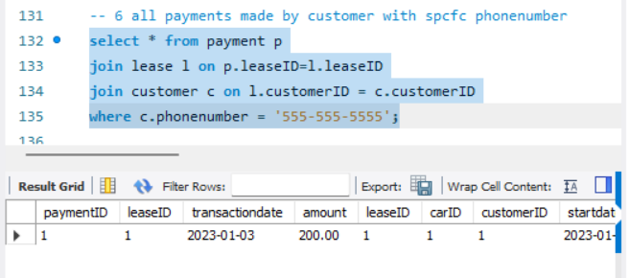

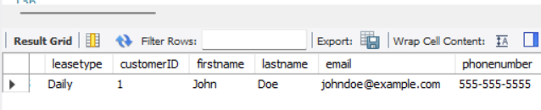

**7. Calculate the average daily rate of all available cars.**

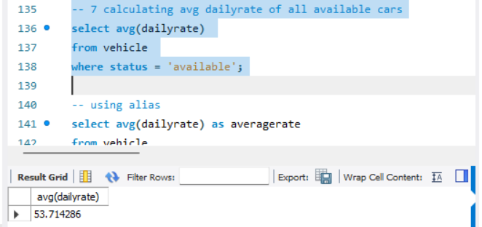

**8. Find the car with the highest daily rate.**

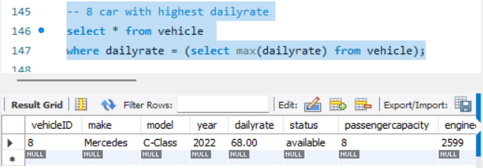

**9. Retrieve all cars leased by a specific customer.**

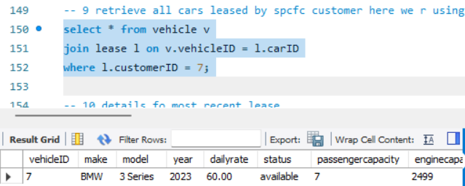

**10. Find the details of the most recent lease.**

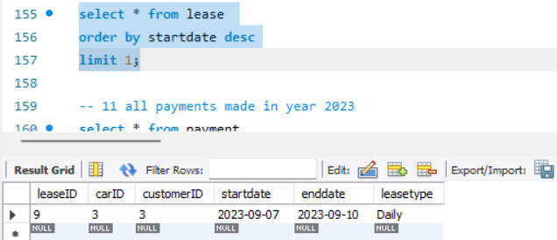

**11. List all payments made in the year 2023.**

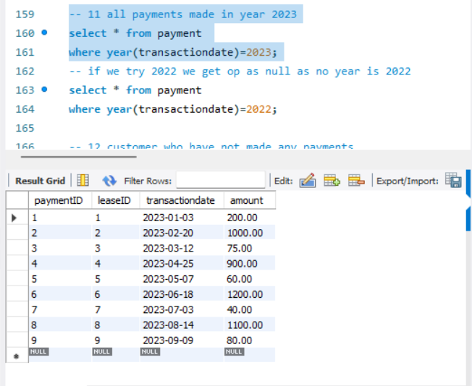

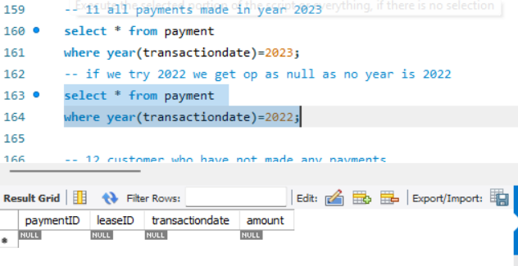

**12. Retrieve customers who have not made any payments.**

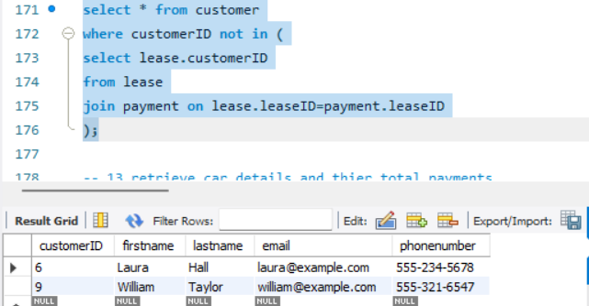

**13. Retrieve Car Details and Their Total Payments.**

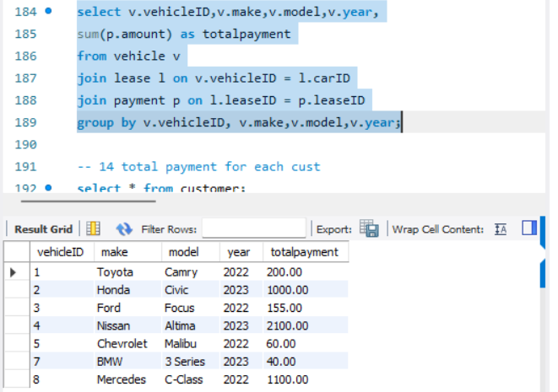

**14. Calculate Total Payments for Each Customer.**

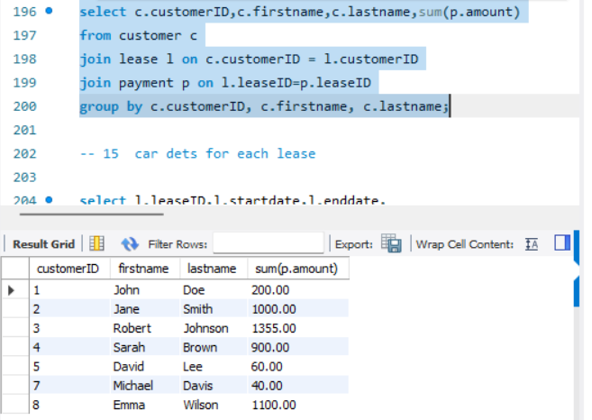

**15. List Car Details for Each Lease.**

**\**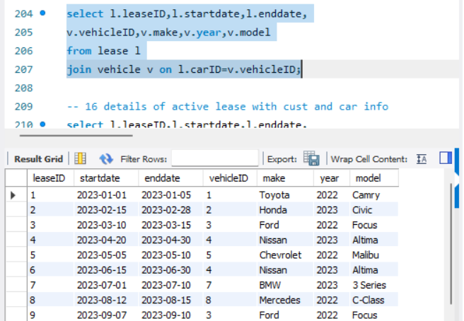

**16. Retrieve Details of Active Leases with Customer and Car Information.**

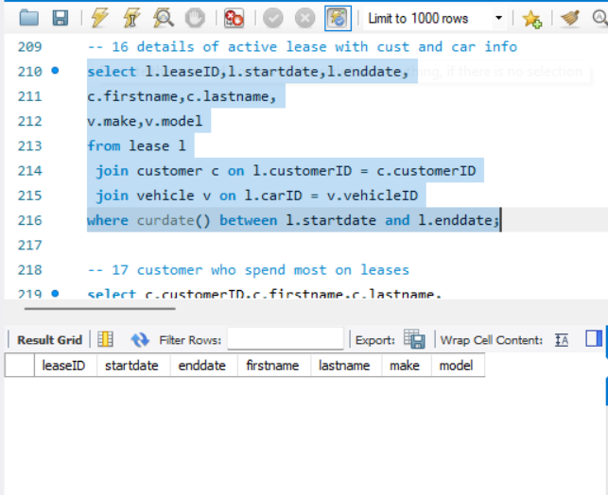

**17. Find the Customer Who Has Spent the Most on Leases.**

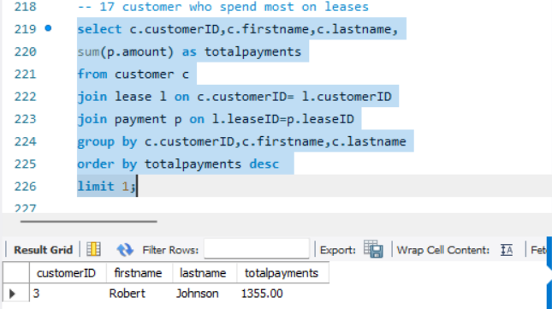

**18. List All Cars with Their Current Lease Information.**

