**Name : N.Gayathri Devi**

**Team id : ltvip2025tmid21812**

**Comprehensive Digital Marketing For Livon**

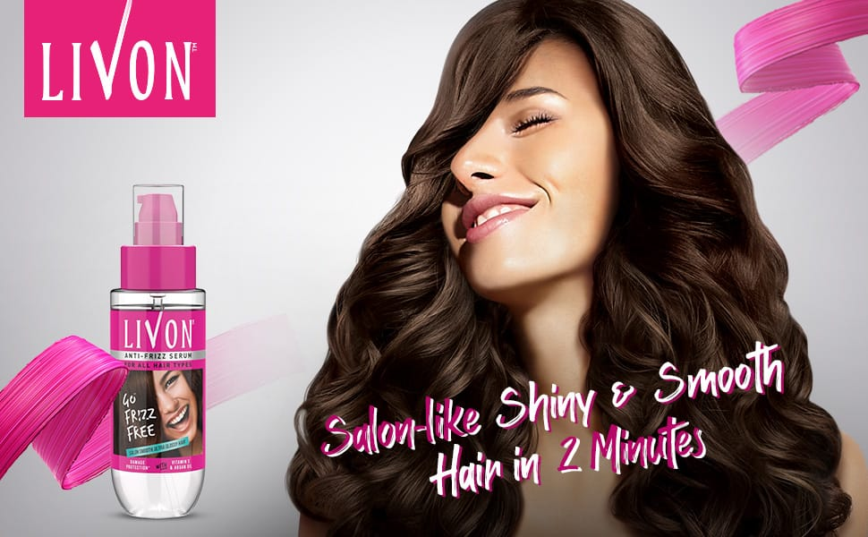

Livon hair serum is a popular hair care product designed to provide salon-smooth, ultra-glossy hair. It's infused with Moroccan Argan Oil extracts and Vitamin E, which moisturize and nourish your hair without weighing it down.

**Brand Study, Competitor Analysis & Buyer’s/ Audience’s persona**

**# Brand Identity Elements**

**1. Logo**

* The Livon logo features a stylized letter "L" made up of flowing lines that resemble hair.
* The logo is often depicted in a bright, energetic color scheme, which reflects the brand's youthful and vibrant personality.

**2. Color Palette**

* + Primary color: Bright and energetic orange (#FFC107)
  + Secondary color: Deep and rich brown (#754975)
  + Accent color: Vibrant and playful pink (#FF69B4)

**3. Typography**

* + Font family: Open Sans
  + Font sizes and styles vary depending on the application, but the brand typically uses a clean and modern sans-serif font.

**4. Imagery**

* + Livon's visual identity features beautiful, high-quality images of hair, often with a focus on movement and flow.
  + The brand also uses lifestyle images that showcase young, vibrant women with healthy and beautiful hair.

**5. Tone of Voice**

* + Friendly and approachable
  + Informative and educational
  + Playful and humorous

**About Product**

* Paras Pharmaceuticals had developed Livon, a non-greasy hair fluid that resembled neither shampoo or hair oil but yet detangled knots in hair.
* Hense Livon is considered as a 'Hair Detangler'.
* Livon Hair Serum prevented hair breakage and hair loss and gives smooth and soft hair.
* It works by pushing cuticle down which leads to less vissible split ends.so we feel smooth hair.
* It is having mild fragrances inspired by fine fragrances.

**Key Ingredients**

* Cyclopentasiloxane
* Dimethiconol
* C12-15 Alkyl Benzoate
* Dimethicone
* Argania Spinosa kernel (Argan) oil
* Tocopheryl (Vitmin E) Acetate
* Fragrance.

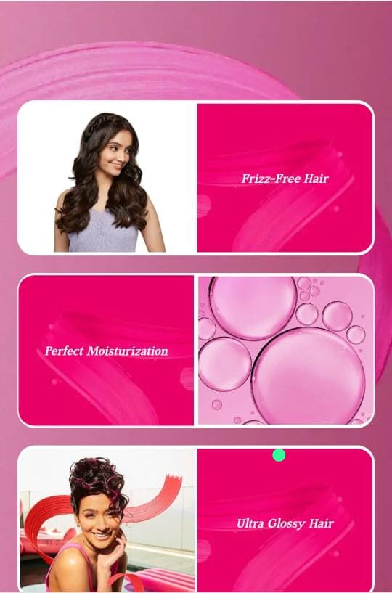

**How to use**

➤ On Wet Hair:

* Use on shampooed and towel-dried damp hair.
* Take a small quantity to start. with, in your palm.
* Ease your tangles by applying gently along the hair length.

➤ On Dry Hair:

* Apply a few drops gently to the ends of the hair.
* Experience a new ease of combing leading to less breakage. 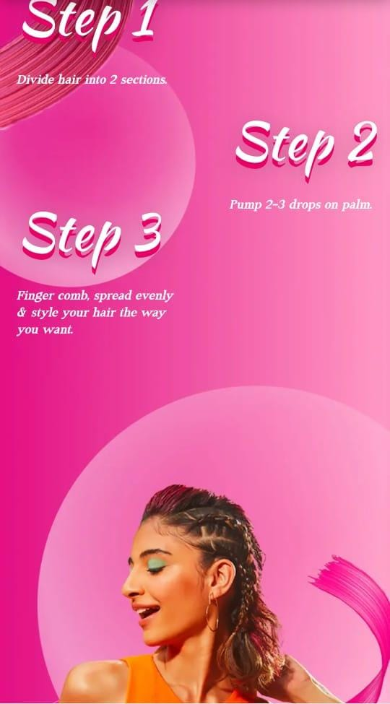**#competitor analysis for Livon:**

I. Direct Competitors

* 1. Pantene: A well-established hair care brand offering a wide range of products.
* 2. L'Oréal: A global beauty brand with a strong presence in the hair care market.
* 3. TRESemmé: A popular hair care brand offering a variety of products for different hair types.
* 4. Garnier: A natural and organic hair care brand offering a range of products.

II. Indirect Competitors

* 1. Biotique: A natural and ayurvedic hair care brand offering a range of products.
* 2. Amla: A natural and herbal hair care brand offering a range of products.
* 3. Dove: A personal care brand offering a range of hair care products.
* 4. Head & Shoulders: A popular anti-dandruff shampoo brand.

III. Market Share

* 1. Pantene: 24.1% market share
* 2. L'Oréal: 20.5% market share
* 3. TRESemmé: 15.6% market share
* 4. Garnier: 12.3% market share
* 5. Livon: 5.2% market share

IV. Strengths and Weaknesses

* Livon Strengths
* 1. Natural ingredients: Livon products are made with natural ingredients, appealing to customers seeking natural and organic products.
* 2. Affordable pricing: Livon products are priced competitively, making them accessible to a wider audience.
* 3. Strong online presence: Livon has a strong online presence, with a user-friendly website and active social media accounts.
* Livon Weaknesses
* 1. Limited product range: Livon's product range is limited compared to larger competitors.
* 2. Less brand awareness: Livon has less brand awareness compared to larger competitors.
* 3. Dependence on online sales: Livon relies heavily on online sales, which can be affected by factors like website downtime and shipping issues.

V. Opportunities and Threats

* Opportunities
* 1. Growing demand for natural products: The demand for natural and organic products is growing, which Livon can capitalize on.
* 2. Expanding online presence: Livon can expand its online presence by partnering with influencers and running targeted ads.
* 3. Entering new markets: Livon can enter new markets, such as the Middle East and Africa, to increase its customer base.
* Threats
* 1. Increasing competition: The hair care market is highly competitive, with new entrants and existing players expanding their product ranges.
* 2. Economic downturn: An economic downturn can affect consumer spending on hair care products.
* 3. Changes in consumer preferences: Changes in consumer preferences, such as a shift towards sustainable and eco-friendly products, can affect Livon's sales.

**#Buyer’s/Audience’s persona**

Persona 1: Young Sarah

* Age: 22-28
* Occupation: Working professional/student
  + Income: ₹25,000-₹50,000 per month
  + Education: College-educated
  + Location: Urban areas (metros and tier-1 cities)
  + Hair type: Dry, damaged, or frizzy hair
  + Goals: Achieve healthy, shiny, and manageable hair
  + Challenges: Busy lifestyle, lack of time for hair care, and struggling with hair frizz and damage
  + Values: Convenience, ease of use, and effectiveness of hair care products
  + Preferred communication channels: Social media (Instagram, Facebook), online advertising, and influencer marketing

Persona 2: Busy Bhavna

* + Age: 29-40
  + Occupation: Working professional/homemaker
  + Education: College-educated
  + Income: ₹50,000-₹1,00,000 per month
  + Location: Urban and semi-urban areas
  + Hair type: Normal to oily hair
  + Goals: Maintain healthy and stylish hair, and address specific hair concerns (e.g., hair fall, dandruff)
  + Challenges: Managing work-life balance, limited time for hair care, and seeking effective solutions for hair concerns
  + Values: Quality, reliability, and expertise in hair care products
  + Preferred communication channels: Online search, social +media, and word-of-mouth recommendations

Persona 3: Style-Conscious Rohan

* Age: 25-35
* Occupation: Creative professional/student
* Education: College-educated
* Income: ₹30,000-₹70,000 per month
* Location: Urban areas (metros and tier-1 cities)
* Hair type: Normal to dry hair
* Goals: Achieve stylish and trendy hair, and express personal style through hair
* Challenges: Finding hair care products that cater to specific styling needs, and staying up-to-date with latest hair trends
* Values: Uniqueness, creativity, and self-expression through hair
* Preferred communication channels: Social media (Instagram, TikTok), influencer marketing, and online beauty forums

Persona 4: Health-Conscious Nalini

* Age: 35-50
* Occupation: Working professional/homemaker
* Education: College-educated
* Income: ₹50,000-₹1,00,000 per month
* Location: Urban and semi-urban areas
* Hair type: Dry, damaged, or color-treated hair
* Goals: Achieve healthy and strong hair, and address specific hair concerns (e.g., hair fall, dandruff)
* Challenges: Finding natural and chemical-free hair care products, and managing hair health with a busy lifestyle
* Values: Natural ingredients, health benefits, and sustainability in hair care products
* Preferred communication channels: Online search, social media, and word-of-mouth recommendations.

**SEO & key word Research**

**# SEO**

**1. On-Page Optimization**

- Keyword Research : Conduct thorough keyword research to identify relevant and high-traffic keywords.

- Optimize Title Tags : Write unique and descriptive title tags for each page, including target keywords.

- Meta Descriptions : Craft compelling and informative meta descriptions to entice users to click through.

**2. Technical SEO**

- Website Audit : Conduct a thorough website audit to identify and fix technical issues, such as broken links, duplicate content, and crawl errors.

- XML Sitemap : Create and submit an XML sitemap to help search engines understand the website's structure.

**3. Content Creation**

- High-Quality Content : Create high-quality, engaging, and informative content that addresses the needs and concerns of the target audience.

- Content Marketing : Develop a content marketing strategy that includes blog posts, videos, infographics, and social media content**.**

**4. Link Building**

- High-Quality Backlinks : Focus on acquiring high-quality backlinks from authoritative sources, such as hair care blogs, websites, and forums.

- Resource Pages : Create resource pages that link to other high-quality websites and blogs in the hair care industry.

**5. Local SEO (if applicable)**

- Google My Business : Claim and optimize the Google My Business listing to improve local search visibility.

- Local Citations : Ensure consistent local citations across the web, including directories, review sites, and social media platforms.

**# Keyword Research**

**1. Product-Specific Keywords**

- Livon hair serum

- Livon hair oil

- Livon hair cream

- Livon hair mask

- Livon shampoo

- Livon conditioner

**2. Hair Care Problem-Specific Keywords**

- Hair fall solution

- Dandruff treatment

- Dry hair care

- Oily hair solution

- Hair growth tips

- Split ends repair

**3. Ingredient-Specific Keywords**

- Argan oil for hair

- Coconut oil for hair

- Olive oil for hair

- Keratin for hair

- Vitamin E for hair

**4. Long-Tail Keywords**

**-** Best hair serum for dry hair

- Hair oil for hair growth and strengthening

- Natural hair care products for oily hair

- Hair mask for damaged hair repair

- Shampoo for dandruff and itchy scalp.

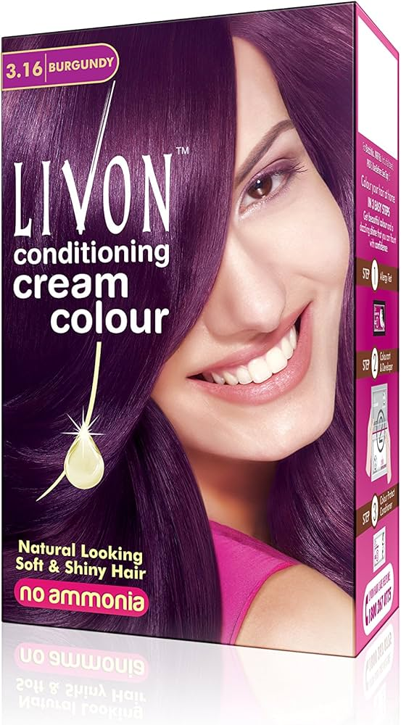

**Content ideas & marketing strategies**

**# Content Ideas**

**1. Blog Posts**

- "10 Hair Care Tips for Healthy and Shiny Hair"

- "Hair Care Routine for Different Hair Types"

**2. Videos**

- "Livon Hair Serum Review: Does it Really Work?"

- "Before and After: Livon Hair Transformation"

**3. Social Media Posts**

- "Hair care tip of the day: Use a wide-tooth comb to detangle your hair"

- "Good morning, beautiful! Start your day with a hair care routine that works for you"

**# Marketing Strategies**

**1. Influencer Marketing**

- Partner with popular beauty and hair care influencers to promote Livon products.

- Collaborate with influencers to create sponsored content, product reviews, and tutorials**.**

**2. Social Media Marketing**

- Establish a strong presence on Facebook, Instagram, Twitter, and Pinterest**.**

- Share engaging content, including product tutorials, customer testimonials, and behind-the-scenes stories**.**

**3. Email Marketing**

- Build an email list through the website and social - media channels.

- Use email marketing automation tools to personalize and optimize campaigns**.**

**4. Content Marketing**

- Develop a content calendar that includes blog posts, videos, and social media content.

- Create informative and engaging content that addresses the target audience's hair care concerns**.**

**5. Paid Advertising**

- Run targeted Google Ads and social media ads to reach the target audience.

- Focus on high-converting keywords and demographics**.**

**# Content Creation**

1. **Blog Posts**

* **"**The Ultimate Guide to Hair Care: Tips, Tricks, and Product Recommendations"
* "The Importance of Using a Sulfate-Free Shampoo: Why Livon is the Best Choice"

**2. Videos**

* "Hair Care Tutorial: How to Use Livon Hair Oil for Best Results"
* "Hair Care Q&A: Answering Your Most Asked Questions"

**3. Social Media Posts**

* **"**Hair goals alert! Get the hair you've always wanted with Livon"
* "It's time to pamper yourself! Treat your hair to a Livon hair mask**"**

**4. Infographics**

* "The Benefits of Using a Hair Serum" (infographic)
* **"**Livon Hair Care Products: A Comprehensive Guide" (infographic)

**# Content Curation**

**1. User-Generated Content (UGC) Campaign**

* Encourage customers to share their Livon hair care experiences and photos on social media.
* Create a branded hashtag and tag @Livon in all UGC posts.
* Feature UGC on Livon's social media channels and website.

1. **Influencer Partnerships**

* Collaborate with popular beauty and hair care influencers to promote Livon products.
* Request influencers to share their Livon hair care experiences and photos on social media.
* Feature influencer content on Livon's social media channels and website.

**3. Guest Blogging**

* Invite hair care experts and influencers to write guest posts for Livon's blog.
* Request guest bloggers to share their expertise and experiences with Livon's audience.
* Feature guest posts on Livon's blog and social media channels.

.

