Supplementary Information
Plasma NMR metabolomic profiles and incident colon and stomach/duodenal polyps: a prospective analysis of 274,260 UK Biobank participants

Supplementary tables
Supplementary tables are provided in the Excel workbook Supplementary_Tables.xlsx (one sheet per table, with an index sheet).
Sheet | Content
TableS1_metabolite_results | One row per outcome and metabolite: primary Cox (Model 1; HR per 1 SD), sensitivity excluding events <2 y, prevalent-disease odds ratio, sex and age-60 subgroups, split-sample (ln HR, 70% discovery / 30% validation), bootstrap (30 resamples; ln HR interval), extended adjustment in the same complete-case sample (M1; M2a +waist, body fat %; M2b +HbA1c, log CRP; M2c +waist, body fat %, HbA1c, log CRP; M3 +prior-diagnosis proxies; M4 all), original 3-character code definition, metabolite-score weight, and dual-site vs single-site OR (identical in both outcome blocks). p_bonf = Bonferroni-adjusted P
TableS2_metabolite_annotation | Metabolite abbreviations (as supplied) with rule-based class and lipoprotein family
TableS3_prediction_performance | Prediction performance: binary (5-fold cross-validation AUC) and survival (test-set C-index, 5- and 10-year AUC) for three feature sets
TableS4_specificity_correlations | Correlation of each outcome's 251 ln(HR) values with the colon and stomach/duodenal polyp profiles (events and number of Bonferroni-significant metabolites)
TableS5_specificity_effects | Model 1 Cox of all 251 metabolites for 23 other digestive outcomes (3-character ICD-10 codes) and colorectal cancer (CRC = C18-C20)
TableS6_lipid_audit | Audit of the lipoprotein results: NMR vs clinical chemistry (alignment and independent hazard ratios), stepwise adjustment for prior-diagnosis proxies, mutual adjustment, crude incidence by HDL tertile

Supplementary figures
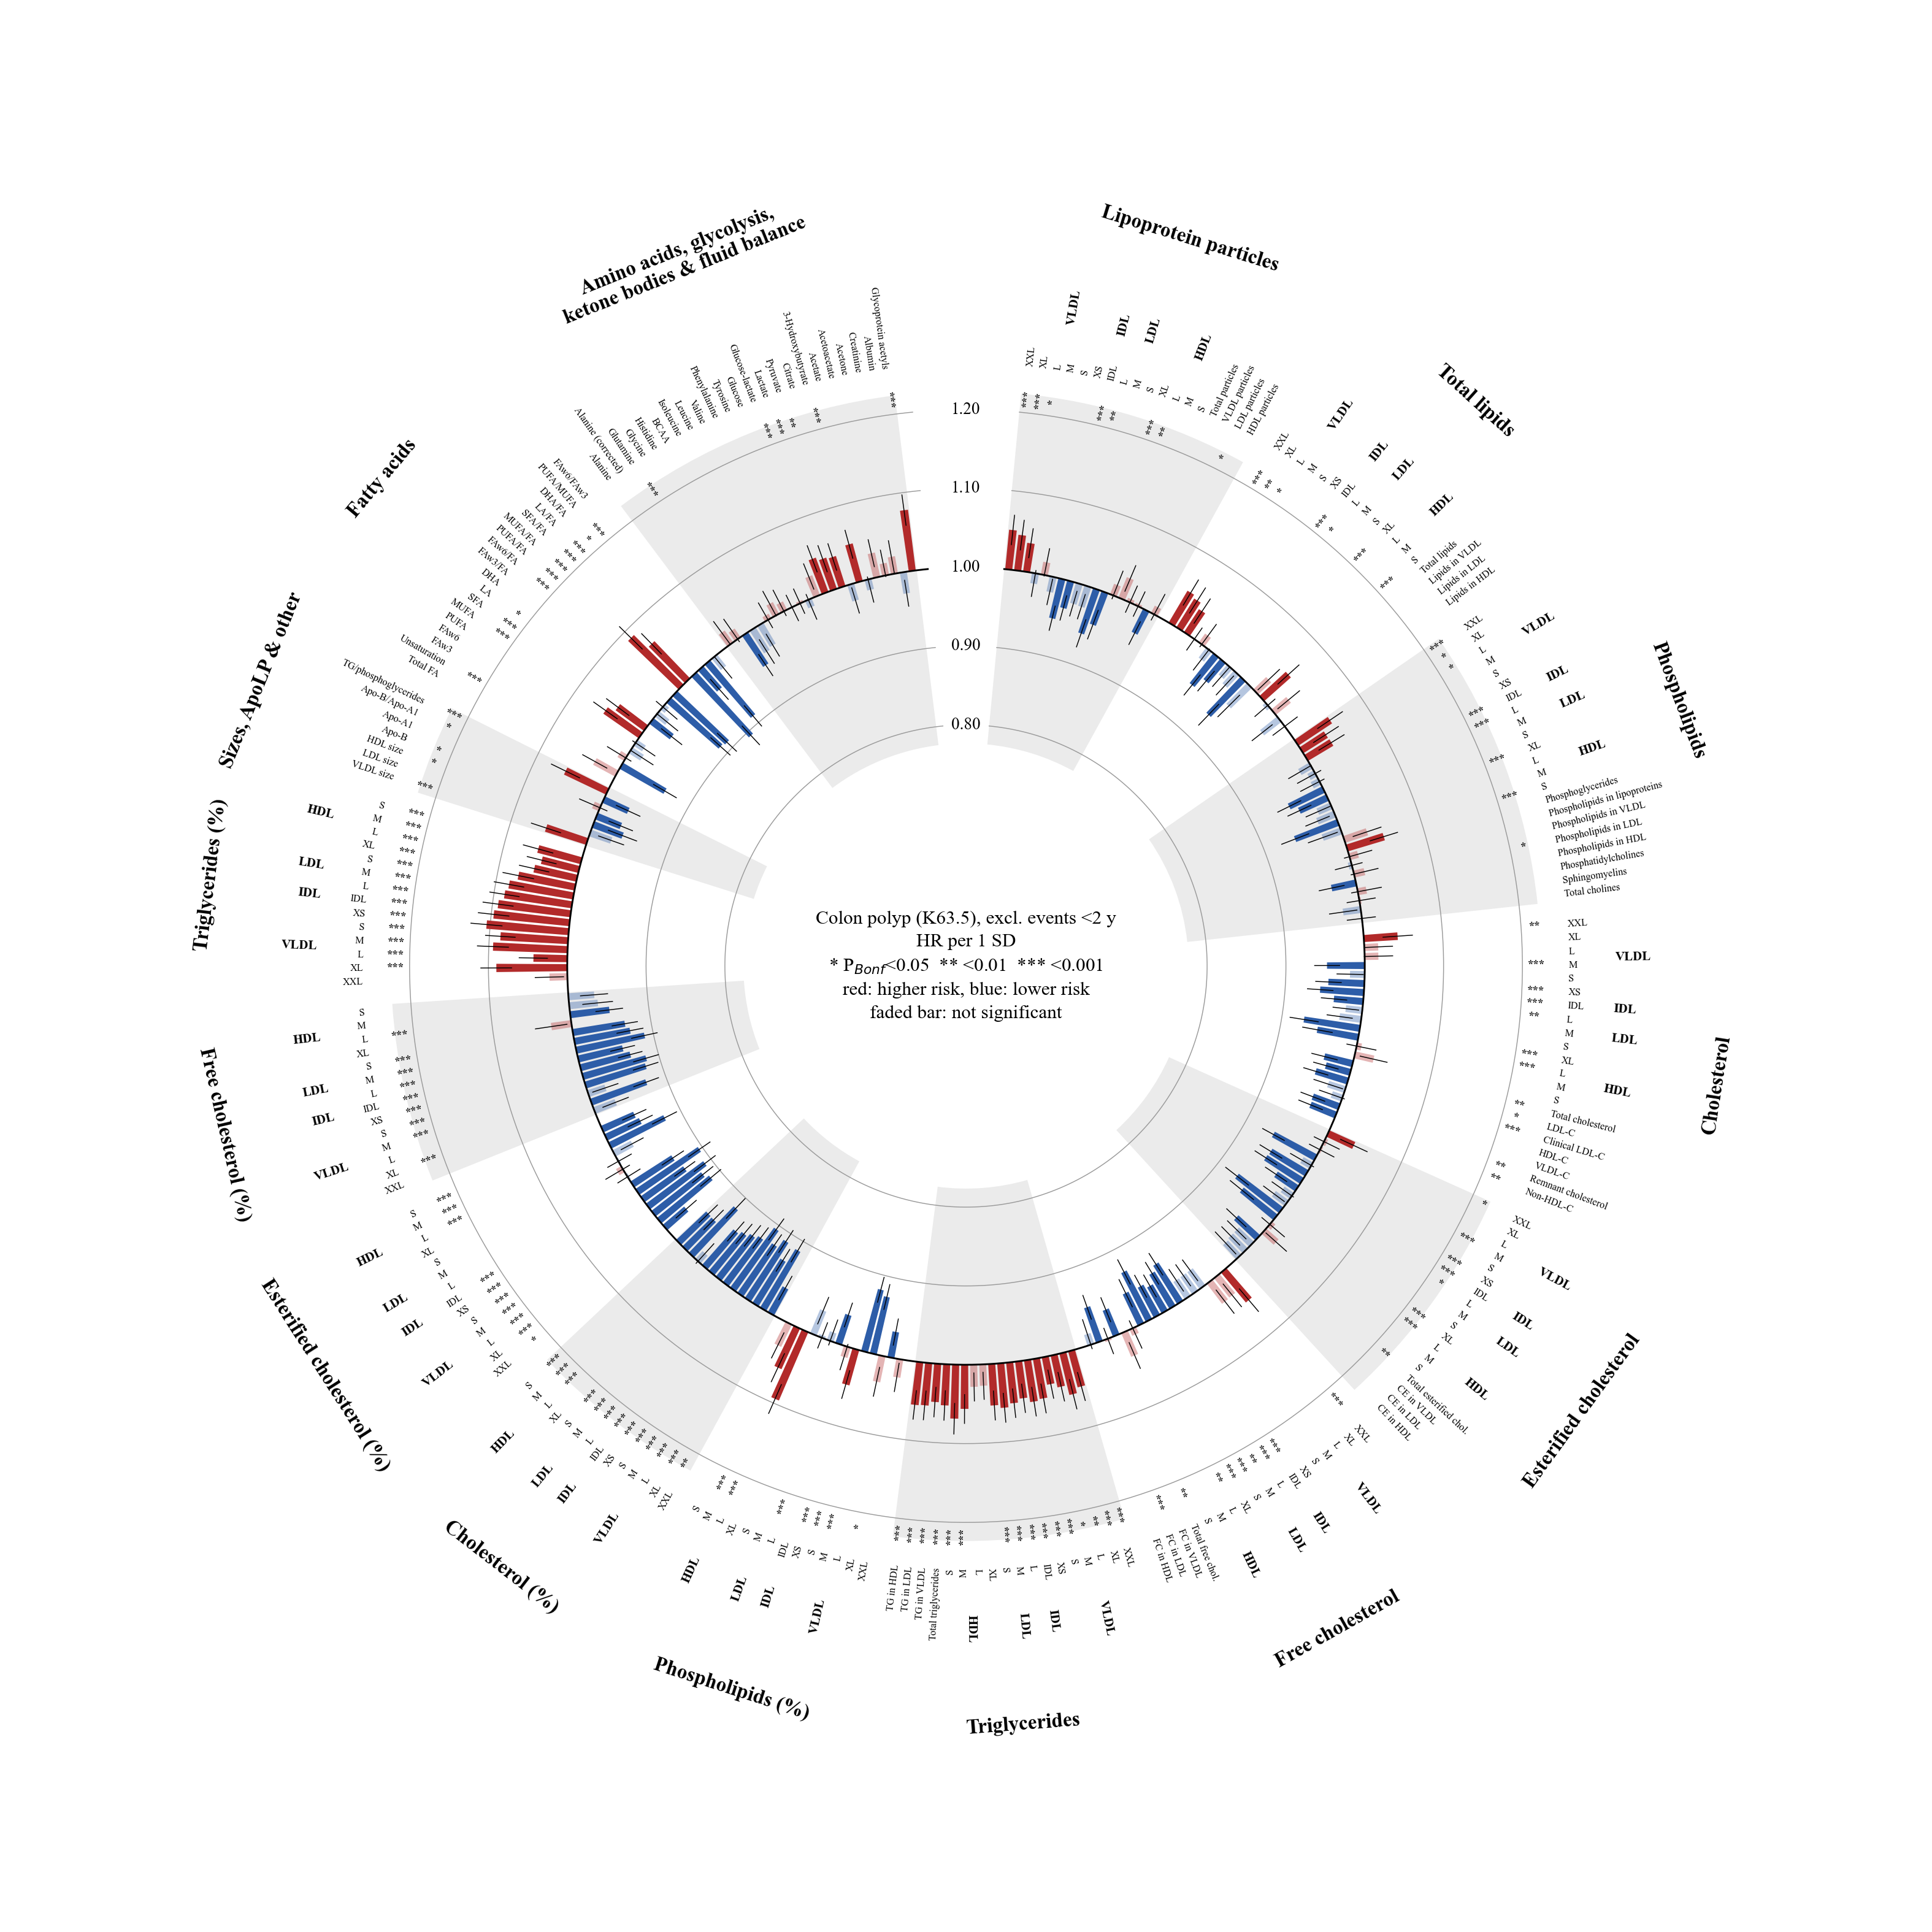
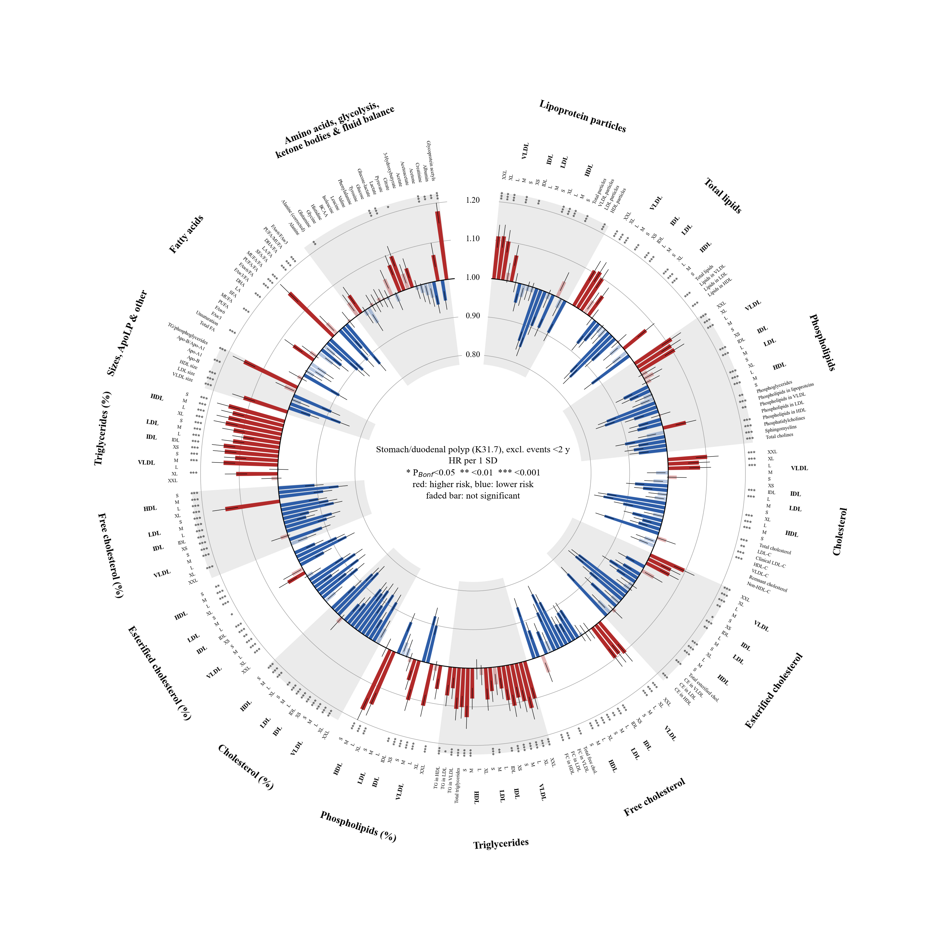
Figure S1. Sensitivity analysis excluding events in the first 2 years. Circular bar plots of hazard ratios for all 251 metabolites for (A) colon polyp and (B) stomach/duodenal polyp; conventions as in Figure 3.

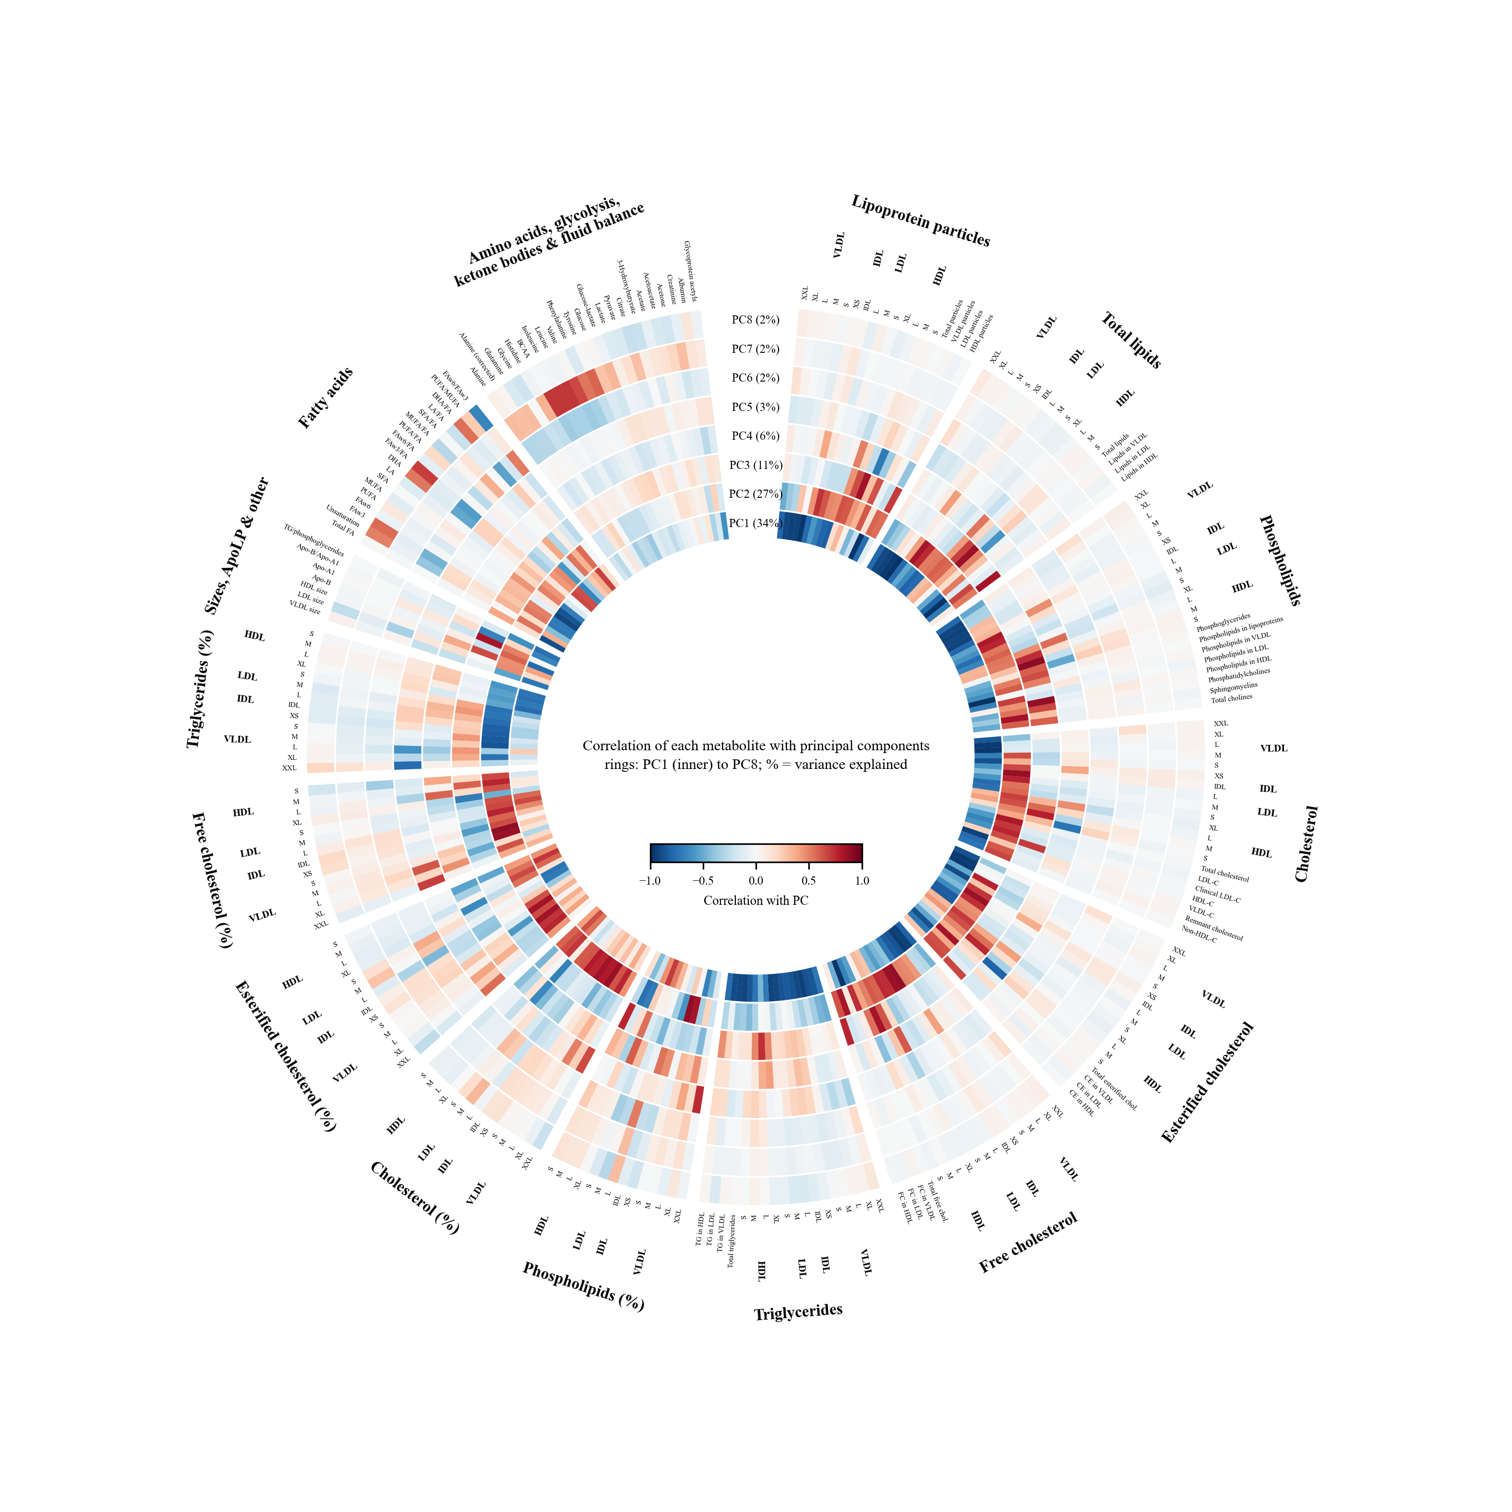
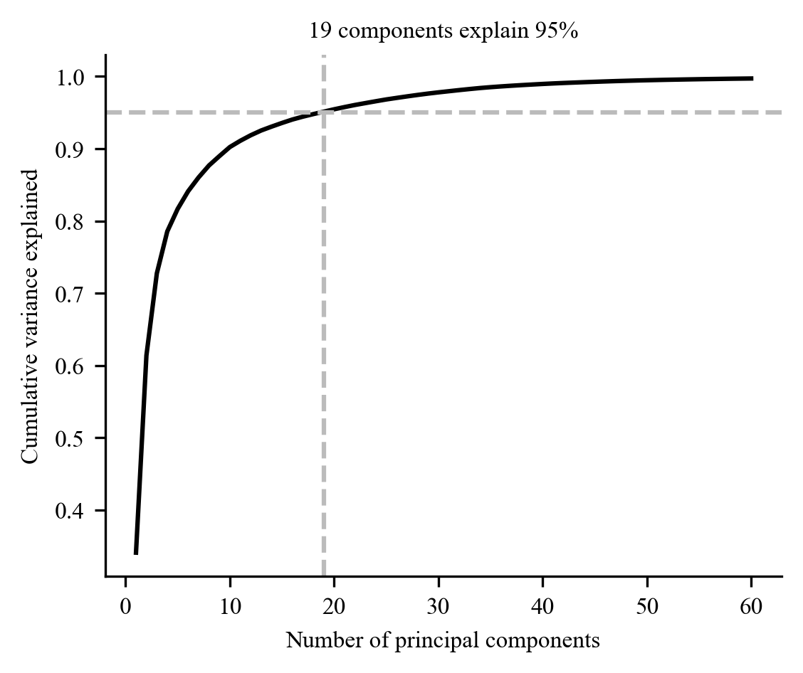
Figure S2. Correlation structure of the metabolites. (A) Circular heat rings of the correlation of each metabolite with principal components 1–8 (percentage of variance in the ring labels). (B) Cumulative variance explained by the principal components; 19 components explain 95%.

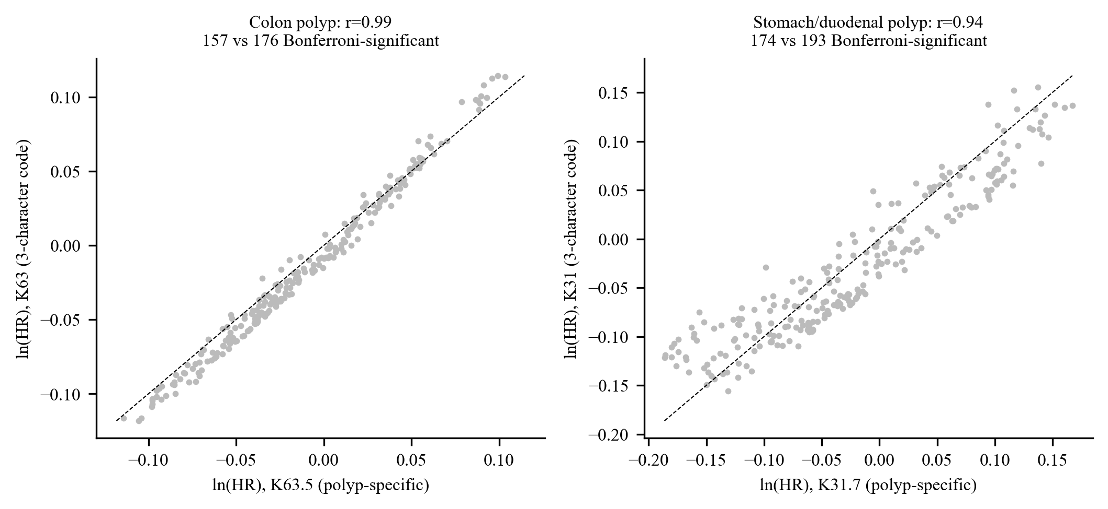
Figure S3. Original three-character codes versus polyp-specific codes. Natural-log hazard ratios per SD for K63 against K63.5 (left) and K31 against K31.7 (right).

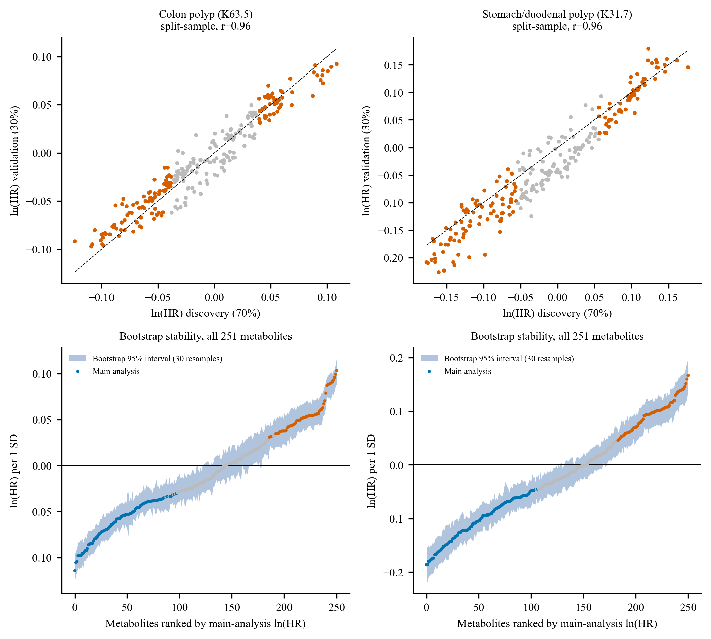
Figure S4. Internal validation. Top, natural-log hazard ratios in the discovery (70%) and validation (30%) halves; orange points are significant in the discovery half after Bonferroni correction. Bottom, bootstrap analysis (30 resamples): metabolites ranked by the natural-log hazard ratio of the main analysis (points; orange, higher risk; blue, lower risk; grey, not significant) with the 95% bootstrap interval (band).

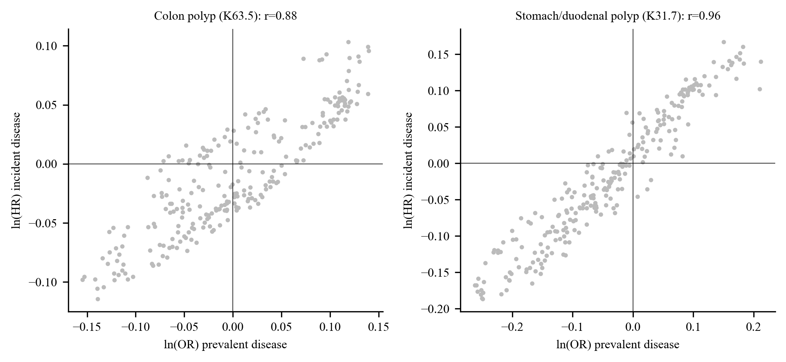
Figure S5. Prevalent and incident disease. Natural-log odds ratio of prevalent disease at baseline against the natural-log hazard ratio of incident disease for colon polyp (left) and stomach/duodenal polyp (right).

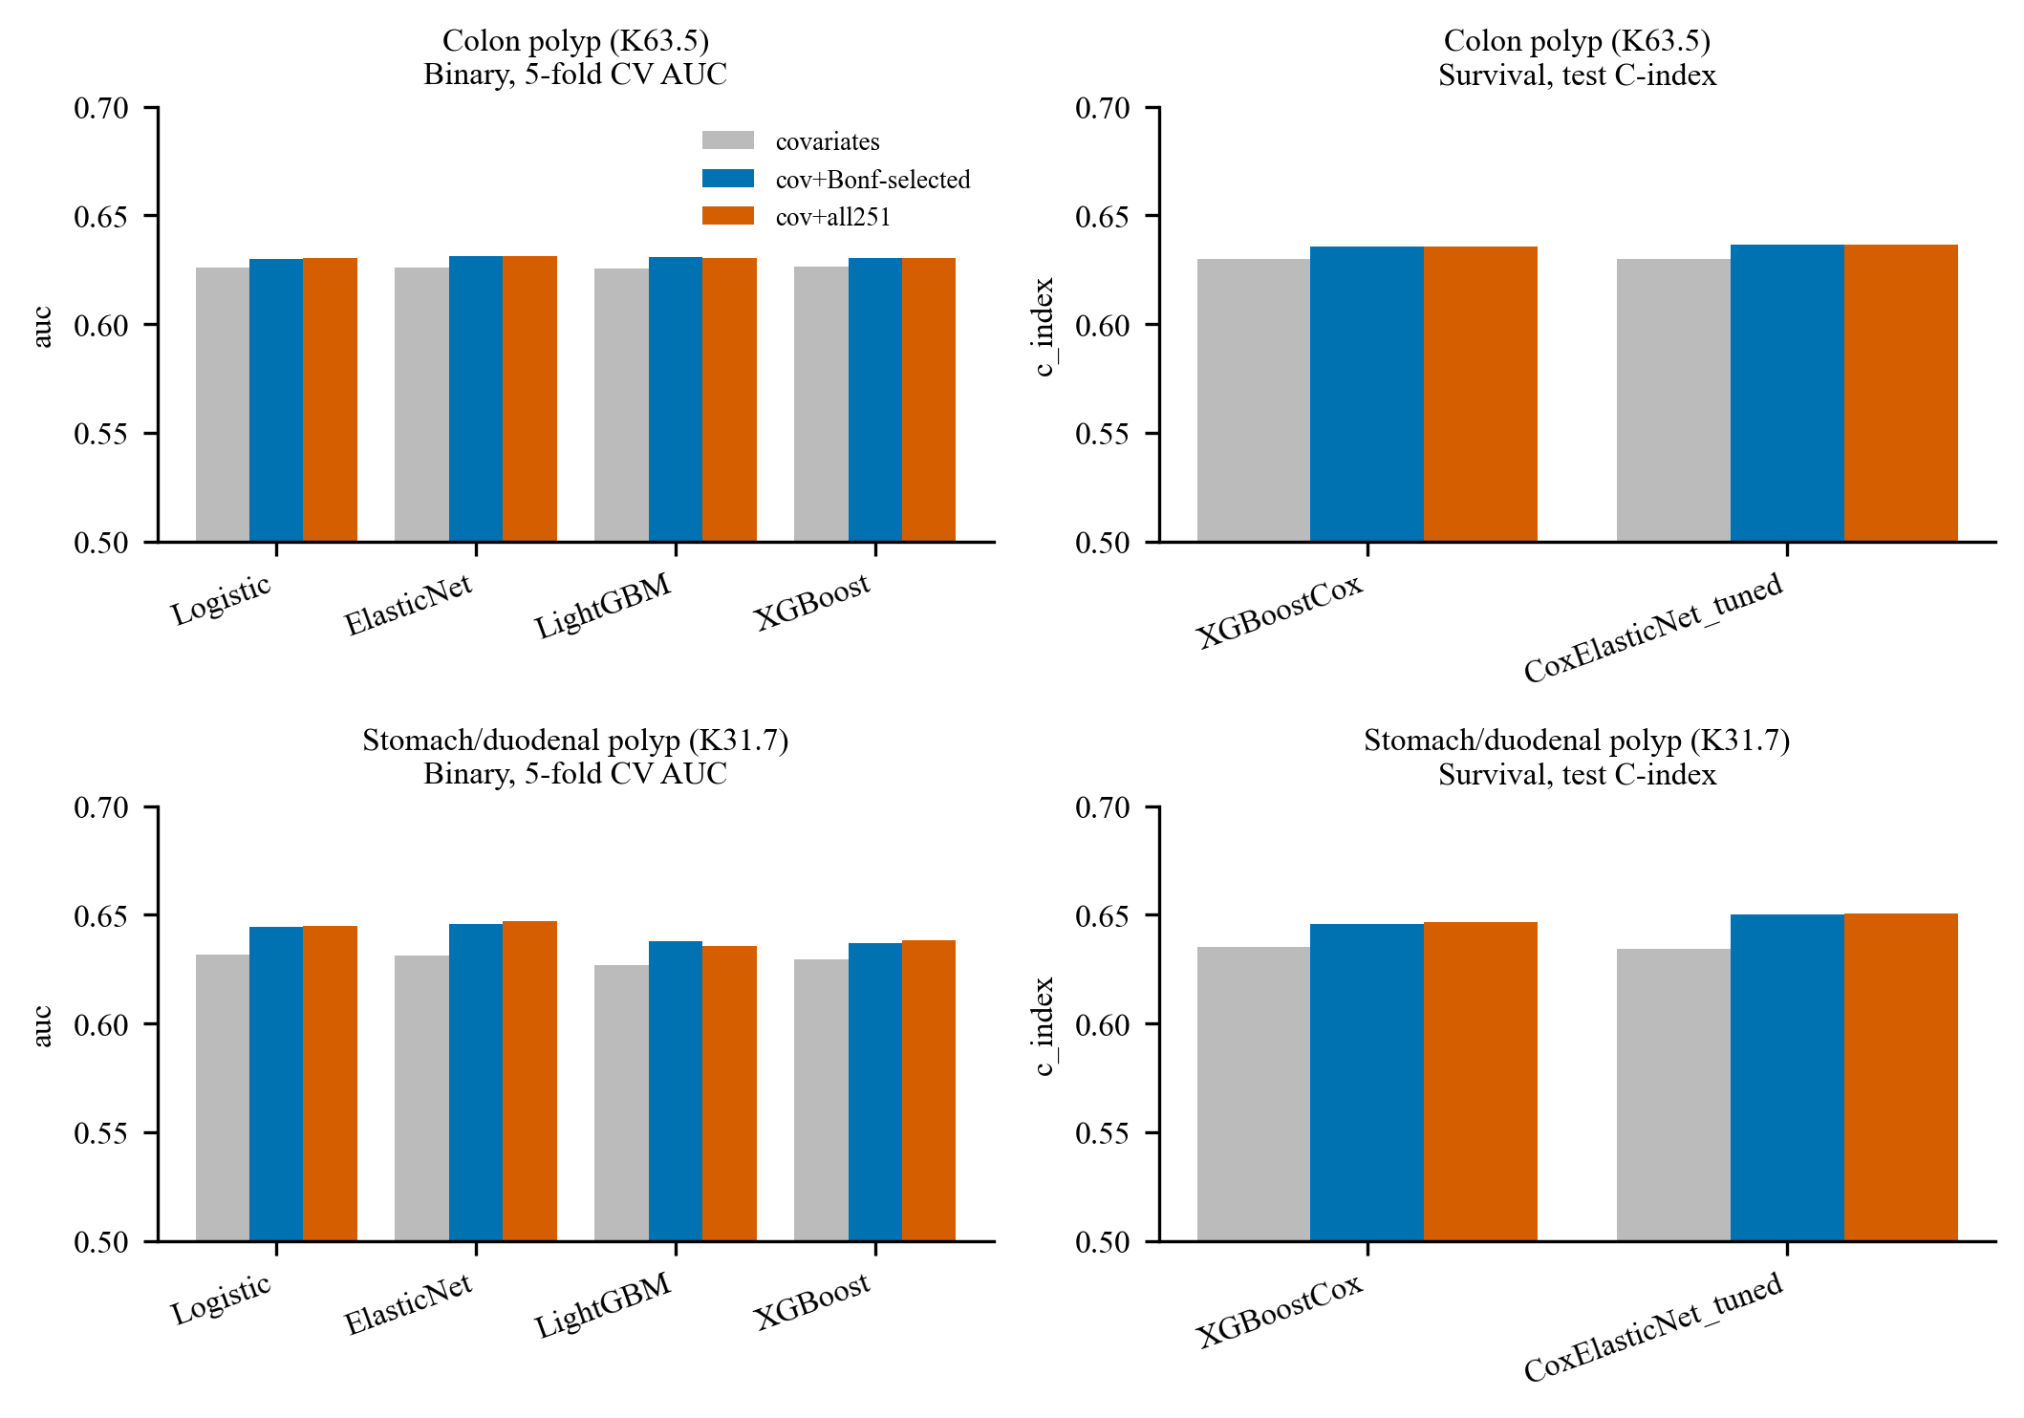
Figure S6. Prediction performance of all models. Area under the curve (binary models, 5-fold cross-validation) and C-index (survival models, test set) by model and feature set.

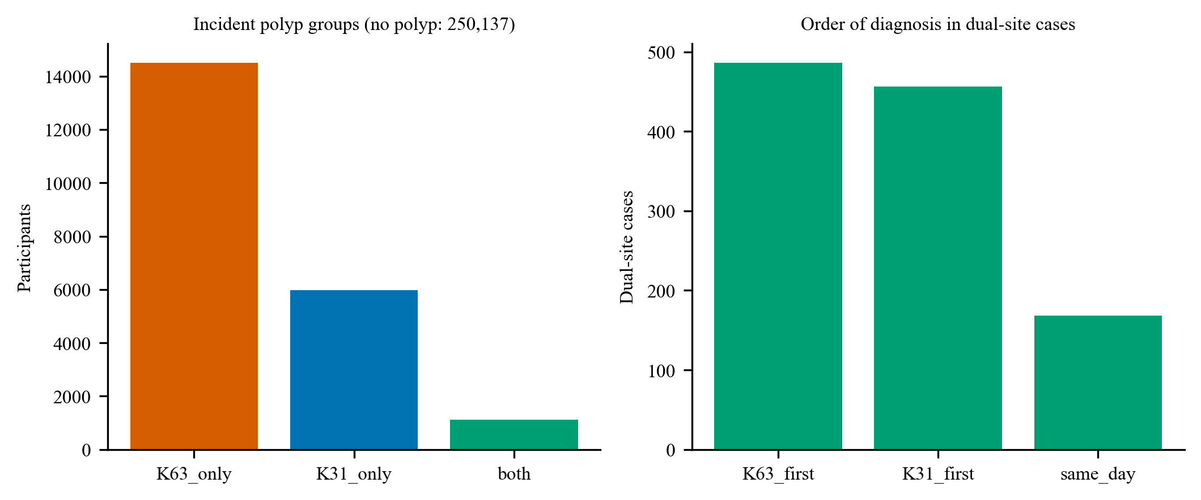
Figure S7. Participants with both polyp types. Left, numbers in the polyp groups; right, order of diagnosis in participants with both polyps.

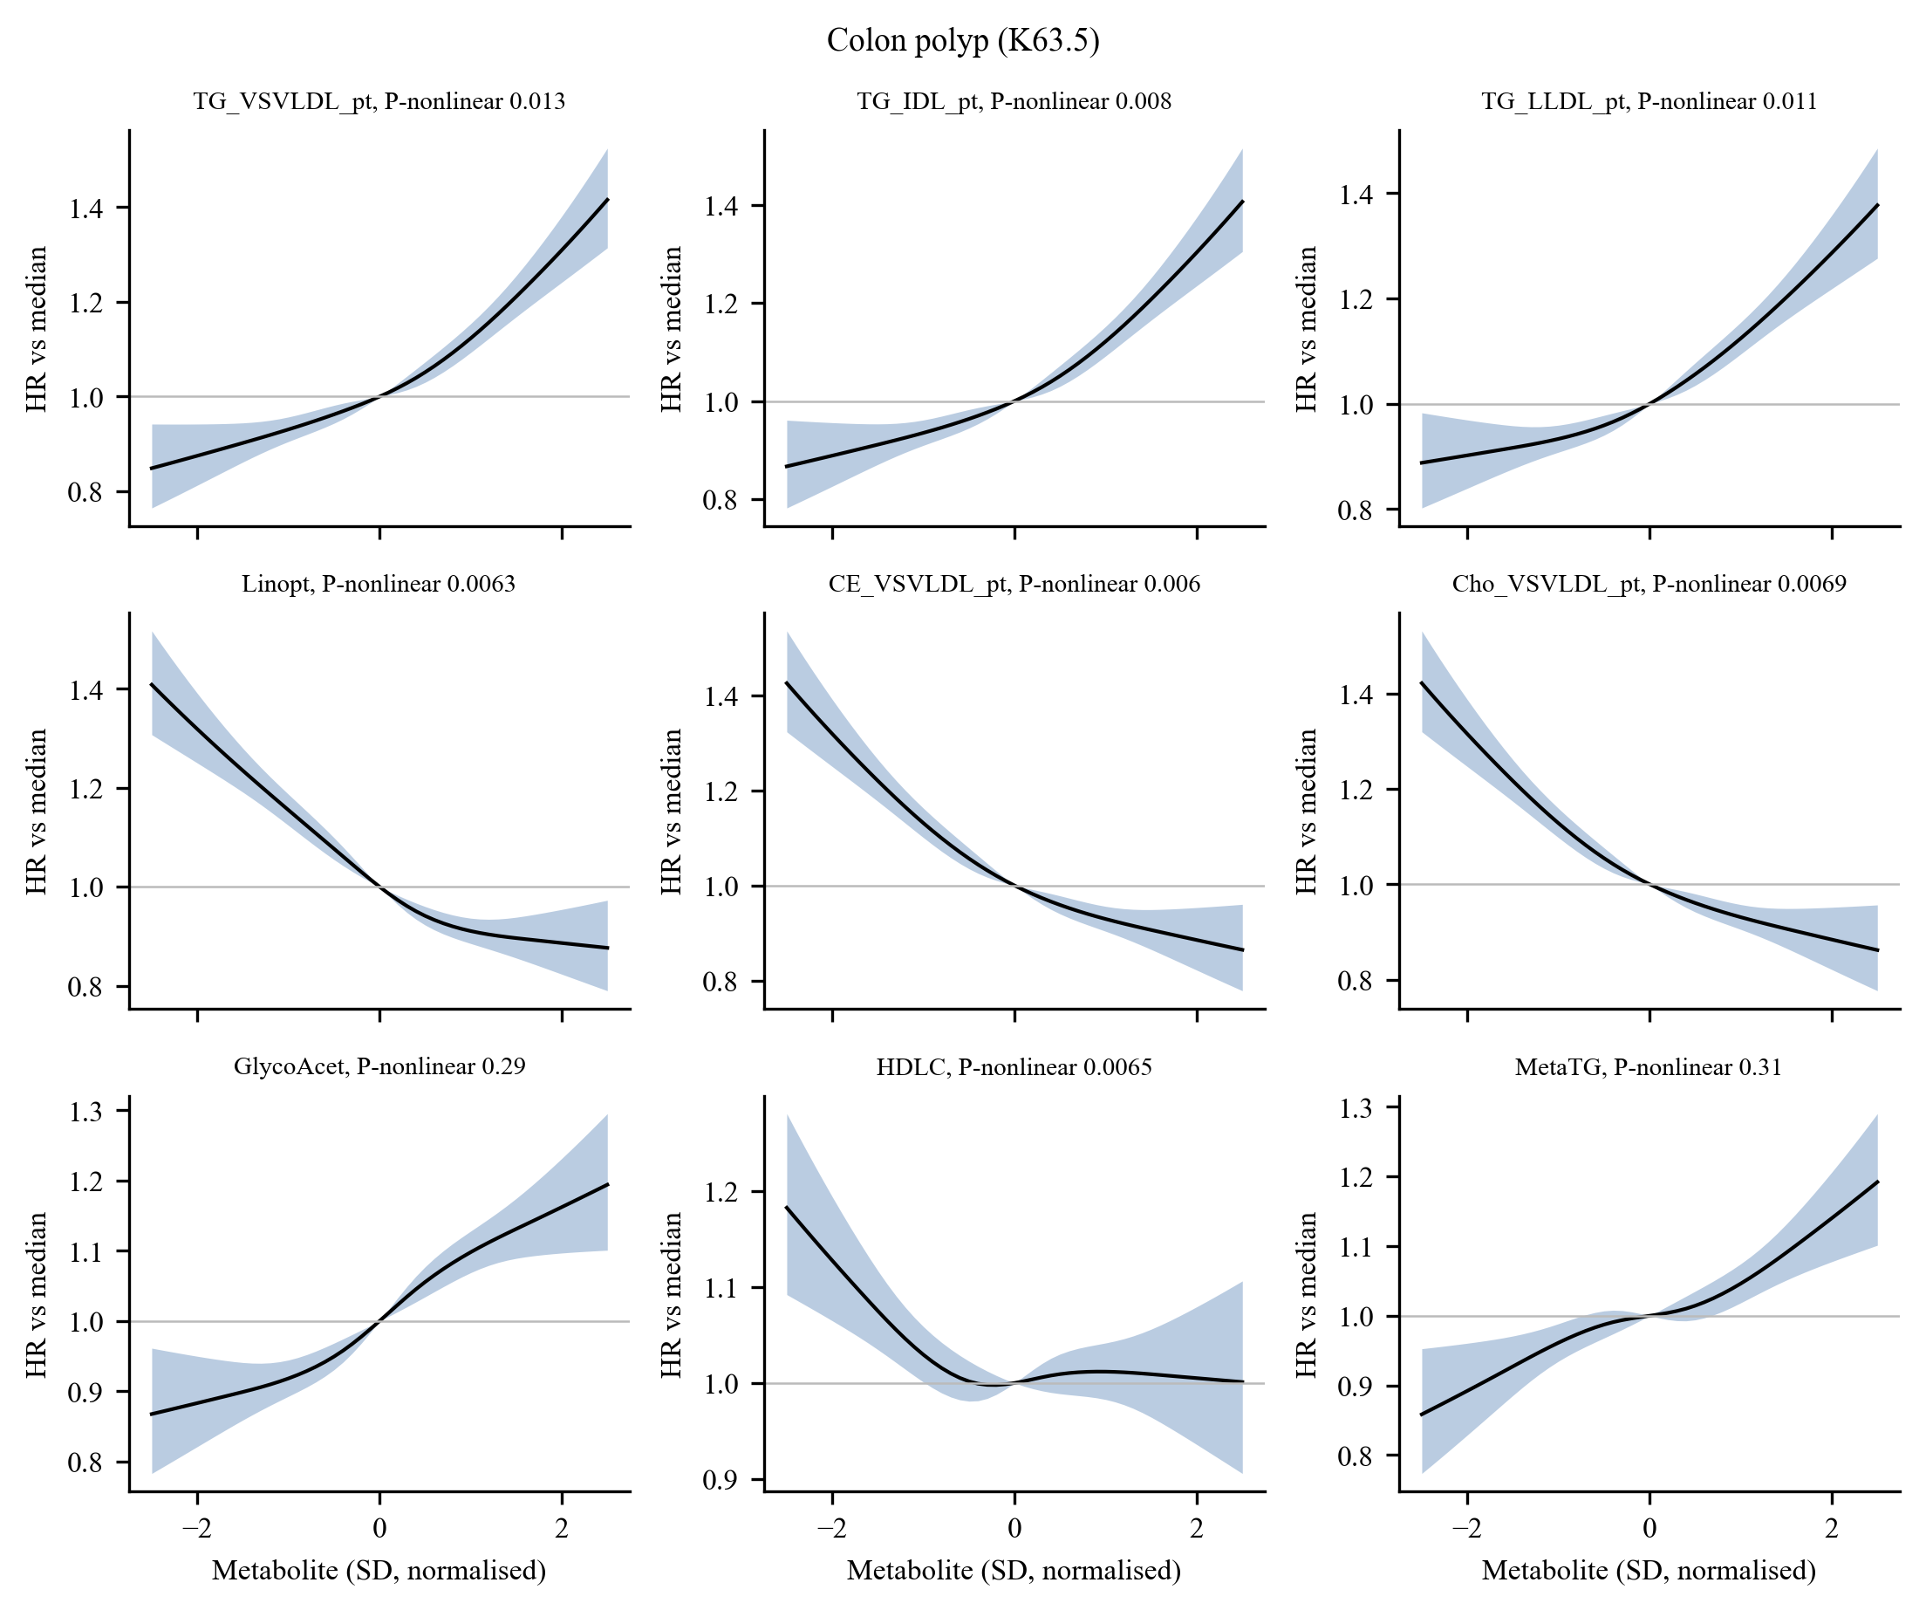
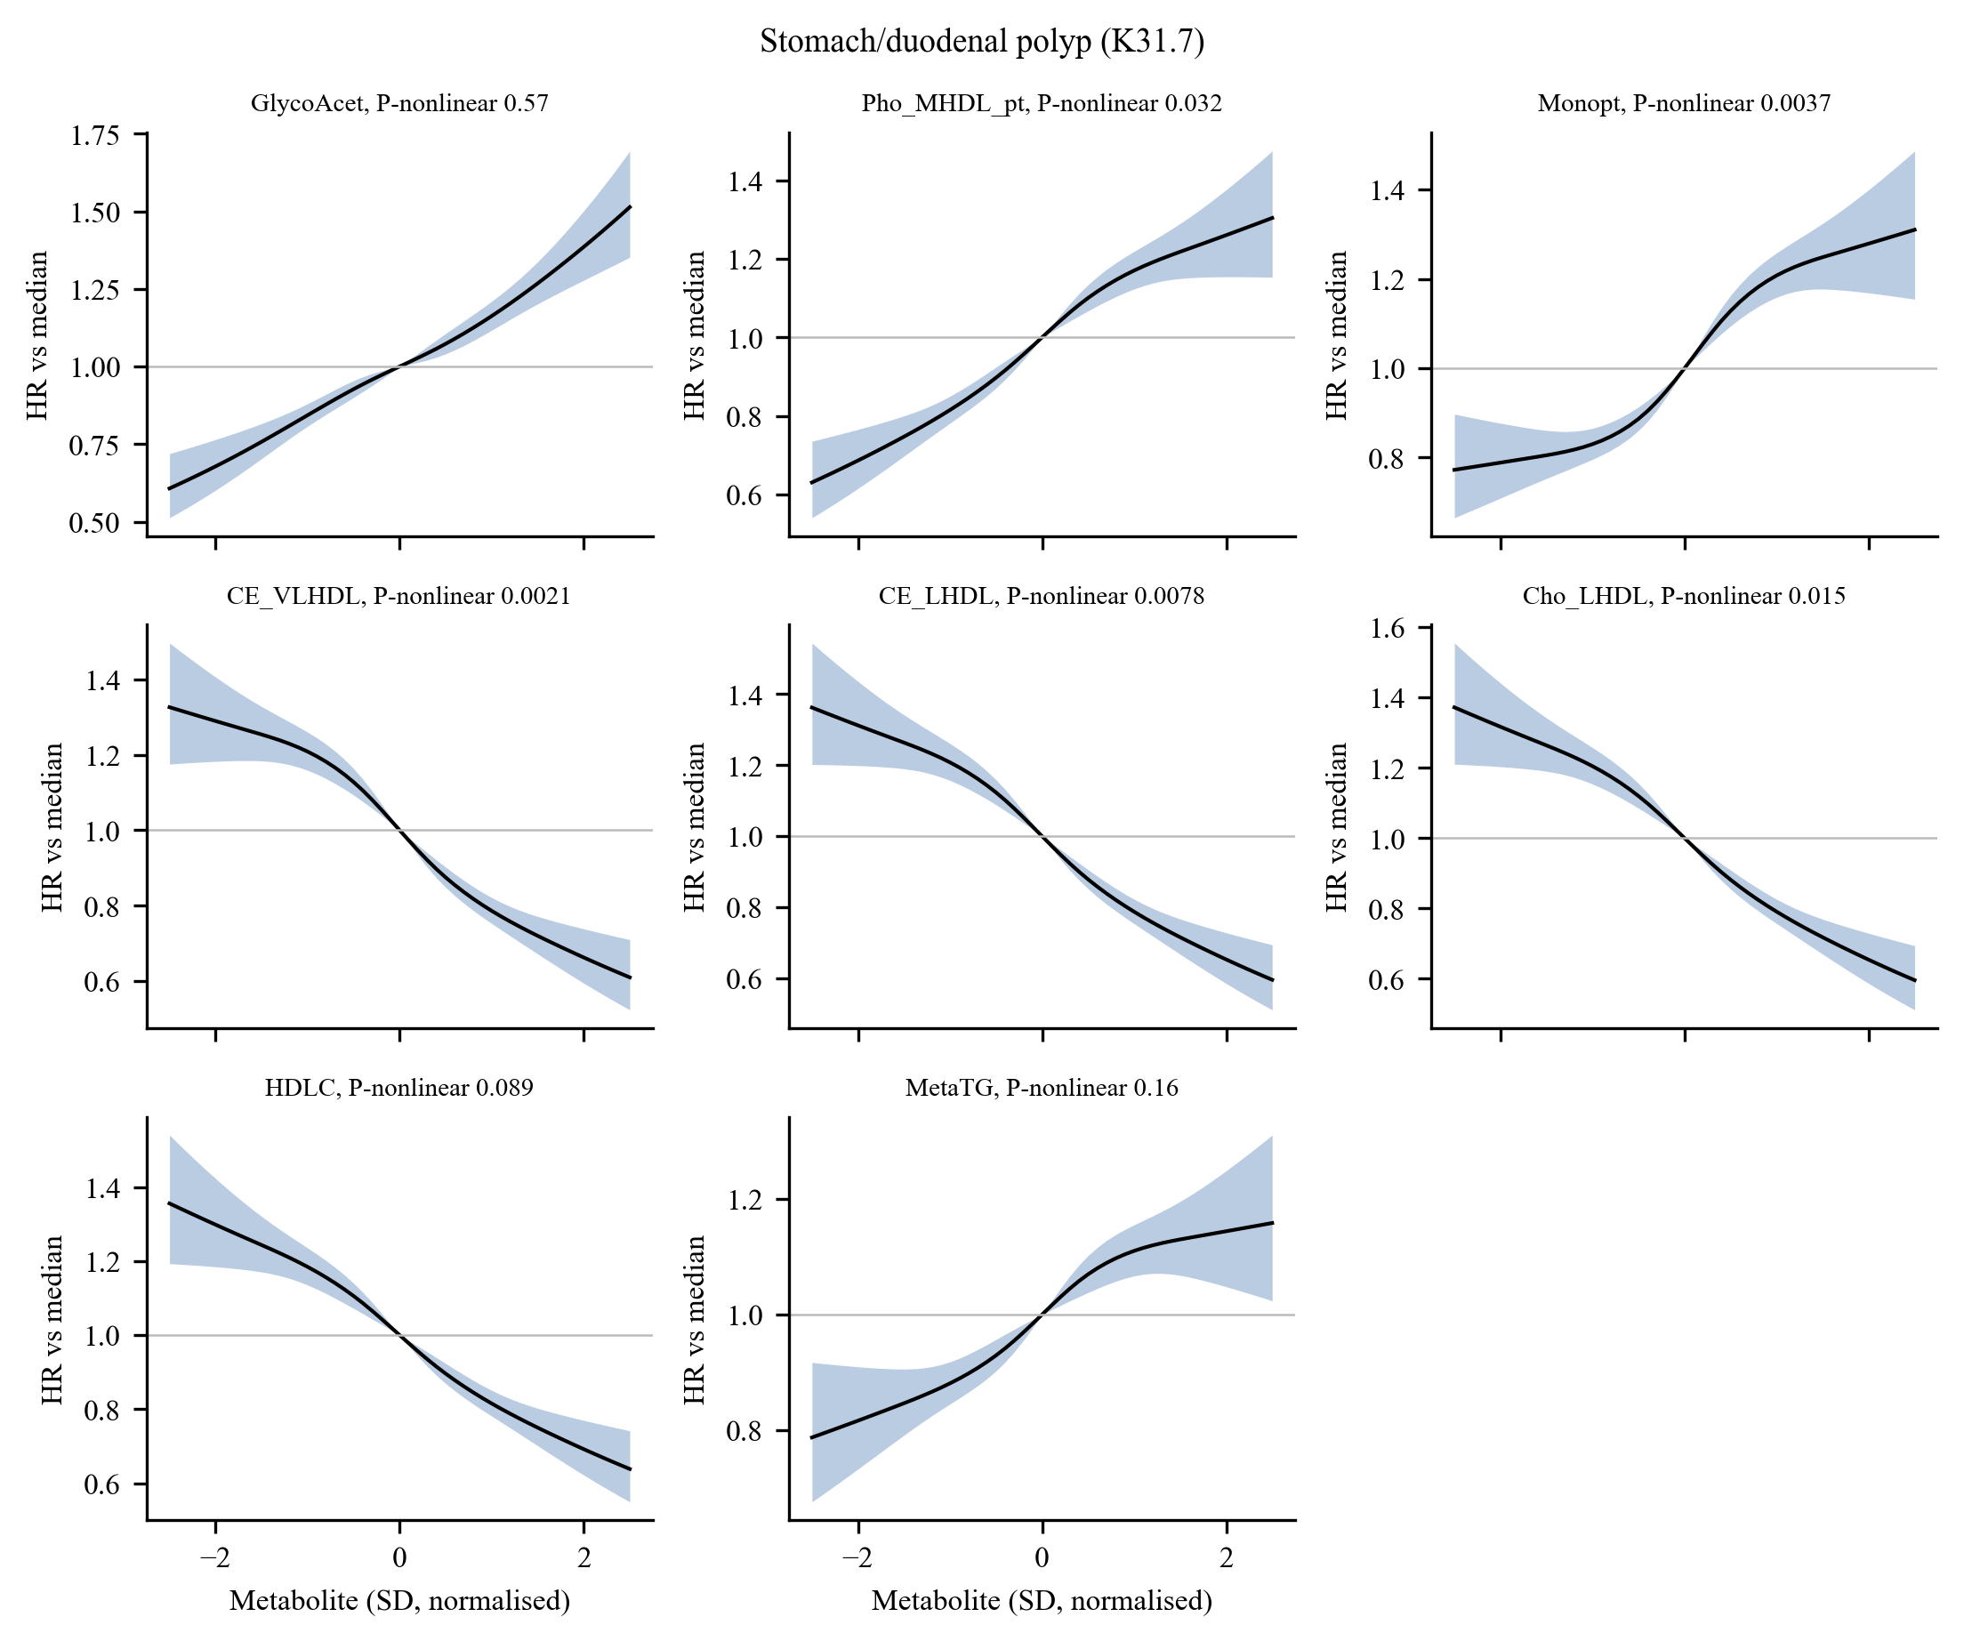
Figure S8. Dose–response curves. Restricted cubic splines (four knots) of selected metabolites for colon polyp and stomach/duodenal polyp; hazard ratio relative to the median (line) with 95% confidence interval (band); the P value for non-linearity is given in each panel title.

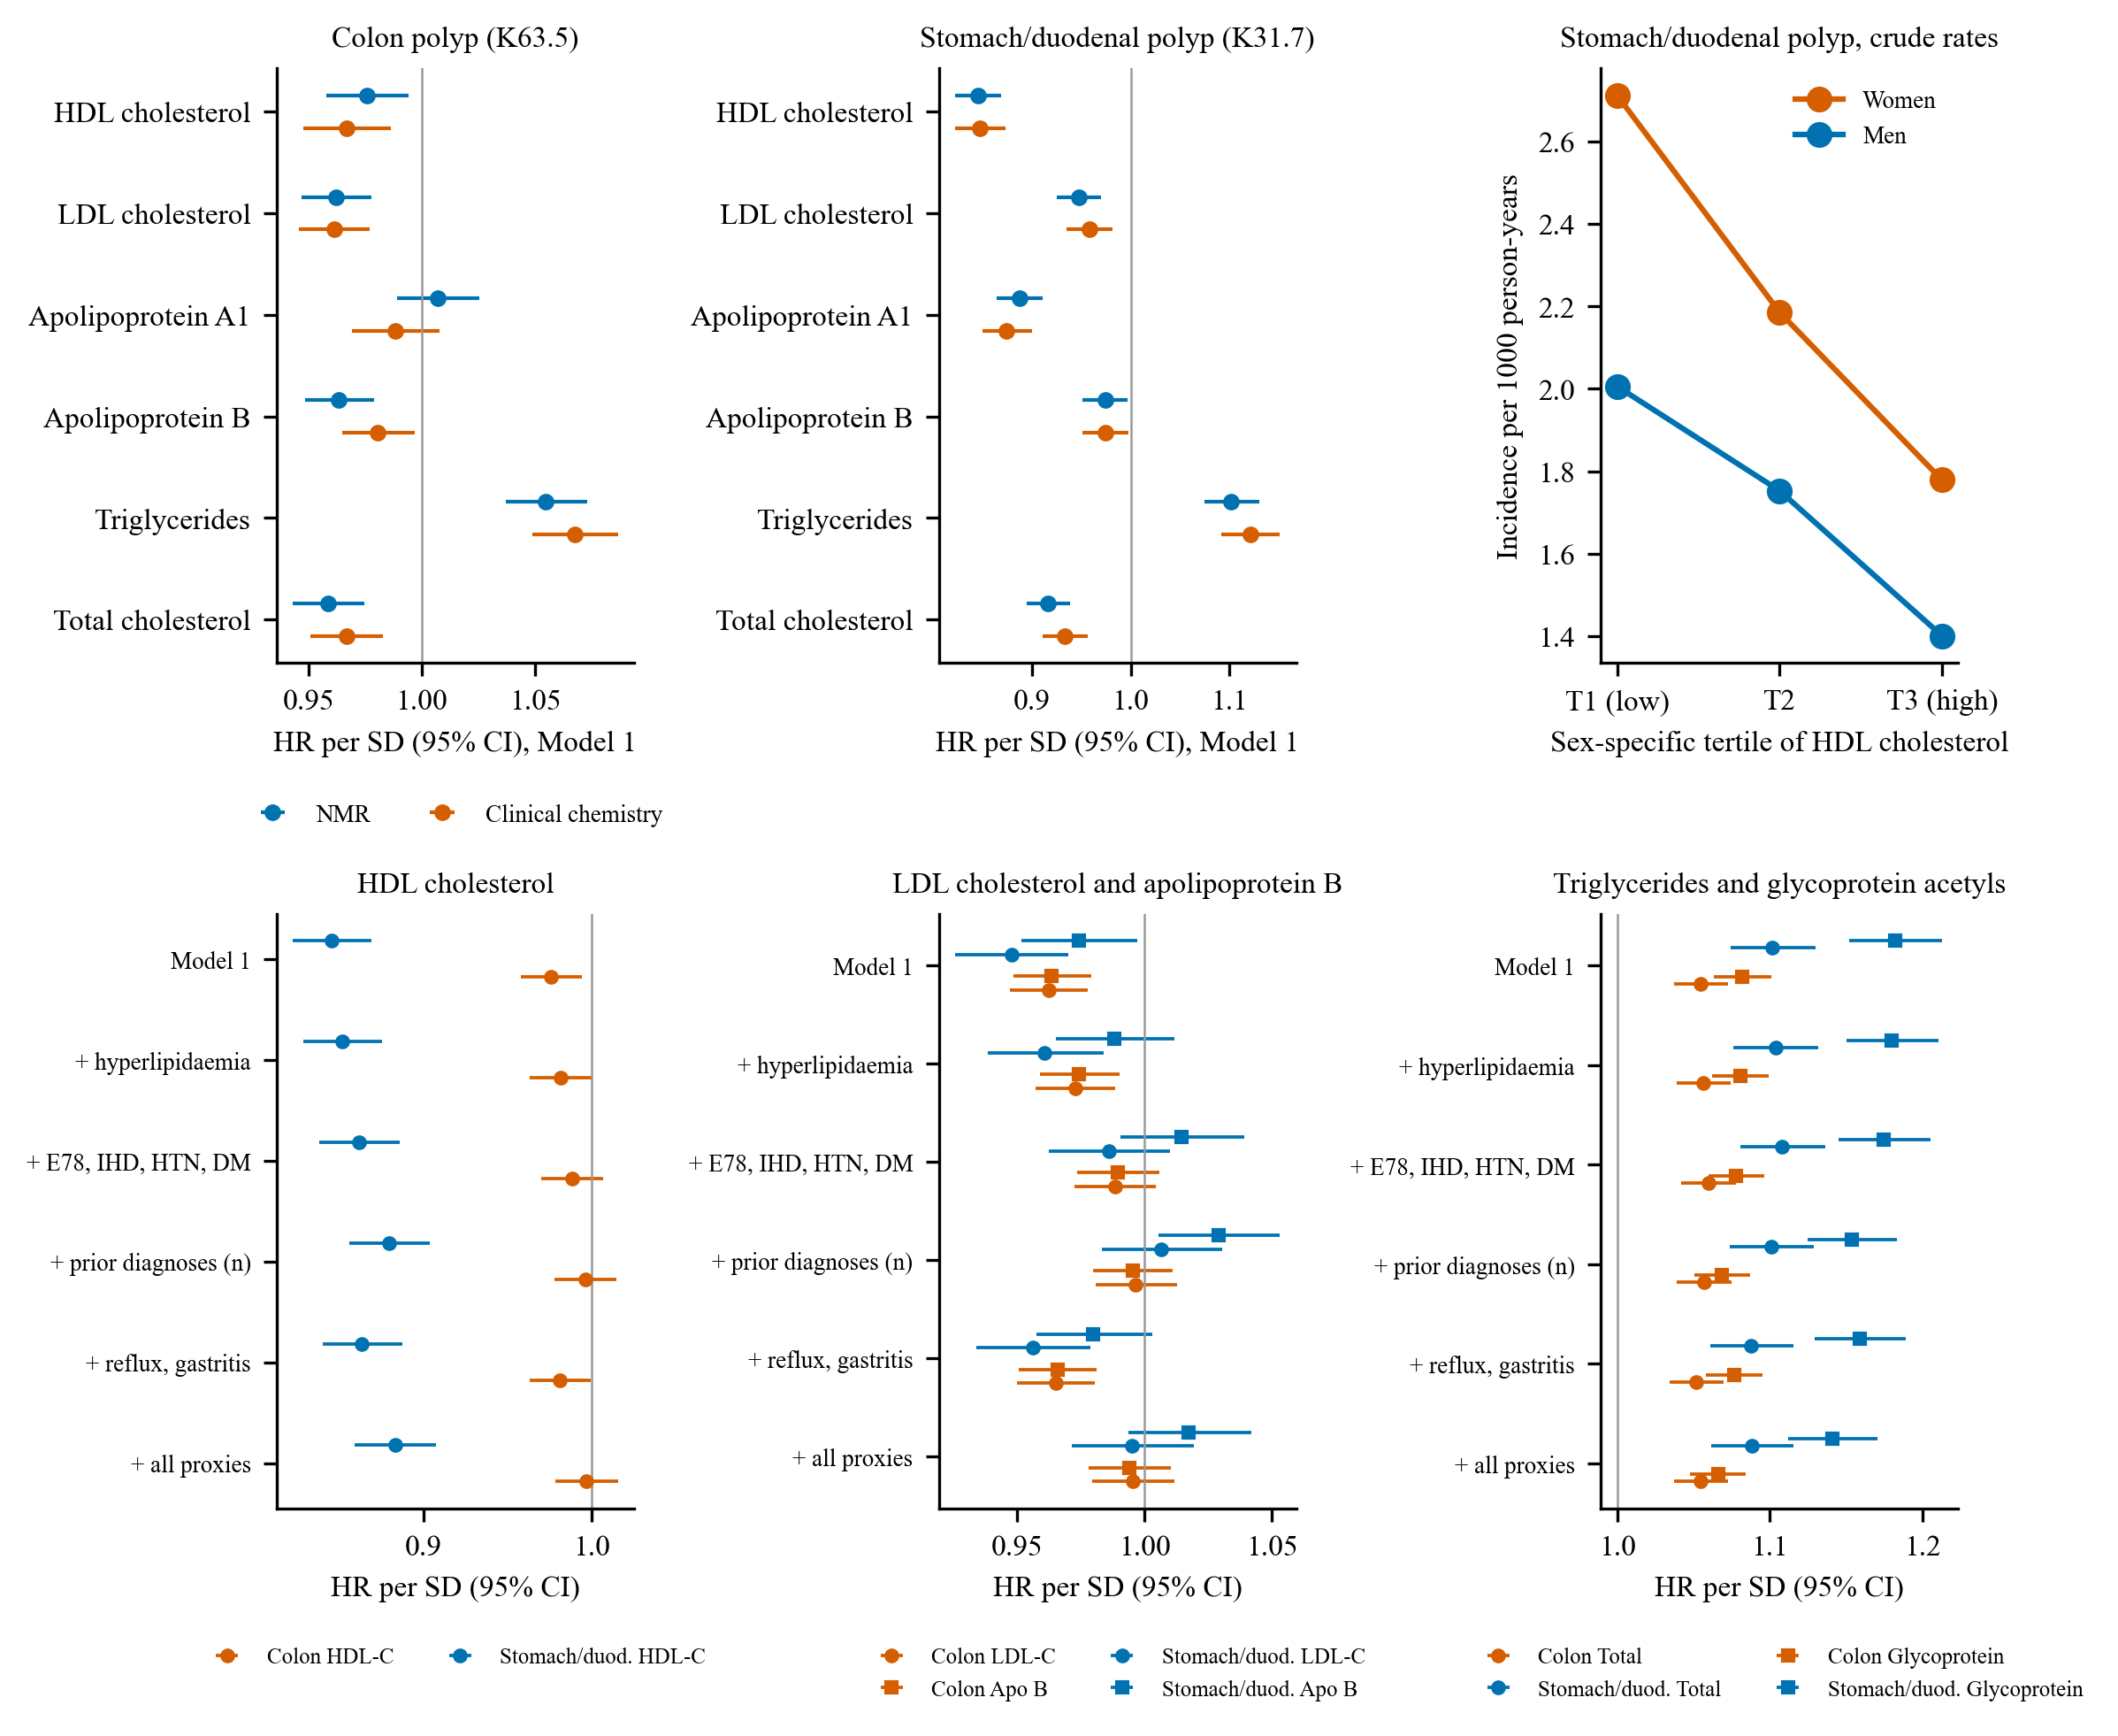
Figure S9. Audit of the lipoprotein results. Top left and middle, hazard ratios per SD for NMR measures and clinical-chemistry assays of the same blood sample; top right, crude incidence of stomach/duodenal polyp by sex-specific tertile of HDL cholesterol; bottom, hazard ratios of HDL cholesterol, LDL cholesterol and apolipoprotein B, and total triglycerides and glycoprotein acetyls, with stepwise adjustment for prior-diagnosis proxies.

