**OBJECTIVE**

* Agriculture is one among the most important sector of Indian Economy. More than 50% of population depends on agriculture as their source of income.
* Growing crops over thousands of years without caring about replenishing has led to depletion and exhaustion of soil nutrients resulting in their low productivity.
* To improve the production, chemical fertilizers were added. But excessive use of these not only makes the plants dependent on artificial fertilizers but also erodes the natural quality of land.
* It is therefore important to make sure that only the sufficient amount of fertilizers is added so that yield can be increased and at the same time, the natural quality of soil remain intact.
* For this, it is essential to know the soil nutrient levels. Our project aims at finding the soil nutrient richness and predict the fertility of a given soil sample in real time.
* Based on the result obtained, the system will also be giving recommendation on the type of fertilizer and in what quantity it is to be used in the soil sample so that the yield can be maximized.

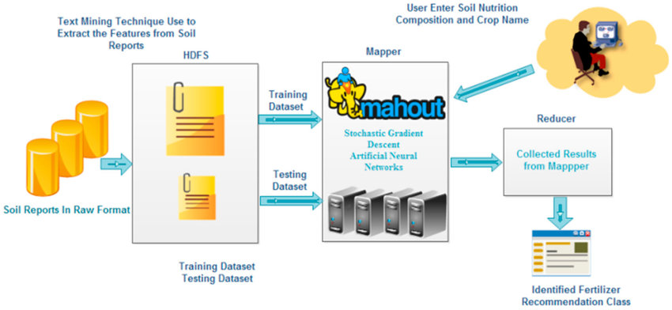s