Traffic Intelligence: Advanced Traffic Volume Estimation Using Machine Learning

Team ID: LTVIP2025TMID41955

Mattam Subhan Bee

223H1A0552

CSE

College: Kandula Lakshuma Memorial College Of Engineering for Women

Objective:

To build a machine learning model that accurately estimates traffic volume based on features like time, weather, temperature, and more — improving traffic management systems using data-driven intelligence.

Traffic congestion is one of the key challenges in smart city development. This project presents a solution using machine learning techniques to predict traffic volume based on historical data. Using visualizations and models, we analyze how external factors such as temperature, weather conditions, and time of day influence traffic. The model helps in forecasting traffic load for better urban planning and transportation control.

Tool and Technologies Used:

- Python, Pandas, Numpy

- Matplotlib, Seaborn

- Scikit-learn, Power BI

- Model: Linear Regression

- Dataset: Simulated Metro Interstate Traffic Volume

- Platform: Jupyter Notebook / Google Colab / Kaggle

Dataset Description:

A traffic dataset typically contains information related to traffic flow, traffic volume, speed, congestion, accidents, and other relevant factors. Here's a general description of what a traffic dataset might include:

Common Variables

1. Traffic Volume: The number of vehicles passing through a specific point or section of road.

2. Speed: The average speed of vehicles on a particular road or segment.

3. Congestion: Measures of traffic congestion, such as traffic density or travel time.

4. Accidents: Information about accidents, including location, time, and severity.

5. Traffic Signals: Data on traffic signal timings, phases, and coordination.

6. Road Characteristics: Information about road geometry, surface conditions, and infrastructure.

7. Weather: Weather conditions that may impact traffic, such as precipitation, temperature, and visibility.

8. Time of Day: Time of day, day of the week, and holidays that may impact traffic patterns.

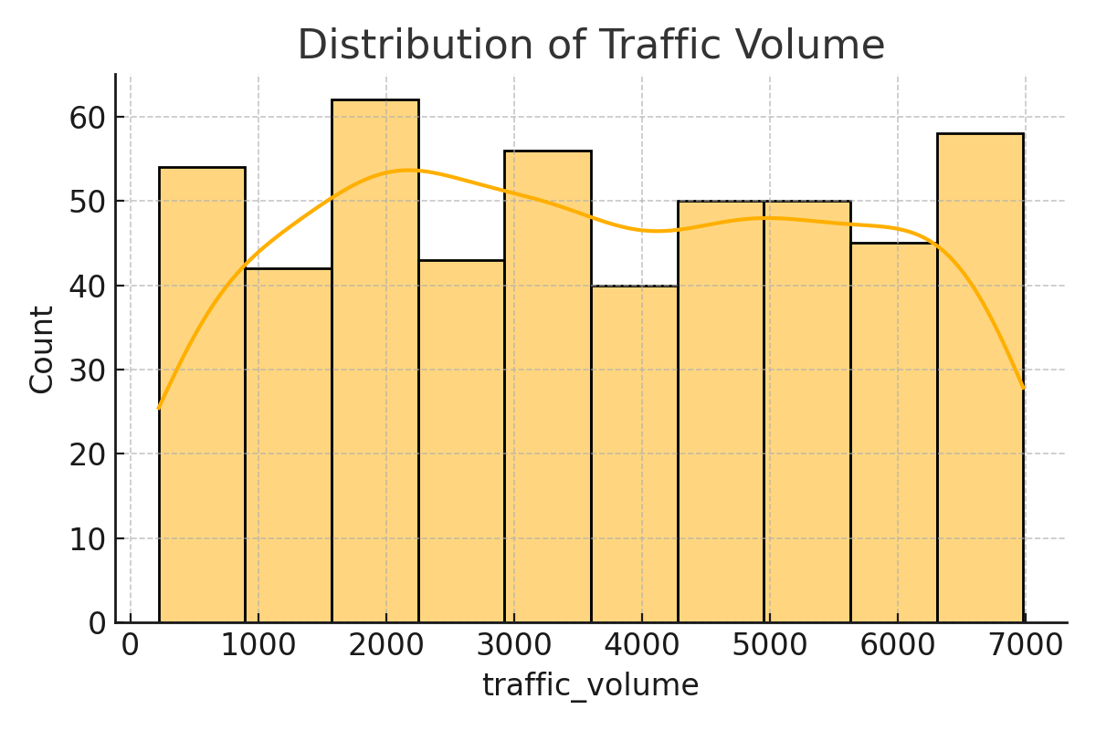

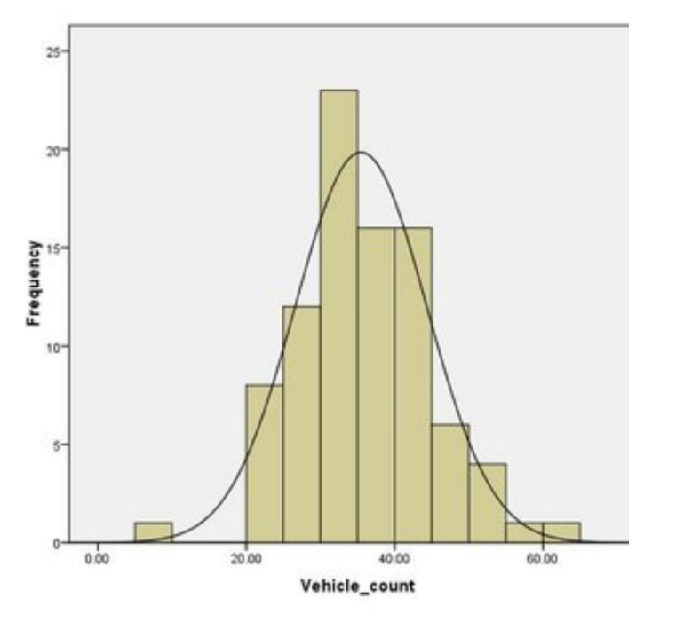WEATHER CONDITIONS: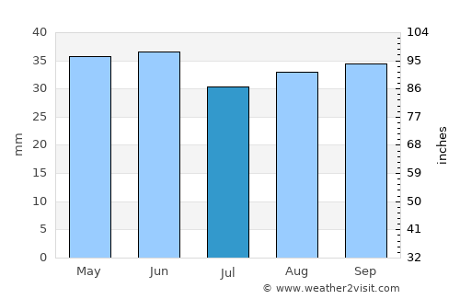

Traffic volume vs temperature

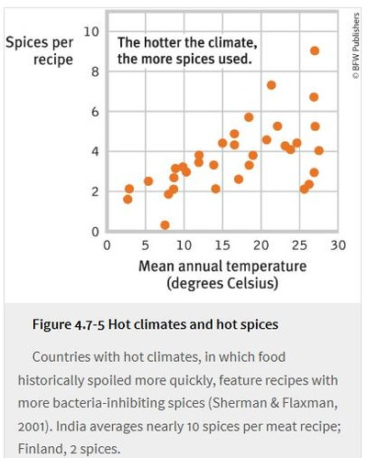

Methodology:

- Collect data

- Clean and preprocess

- Feauture engineering

- Model training

- Evaluation

- Visualisation 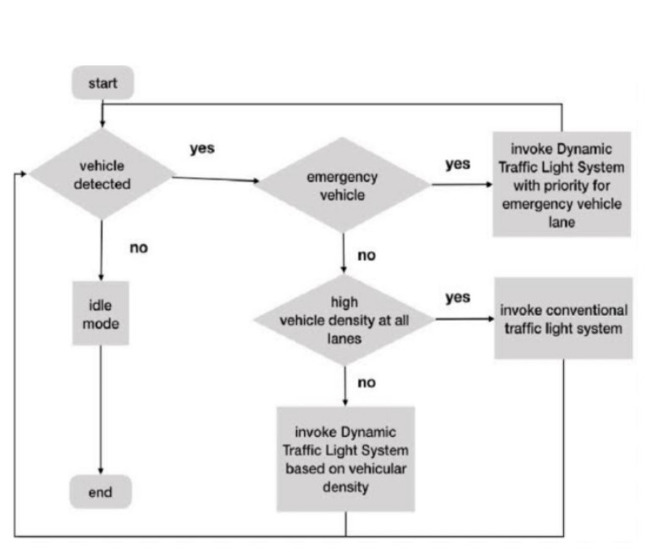

RESULT:

Model Performance (example Value) :

- MAE: 452.23

- MSE: 390820.45

- RMSE: 625.00

The model predicts traffic volume based on weather, time, and temperature

FUTURE ENHANCEMENT:

Future traffic management enhancements will be driven by technologies like AI, IoT, and smart systems, aiming to optimize traffic flow, enhance safety, and improve overall transportation efficiency. These advancements will lead to features like smart traffic lights, real-time data analysis for incident detection and response, and connected/autonomous vehicles.

- Try advanced model like random forest or XGBOOST

- Use real-time sensor data

- Integrate with Google Maps or IOT system

REFERENCES:

- UCI ML Repository (cited as the original source)

- Scikit-learn documentation

- Python official documentation

CONCLUSION:

traffic, whether it refers to the movement of vehicles or the congestion it can cause, is a significant issue with far-reaching consequences.