Day-Wise Steps Logging:-
2-3-26:
flask db migrate -m "Add assistant_training_logs table"
flask db upgrade
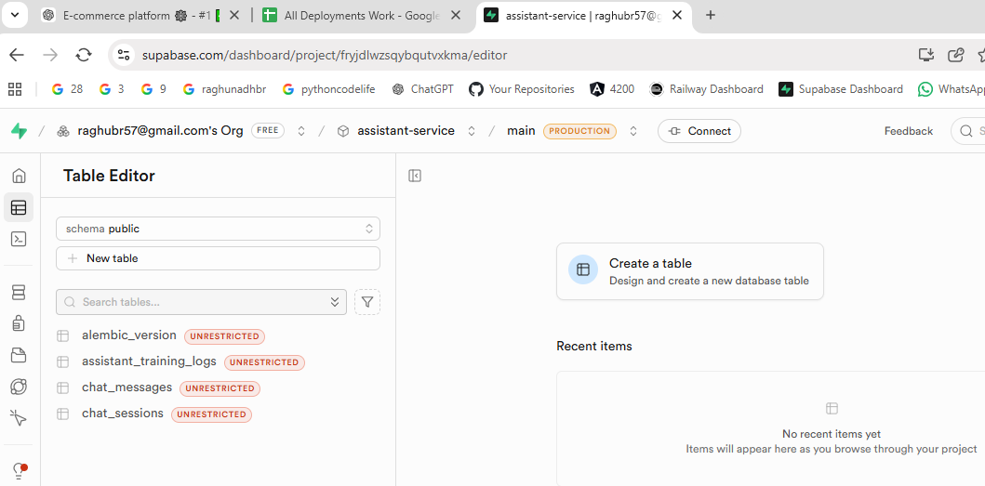

🧠 What This Means Architecturally
Now your system has:
Layer 1: Chat Sessions
Layer 2: Chat Messages
Layer 3: Training Logs (NEW AI layer)
This is the foundation of real AI system.
You are no longer just a rule-based chatbot.
You now have a data engine.

🚀 NEXT STEP (VERY IMPORTANT)
Now we must:
👉 Modify assistant route to log predictions into assistant_training_logs.
This is where AI journey truly begins.

🎯 What We Will Do Next
Inside your assistant route:
After intent detection:
- Save:
  - user_id
  - user_message
  - predicted_intent
  - confidence_score
  - model_version = "rule_based_v1"
- Commit to DB.
Now every chat becomes training data.

🧠 What Just Changed
Now every chat does 3 things:
1️⃣ Saves session
2️⃣ Saves chat messages
3️⃣ Saves AI training log
Your system is now officially:
AI data collection ready.
(venv) PS E:\ecommerce-platform\assistant-service>
(venv) PS E:\ecommerce-platform\assistant-service> git branch
* main
(venv) PS E:\ecommerce-platform\assistant-service>
(venv) PS E:\ecommerce-platform\assistant-service>
(venv) PS E:\ecommerce-platform\assistant-service> git status
On branch main
Changes not staged for commit:
(use "git add <file>..." to update what will be committed)
(use "git restore <file>..." to discard changes in working directory)

Untracked files:
(use "git add <file>..." to include in what will be committed)
app/models/assistant_training_log.py
docs/Model-Development/
migrations/versions/bf3bb287b2d1_add_assistant_training_logs_table.py

no changes added to commit (use "git add" and/or "git commit -a")
(venv) PS E:\ecommerce-platform\assistant-service>
(venv) PS E:\ecommerce-platform\assistant-service>
(venv) PS E:\ecommerce-platform\assistant-service>

