创建maven项目

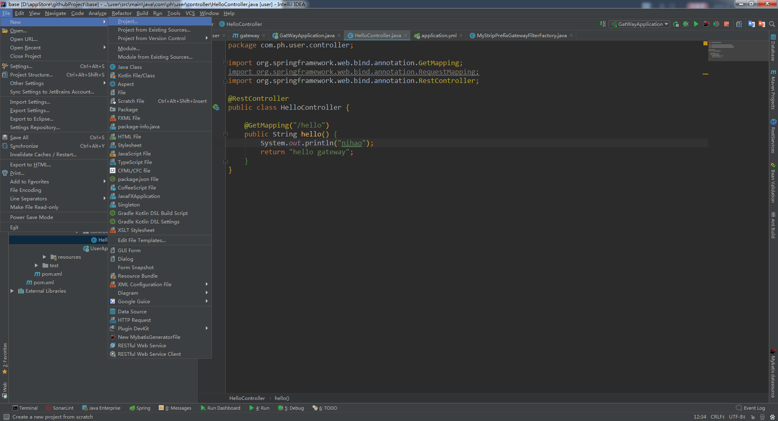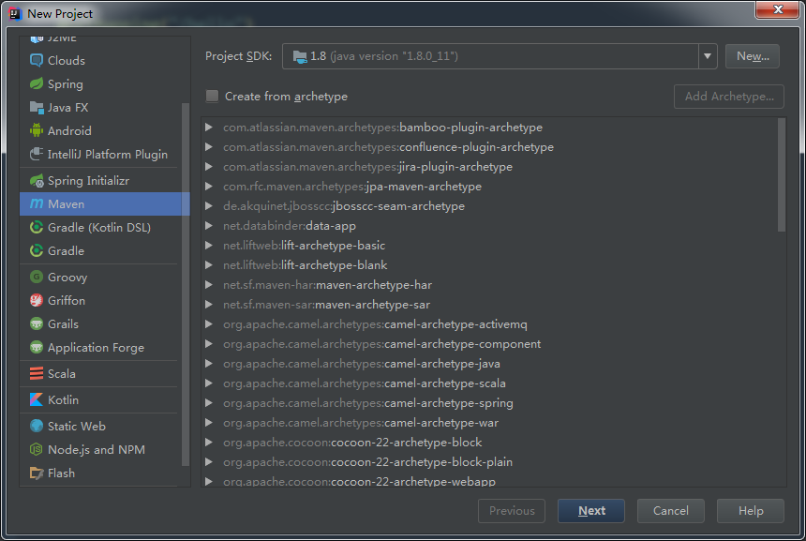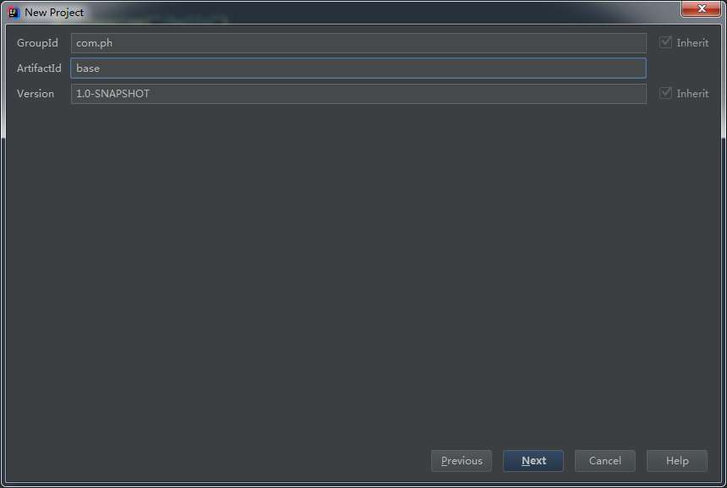

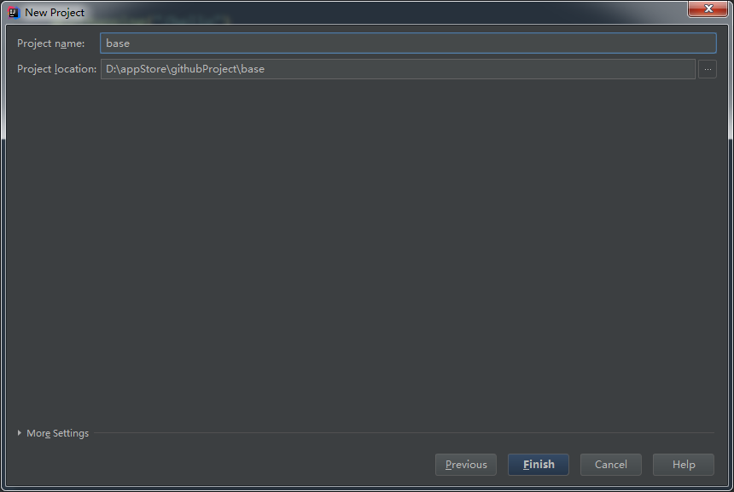

删除项目src目录

配置pom.xml

*<*parent*>  
 <*groupId*>*org.springframework.boot*</*groupId*>  
 <*artifactId*>*spring-boot-starter-parent*</*artifactId*>  
 <*version*>*2.1.7.RELEASE*</*version*>  
 <*relativePath */>  
</*parent*>  
  
<*dependencyManagement*>  
 <*dependencies*>  
 <*dependency*>  
 <*groupId*>*org.springframework.cloud*</*groupId*>  
 <*artifactId*>*spring-cloud-dependencies*</*artifactId*>  
 <*version*>*Greenwich.SR2*</*version*>  
 <*type*>*pom*</*type*>  
 <*scope*>*import*</*scope*>  
 </*dependency*>  
 </*dependencies*>  
</*dependencyManagement*>*

创建模块

