卸载旧版本

$ sudo yum remove docker \

docker-client \

docker-client-latest \

docker-common \

docker-latest \

docker-latest-logrotate \

docker-logrotate \

docker-engine

安装所需的软件包。yum utils提供yum config manager实用程序，device mapper存储驱动程序需要设备映射器持久数据和lvm2。

$ sudo yum install -y yum-utils \

device-mapper-persistent-data \

lvm2

使用以下命令设置稳定存储库。

$ sudo yum-config-manager \

--add-repo \

https://download.docker.com/linux/centos/docker-ce.repo

安装docker

sudo yum install docker-ce

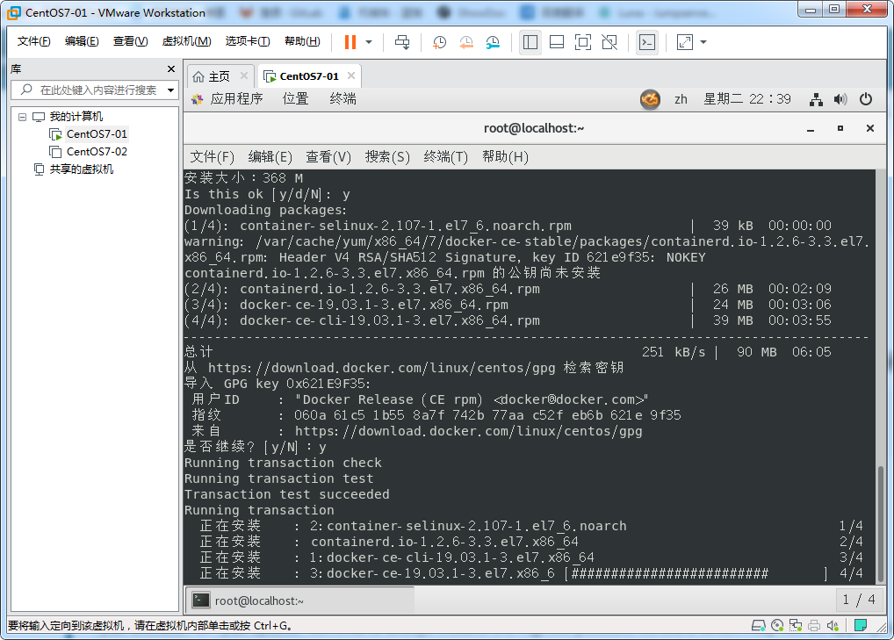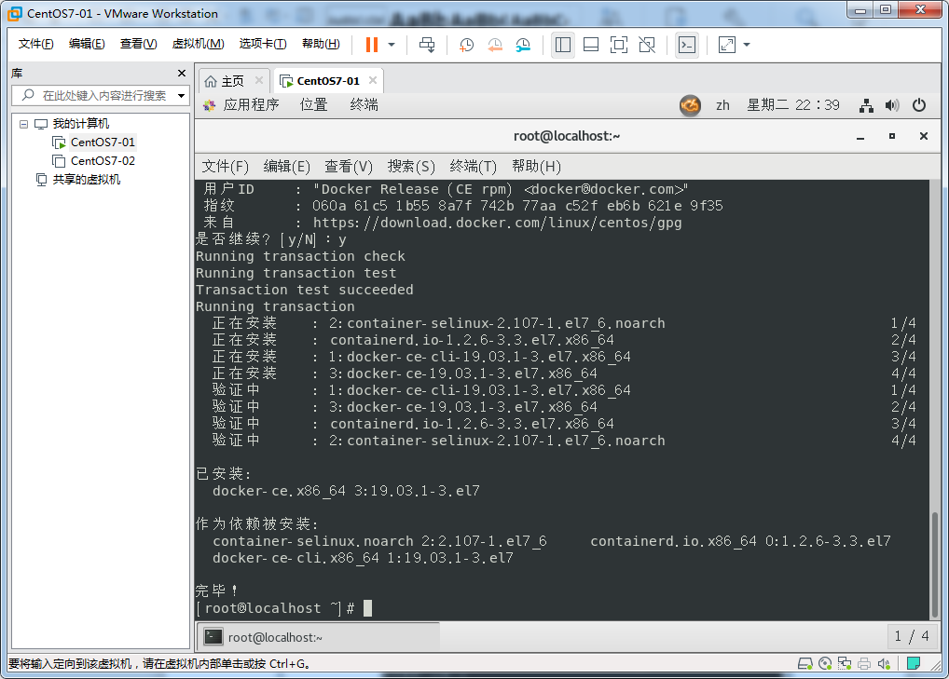

启动服务

systemctl daemon-reload

systemctl restart docker.service

docker info 测试启动否

docker images

配置阿里加速器

<https://cr.console.aliyun.com/cn-hangzhou/instances/mirrors>

sudo mkdir -p /etc/docker

sudo tee /etc/docker/daemon.json <<-'EOF' { "registry-mirrors": ["https://qakitzf8.mirror.aliyuncs.com"] } EOF

sudo systemctl daemon-reload

sudo systemctl restart docker