SENTIMENT ANALYSIS USING DEEP LEARNING

BY : ANAND KUMAR SINGH
Email- 93anandsingh2011@gmail.com

Introduction to the Project:
The course-end project analyzes sentiments expressed in over 34,000 reviews for Amazon brand products within the e-commerce domain. The dataset contains attributes such as brand, categories, review titles, review text, and sentiment levels categorized into "Positive," "Negative," and "Neutral." The project aims to predict sentiment or satisfaction levels based on various features and review text.
Objectives of the Project:
- Understand the sentiment expressed in consumer reviews.
- Address class imbalance in sentiment categories.
- Implement classifiers and advanced techniques for sentiment analysis.
- Evaluate model performance using appropriate metrics.
- Compare traditional machine learning algorithms with neural network approaches.
- Explore topic modeling techniques for clustering similar reviews.
DATA EXPLORATION

I explored the training and testing datasets by examining their shapes, data types, descriptive statistics, missing values, and distributions of key features, including the 'topic' column (which in this case seems to be 'reviews.text'). I also analyzed the target variable 'sentiment' in the training data. I computed text statistics for the reviews and look for potential imbalances between train and test datasets.

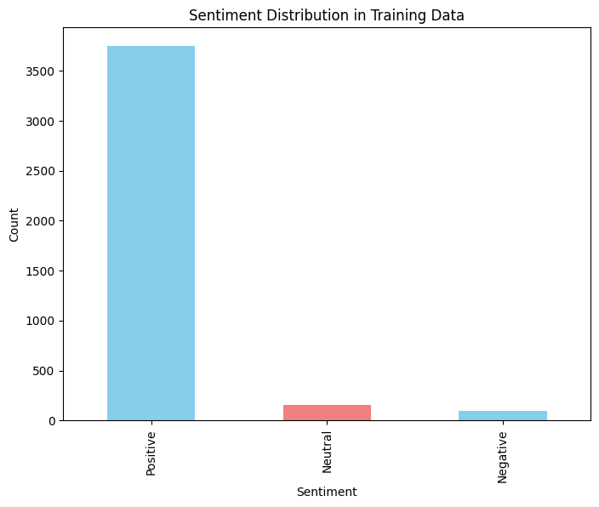
FEATURE ENGINEERING

In this I combined both training and testing data and analyzed the engineered features (TF-IDF features) in df_train_final and explored their relationships with the target variable ('sentiment').
Then calculated the correlation between TF-IDF features and the 'sentiment' column, identify the top features, and visualize their relationship with sentiment.

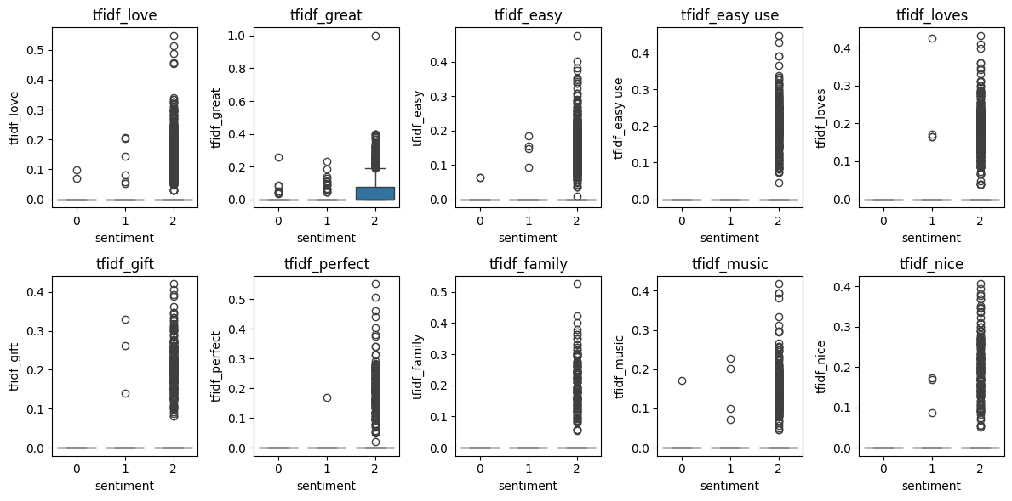

MODEL EVALUATION
Trained a Multinomial Naive Bayes classifier using the prepared training data.
Evaluated the performance of the trained Multinomial Naive Bayes model (mnb_model) on the test data (df_test_final). And we can see the findings from this Confusion Matrix.

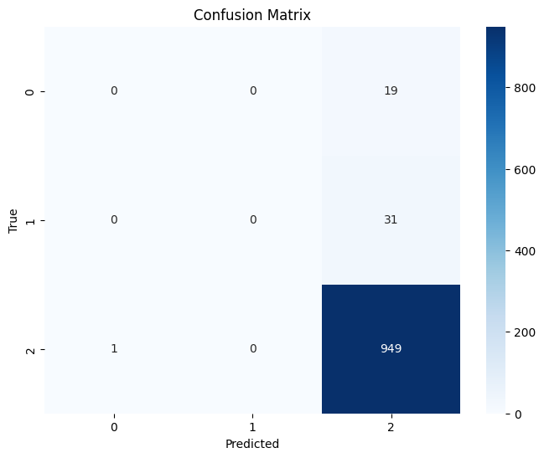

MODEL TRAINING AND EVALUATION

Trained with a Multi-class Support Vector Machine (SVM) classifier on the training data (df_train_final). Evaluated the performance of the trained SVM model on the test data. This involves preparing the test data, making predictions, and calculating evaluation metrics. Which shows the following findings as :
Accuracy: 0.947
Precision: 0.9326450376454484
Recall: 0.947
F1-score: 0.9380773405079288
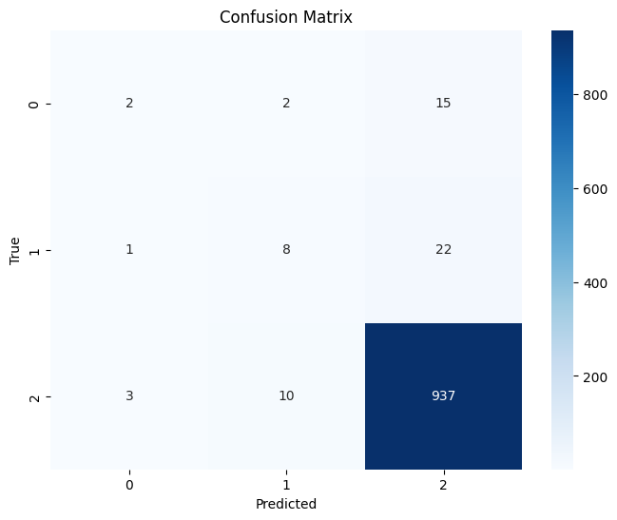
Amazon product review sentiment analysis project has provided valuable insights into customer opinions and feedback. By leveraging a Multi-class Support Vector Machine classifier, we achieved a strong accuracy of 94.7%, demonstrating the model's effectiveness in classifying sentiments with precision and reliability.
These findings emphasize the importance of machine learning in understanding consumer sentiments, helping businesses improve their products and services based on customer experiences. From identifying trends in product satisfaction to detecting areas of improvement, sentiment analysis plays a crucial role in enhancing user engagement and brand reputation.
Thank you for your time and interest in this project

