Chapter Two

Theoretical Framework and Literature Review

**2.1 Literature Review**

**2.2 Theoretical Framework**

**2.3 Research Hypothesis**

Name: Ahmed Mohamed Ramadan Khedr

ID#: 20113798

Chapter Two

Theoretical Framework and Literature Review

Literature Review

This section investigates the start and spread of the coronavirus disease (COVID-19) and how the health systems across the world have reacted to the pandemic, in terms of hospital capacity. This section will also investigate how the Kingdom of Bahrain’s health system has been able to prepare and respond to the pandemic.

Background of Coronavirus Disease (COVID-19)

Coronaviruses are a strain of Ribonucleic Acid (RNA) viruses that affect humans and several other species causing life-threatening diseases which include respiratory diseases (Weiss & Leibowitz, 2011). The seventh, and latest, member of the family of coronaviruses appeared in 2019 and hence was referred to as 2019-nCov (Zhu, et al., 2020) or COVID-19.

COVID-19 has several similarities to its siblings, namely the severe acute respiratory syndrome coronavirus (SARS-CoV) with almost 79% shared sequence identity (Zhou, et al., 2020) and the diseases, COVID-19 itself, was caused by the severe acute respiratory syndrome coronavirus 2 (SARS-CoV-2) (Shereen, Khan, Kazmi, Bashir, & Siddique, 2020). COVID-19 also has similarities with the Middle East respiratory syndrome coronavirus (MERS-CoV) which along with SARS-CoV had a severe impact on the respiratory system in humans, causing severe pneumonia infection – an infection in air sacs the lungs (Zhu, et al., 2020).

Beginning and Spread of Coronavirus Disease (COVID-19)

COVID-19 was first identified in a cluster of patients with a severe pneumonia infection in Wuhan, China (World Health Organization, 2020) and has quickly spread throughout China and the rest of the world.

By March 2020, approximately 4 months since it’s discovery, the World Health Organization (WHO) announced and classified COVID-19 as a global pandemic with an outbreak of infections in over 110 countries and more than 118,000 cases (WHO Director-General, 2020).

By the end of March 2020, according to 71st Situation Report published by the WHO, there were over 750,000 cases of COVID-19 worldwide and the outbreak has reached the Americas, Europe, Africa, and the Middle East (World Health Organization, 2020).

The maps in **Figure1** and **Figure 2**, extracted from the WHO situation reports, illustrate how the outbreak drastically spread in 25 days.

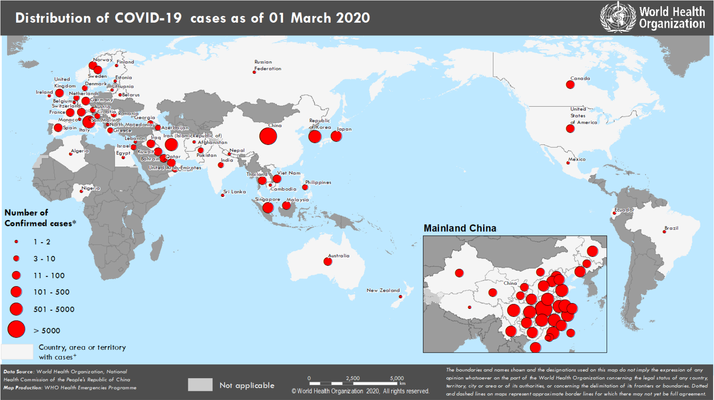

**Figure 1**: Distribution of COVID-19 cases as of 01-March-2020 (World Health Organization, 2020)

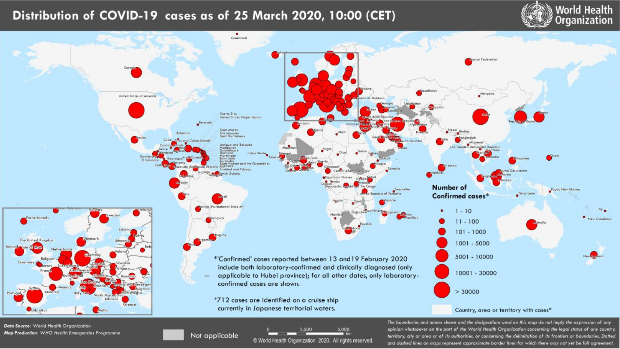

**Figure 2**: Distribution of COVID-19 cases as of 25-March-2020 (World Health Organization, 2020)

COVID-19 in the GCC and the Kingdom of Bahrain

The first cases of COVID-19 in the Gulf Cooperation Council (GCC) countries were reported in the United Arab Emirates (UAE) around January 2020. Shortly after that, in February 2020, COVID-19 cases were reported in neighbouring GCC countries including Kuwait, Oman, and the Kingdom of Bahrain. The first case in Saudi Arabia was reported in March 2020, these cases were suspected to have contracted the infection from local citizens that have visited Iran. (Alandijanya, Faizoa, & Azhar, 2020)

While the first case in the Kingdom of Bahrain was reported in February, due to citizens returning from Iran, as of the 18th of May 2020 Bahrain reported approximately 4,200 active cases (Alandijanya, Faizoa, & Azhar, 2020). It was clear that the viral infections were local transmitted, by people getting in contact with previously infected individuals or local gatherings (Naar, 2020) (Abueish, 2020). By approximately mid-September 2020, the kingdom registered its highest peak (at the time of writing this chapter) of active cases with approximately 6,900 cases (Worldometer, 2020). Since then, and to the time of writing this chapter, the current number of active cases in Bahrain is 1,474 (Ministry of Health, 2020) – which is a significant decrease from the registered peak and is predominantly due to the well-orchestrated response of the government to slow and control the spread of the disease. Such viral transmission of the disease forced governments to respond to the epidemic by implementing policies and regulations to slow and control the spread of the disease.

Government Response to Epidemics & COVID-19

Epidemics pose a major threat to governments across the world, not only because of morbidity and mortality, but also because they can disrupt systems (i.e. health systems), economies, and several social aspects of a community (Madhav, et al., 2017). Hence, it is very important that governments can plan and respond to outbreaks by ensuring that their health systems can accommodate an increase in demand due to the epidemic.

Failing to respond to such epidemics will cause health systems to be overwhelmed and could increase infections, and eventually morbidity and mortality rates (WHO, 2020). Countries all around the world have adopted their own methods to forecast, plan, and respond to the COVID-19 pandemic; from statistical analysis to predict infection spread (e.g. SIR models), to applying policies & regulations (e.g. lockdowns) to control the spread of the infection (International Monetary Fund, 2020).

Such epidemics put stress on a government’s health system as they can cause a sudden increase in demand for health care and resources. These resources, such as hospital bed capacity, medical supplies, or health care workers, must be properly planned for and efficiently allocated to ensure a swift response to the outbreak of infection to reduce to impact on the society and country as a whole. Since COVID-19 impacts the respiratory system, a focus on the bed capacity (normal and ICU beds), as well as ventilators, is crucial in the planning of the response and handling of infections (Barasa, Ouma, & Okiro, 2020).

Kingdom of Bahrain Response to COVID-19

The Kingdom of Bahrain has had, and continues to have, an extraordinary, well-orchestrated response to the COVID-19 pandemic. The World Health Organization has even commended and recognized Bahrain’s response to slow and control the spread of the COVID-19 (Bahrain News Agency, 2020). From the early creation of The National Taskforce for Combating the Coronavirus (COVID-19) which planned, strategized, and implemented the national response to COVID-19, to the innovative development and deployment of a mobile application “BeAware Bahrain” which according to Mohammed Al Qaed (2020) has helped identify cases and even saved lives.

The National Taskforce for Combating the Coronavirus has set a comprehensive plan that was strictly followed by the Ministry of Health. The plan was dynamic in its nature and adapted to the situation to ensure the correct measures were put in place to control the spread of COVID-19. From shutting down schools as a precautionary measure (MOH, 2020) to establishing Field Intensive Care Units (FICU) to increase hospital capacity and resources; such as the FICU 1 in Riffa and FICU 2 in Sitra – which at the time, increased the total capacity of beds (both quarantine and isolation) by 9,746 units (Naar, 2020). Louri, et al. (2020) have also contributed to the international community and documented their approach and model of rapidly setting up an FICU within 7 days in the Kingdom’s military hospital to allow its replication in response to COVID-19 demand.

Modeling Approaches for Epidemics & COVID-19

As all previous researches have agreed, for governments and health systems to be able to respond to epidemics such as COVID-19, estimation and modeling techniques are crucial as they provide the needed information to plan for, decide and allocate the proper resources in their response. Hence, the importance of applying such techniques to the Kingdom of Bahrain will assist and further improve the current response to COVID-19.

There are several estimation models, based on mathematical/statistical models, that have been adopted by researchers to predict the spread of epidemics and assess hospital capacity that can be utilized in response to an outbreak of COVID-19 infections. A majority of the researchers have adopted the well-known epidemiological Susceptible (S), Infected (I), and Recovered or Removed (R) model, referred to as the SIR model – which predicts the spread of infectious diseases based on parameters such as the basic reproduction number (). The reproduction number is a numerical value that indicates how contagious the infectious disease is, which is usually an uncertain value until the outbreak is over (Alboaneen, Pranggono, Alshammari, Alqahtani, & Alyaffer, 2020). However, since COVID-19 is relatively new and ongoing, the uncertainty of has allowed researchers to conduct scenario-based analysis using different values based on their focused countries, along with different values for the parameters related to their local regions – in addition to other model adjustments.

Alboaneen, Pranggono, Alshammari, Alqahtani, & Alyaffer (2020) have adopted the SIR model and predicted the outbreak in the Kingdom of Saudi Arabia and compared it to the results of a Logistic Growth model and found that the SIR model predicted higher numbers.

Massonnaud, Roux, & Crépey (2020) have also adopted the SIR model to predict the outbreak in France, with a minor adjustment of adding an extra classification of Exposed (E) but not infected individuals; hence turning it into SEIR model. Although they have made the model more complex, it would have been interesting if they would have also compared results from SEIR and the base SIR model.

Shoukat, et al. (2020) have taken the SIR model further, to predict the demand of critical care in Canada, by adding more epidemiologic statuses – susceptible; infected and incubating; infectious and symptomatic with mild, severe or critical illness; recovered; and dead. With more complex models such as this, the number of parameters required for the model will increase as well. In contrast, Weissman, et al. (2020) have adopted and rather simplified the SIR model by the development of the COVID-19 Hospital Impact Model for Epidemics (CHIME), a user-friendly web tool which can be used to assist decision makers by predicting different scenarios under varying assumptions. Weissman, et al. (2020) have also cross-validated their CHIME model with other similar models – Hill model (Hill, et al., 2020) and the Goh model (Goh, 2020) – and found variations in predictions that may be attributed to the difficulty of aligning input parameters across the models.

Though the SIR model and its adaptions were widely used to predict the outbreak of COVID-19 and the health system’s ability to respond over a given timeframe of infection spread; majority researches shared the common result of over-exceeding hospital capacity if COVID-19 infections occurred over a short period of time compared to a longer more spread period of time, allowing the health system to recover from the sudden increase in demand.

It is worth noting that there are other models and techniques that can be implemented to assess hospital capacity and ability to respond such as the research conducted by Barasa, Ouma, & Okiro (2020) which accounted for geographical access to hospital services (such as ICU beds). With such findings and overall understanding of the distribution (geographically) of health care services, governments can plan to ensure accessibility to the needed resources in the case of COVID-19 infections in specific areas.

In addition, several other mathematical models can be tailored to predict the outbreak and transmission of COVID-19, such as Thompson’s (2020) usage of probability. On the other hand, other techniques can utilize advanced concepts such as Artificially Intelligent (AI) frameworks to predict case severity as implemented by Jiang, et al. (2020). However, without mapping or overlaying these findings with hospital capacity, it would be more difficult to assess the impact of such an outbreak on the health system.

To summarize, with the outbreak of COVID-19, there are several adaptations to the SIR model to predict infection rates and assess hospitals’ capacity to accommodate the surge in demand for hospitalization. Mathematical & computational techniques and models can be leveraged to predict the infection rate; however, it is important to relate the outcome of these models with hospital capacity to be able to assess the impact on health systems.

Theoretical Framework

Given the importance of predicting the outbreak COVID-19 and its impact on the health system, the aim of this study is to assess the hospitals’ capacity in the Kingdom of Bahrain in response to the COVID-19 epidemic. The previously reviewed studies have helped formulate the theoretical framework, ensuring that the aims of this study are achieved.

The data collected will be concerning the Kingdom of Bahrain. The data will be carefully selected; from the start of the first case of COVID-19 in Bahrain, until approximately the end of July 2020. The data will be checked, cleaned, and pre-processed before conducting the statistical modeling and projection.

This study will focus on assessing the hospital capacity of Bahrain, and its ability to respond to the COVID-19 infections over a defined period (three months), by considering the following variables:

1. **Population**: total population of the Kingdom of Bahrain
2. **Beds per 1,000 inhabitants**: total beds per 1,000 inhabitants
3. **Total beds**: total number of available beds within the health system
4. **BOR (Bed Occupancy Rate)**: the rate of utilization of the available bed capacity; percentage of beds occupied in a defined period
5. **Available Beds**: the total number of available beds that can be utilized for COVID-19 cases
6. **Hospitalization Rate**: the rate of which a COVID-19 case will require hospitalization
7. **ALOS (Average Length of Stay)**: the average length of stay when under hospitalization due to COVID-19 infection

Using the mentioned variables, as well as the projected COVID-19 cases from the statistical growth model, the measures (model outputs) that will be used to assess the hospital capacity of Bahrain are the following:

1. **Projected Hospitalized Cases:** The predicted number of cases that will require hospitalization and medical resources (i.e. bed) and care.
2. **Hospital Bed Days:** The number of days a single patient will occupy a bed in case of hospitalization, and hence the bed will not be available for use.
3. **Percentage of Bed Utilization due to COVID-19:** The percentage of beds that will be utilized due to COVID-19 infection.

Figure 3 below presents a schematic diagram of the theoretical framework.

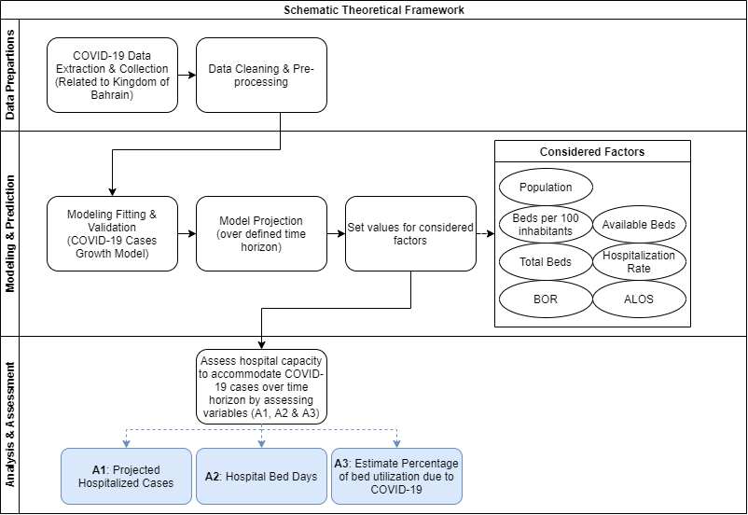

**Figure 3**: Schematic diagram of the adopted theoretical framework.

Figure 4 below illustrates the conceptual data flow diagram from our variables and projections, into our model, resulting with the measures.

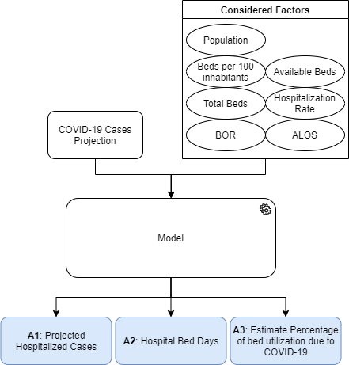

**Figure 4**: Conceptual Data Flow Diagram

Research Hypothesis

The research hypothesis is stated as follows:

The hospitals in the Kingdom of Bahrain will not reach saturation over a short time horizon (three months) due to COVID-19.

Saturation is defined as fully utilizing the available resources (i.e. capacity) that can be used to respond to demand.

References

Abueish, T. (2020, May 12). *Coronavirus: Bahrain reports 173 new cases, mostly detected in workers*. Retrieved from Al Arabiya English: https://english.alarabiya.net/en/coronavirus/2020/05/12/Coronavirus-Bahrain-reports-173-new-cases-mostly-detected-in-workers-

Alandijanya, T. A., Faizoa, A. A., & Azhar, E. I. (2020). Coronavirus disease of 2019 (COVID-19) in the Gulf Cooperation Council (GCC) countries: Current status and management practices. *Journal of Infection and Public Health, 13*(6), 839-842. doi:10.1016/j.jiph.2020.05.020

Alboaneen, D., Pranggono, B., Alshammari, D., Alqahtani, N., & Alyaffer, R. (2020). Predicting the Epidemiological Outbreak of the Coronavirus Disease 2019 (COVID-19) in Saudi Arabia. *International Journal of Environmental Research and Public Health, 17*(12). doi:10.3390/ijerph17124568

Bahrain News Agency. (2020, March 04). *World Health Organization: Bahrain should be commended on its efforts to contain COVID 19 and has set a good example to other countries*. Retrieved from Bahrain News Agency: https://www.bna.bh/en/WorldHealthOrganizationBahrainshouldbecommendedonitseffortstocontainCOVID19andhassetagoodexampletoothercountries.aspx?cms=q8FmFJgiscL2fwIzON1%2BDnwQ1MRwzd%2BIKxCJbAyAyyc%3D

Barasa, E. W., Ouma, P. O., & Okiro, E. A. (2020). Assessing the hospital surge capacity of the Kenyan health system in the face of the COVID-19 pandemic. *PLOS ONE, 15*(7), e0236308.

Goh, G. (2020). *Epidemic Calculator*. Retrieved from http://gabgoh.github.io/COVID/index.html

Hill, A., Levy, M., Xie, S., Sheen, J., Shinnick, J., Gheorghe, A., & Rehmann, C. (2020, April 03). *Modeling COVID-19 Spread vs Healthcare Capacity*. Retrieved from https://alhill.shinyapps.io/COVID19seir/

International Monetary Fund. (2020, November 20). *Policy Responses to COVID-19*. Retrieved from International Monetary Fund: https://www.imf.org/en/Topics/imf-and-covid19/Policy-Responses-to-COVID-19

Jiang, X., Coffee, M., Bari, A., Wang, J., Jiang, X., Huang, J., . . . Huang, Y. (2020). Towards an Artificial Intelligence Framework for Data-Driven Prediction of Coronavirus Clinical Severity. *Computers, Materials & Continua, 63*(1), 537-551. doi:10.32604/cmc.2020.010691

Louri, N. A., Alkhan, J. A., Isa, H. H., Asad, Y., Alsharooqi, A., Alomari, K. A., . . . Al Khalifa, K. (2020). Establishing a 130-Bed Field Intensive Care Unit to Prepare for COVID-19 in 7 Days in Bahrain Military Hospital. *Disaster Medicine and Public Health Preparedness*. doi:10.1017/dmp.2020.297

Madhav, N., Oppenheim, B., Gallivan, M., Mulembakani, P., Rubin, E., & Wolfe, N. (2017). Chapter 17 Pandemics: Risks, Impacts, and Mitigation. In D. T. Jamison, H. Gelband, S. Horton, P. Jha, R. Laxminarayan, C. N. Mock, & R. Nugent (Eds.), *Disease Control Priorities: Improving Health and Reducing Poverty, 3rd edition* (Vol. 9). Washington (DC): World Bank. doi:10.1596/978-1-4648-0527-1

Massonnaud, C., Roux, J., & Crépey, P. (2020). COVID-19: Forecasting short term hospital needs in France. *medRxiv*. doi:10.1101/2020.03.16.20036939

Ministry of Health. (2020, November 29). *COVID-19 Summary*. Retrieved November 30, 2020, from Ministry of Health - Kingdom of Bahrain: https://www.moh.gov.bh/

MOH. (2020, February 02). *All public and private schools and kindergartens to be closed for two weeks*. Retrieved from Ministry Of Health - News: https://www.moh.gov.bh/COVID19/Details/3879

Naar, I. (2020, May 12). *Coronavirus: Bahrain expands bed capacity at its isolation, quarantine centers*. Retrieved from Al Arabiya English: https://english.alarabiya.net/en/coronavirus/2020/05/13/Coronavirus-Bahrain-expands-bed-capacity-at-its-isolation-quarantine-centers

Naar, I. (2020, May 13). *Coronavirus: Bahrain expands bed capacity at its isolation, quarantine centers*. Retrieved from Al Arabiya: https://english.alarabiya.net/en/coronavirus/2020/05/13/Coronavirus-Bahrain-expands-bed-capacity-at-its-isolation-quarantine-centers

Qaed, M. A. (2020, August 13). *Bahrain’s ‘BeAware’ coronavirus app has saved lives: Here’s how*. Retrieved from AlArabiya: https://english.alarabiya.net/en/views/news/middle-east/2020/08/13/Bahrain-s-BeAware-coronavirus-app-has-saved-lives-Here-s-how

Shereen, M., Khan, S., Kazmi, A., Bashir, N., & Siddique, R. (2020). COVID-19 infection: Origin, transmission, and characteristics of human coronaviruses. *Journal of Advanced Research, 24*, 91-98. doi:10.1016/j.jare.2020.03.005

Shoukat, A., Wells, C. R., Langley, J. M., Singer, B. H., Galvani, A. P., & Moghadas, S. M. (2020). Projecting demand for critical care beds during COVID-19 outbreaks in Canada. *Canadian Medical Association Journal, 192*(19). doi:10.1503/cmaj.200457

Thompson, R. N. (2020). Novel Coronavirus Outbreak in Wuhan, China, 2020: Intense Surveillance Is Vital for Preventing Sustained Transmission in New Locations. *Journal of Clinical Medicine, 9*(2). doi:10.3390/jcm9020498

Weiss, R. S., & Leibowitz, L. J. (2011). Chapter 4 - Coronavirus Pathogenesis. In K. Maramorosch, J. A. Shatkin, & A. F. Murphy, *Advances in Virus Research* (Vol. 81, pp. 85-164). Academic Press. doi:10.1016/B978-0-12-385885-6.00009-2

Weissman, G. E., Crane-Droesch, A., Chivers, C., Luong, T., Hanish, A., Levy, M. Z., . . . Halpern, S. D. (2020). Locally Informed Simulation to Predict Hospital Capacity Needs During the COVID-19 Pandemic. *Annals of internal medicine, 173*(1). doi:10.7326/m20-1260

WHO. (2020). *Critical preparedness, readiness and response actions for COVID-19.* WHO. Retrieved from https://www.who.int/publications/i/item/critical-preparedness-readiness-and-response-actions-for-covid-19

WHO Director-General. (2020, March 11). *WHO Director-General's opening remarks at the media briefing on COVID-19*. Retrieved from World Health Organization: https://www.who.int/dg/speeches/detail/who-director-general-s-opening-remarks-at-the-media-briefing-on-covid-19---11-march-2020

World Health Organization. (2020, February 27). *Coronavirus disease 2019 (COVID-19) Situation Report – 38*. Retrieved from https://www.who.int/docs/default-source/coronaviruse/situation-reports/20200227-sitrep-38-covid-19.pdf

World Health Organization. (2020, March 01). *Coronavirus disease 2019 (COVID-19) Situation Report – 41*. Retrieved from https://www.who.int/docs/default-source/coronaviruse/situation-reports/20200301-sitrep-41-covid-19.pdf

World Health Organization. (2020, March 25). *Coronavirus disease 2019 (COVID-19) Situation Report – 65*. Retrieved from https://www.who.int/docs/default-source/coronaviruse/situation-reports/20200325-sitrep-65-covid-19.pdf

World Health Organization. (2020, March 31). *Coronavirus disease 2019 (COVID-19) Situation Report – 71*. Retrieved from https://www.who.int/docs/default-source/coronaviruse/situation-reports/20200331-sitrep-71-covid-19.pdf

Worldometer. (2020, November 30). *Bahrain Coronavirus Worldometer*. Retrieved November 30, 2020, from Worldometer: https://www.worldometers.info/coronavirus/country/bahrain/

Zhou, P., Yang, X.-L., Wang, X.-G., Hu, B., Zhang, L., Zhang, W., . . . Shi, Z.-L. (2020). A pneumonia outbreak associated with a new coronavirus of probable bat origin. *Nature, 579*(7798), 270-273. doi:10.1038/s41586-020-2012-7

Zhu, N., Zhang, D., Wang, W., Li, X., Yang, B., Song, J., . . . Tan, W. (2020). A Novel Coronavirus from Patients with Pneumonia in China, 2019. *The New England Journal of Medicine, 382*(8), 727-733. doi:10.1056/NEJMoa2001017

Table of Figures

**Figure 1**: Distribution of COVID-19 cases as of 01-March-2020 (World Health Organization, 2020) 2

**Figure 2**: Distribution of COVID-19 cases as of 25-March-2020 (World Health Organization, 2020) 2

**Figure 3**: Schematic diagram of the adopted theoretical framework. 10

**Figure 4**: Conceptual Data Flow Diagram 10