**Chapter Two**

**Theoretical Framework and Literature Review**

**2.1 Literature Review**

**2.1.1 Background on COVID-19**

**2.1.2 Governments’ Intervention in face of COVID-19**

**2.1.3 Estimation and Modeling Approaches for COVID-19**

**2.1.4 Recommendations Based on Estimation and Modeling Approaches for COVID-19**

**2.2 Theoretical Framework**

**2.3 Research Hypothesis**

Name: Aysha Khalid Mubarak

ID#: 20092905

**Chapter Two**

**Theoretical Framework and Literature Review**

**2.1 Literature Review**

This chapter is introducing the initiation of the pandemic of coronavirus (COVID-19), passing through its spreading worldwide and concluding with the situation in Kingdom of Bahrain in face of COVID-19.

**2.1.1 Background on COVID-19**

The first COVID-19 infected cases were for three Chinese detected on December 30, 2019 in Wuhan Jinyintan Hospital according to World Health Organization (WHO) report. The number of cases in the few weeks later were not increased much, however as of February 20, 2020, a cumulative total of 75,465 COVID-19 cases were reported in China (WHO report).

As of March 12, 2020, the pandemic of COVID-19 has already caused more than 135,000 confirmed cases across 117 countries according to WHO Coronavirus disease 2019 (COVID-19) Situation Report – 52. The continuous rapid increase of infected cases is exhausting the health system in any country. Likewise, in such sophisticated health systems like United State (Moghadas et al., 2020). On 27 February 2020, the total number of cases in the United States was 65 and as of July 20, 2020 it reached 7 584 675 cases according to WHO Coronavirus disease (COVID-19) Situation Report – 182. The mounting of coronavirus disease 2019 (COVID-19) outbreak in the United States could grievously challenge the critical care capacity which will aggravate deaths case rates (Moghadas et al., 2020).

In Canada, the total number of confirmed cases is exceeding 8500 as of March 31, 2020, including cases caused by local transmission in several communities (Shoukat et al., 2020). This ring a bell of having a sooner outbreak and shows a significant surge in demand for both hospital and critical care of COVID-19 patients.

The large number of cases is not only attached to the American/Canadian regions, but also European region is affected (WHO report). On January 24, 2020, the European continent announced the first confirmed cases were in France (Bernard et al., 2020). The European Centre for Disease Prevention and Control (ECDC) reported on March 5, 2020 the total number of COVID-19 confirmed cases is 91,315 in 81 countries, and 3,282 deaths (3.4%). In Europe, 38 countries reported cases, Italy accounting for most of them, with 3,089 cases out of 4,290 (72%), and 107 deaths out of 113 (94.7%). France was ranked second with 423 cases and 5 deaths (1.2%) according to the epidemiological update report of Public Health in France.

Some of sub-Saharan African countries, including Kenya, were at moderate to high risk of novel coronavirus importation, measured by volume of air travel arriving from infected Chinese provinces (Gilbert et al. 2020). The first case reported in Kenya in on March 13, 2020, from that time the number of confirmed cases has been increasing very quick (Brand et al., 2020).

This epidemic reached many countries including the Gulf Cooperation Council (GCC) countries. On late February 2020, Bahrain, Kuwait, Oman, Iraq, and Qatar reported their first COVID-19 confirmed cases. These cases were either Iranians or citizens of the GCC countries who had recently visited Iran. By May 18, 2020, the total active cases reached 92171 (62.6%) with total number of deaths 841 (0.6%) (Alandijanya et al., 2020).

Kingdom of Bahrain, as one of GCC counties affected by this epidemic has reported the first COVID-positive case on February 24, 2020 and within one month it exceeded 400. By now it reached 39921 as a total number of confirmed cases and total of 141 deaths according to Ministry of Health Bahrain daily summary of cases.

**2.1.2 Governments’ Intervention in face of COVID-19**

The governments all over the world has been taken several actions in different stages to mitigate the epidemic consequences.

For instance, the French government as the most European affected country has announced a series of nation-wide measures, of increasing importance. On February 29, gatherings were restricted to 5,000 persons in confined settings. This threshold has since been revised downwards, from 5,000 persons to 100 persons within March 8-13. Schools and universities were asked to close from March 16, and voluntary household quarantine and social distancing of those over 70 years of age were recommended. Finally, stage 3 of the epidemic was declared. Therefore, all non-essential public places are closed, and people are directed to stay home, limit social interactions and travels (Moghadas et al., 2020).

The African governments also took some actions, such as the Kenyan government which is considering non-hospital spaces for expanding their health system capacity. They earmarked educational institutions (high schools, colleges, universities) with boarding facilities as potential isolation centers (Barasa, Ouma & Okiro, 2020).

GCC countries commenced strict control measures to bound the spread of infection immediately after confirmed COVID-19 cases. There are common actions had been taken from GCC countries governments, such as lockdown of major cities, full suspension of flights, university and school closure, banning of social gathering and sport events, provision of free-of-charge healthcare to patients, and launching of COVID-19 active screening. Positively, the governmental officials had generally succeeded in bringing the outbreak under control in these countries with the cooperation from the public. Moreover, they created multiple awareness campaigns in different languages with various forms of media to increase public awareness about COVID-19 infection. They used also to provide-updated information on new cases, deaths, and recoveries. All GCC countries during Ramadhan, two Eids and Hajj faced challenges as special occasions for Muslims who represent the vast majority of population in the GCC countries (where people to gather frequently in large groups in homes and mosques) however, they controlled it (Alandijanya et al., 2020).

Along with the commonly actions taken by the governments of GCC countries, the government in the Kingdom of Bahrain has initiated several actions.

In March 2020, Bahrain National Taskforce took up the initiative to establish 4 field intensive care units (FICU) with additional 500 ICU beds for the outbreak. The Bahrain Defence Force Royal Medical Services (BDF-RMS) military hospital was given the responsibility to establish a fully equipped FICU in its premise as a part of the national plan to combat the outbreak as per WHO guidelines The whole project was completed in 7 days. Construction and Assembly commenced on April 1, 2020, and the project was completed on April 8, 2020, and officially inaugurated on April 9, 2020 (Louri et al., 2020).

Furthermore about the hospital capacity in Bahrain, in April 13, 2020, Dr. Waleed Khalifa Al Manea, Undersecretary of the Ministry of Health stated that “The capacity of the isolation and treatment centers is 1699 and the occupancy is 744 beds only, and in the private sector centers the capacity is 172 and the current occupancy is 7 beds only. While the capacity of the preventive quarantine centers is 2504 and the occupancy is 824 beds, and in the private sector centers the capacity is 321, and the occupancy is 65 beds.”

In addition, Faeqa al-Saleh the Bahraini Minister of Health stated “The ministry is following a comprehensive national plan initiated by the National Taskforce for Combating the Coronavirus (COVID-19), which is continually reviewed and modified based on COVID-19 developments”. She followed that by highlighting the increase in bed capacity across the isolation and quarantine centres treating coronavirus-infected patients, adding that total capacity stands at 9,746 beds at those centres, according to Al Arabiya English May,13 2020.

**2.1.3 Estimation and Modeling Approaches for COVID-19**

To face the escalated increase of infected cases and the criticality of exceeding hospital capacity, projection systems to assess the hospitals capacity have been initiated to prevent the discontinuity of health services providence for COVID-19 patients.

A Scenario based transmission model, using compartment-based system of differential equations was used to project hospital utilization in the United States (Moghadas et al., 2020). They used a factor called reproduction number, R0 = 2.5 (initial estimate) and R0 = 2 (alternative scenario), average time to self-isolation post-symptom onset for individuals with mild symptoms $\frac{1}{τ }$ = 1 d and $\frac{1}{τ }$ = 2 d along with other factors. It shows that the number of hospital beds needed is 5.8-10.9 times more than typically unoccupied in the case of (No self-isolation) respectively R0 = 2.5 - 2. In the case of (self-isolation compared to no self-isolation) the weekly requirement for ICU beds at peak reached 3% reduction and the outbreak time will delay for 1 week when the proportion of self-isolation with mild symptoms individuals ***f*** =5%. However, when ***f*** =20% and $\frac{1}{τ }$ = 2 d, the weekly requirement for ICU beds at peak reaches 48.4% reduction and the outbreak time will delay for 12 weeks.

Similarly, with projecting demand for critical care beds during COVID-19 outbreaks in Canada (Shoukat et al., 2020). They used self-isolation and no self-isolation scenarios and resulting that with assumption of ICU bed occupancy rates above 80% and self-isolation of 40% the demand would still exceed available (unoccupied) ICU bed capacity of the hospitals in Canada.

In other scenarios, estimating the timing of surges increase in demand for hospitalization due to COVID-19 infection under best/worst case scenario for the spread of the infection in the United States (Weissman et al., 2020). They used to estimate how much time in days that the hospital capacity would be fully utilized in the given scenario. They considered the sensitivity analysis to assess impact of doubling time – T as parameter on time to hospital capacity peak (fully utilized), it showed that with reduced of doubled time (worst case: T= 2) it will reduce the time until peak of hospital capacity utilization (20 day), while when the doubled time (best case: T= 10) the time until peak will increase to (73 days).

Likewise, the French experience of forecasting hospital needs during COVID-19 (Massonnaud, Roux & Crépey, 2020). The authors conducted one month forecast for COVID-19 cases, hospitalization and death rates, and ICU demand under three scenarios, best case scenario: R0 = 1.5, mid-case scenario: R0 = 2.25 and worst case scenario: R0 = 3. They presented results of worst-case scenario, all Region will be overrun before April 14th,2020 while in the mild scenario, half of the French Regions will run out of ICU capacities before mid-April. Corse region is likely to be at full ICU capacity before the end of March 2020 (where March 28 in the best case, March 18 in the worst-case scenario). They concluded that the French healthcare system will very soon be overwhelmed. While drastic social distancing measures may temper their results.

Differently with predicting the epidemiological outbreak of COVID-19 in Saudi Arabia (Alboaneen, et al., 2020). They used different methods, such as Logistic Growth Model (LG) and Susceptible Infected Recovered Model (SIR) where the results of predictions respecting to them. As the peak infection rate is May 17, 2020 and May 1, 2020, the transition to steady state start May 28, 2020 and June 2, 2020, the transition to steady state ends June 14, 2020 and June 24, 2020 with final number of cases 69000 and 79000.

**2.1.4 Recommendations Based on Estimation and Modeling Approaches for COVID-19**

Through all the mentioned studies the authors came out with beneficial recommendations which could be helpful for other governments.

Promoting effective self-isolation through public awareness campaigns to educate the public on the reasons for self-isolation and give public support for those who are isolated.

Promoting effective self-isolation through public awareness campaigns to educate the public on the reasons for self-isolation and give public support for those who are isolated, with applying policies that encourage self-isolation, such as paid sick leave, may delay the epidemic peak, giving a window of time that could facilitate emergency mobilization (Moghadas et al., 2020).

While other authors recommended the modelling enhancements like including role of local hospitals to assist in reducing demand in model, using region local data and parameter in iterative development of model, keeping model up-to-date with actual measure to validate model projections, using mean-squared error (MSE) to assess model prediction accuracy on weekly basis, using more data on the dynamics of COVID-19 epidemic to generate more feasible parameters for complex models to account for other aspects such as immunity, death, and exposure periods (Weissman et al., 2020). Where others found AI tools need to be developed iteratively and include clinicians in their development to be clinically applicable. Further refinement of these models with more data, from different settings with different spectrums of severity, would strengthen the predictive power of the model and allow it to be a useful tool in identifying early from the many with COVID-19, who will develop more serious disease and require closer clinical attention and resources. (Jiang et al., 2020).

Where others are thinking of other factors related to the spread of COVID-19 such as the need of estimating whether warm weather will contribute to slowing the spread of the virus. (Alboaneen, et al., 2020).

**2.2 Theoretical Framework**

The collection of studies declared earlier are influenced this study and facilitated its theoretical framework development. This study is aiming to assess the hospital capacity in the Kingdom of Bahrain as a response to COVID-19. Fig. 1 presents a schematic diagram for the adopted theoretical framework.

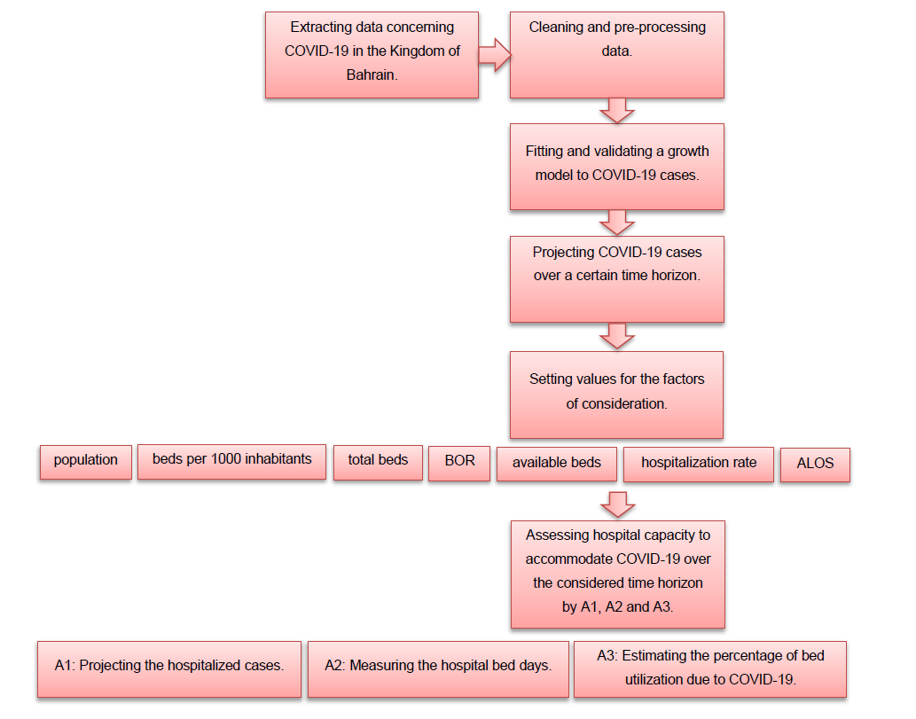

Fig. 1: A schematic diagram for the adopted theoretical framework.

This study is started with extracting the data concerning COVID-19 in the Kingdom of Bahrain, then cleaning and preprocessing the data. After that fitting and validating a growth model to COVID-19 cases. Next, setting the values for factors of consideration (population, beds per 100 inhabitants, total beds, bed occupation rare (BOR), available beds, hospitalization rate and average length of stay (ALOS), from these factors, we are going to assess the hospital capacity to accommodate time horizon by projecting the hospitalized cases, measuring the hospital bed days and estimating the percentage of bed unitization due to COVID-19.

**2.3 Research Hypothesis**

This research is aiming to prove that the hospitals in Kingdom of Bahrain will not achieve the fullness of its capacity capability within short period (three months) during the pandemic of COVID-19.

References

Alandijany, T. A., Faizo, A. A., & Azhar, E. I. (2020). Coronavirus disease of 2019 (COVID-19) in the Gulf Cooperation Council (GCC) countries: Current status and management practices. *Journal of Infection and Public Health*, *13*(6), 839–842. https://doi.org/10.1016/j.jiph.2020.05.020

Alboaneen, D., Pranggono, B., Alshammari, D., Alqahtani, N., & Alyaffer, R. (2020). Predicting the Epidemiological Outbreak of the Coronavirus Disease 2019 (COVID-19) in Saudi Arabia. *International Journal of Environmental Research and Public Health*, *17*(12), 4568. https://doi.org/10.3390/ijerph17124568

Barasa, E. W., Ouma, P. O., & Okiro, E. A. (2020). Assessing the hospital surge capacity of the Kenyan health system in the face of the COVID-19 pandemic. *PLOS ONE*, *15*(7), e0236308. https://doi.org/10.1371/journal.pone.0236308

Bernard Stoecklin, S., Rolland, P., Silue, Y., Mailles, A., Campese, C., Simondon, A., Mechain, M., Meurice, L., Nguyen, M., Bassi, C., Yamani, E., Behillil, S., Ismael, S., Nguyen, D., Malvy, D., Lescure, F. X., Georges, S., Lazarus, C., Tabaï, A., … Levy-Bruhl, D. (2020). First cases of coronavirus disease 2019 (COVID-19) in France: surveillance, investigations and control measures, January 2020. *Eurosurveillance*, *25*(6). https://doi.org/10.2807/1560-7917.ES.2020.25.6.2000094

Brand, S. P. C., Aziza, R., Kombe, I. K., Agoti, C. N., Hilton, J., Rock, K. S., Parisi, A., Nokes, D. J., Keeling, M. J., & Barasa, E. W. (2020). *Forecasting the scale of the COVID-19 epidemic in Kenya*. https://doi.org/10.1101/2020.04.09.20059865

*Coronavirus disease (COVID-19) Situation Report -182*. (n.d.). Retrieved December 4, 2020, from https://www.who.int/docs/default-source/coronaviruse/situation-reports/20200720-covid-19-sitrep-182.pdf?sfvrsn=60aabc5c_2

Gilbert, M., Pullano, G., Pinotti, F., Valdano, E., Poletto, C., Boëlle, P.-Y., D’Ortenzio, E., Yazdanpanah, Y., Eholie, S. P., Altmann, M., Gutierrez, B., Kraemer, M. U. G., & Colizza, V. (2020). Preparedness and vulnerability of African countries against importations of COVID-19: a modelling study. *The Lancet*, *395*(10227), 871–877. https://doi.org/10.1016/S0140-6736(20)30411-6

Jiang, X., Coffee, M., Bari, A., Wang, J., Jiang, X., Huang, J., Shi, J., Dai, J., Cai, J., Zhang, T., Wu, Z., He, G., & Huang, Y. (2020). Towards an Artificial Intelligence Framework for Data-Driven Prediction of Coronavirus Clinical Severity. *Computers, Materials & Continua*, *62*(3), 537–551. https://doi.org/10.32604/cmc.2020.010691

Louri, N. A., Alkhan, J. A., Isa, H. H., Asad, Y., Alsharooqi, A., Alomari, K. A., Hasan, N. K., Al Khalifa, F. B. K., Ahmed, G. F., Alasmi, M. Y., Al-Khalifa, D. K., & Al Khalifa, K. B. A. (2020). Establishing a 130-bedded field intensive care unit to prepare for COVID-19 in 7 days in Bahrain Military Hospital. *Disaster Medicine and Public Health Preparedness*, 1–26. https://doi.org/10.1017/dmp.2020.297

Massonnaud, C., Roux, J., & Crépey, P. (2020). COVID-19: Forecasting short term hospital needs in France. *MedRxiv*. https://doi.org/10.1101/2020.03.16.20036939

Moghadas, S. M., Shoukat, A., Fitzpatrick, M. C., Wells, C. R., Sah, P., Pandey, A., Sachs, J. D., Wang, Z., Meyers, L. A., Singer, B. H., & Galvani, A. P. (2020). Projecting hospital utilization during the COVID-19 outbreaks in the United States. *Proceedings of the National Academy of Sciences*, *117*(16), 9122–9126. https://doi.org/10.1073/pnas.2004064117

Shoukat, A., Wells, C. R., Langley, J. M., Singer, B. H., Galvani, A. P., & Moghadas, S. M. (2020). Projecting demand for critical care beds during COVID-19 outbreaks in Canada. *Canadian Medical Association Journal*, *192*(19), E489–E496. https://doi.org/10.1503/cmaj.200457

*Situation Report -38 SITUATION IN NUMBERS total and new cases in last 24 hours*. (n.d.). https://www.who.int/docs/default-source/coronaviruse/situation-reports/20200227-sitrep-38-covid-19.pdf

SPF. (n.d.). *COVID-19 : point épidémiologique du 5 mars 2020*. Www.Santepubliquefrance.Fr. https://www.santepubliquefrance.fr/maladies-et-traumatismes/maladies-et-infections-respiratoires/infection-a-coronavirus/documents/bulletin-national/covid-19-point-epidemiologique-du-5-mars-2020

Weissman, G. E., Crane-Droesch, A., Chivers, C., Luong, T., Hanish, A., Levy, M. Z., Lubken, J., Becker, M., Draugelis, M. E., Anesi, G. L., Brennan, P. J., Christie, J. D., Hanson III, C. W., Mikkelsen, M. E., & Halpern, S. D. (2020). Locally Informed Simulation to Predict Hospital Capacity Needs During the COVID-19 Pandemic. *Annals of Internal Medicine*, *173*(1). https://doi.org/10.7326/m20-1260

*WHO COVID-19 Explorer*. (n.d.). Worldhealthorg.Shinyapps.Io. https://worldhealthorg.shinyapps.io/covid/

*فيروس الكورونا COVID-19 - وزارة الصحة*. (n.d.). Www.Moh.Gov.Bh. https://www.moh.gov.bh/COVID19/