**University of Bahrain**

|  |  |
| --- | --- |
| **College of Science** | **Department of Mathematics** |



**Assessing Bahrain Bed Capacity during the COVID-19 Pandemic**

This report is submitted in partial fulfilment of the requirements for the Research Methods course in pursuit of a master’s degree in Big Data Science and Analytics

**Prepared by**

**Aisha Khalid & Ahmed Khedr**

20092905 & 20113798

**Supervised by**

**Dr. Sawsan Hilal**

Assistant Professor

University of Bahrain

**Kingdom of Bahrain**

**December 2020**

جامعة البحرين

|  |  |  |
| --- | --- | --- |
| كلية العلوم |  | قسم الرياضيات |



تقييم سعة المستشفيات في مملكة البحرين أثناء فترة الوباء كوفيد-19

**يُسلم هذا التقرير كمطلب جزئي لمقرر طرق البحث العلمي استكمالًا لبرنامج الماجستير في علم البيانات الضخمة وتحليلها**

تم تحضيره من قبل

عايشة خالد - أحمد خضر

20092905 - 20113798

بإشراف

د. سوسن هلال

**استاذ مساعد**

**جامعة البحرين**

مملكة البحرين

ديسمبر 2020

Abstract

<write abstract>

Acknowledgements

We would like to acknowledge Dr. Sawsan Hilal, University of Bahrain, for her continuous support and guidance throughout this research and report writing. We would also like to acknowledge Our World in Data for their efforts in making such useful data publicly available and free to use.

<double check if we missed anyone>

Table of Contents

1 Chapter One 1

1.1 Introduction 2

1.2 Research Problem 2

1.3 Research Questions 2

1.4 Research Objectives 2

1.5 Research Significance 2

1.6 Research Setting 2

1.7 Definition of Terms 2

2 Chapter Two 3

2.1 Literature Review 4

2.2 Theoretical Framework 4

2.3 Research Hypothesis 4

3 Chapter Three 5

3.1 Methodology 6

3.2 Population 8

3.3 Research Study Tools 8

3.3.1 Data and Variable Extraction 8

3.3.2 Other Study Tools 9

3.4 Data Collection and Procedures 9

3.5 Statistical Analysis Approach 10

3.5.1 COVID-19 Prediction Model 10

3.5.2 Statistical Calculation of Study Factors 11

4 Chapter Four 15

4.1 Results 16

4.1.1 Initial Data Observations 16

4.1.2 Logistic Growth Model Predictions 17

4.1.3 Bed Capacity 19

4.1.4 Hospitalized Cases (Current versus Projected) 20

4.2 Discussion 23

4.3 Conclusion 27

4.4 Recommendations and Limitations 27

4.4.1 Limitations 28

References 30

Appendices 33

List of Tables

Table (1): Adopted Scenario Variables 7

Table (2): Extracted Variables used in calculation of Research Factors 9

Table (3): Statistical Results of Bed Capacity related Variables 19

List of Figures

Fig. 1: Scenario-Based Design Template 6

Fig. 2: High-Level Data Collection Procedure 10

Fig. 3: Detailed Statistical Analysis Process Flow Diagram 14

Fig. 4: Trend Observation Plots of COVID-19 Total Cases and Deaths in Bahrain 17

Fig. 5: Logistic Growth Model of COVID-19 in the Kingdom of Bahrain 18

Fig. 6: Projected Cases and Hospitalized Cases 20

Fig. 7: Projected Hospitalized Cases and Available Beds 21

Fig. 8: Side-by-side Projected COVID-19 Cases, Hospitalized Cases, and Available Beds 22

Fig. 9: Actual Data and Predicted Model Data 23

Fig. 10: Actual Data versus Logistic Growth Model 24

List of Equations

Equation 1: Adopted Logistic Growth Model 11

Equation 2: Calculation of Total Hospital Beds 12

Equation 3: Calculation of Available Hospital Beds 12

Equation 4: Calculation of Total IQC Beds 12

Equation 5: Calculation of IQC BOR 13

Equation 6: Calculation of Available IQC Beds 13

Equation 7: Calculation of Total Available Beds 13

Equation 8: Calculation of Current Hospitalization Rate 13

Equation 9: Calculation of Projected Hospitalized Cases 13

Equation 10: Logistic Growth Model - Fitted Model 17

Chapter One

Introduction to the Study

‎‎1.1 Introduction

‎1.2 Research Problem

‎1.3 Research Questions

‎1.4 Research Objectives

‎1.5 Research Significance

‎1.6 Research Setting

‎1.7 Definition of Terms

Chapter One

Introduction to the Study

Introduction

This section introduces the research and report.

Research Problem

This section describes the research problem addressed by this research.

Research Questions

This section describes the questions that this research aimed to answer.

Research Objectives

This section describes the objectives that this research aimed to achieve.

Research Significance

This section describes the importance of this research.

Research Setting

This section describes the context of how this research was conducted, including scope.

Definition of Terms

This section lists all the terms and their abbreviations used within the report.

Chapter Two

Theoretical Framework and Literature Review

‎‎1.1 Introduction

‎2.1 Literature Review

‎2.2 Theoretical Framework

‎2.3 Research Hypothesis

Chapter Two

Theoretical Framework and Literature Review

Literature Review

This section goes through similar research topics conducted and compares between previous relevant works related to this research.

Theoretical Framework

This section describes the how this research will be implemented and carried out.

Research Hypothesis

This section defines and describes the hypothesis assumed by the researchers.

Chapter Three

Methods and Procedures

‎3.1 Research Study’s Methodology

‎3.2 Research Study’s Population and Sample

‎3.3 Research Study’s Tools

‎3.4 Data Collection and Procedures

‎3.5 Statistical Approaches

Chapter Three

Methods and Procedures

Methodology

This research has adopted an exploratory scenario-based research design in which will assess the capability, in terms of bed capacity, of the Kingdom of Bahrain to respond to the sudden increase of COVID-19 cases that will require hospitalization. Based on quantitative historical data (for COVID-19 cases), a statistical growth model will be used to project the increase in the number of cases for the upcoming three months (90 days). Thus, with the projected number of hospitalized cases and based on the current capacity of the health system, it will assess the health system’s ability to respond to the increase of infections and avoid reaching saturation of bed capacity (i.e., over-exceeded).

The below figure, **Fig. 1**, illustrates the scenario-based design template, which is developed for this research, highlighting the variables that can be altered across different scenarios.

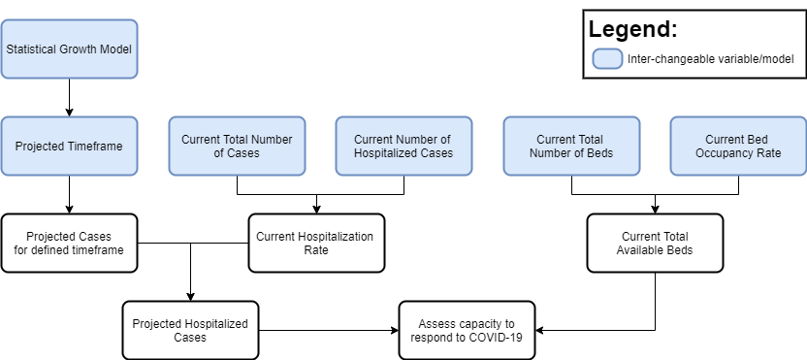

Fig. 1: Scenario-Based Design Template

The table below, **Table (1)**, illustrates the assumptions and definitions that will be used to define the context of our scenario (based on the scenario-based design template).

Table (1): Adopted Scenario Variables

|  |  |
| --- | --- |
| **Variable** | **Adaptation in this research scenario** |
| Statistical Growth Model | The Logistic Growth Model will be used to project the number of cases in the scenario, as a different model would project a different number and hence change the applied scenario. |
| Projected Timeframe | This research will project the cases for three months (90 days). |
| Current Total Number of Cases | This research will use the total number of cases and hospitalized cases as published by the Ministry of Health (2020) on the 1st of August, 2020. These values play an important role as they determine the hospitalization rate for the chosen scenario. |
| Current Number of Hospitalized Cases |
| Current Total Number of Beds | This value will be calculated based on publicly available data. |
| Current Bed Occupancy Rate (BOR) | The current hospital BOR was assumed at 80% as per conversation with a health worker in the Kingdom of Bahrain (Hilal, 2020) and the Field Intensive Care Units (FICU) BOR was obtained (0.38%) from publicly reported figures by Naar (2020). |

In summary, this research aims to assess the total bed capacity of the Kingdom of Bahrain in the scenario that the COVID-19 infections follow a logistic growth pattern and based on 80% of hospital beds being occupied and 0.38% FICU beds are occupied. The scenario will be projecting cases for the upcoming 90 days relative to the current available total bed capacity.

Population

The population considered in this study will be all hospitals (public and private) in the Kingdom of Bahrain. This study will also include Field Intensive Care Units, which are ad-hoc centers; isolation centers (IC) and quarantine centers (QC), that were built to increase total bed capacity in the Kingdom of Bahrain (Naar, 2020). As the COVID-19 epidemic will impact the country, the entire health system will need to work together, under the direction of the National Taskforce for Combating the Coronavirus (COVID-19) and the Ministry of Health, to ensure a rapid response to the epidemic.

Research Study Tools

This section illustrates how the data will be extracted and the tools that will be used to conduct the statistical analysis for this research.

Data and Variable Extraction

To extract historical data related to COVID-19 cases in Bahrain, including the total number of cases and deaths, the publicly reliable dataset provided by Our World in Data (Roser et al., 2020) will be extracted in comma separated values (CSV) format. This public dataset includes the following attributes which will be used in our study:

1. Date
2. Total Cases – the cumulative total number of COVID-19 cases as of the given date
3. Total Deaths – the cumulative total number of deaths caused by COVID-19 as of the given date
4. Population – the population of the country as of 2020
5. Hospital Beds per Thousand – the number of hospital beds per 1,000 people

The following variables, in **Table (2)**, will be extracted from various sources as they will play an important role in the statistical analysis to produce factors related to this study. The equations will be further detailed in section ‎3.5 of this report.

Table (2): Extracted Variables used in calculation of Research Factors

|  |  |
| --- | --- |
| **Extracted Variables** | **Source** |
| Total Field Intensive Care Units’ Beds (including Isolation Centers and Quarantine Centers) | This variable will be extracted and calculated from publicly reported figures by Naar (2020). |
| Hospital Beds Occupancy Rate (BOR) | This variable is assumed as per conversation with a health worker in the Kingdom of Bahrain. |

Other Study Tools

To execute the statistical analysis in this research, the reliable and data analysis feature-heavy “R” programming language and environment, version 4.0.3, will be utilized.

Data Collection and Procedures

All data that will be collected in this research is secondary data as it has not been gathered directly by the authors, however, the data sources are globally (Roser et al., 2020) and governmentally (Ministry of Health, 2020) reliable sources. The data is quantitative, and time-series based, and extracted into CSV format and loaded into the data analysis tool used (R) for cleaning, processing, and modeling. The below figure, **Fig. 2**, illustrates, on a high-level, the data collection and procedure that will be carried out in this research.

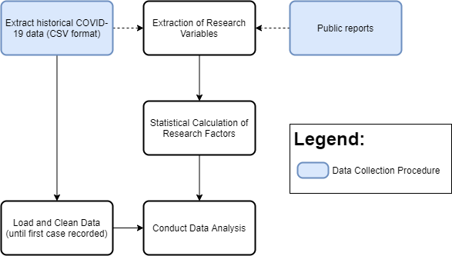

Fig. 2: High-Level Data Collection Procedure

Statistical Analysis Approach

This section illustrates the statistical analysis that will be implemented in this research, including the research factors considered.

COVID-19 Prediction Model

Historical quantitative data related to the number of COVID-19 cases will be extracted and used within our COVID-19 prediction model. The timeframe of the historical data will start from the first recorded case, the 24th of February 2020, until the 29th of July 2020. This data will be used as training data to generate a prediction model and then project the total number of cases for the next three months (90 days) – hence the projection timeframe will start and include the 30th of July 2020 until (and including) the 27th of October 2020. The data will be sorted chronologically as time-series data and formatted into the following structure to generate the model:

1. Day Counter – indicator for the day number since the first case occurrence (i.e., 10 will be the tenth day after the first case was reported, while 1 is the first day the first case was reported).
2. Total Cases – the cumulative number of cases on the given day (i.e., the total number of cumulative cases as of the 10th day).

After extraction and preparation of COVID-19 data, the Logistic Growth Model will be used, as defined in the scenario, to generate a prediction model to predict and forecast the cumulative number of COVID-19 cases the Kingdom of Bahrain.

The Logistic Growth Model is widely used to model population growth and besides its simplicity, has the advantage of setting a limit for the increase in population growth. In the case of COVID-19 infections, the number of cases cannot surpass the population of the country, which is realistic in comparison to an Exponential Growth Model which would increase (the number of cases) infinitely. The logistic growth model was also used to predict the 2015 Ebola epidemic (Chowell et al., 2014; Pell et al., 2018) and was used to predict COVID-19 cases in the neighboring Kingdom of Saudi Arabia (Alboaneen et al., 2020).

The Logistic Growth Model that will be used in this research can be expressed in the following equation, **Equation 1**, where is the cumulative number of cases on a given day number , is the maximum value for number of cases , and represents the daily growth rate, and the values of will be automatically estimated by the data analysis tool used; to fit the model with the data presented:

Equation 1: Adopted Logistic Growth Model

Statistical Calculation of Study Factors

Several research factors are not publicly available for direct use and for this reason, the statistical approaches in this research are devised to calculate their values. While others, such as Beds per Thousand People (BPTP) and Population were publicly available and were used to calculate other factors.

Given that the total number of hospital beds in the Kingdom of Bahrain could not be extracted from previous studies or reports, it will be calculated based on the variable *Beds per Thousand People (BPTP)* and *Population*. From the public dataset provided by Our World in Data (Roser et al., 2020), the variables are reported as and . To calculate the total hospital beds (), these variables will be used in the following equation, **Equation 2**:

Equation 2: Calculation of Total Hospital Beds

With the total hospital beds calculated along with the assumption that the hospital beds occupancy rate () currently stands at 80% (Hilal, 2020), the available hospital beds () that can actually be utilized in the treatment of COVID-19 cases, will be calculated using the below equation, **Equation 3**:

Equation 3: Calculation of Available Hospital Beds

Furthermore, the total number of Field Intensive Care Units’ (FICU) beds and their occupancy rate, including both Isolation Centers and Quarantine Centers (IQC), will also be calculated based on publicly reported figures by Naar (2020) – which reported 4,257 and 5,489 beds in Isolation Centers () and Quarantine Centers () respectively. The report also stated that 3,218 IC beds and 533 QC beds were occupied at the time of publishing, denoted as and respectively. Using these variables, the total beds in isolation and quarantine centers () will be calculated as per the below equation, **Equation 4**:

Equation 4: Calculation of Total IQC Beds

The bed occupancy rate (BOR) in isolation and quarantine centers (denoted by ) will be calculated as follows, **Equation 5**:

Equation 5: Calculation of IQC BOR

To obtain the available isolation and quarantine centers beds () that can actually be utilized in the treatment of COVID-19 cases, the total IQC beds and their occupancy rate will then be used in the below equation, **Equation 6**:

Equation 6: Calculation of Available IQC Beds

To conclude on the total available beds () in the Kingdom of Bahrain, a simple addition of the available hospital beds and the available IQC beds will be performed, **Equation 7**:

Equation 7: Calculation of Total Available Beds

As of the 1st of August 2020, the current number of active cases () and hospitalized cases () will be extracted from Bahrain’s Ministry of Health (2020) public daily report and calculate the current hospitalization rate (), using the following equation, **Equation 8**:

Equation 8: Calculation of Current Hospitalization Rate

Lastly, using the current hospitalization rate (), and the projected total number of cases, the projected hospitalized cases on a given day () will be calculated by multiplying the with the projected hospitalized cases on that given day () as per the below, **Equation 9**:

Equation 9: Calculation of Projected Hospitalized Cases

The figure below, **Fig. 3**, illustrates the detailed process flow diagram of the statistical analysis approach that was adopted in this research.

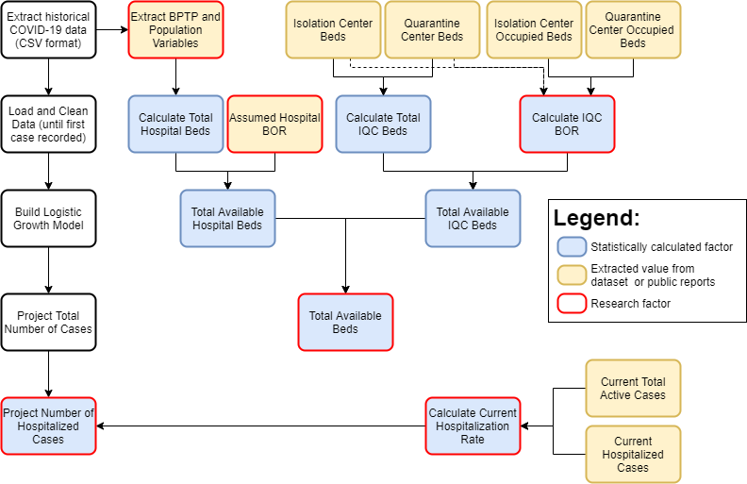

Fig. 3: Detailed Statistical Analysis Process Flow Diagram

Chapter Four

Results, Discussion, Conclusion and Recommendations

‎4.1 Results

‎4.2 Discussion

‎4.3 Conclusion

‎4.4 Recommendations and Limitations

Chapter Four

Results, Discussion, Conclusion and Recommendations

Results

This section presents the results obtained from the statistical analysis implemented in this research to assess the bed capacity in Kingdom of Bahrain, in response to the COVID-19 epidemic.

Initial Data Observations

As per the data source, Our World in Data (Roser et al., 2020), the first case in Bahrain was reported on the 24th of February 2020. For the scope of this research, the data extracted and considered will encompass the first case reported until the 29th of July 2020 (a timeframe of 156 days), where the total number of cases reached 39,921. While the first death recorded in Bahrain was on the 17th of March 2020, the total deaths by end of the studied period was 141.

The total COVID-19 cases and deaths were plotted in the following figure, **Fig. 4**, to visualize and verify the trend taken by COVID-19 cases and deaths (represented on the y-axis) in Bahrain over the studied time-period; from the first case occurrence, until the 156th day (final day of the studied period corresponding to the 29th of July 2020) represented on the x-axis. As it can be observed, within the study timeframe of 156 days, the total number of COVID-19 cases seems to be growing exponentially since the first case was reported. Though the first COVID-19 related death was reported later, the deaths also seem to be growing in a less exponentially manner.

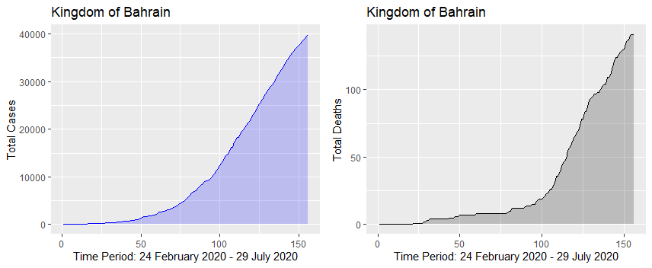

Fig. 4: Trend Observation Plots of COVID-19 Total Cases and Deaths in Bahrain

Logistic Growth Model Predictions

Based on the provided training data of total cases over the study timeframe (156 days), the best model generated by R can be presented by the substituting the estimated values in the following equation where is the total number of cases, calculated as a function, for the given day , **Equation 10**:

Equation 10: Logistic Growth Model - Fitted Model

With the fitted logistic growth model and based on the current trend of COVID-19 cases in the Kingdom, it can be deduced that the Daily Growth Rate for this study timeframe is . Furthermore, according to this model, the estimated maximum (upper limit, represented by ) number of cases that will be reached is 47,408 cases. While the total projected cases at the end of the time-period (on the 27th of October 2020) is estimated to be 47,277 cases.

The generated logistic growth model for the COVID-19 cases, illustrated in **Fig. 5**, shows that the model was closely fitted to the provided data; the actual total number of cases (represented on the y-axis) for the studied period (24th of February until the 29th of July 2020). The actual data, total number of cases, is presented in the grey line, while the predictions, predicted cases for the study period, is presented in the blue line and it can be observed that they are very close. The projected number of cases generated from the model, presented in the red line, shows how the model predicts the upcoming number of cases for a given day (represented on the x-axis) in the projection timeframe (90 days). Furthermore, as per the generated logistic model, it shows that the number of cases will stop increasing exponentially approximately at the 200th day, after the first case – in medical terms, the curve will begin to flatten as the amount of increase in the number of cases day after day will decrease.

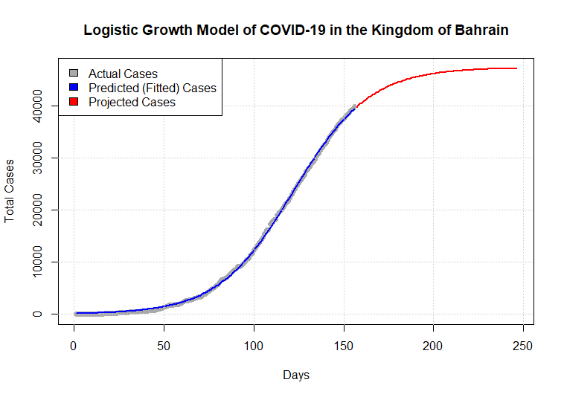

Fig. 5: Logistic Growth Model of COVID-19 in the Kingdom of Bahrain

Bed Capacity

In this study, the total bed capacity is the main variable of interest in assessing the ability of the Bahrain health system to respond to the COVID-19 epidemic. However, to be able to accommodate COVID-19 cases that will require hospitalization, the total available beds (excluding the beds that are already occupied due to general demand) will be required to be able to judge whether the capacity of the health system, in terms of beds, will be over-exceeded (saturated) or not. This variable (available beds) is determined by the total beds and bed occupancy rate. To be able to compare this with the projected cases, the current hospitalization rate will be required as well. This section highlights the resulting values for all these factors and variables.

Based on the implemented statistical analysis in this research, the estimated values for the factors related to bed capacity within the scenario of this research are presented in **Table (3)** below. In this research’s given scenario, with 80% hospital BOR, it can be observed that the there is a high variation in the number of available IQC beds relative to hospital beds, IQC beds account for approximately 90% of the total available beds in the Kingdom that can be utilized to respond to COVID-19 cases.

Table (3): Statistical Results of Bed Capacity related Variables

|  |  |
| --- | --- |
| **Factor** | **Estimated Value (within scenario)** |
| Total Hospital Beds () | 13,149 |
| Available Hospital Beds () | 681 |
| Total IQC Beds () | 9,746 |
| Available IQC Beds () | 5,995 |
| Total Available Beds () | 6,676 |

Hospitalized Cases (Current versus Projected)

The current number hospitalized cases, as well as the current active cases, are important factors as they will determine the current hospitalization rate that will be used to project the hospitalized cases from the projected total number of cases.

Based on the implemented statistical analysis, the current hospitalization rate () stands at approximately . Presented below in **Fig. 6**, is the result of using the current and applying it on every day for the projected timeframe of three months (90 days) to estimate the hospitalized cases (represented on the y-axis of the right graph) based on the projected total cases (represented on the y-axis of the left graph) for the given day number (represented on the x-axis). For example, it can be seen from the following graph that on the 240th day after the first reported case (which is the 21st of October 2020), based on the generate logistic model, the projected total cases will reach approximately 47,000 while the total number of hospitalized cases will reach approximately a little over 1,350.

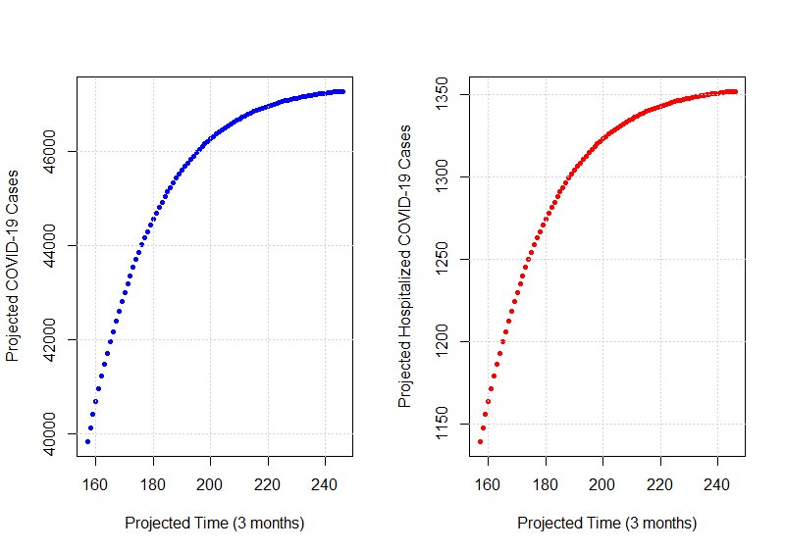

Fig. 6: Projected Cases and Hospitalized Cases

Using the projected hospitalized cases and deducting these cases from the current total available beds calculated previously, this will provide a projected number of available beds (after the available beds have consumed to serve the cases) for that given date. The below figure, **Fig. 7**, presents the results of the projected hospitalized cases (represented on the y-axis of the left graph) and the projected number of available beds (represented on the y-axis of the right graph) for each given day (represented on the x-axis). It can be noted that the lowest number of projected available beds will approximately reach 5,300 which is significantly higher than maximum number of projected hospitalized cases at approximately 1,350. This is because the simple statistical analysis implemented deducts the hospitalized cases on that day from the current available beds. For example, on the 240th day (21st of October 2020) the projected hospitalized cases will be approximately 1,350 – which after deducted from the current total available beds (6,676) will mean that there is a surplus of approximately 5,320 total available beds.

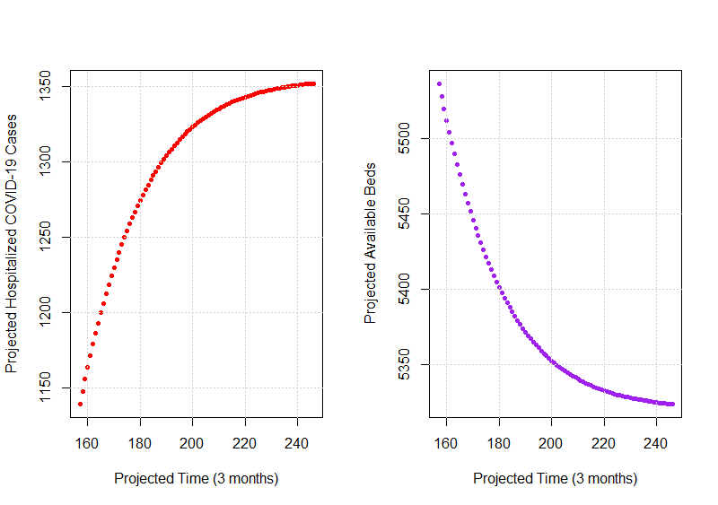

Fig. 7: Projected Hospitalized Cases and Available Beds

To conclude the results, the below figure, **Fig. 8**, illustrates all graphs displayed side-by-side for comparison purposes for the most important research variables, starting from the left to right; the projected total COVID-19 cases, the projected hospitalized COVID-19 cases, and the projected available beds for each given day in the projected timeframe (three months). Finally, as per the generated logistic growth model, the values for these variables on the final day of the projected time-horizon, the 27th of October 2020, are:

* Projected COVID-19 Cases: 47,277
* Projected Hospitalized COVID-19 Cases: 1,352
* Projected Available Beds: 5,324

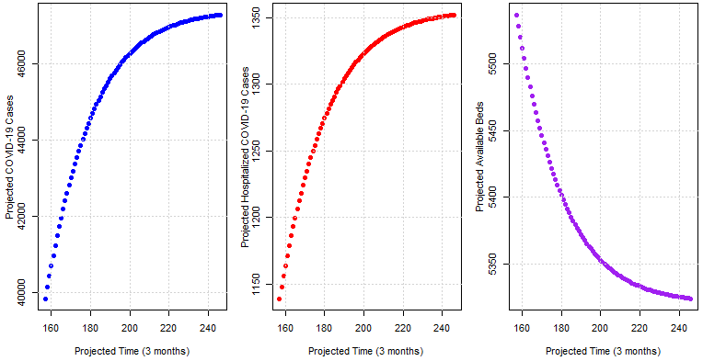

Fig. 8: Side-by-side Projected COVID-19 Cases, Hospitalized Cases, and Available Beds

<any other result we need to present? >

Discussion

The selection of the Logistic Growth Model is commonly used to project population growth in epidemics such as COVID-19. Several researchers have implemented the logistic growth model in studies such as forecasting the 2015 Ebola epidemic in West Africa (Chowell et al., 2014; Pell et al., 2018) and recently to forecast COVID-19 cases in the Kingdom of Saudi Arabia (Alboaneen et al., 2020). The selected Logistic Growth Model was a good statistical approach as the generated model fit very well with the provided data (for the study timeframe) as presented in the figure below, **Fig. 9**, which illustrate the actual data and the predicted data.

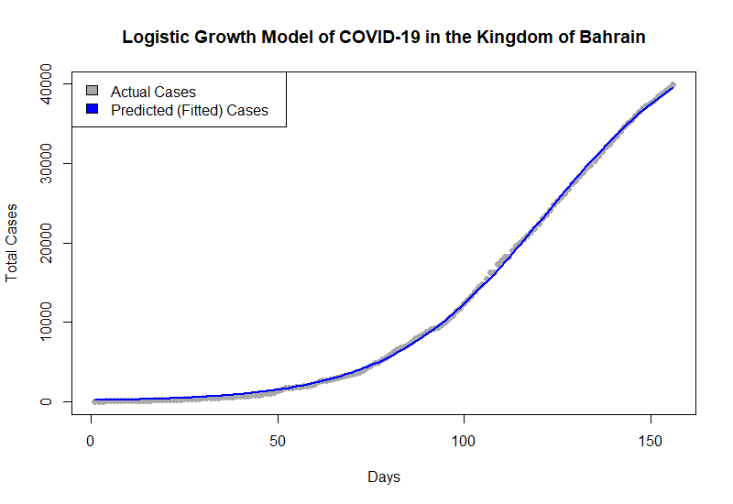

Fig. 9: Actual Data and Predicted Model Data

However, such a close-fitting model is also referred to as an overfitted model (or overfitting with the data) which presents a problem as it has a very low bias (since it is close to the data provided) but a very high variance. <define bias and variance in simple and short words> This prompted to question whether logistic growth model was truly able to capture the trend of COVID-19 cases for the Kingdom of Bahrain based on short-term provided data. To test the model accuracy, the figure below, **Fig. 10**, shows the actual data (including the study timeframe and projection time-horizon), against the generated logistic model’s data (prediction in blue and forecast in red). With this, it is noted that the logistic model might have been short-sighted in the sense that it quickly flattened the curve and set a relatively low maximum number of cases – as similarly reported by Alboaneen et al. (2020) relative to the SIR model they implemented. However, due to its simplicity and lower number of parameters and ease of implementation, the logistic model as well as the SIR model (Weissman et al., 2020) are still used commonly amongst researches.

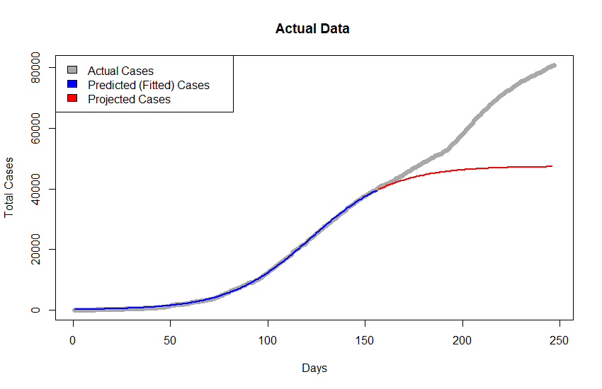

Fig. 10: Actual Data versus Logistic Growth Model

To address the purpose of this research, in terms of bed capacity, this research finds that the Kingdom of Bahrain will not reach saturation over the defined time-horizon of three months (90 days) as the presented results illustrate that with there will be a surplus of approximately 5,000 available beds that can be utilized for COVID-19 cases.

It is interesting to note that the distribution of available beds in the Kingdom of Bahrain, based on our given scenario, are primarily within the Isolation Centers and Quarantine Centers (IQC) – accounting for 90% of the total available beds. This indicates that if the Kingdom of Bahrain has not responded to, or prepared for, the COVID-19 epidemic in such a rapid manner, as highlighted and documented by Louri et al. (2020) as an instance of Bahrain’s quick response, the country would likely have reached bed capacity saturation in the early stages of the epidemic crisis.

However, it is important to note that without the Average Length of Stay (ALOS) included in the statistical analysis, as implemented by Barasa et al. (2020) , this finding (of projected total available beds) is potentially overestimated.

Furthermore, the implemented statistical analysis in this research was conducted on a single scenario (i.e., 90 days’ time horizon and 80% BOR) while other researchers have often conducted multiple scenario’s with a defined base-case, best-case, and worst-case scenarios and compared results of each scenario (Shoukat et al., 2020; Weissman et al., 2020).

Several variables in the adopted scenario were calculated from publicly available data or reports, such as the total beds and the occupancy rates, which may be inconsistent or inaccurate. This stresses the importance of the Kingdom of Bahrain to monitor, maintain and publicly avail such data (i.e., total beds, bed occupancy rate) for research purposes and to better plan and respond to the COVID-19 or other epidemics.

This research did not consider the demographic composition of the Kingdom of Bahrain, social connections/ties, governmental policies (International Monetary Fund, 2020) and restrictions (Alandijany et al., 2020), common diseases such as sickle cell, spatial variation (Verhagen et al., 2020) or geographical locations, or other variables that may have played a role in the control and limiting of the spread of the COVID-19 disease. A more elaborate and complex model to simulate and incorporate these variables to better understand the spread of COVID-19 would be helpful, along with more information about COVID-19 such as impact of temperature or season on the spread of the diseases.

<think of more things to discuss related >

Conclusion

In conclusion, the Logistic Growth Model had a good fit with the data related to the COVID-19 total cases, however set a relatively low maximum number of total COVID-19 cases. It would be beneficial to include and compare other scenarios or modeling approaches such as the SIR to be able to comment on the accuracy of the selected model relative to others. Nonetheless, due to the great efforts of the Kingdom of Bahrain, guided by the National Taskforce for Combating the Coronavirus (COVID-19) to ensure a preparedness and a rapid response to spread of the disease, the Kingdom of Bahrain will not reach saturation in terms of bed capacity, with an estimated surplus of 5,300 available beds across hospitals, isolation, and quarantine centers.

<conclude something here more if you feel like we need to >

Recommendations and Limitations

This research was conducted to forecast the number of COVID-19 cases in the Kingdom of Bahrain over a three months (90 days) time-period. Though it has implemented a commonly used population growth model, Logistic Growth Model, it is always recommended to run multiple simulations and predictions using multiple models, such as the several variations of the Susceptible, Infected, Removed or Recovered (SIR) model, to compare between model outcomes and a decide on which is most accurate.

It is highly recommended that further research is conducted to publicly avail and maintain records with regards to the overall health system capacity in Bahrain (including but not limited to the inventory and classification of general beds, ICU beds, and ventilators). Such metrics are vital in understanding the overall preparedness of the health system to respond to the COVID-19 epidemic (Barasa et al., 2020). As implemented in Kenya, maintenance of a nation-wide assets inventory list and regular nation-wide surveys to document and obtain these metrics, could prove helpful in the planning and execution of the response to the COVID-19 epidemic.

Furthermore, as COVID-19 is relatively novel and with limited, though growing, information on the disease and how it spreads, further investigations can be conducted to assess the impact of governmental restrictions on the spread of the disease. Such governmental policies and restrictions are not taken into consideration with models such as the Logistic Growth Model, which for a country such as Bahrain, could have played an important role in controlling and reducing the spread of the diseases.

Holidays and occasions can also be considered as variables of interest in the modeling of infection spread, as it has been observed with latest data that there seems to a spike in infections surrounding these occasions (Abueish, 2020). Such spikes would mean that the curve (a line that represents the number of infections on a given day) will be fluctuating rapidly around those occasions (i.e., a sudden increase while the trend would be decreasing) and hence a model such as the Logistic Growth Model would not accurately capture these fluctuations as it deals with the total cumulative number of cases instead.

Limitations

Though this research intended to implement a simplified forecast model and assessment, due to the limited time frame available to conduct this research, the authors had to oversimplify the research which resulted with several limitations and drawbacks.

The most prominent limitation was the exclusion of the Average Length of Stay (ALOS) research factor, which indicates the number of days that a patient will occupy a bed once hospitalized due to COVID-19. This measure is important because it accurately reflects and adjusts the available beds that can be utilized to respond to COVID-19 cases that require hospitalization. With its absence, the available bed capacity is overestimated which means that there might be an occurrence where the bed capacity might reach saturation. For example, if the ALOS is defined at 7 days, then once the hospitalized cases increase by 1 unit (person) this means that the available beds will decrease by 1 unit (bed) and remain out of service for 7 days until it is re-usable to serve another patient. In this research, since ALOS is excluded, this means the patient is admitted and released on the same day, and the bed is available to serve new cases immediately the next day – which is not the case.

Due to the lack of publicly available data related to the Bahraini health system, such as the total number of beds in the Kingdom or a real-time indicator on the bed occupancy rate, such variables were assumed or calculated from other sources which may not resemble the reality of the situation.

Furthermore, due to not implementing different growth prediction models, drawing conclusions on the accuracy of the selected model cannot be done and hence the findings (number of cases) maybe be underestimated.

References

Abueish, T. (2020). *Coronavirus: Bahrain reports 173 new cases, mostly detected in workers*. Al Arabiya English. https://english.alarabiya.net/en/coronavirus/2020/05/12/Coronavirus-Bahrain-reports-173-new-cases-mostly-detected-in-workers-.html

Alandijany, T. A., Faizo, A. A., & Azhar, E. I. (2020). Coronavirus disease of 2019 (COVID-19) in the Gulf Cooperation Council (GCC) countries: Current status and management practices. *Journal of Infection and Public Health*, *13*(6), 839–842. https://doi.org/10.1016/j.jiph.2020.05.020

Alboaneen, D., Pranggono, B., Alshammari, D., Alqahtani, N., & Alyaffer, R. (2020). Predicting the Epidemiological Outbreak of the Coronavirus Disease 2019 (COVID-19) in Saudi Arabia. *International Journal of Environmental Research and Public Health*, *17*(12), 4568. https://doi.org/10.3390/ijerph17124568

Barasa, E. W., Ouma, P. O., & Okiro, E. A. (2020). Assessing the hospital surge capacity of the Kenyan health system in the face of the COVID-19 pandemic. *PLOS ONE*, *15*(7), e0236308. https://doi.org/10.1371/journal.pone.0236308

Chowell, G., Simonsen, L., Viboud, C., & Kuang, Y. (2014). Is West Africa Approaching a Catastrophic Phase or is the 2014 Ebola Epidemic Slowing Down? Different Models Yield Different Answers for Liberia. *PLoS Currents*. https://doi.org/10.1371/currents.outbreaks.b4690859d91684da963dc40e00f3da81

Hilal, D. S. (2020). *Conversation with Dr. Sawsan Hilal*.

International Monetary Fund. (2020). *POLICY RESPONSES TO COVID-19*. https://www.imf.org/en/Topics/imf-and-covid19/Policy-Responses-to-COVID-19

Louri, N. A., Alkhan, J. A., Isa, H. H., Asad, Y., Alsharooqi, A., Alomari, K. A., Hasan, N. K., Al Khalifa, F. B. K., Ahmed, G. F., Alasmi, M. Y., Al-Khalifa, D. K., & Al Khalifa, K. B. A. (2020). Establishing a 130-Bed Field Intensive Care Unit to Prepare for COVID-19 in 7 Days in Bahrain Military Hospital. *Disaster Medicine and Public Health Preparedness*, 1–10. https://doi.org/10.1017/dmp.2020.297

Ministry of Health. (2020). *Coronavirus COVID-19 - Summary of Cases*. https://www.moh.gov.bh/?lang=en

Naar, I. (2020). *Coronavirus: Bahrain expands bed capacity at its isolation, quarantine centers*. Al Arabiya English. https://english.alarabiya.net/en/coronavirus/2020/05/13/Coronavirus-Bahrain-expands-bed-capacity-at-its-isolation-quarantine-centers

Pell, B., Kuang, Y., Viboud, C., & Chowell, G. (2018). Using phenomenological models for forecasting the 2015 Ebola challenge. *Epidemics*, *22*, 62–70. https://doi.org/10.1016/j.epidem.2016.11.002

Roser, M., Ritchie, H., Ortiz-Ospina, E., & Hasell, J. (2020). *Coronavirus Pandemic (COVID-19)*. OurWorldInData.Org. https://ourworldindata.org/coronavirus

Shoukat, A., Wells, C. R., Langley, J. M., Singer, B. H., Galvani, A. P., & Moghadas, S. M. (2020). Projecting demand for critical care beds during COVID-19 outbreaks in Canada. *Canadian Medical Association Journal*, *192*(19), E489–E496. https://doi.org/10.1503/cmaj.200457

Verhagen, M., Brazel, D., Dowd, J., Kashnitsky, I., & Mills, M. (2020). *Mapping hospital demand: demographics, spatial variation, and the risk of “hospital deserts” during COVID-19 in England and Wales*. https://doi.org/10.31219/osf.io/g8s96

Weissman, G. E., Crane-Droesch, A., Chivers, C., Luong, T., Hanish, A., Levy, M. Z., Lubken, J., Becker, M., Draugelis, M. E., Anesi, G. L., Brennan, P. J., Christie, J. D., Hanson, C. W., Mikkelsen, M. E., & Halpern, S. D. (2020). Locally Informed Simulation to Predict Hospital Capacity Needs During the COVID-19 Pandemic. *Annals of Internal Medicine*, *173*(1), 21–28. https://doi.org/10.7326/M20-1260

Appendices

**Appendix 1 – R Code**

The R-code used for this research is publicly available through the following link:

<https://github.com/93ramadan/uob-bdsa601-project>

To execute the code, simply execute code in the “main.R” file which will source and execute all the sub-components required. The code is written in pieces to make the code readable and re-usable and maintainable.

**Appendix 2 – Extraction of Variables**

Extraction of the current active cases and hospitalized cases from Ministry of Health:

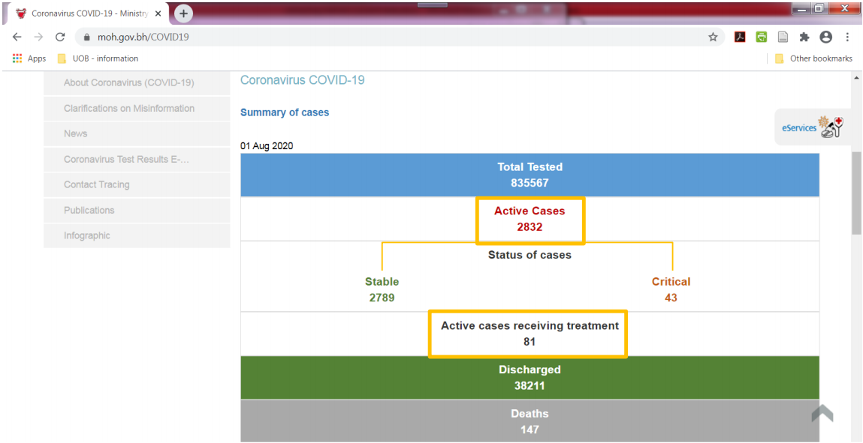

Extraction of the total beds in isolation and quarantine centers, and the number of occupied beds in each:

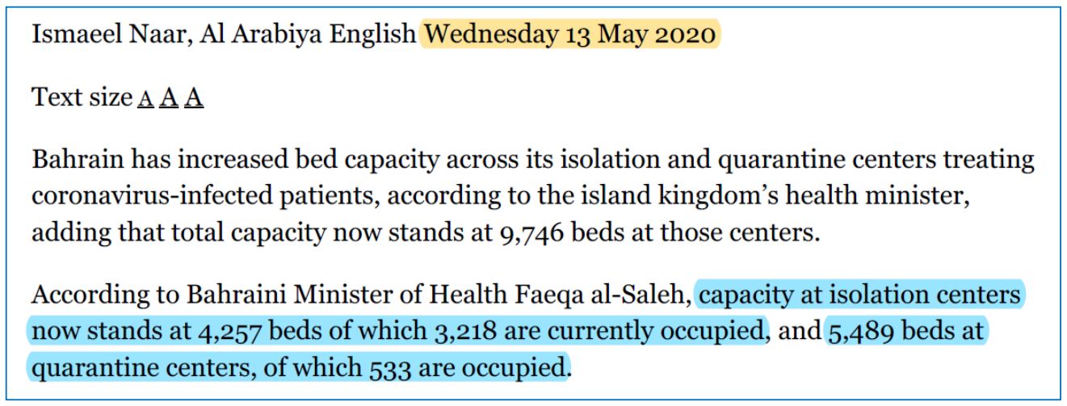

**Appendix 3 – Additional Results Plots**

