Use Case Diagram

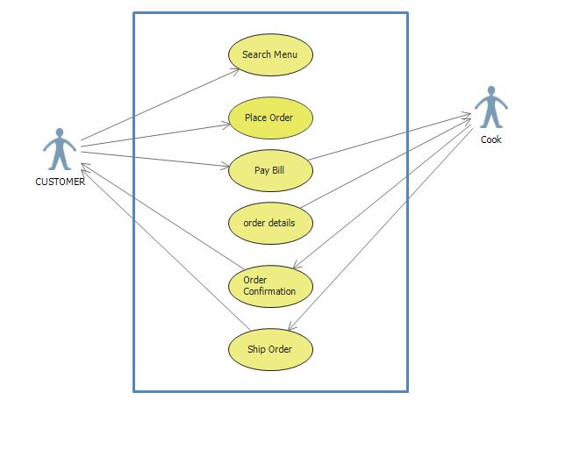

Description

Use case Title : Online Order System

Primary Actor : Customer , Cook , Payment Method

Level : 1

Stakeholders: Customer

Precondition: Customer visit to website

Minimal Guarantees: Rollback of any uncompleted transaction.

Success Guarantees : Food will be prepared within 10 mins.

Trigger : Customer accesses shop homepage.

Main Success Scenario :

1. Customer search for menu.
2. Customer place order.
3. Customer pay the bill using credit card, Net banking
4. Details will send to cook
5. Cook send order complete information
6. Cook ship order to Customer.

Extensions:

1. Food is not available

Customer will not place order and quit site.

1. Transaction is interrupted.

Transaction rolled back. Customer Starts again.

1. Customer cancel order within time.

All the money will be pay back to Customer.

1. Customer will not pick order.

No money will be refunded.