How to compile ？

We use cmake compile demo program，support windows and linux platfroms.

1,windows

1.1)We use cmake to generate vs2019 x86 project ,you first need to install

cmake and vs2019, and then open cmake, set the source path ,set source

code path and build bin path.As shown below:

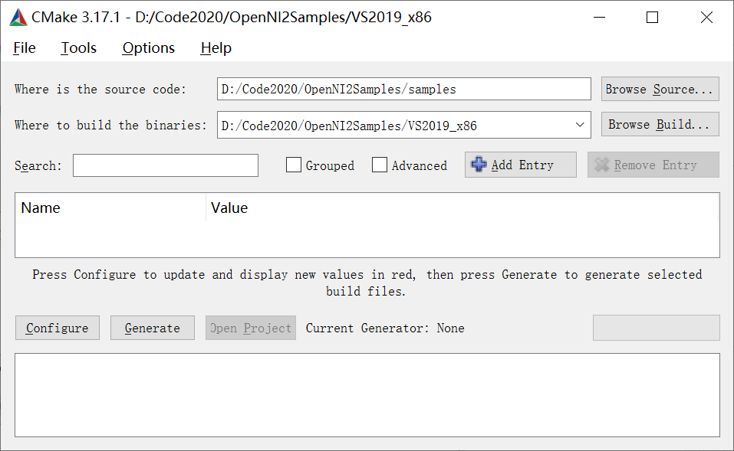

1.2)click configure,and select visual studio 16 2019, win32;As shown below:

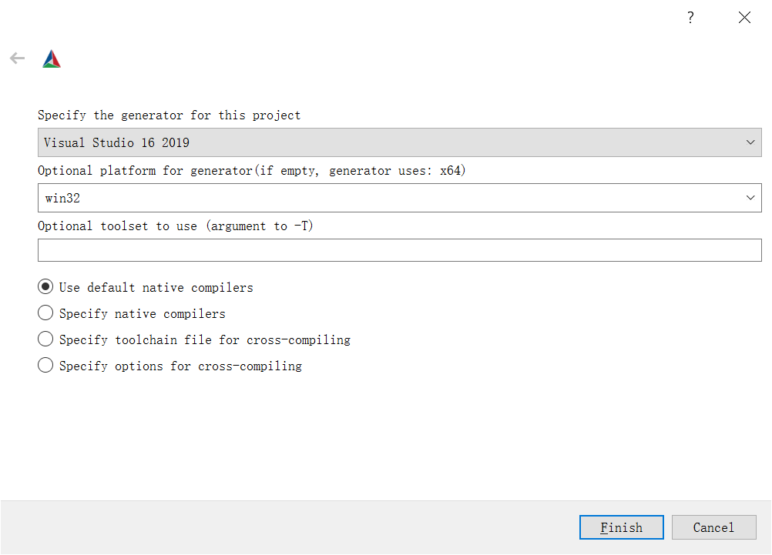

1.3)configure successfully.

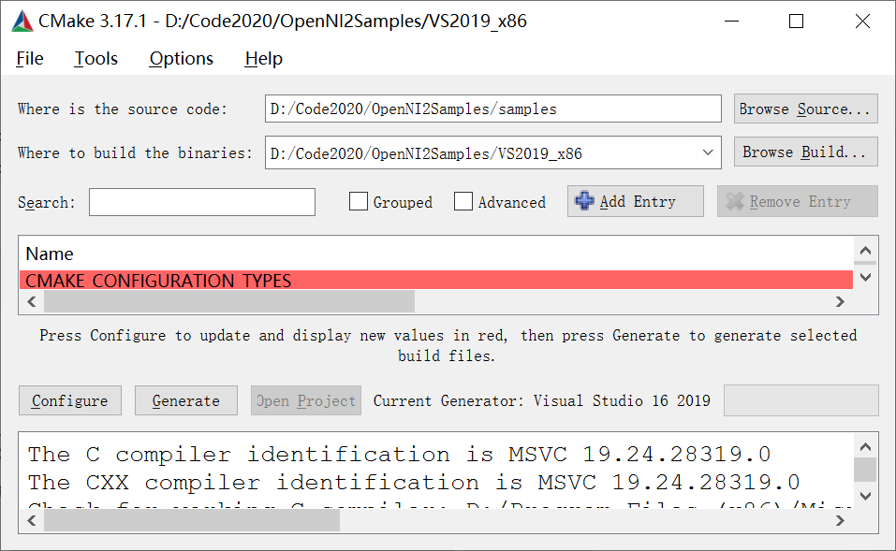

1.4 )Click Generate

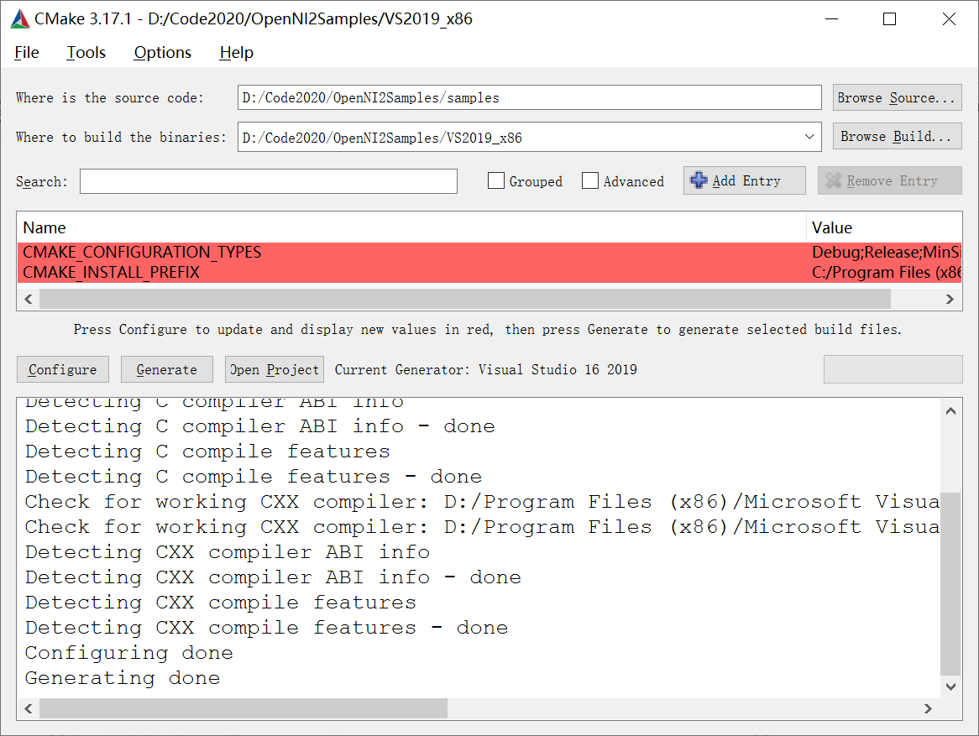

1.5)compile samples using VS2019

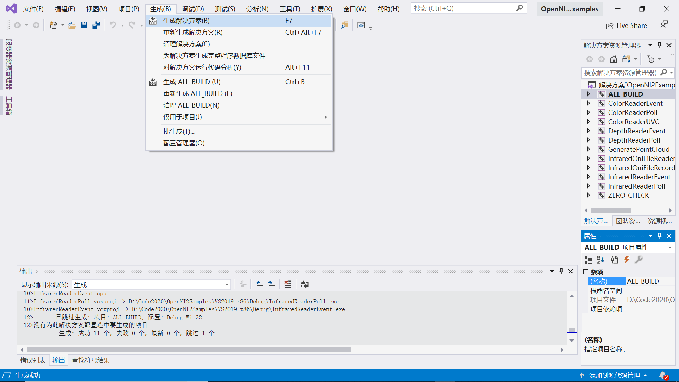

1.6) copy files bin_x86 to Debug or Release directory. If you generate x64 project, you should copy bin_x64 files to Debug or Release directory.

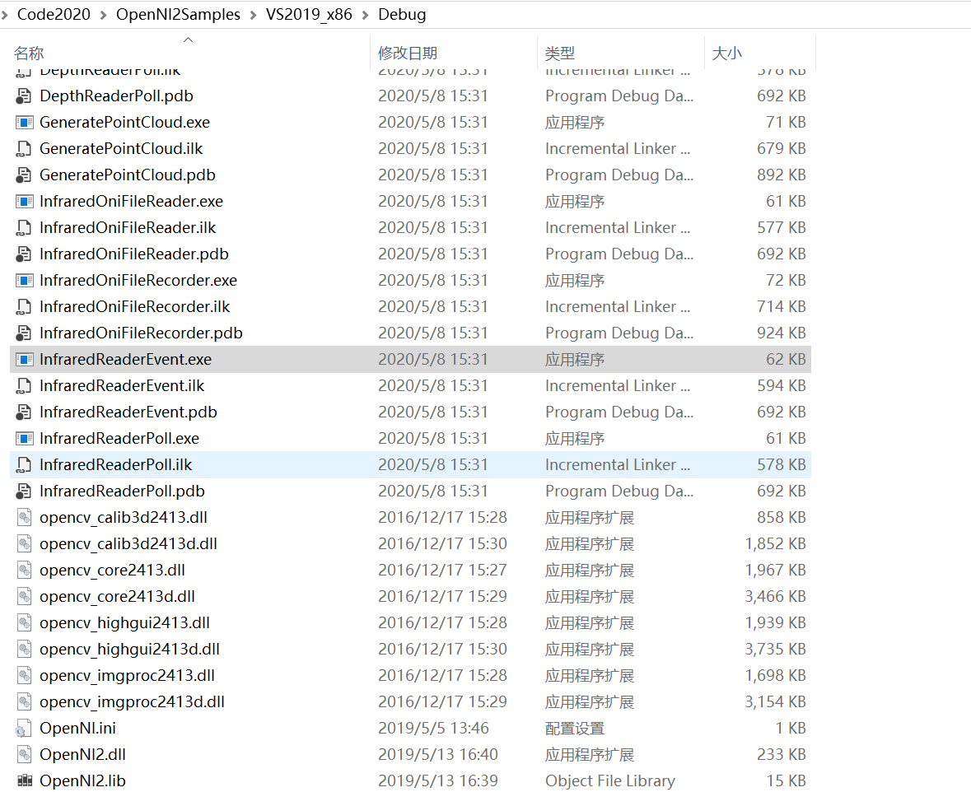

1.7) run executable files.

2,Linux

2.1)install CMake

Sudo apt-get install cmake

2.2)go to samples path

cd OpenNI2Samples

mkdir build

cd build

cmake ../samples

make