MuZero-Based Adaptive Active Sonar Target Detection Strategy: When Does Learned Planning Outperform Reactive Policies?
Rui Tan1, Fei Hu1*
1 School of Computer Science and Engineering (School of Artificial Intelligence), 【University Name】
*Corresponding author: 【advisor email】

Active sonar target detection under partial observability and noisy detections is a sequential decision problem in which each ping is expensive and information must be exploited efficiently. We study whether a model-based reinforcement learning agent (MuZero) can adaptively plan probing actions more effectively than reactive policies. We formalize the task as a POMDP over N angular sectors with a Bayesian belief filter, and build a two-level sonar simulation environment (a detection-probability abstraction for large-scale training and a signal-level LFM environment with matched filtering for validation). We compare MuZero against eight baselines — Sequential, Random, Belief-Greedy, DQN, PPO, memory-augmented DQN-GRU and PPO-Stack, and POMCP, an online POMDP planner with access to the true observation model — across Easy/Medium/Hard difficulties, five independent seeds, 1000 paired evaluation episodes per condition, and Holm-corrected paired statistical tests. Four findings emerge. First, when a calibrated belief map is directly observable, reactive methods dominate (Belief-Greedy SR=0.96, DQN SR=0.92), and MuZero underperforms (SR=0.61). Second, under a blind-search regime where the belief is not observable, MuZero significantly outperforms every learned baseline on Medium and Hard (Medium SR=0.679 vs DQN 0.335, PPO 0.303, DQN-GRU 0.448, PPO-Stack 0.339; all Holm p<0.001), and a memory-versus-planning decomposition shows that recurrent memory alone (DQN-GRU) recovers only one-third of the gap over DQN, the remainder coming from MCTS lookahead over the learned model (+0.18 in ablation). Third, POMCP with the true observation model sets an oracle ceiling (Medium SR=0.911), quantifying the headroom that remains for learned models; yet under biased priors (Hard) the same planner collapses (SR=0.173), as does Belief-Greedy (SR=0.000), while MuZero remains the best learned policy (SR=0.278, +0.104 over POMCP, p<0.001). Fourth, the information-free sequential scan is the most robust policy on Hard (SR=0.432) and should not be dismissed as a baseline. These results delineate the conditions under which MuZero-style planning pays off: planning matters when observation structure degrades belief sufficiency, and a learned model is more robust to prior misspecification than exact inference over a wrong prior.

1. Introduction

1.1 Background and motivation
Underwater target detection and localization is a foundational capability for ocean resource exploration, underwater engineering, maritime security, and marine scientific observation. Among all sensing modalities, acoustic waves are the only information carrier that propagates over long distances underwater [1], making active sonar the primary and most effective means of remote underwater detection.
Conventional active sonar operates in an open-loop mode: the transmitter emits a signal with fixed frequency, pulse width, power, and beam pointing, while the receiver performs beamforming, matched filtering, and CFAR detection on the returns [1][8]. When the target position is highly uncertain and the environment varies, this fixed policy wastes emission resources on low-value bearings, leading to low detection efficiency, high energy cost, and high exposure risk.
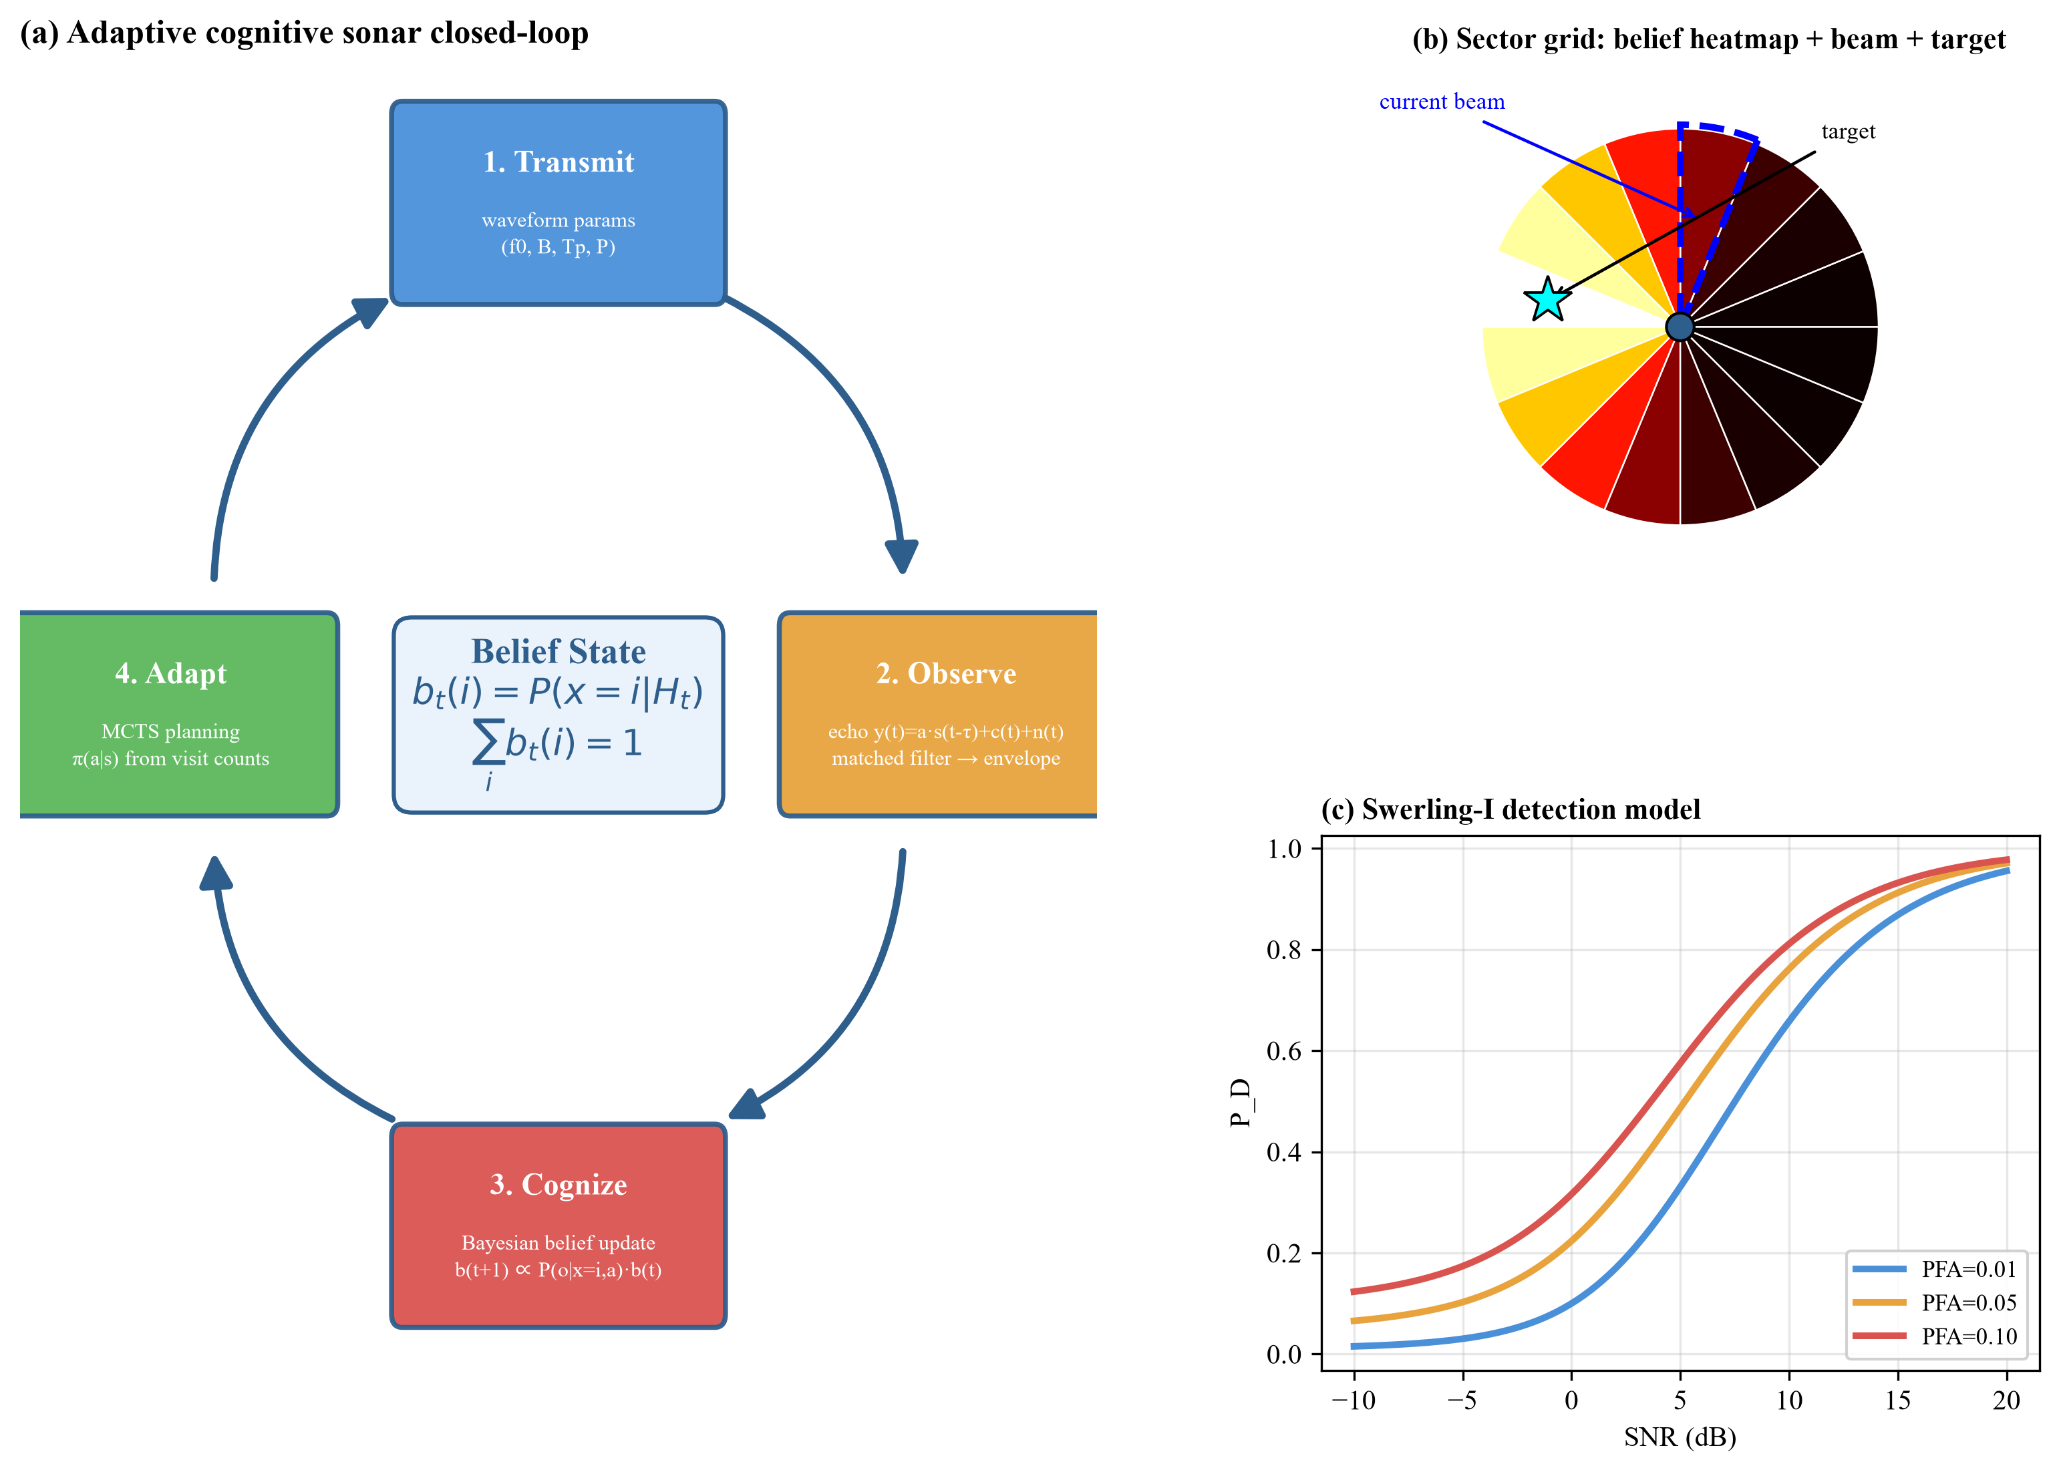
Figure 1-1 The adaptive cognitive sonar closed-loop: (a) four-stage transmit-observe-cognize-adapt cycle, (b) sector grid with belief heatmap and current beam, (c) Swerling-I detection model
To overcome these limitations, cognitive sonar was proposed, borrowing from cognitive radar, with the idea of a closed-loop adaptive detection chain: sense, observe, adapt, and re-transmit [6][7]. The sonar actively adjusts its next emission parameters (frequency, pulse width, gain, beam pointing) based on the current echo, matching the transmit signal to the current environment and task objective. However, most existing adaptive strategies rely on heuristic rules or single-step greedy policies — for example, probing harder near a strong echo and moving to adjacent bearings otherwise. Such rules lack multi-step planning and cannot make globally optimal arrangements for which bearings to probe first, which to check next, and when to converge.
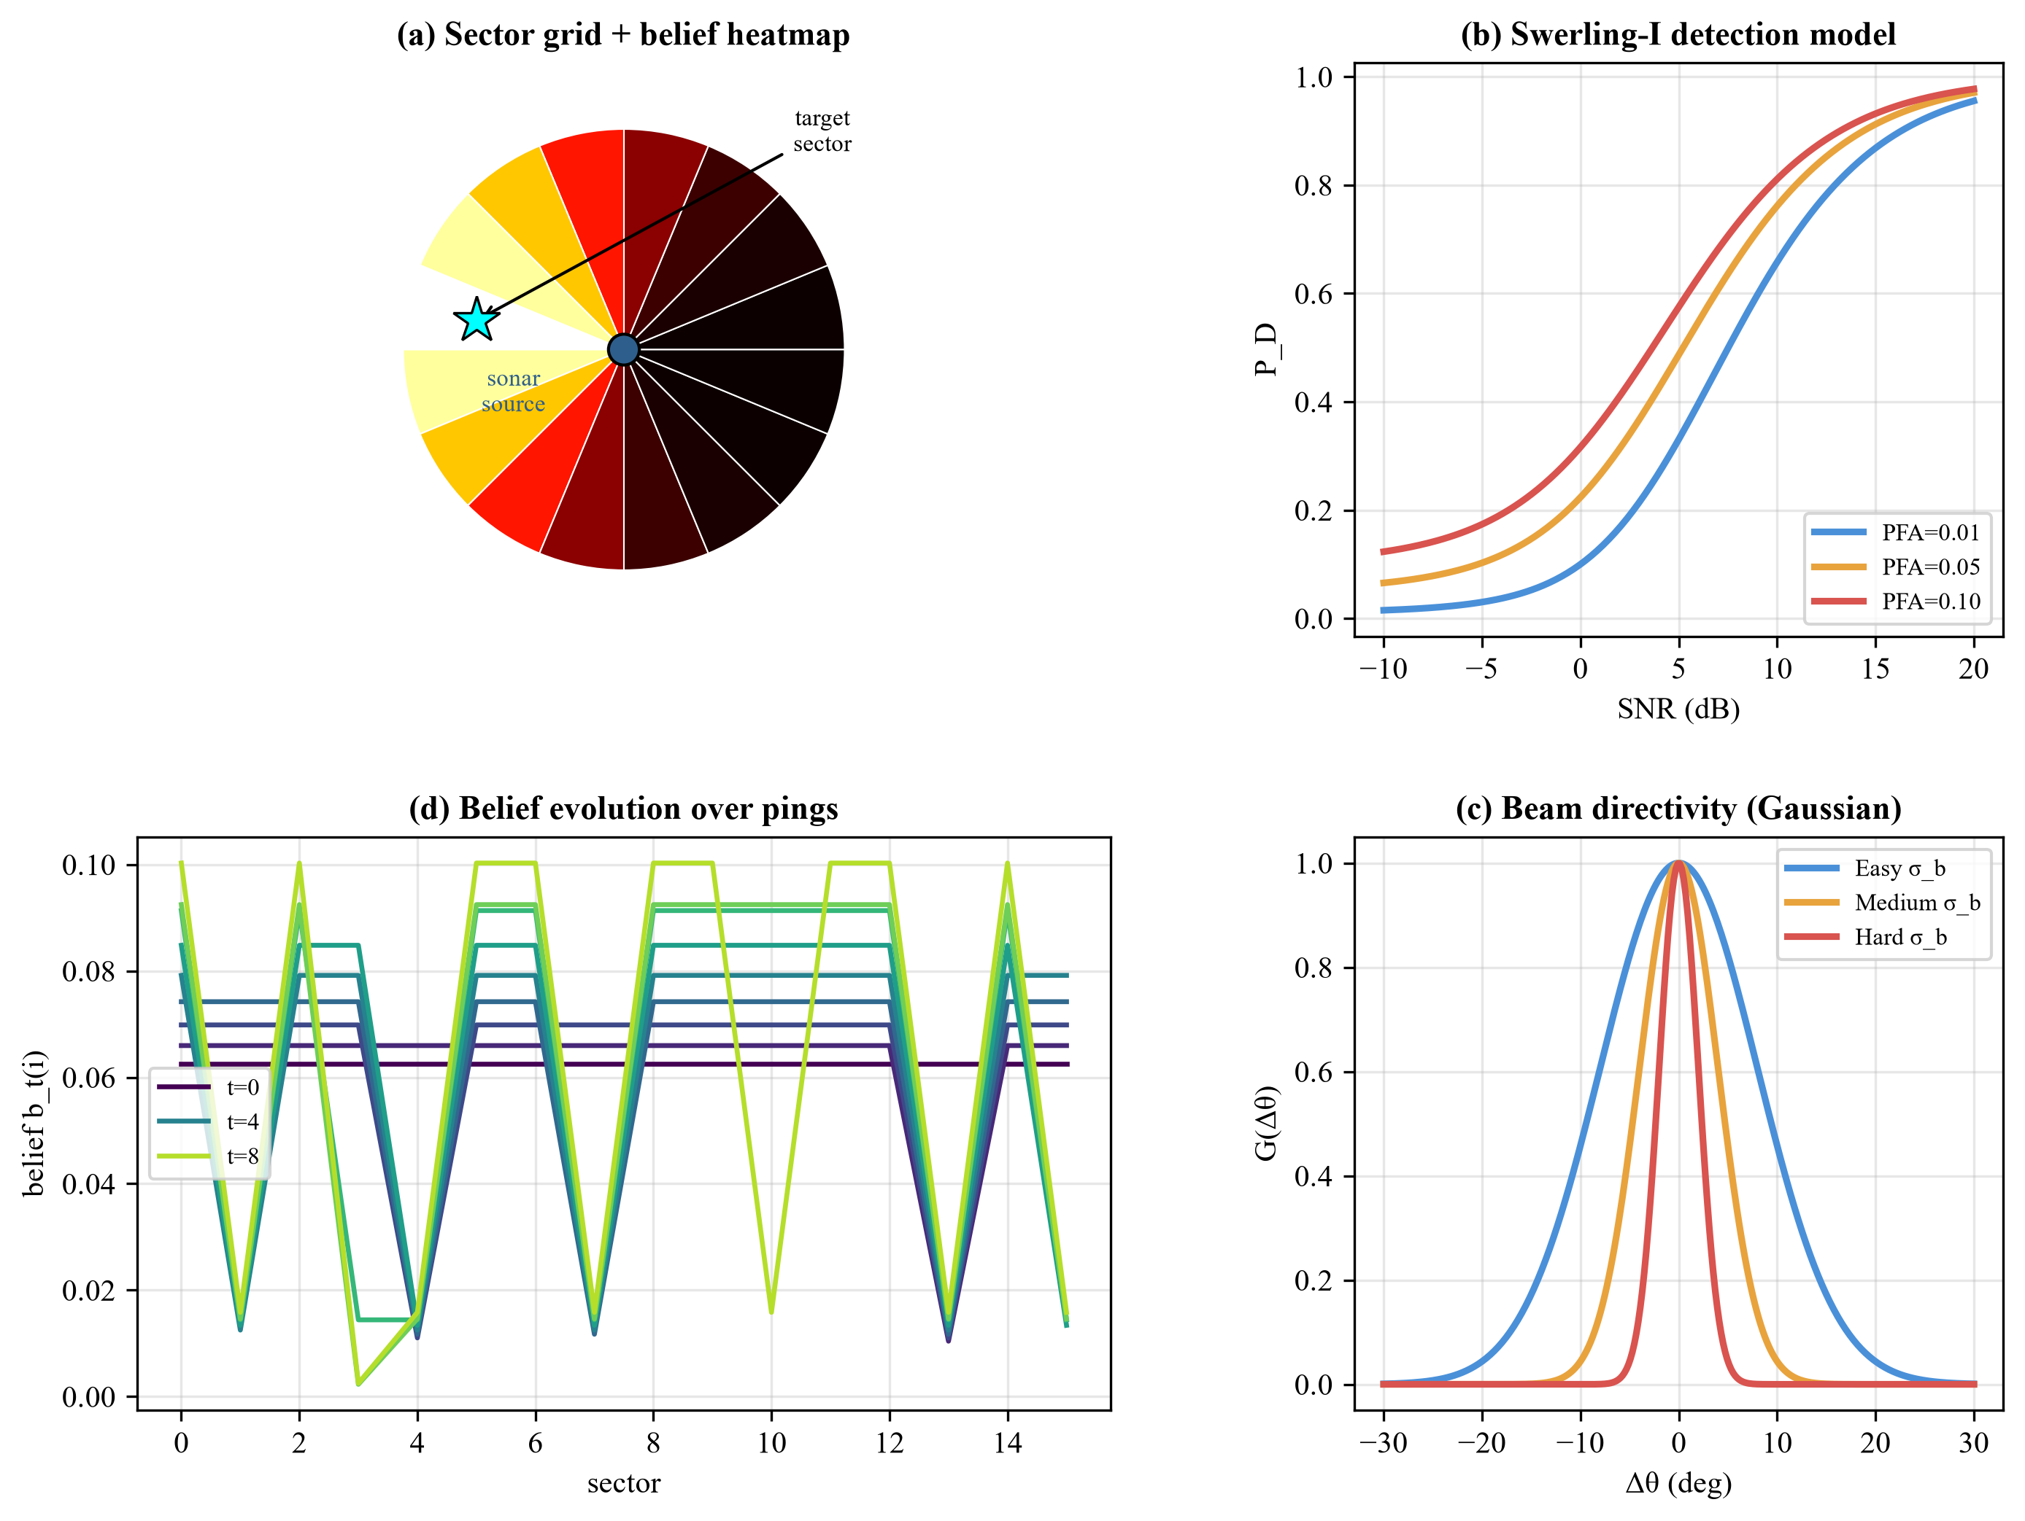
Figure 1-2 The active sonar search scenario: (a) sector grid + belief heatmap, (b) Swerling-I detection model, (c) beam directivity, (d) belief evolution over pings
More recently, model-free deep reinforcement learning (DQN, PPO, SAC) has been applied to sensor management and underwater target search [30][31][32], demonstrating that learned policies can outperform fixed rules. Yet model-free methods suffer from low sample efficiency — they require large interaction budgets — and learn only an implicit mapping from current observation to action, lacking explicit reasoning about multi-step future returns. In partially observable settings with sparse rewards, they often fall into short-sighted local optima.

1.2 Why MuZero
Model-based reinforcement learning offers a promising alternative by learning or exploiting a model of the environment to plan ahead. MuZero [2] is a representative method: it does not require an explicit reconstruction of the true environment, nor does it require a known transition model; instead, it learns an implicit latent dynamics model through interaction and performs Monte-Carlo Tree Search (MCTS) in that latent space to guide action selection. Training supervises only rewards, policy, and value through a multi-objective loss, balancing model-agnosticism with planning capability.
MuZero is well-matched to underwater active detection for three reasons. First, it bypasses the hard-to-model acoustic channel: the agent does not need to know the exact sound propagation model — it imagines the consequences of different probing actions through its learned latent model. Second, it possesses foresight: through MCTS rollouts in latent space, it weighs which sector to ping now and how future pings should continue, avoiding the myopia of single-step greedy or fixed scanning. Third, it aligns naturally with the cognitive sonar closed-loop idea: the latent model updates with each new observation, and the policy adapts online, forming a true adaptive loop.

1.3 Research questions and hypotheses
We formulate the following research questions: (RQ1) In a partially observable active sonar detection environment with missed detections and false alarms, can MuZero reduce the average number of pings required to detect the target and increase the success probability compared with baselines? (RQ2) Does multi-step lookahead planning via MCTS provide additional benefit over using only the network policy without search? (RQ3) When noise, false-alarm probability, and target priors change, does MuZero exhibit more stable robustness than fixed scanning and model-free RL? (RQ4) Do explicit belief representation and GRU history memory improve decision quality under partial observability? (RQ5) Does MuZero's performance gain come from the implicit dynamics model, the tree search, or both?

1.4 Contributions
Our contributions are fourfold. (1) We present the first systematic application of MuZero to active sonar target detection, including a complete POMDP formulation, a two-level reproducible simulation environment, and a unified benchmark with eight baselines spanning heuristics, model-free RL, memory-augmented RL (DQN-GRU, PPO-Stack), and a known-model POMDP planner (POMCP). (2) We provide a boundary characterization — we identify the observation-regime and prior-quality conditions under which model-based planning outperforms reactive policies, and show that reactive and oracle-model methods dominate when a reliable belief is available, while learned planning dominates once priors are misspecified. (3) We demonstrate through ablations and a memory-versus-planning decomposition that MuZero's advantage in blind search comes from MCTS lookahead on top of recurrent memory — memory alone (DQN-GRU) recovers only part of the gap — and we confirm the abstraction's validity by Level-1/Level-2 consistency. (4) We openly release the complete codebase, raw experimental data, trained checkpoints, and all analysis at https://github.com/94346hddjna/muzero-adaptive-sonar to support reproducibility.

2. Methods
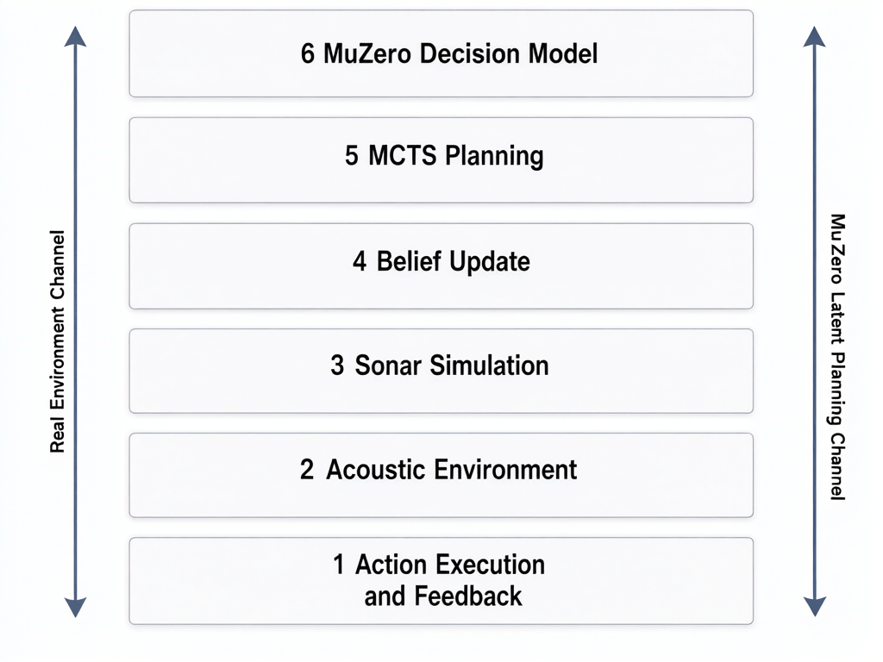
Figure 2-1 Overall system architecture: six layers with dual channels (real environment and MuZero latent planning)

2.1 Task formalization: POMDP for active detection
We consider active sonar detection in a two-dimensional bearing space partitioned into N angular sectors. A single stationary target occupies an unknown sector x ∈ {1,…,N}. At each decision step t, the agent selects a probing action a_t ∈ A = {1,…,N} (beam pointing), receives a Bernoulli detection observation o_t, and updates its belief. The episode ends when the target is correctly detected (o_t = 1 and x = a_t) or the budget T_max = 20 pings is exhausted.
$J(π) = E_π [ R_D · 1\{T_D ≤ T_max\} − λ₁ T_D − λ₂ C_E − λ₃ N_FA ]$ (1)
where π is the detection policy; T_D is the number of pings required to find the target; R_D > 0 is the one-time reward for successful detection; C_E is the cumulative energy cost; N_FA is the cumulative number of false alarms; and λ₁, λ₂, λ₃ are cost weights. The objective formalizes the requirement of detecting the target reliably with as few pings as possible.
The task is a POMDP M = ⟨S, A, T, O, Z, R, γ⟩ with hidden state space S = {1,…,N} (target sector), action space A, observation space O = {0,1} (binary detection), observation probability Z given by the detection model, reward function R, and discount factor γ ∈ [0,1). The belief state captures the partial observability:
$b_t(i) = P(x = i | H_t), Σᵢ b_t(i) = 1$ (4)
where b_t(i) is the posterior probability that the target is in sector i given the interaction history H_t. The belief is updated by Bayes' rule after each observation:
$\frac{P(o_\{t+1\} | x = i, a_t) b_t(i)}{Σ_j P(o_\{t+1\} | x = j, a_t) b_t(j)}$ (5)
The denominator is the normalization factor. Importantly, a missed detection does not simply zero out a sector's probability — the posterior decays by the miss probability (1 − P_D), while the remaining sectors' probabilities rise accordingly. This negative-observation information is precisely what multi-step active detection can exploit.
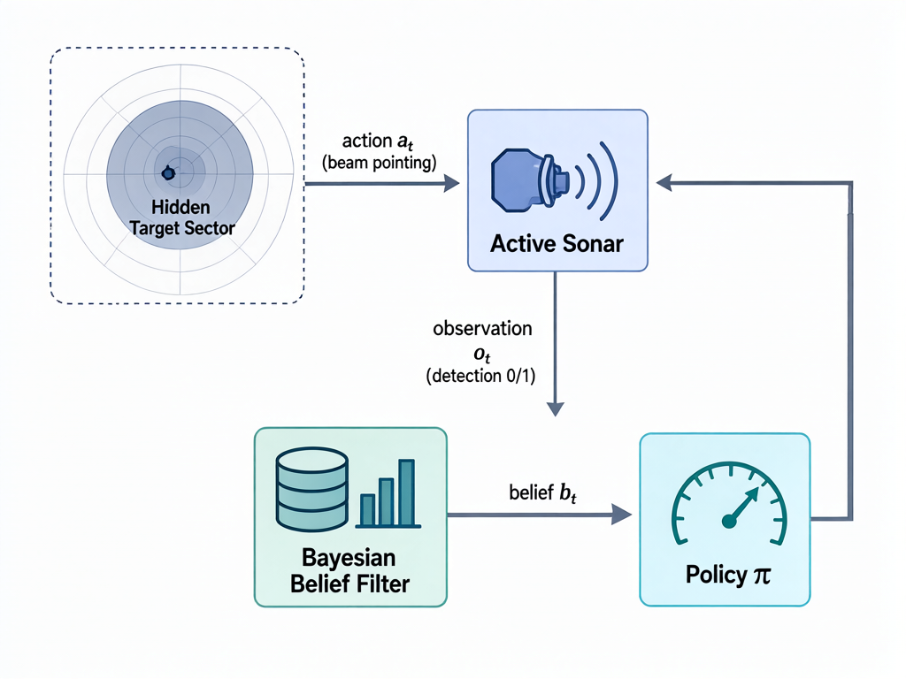
Figure 2-2 The POMDP interaction loop: hidden target sector, active sonar emission, observation, Bayesian belief update, and policy action

2.2 Acoustic environment model
The transmitted signal is the most common active-sonar waveform, a linear frequency modulated (LFM) pulse:
$s(t) = A · rect(t/T_p) · cos(2π(f₀t + ½kt²))$ (6)
where A is amplitude, T_p is pulse width, f₀ is center frequency, k = B/T_p is the chirp rate, and B is the sweep bandwidth. The received signal is modeled as:
$y(t) = α s(t − τ) + c(t) + n(t)$ (7)
where α is the combined target-reflection and propagation-attenuation coefficient, τ is the two-way propagation delay, c(t) is reverberation, and n(t) is ambient noise. The target range is determined from the two-way delay:
$\frac{c τ}{2} ⟹ R = cτ/2$ (8)
where c is the speed of sound in water (≈ 1500 m/s).
Propagation loss follows a parameterized model of spherical spreading plus absorption [1]:
$TL(R) = 20 log₁₀(R) + α_f R$ (9)
where the first term is spherical spreading and α_f is the frequency-dependent absorption coefficient (dB/m).
The transmit beam's directivity gain follows a simplified Gaussian beam pattern:
$G(Δθ) = exp( −Δθ² / (2σ_b²) )$ (10)
where Δθ is the misalignment between beam pointing and target bearing, and σ_b controls the beam width (half-power beam width ≈ 2√(2 ln 2) σ_b). When the beam is centered on the target, G is maximal; off-axis, the return energy drops.
The effective echo SNR per ping is given by the active sonar equation (in dB) [1]:
$SNR_t = SL − 2 TL(R) + TS + 20 log₁₀ G(Δθ_t) − (NL − DI)$ (11)
where SL is the source level, TL(R) is the one-way transmission loss from (9) (counted twice for the round trip), TS is the target strength, 20 log₁₀ G(Δθ_t) is the directivity loss from misalignment, NL is the background noise level, and DI is the receiver directivity index. Reverberation is not modeled as a separate time series but is folded into the background term by the specified signal-to-reverberation ratio.
Detection follows the classical threshold model in Rayleigh noise. Given a detection threshold V_T and noise envelope variance σ_n², the false-alarm probability is:
$P_FA = exp( −V_T² / (2σ_n²) )$ (12)
For a Swerling-I fluctuating target, the detection probability is [1]:
${P_FA}^{1/(1+SNR)}$ (13)
that is, P_D is jointly determined by P_FA and the SNR from (11). Given a preset SNR and P_FA, the threshold is obtained by inverting (12). The environment then samples a Bernoulli detection with the observation model:
$P(o=1 | x=a) = P_D, P(o=1 | x≠a) = P_FA$ (14)

2.3 State, observation, action, and reward
MuZero does not take the raw history H_t as input; instead, a belief-map-centered observation vector feeds the representation network:
$o_t = ( b_t, m_t, a_\{t−1\}, d_\{t−1\}, t/T_max )$ (15)
where b_t is the N-dimensional belief map; m_t is the per-sector visit count; a_{t−1} and d_{t−1} are the previous action and detection; and t/T_max is the normalized remaining budget. History is exploited via a GRU memory unit (see (17)).
The reward function combines a sparse success reward with process costs:
$r_t = R_hit · 1\{o_t=1\} − λ_s − λ_f · 1\{o_t=1, x≠a_t\} − λ_e · C(a_t)$ (16)
where R_hit > 0 is the one-time reward for a correct detection; λ_s is the per-ping emission cost; λ_f is the false-alarm penalty (constraining 'rather probe more than misreport'); and λ_e · C(a_t) captures action-dependent energy cost (degenerate in the core experiments where all actions cost equally). The step penalty directly embodies the 'few and accurate' objective; the reward is kept sparse to avoid reward hacking, and we verify via ablation (Table 3-3) whether shaped rewards alter the optimal policy.
Table 2-1 Difficulty configuration (mean P_D calibrated to target via the physical SNR equation)
Difficulty | N sectors | Target P_D | P_FA | Prior type
Easy | 8 | 0.95 | 0.01 | Concentrated (correct)
Medium | 16 | 0.85 | 0.05 | Dispersed (correct)
Hard | 32 | 0.70 | 0.10 | Biased (wrong sector)

Calibration: the physical SNR base offset is solved by bisection so that the mean detection probability over the target-bearing distribution matches the target P_D in Table 2-1. Achieved mean P_D: Easy 0.9501, Medium 0.8504, Hard 0.7011 (targets 0.95/0.85/0.70). The actual per-episode P_D distribution (std: Easy 0.051, Medium 0.129, Hard 0.196) is recorded and reported.

2.4 MuZero agent: representation, dynamics, prediction
MuZero learns three differentiable mappings that respectively encode history, imagine the future, and evaluate the present [2]. The representation network encodes the interaction history into a latent state:
$h_t⁰ = h_θ(H_t)$ (17)
implemented as a recursive encoding z_t = GRU(z_{t−1}, o_t), h_t⁰ = φ(z_t), where z_t is the GRU hidden output and φ is a linear map. This recursive encoding lets the agent exploit the full interaction history without storing the complete sequence.
The dynamics network predicts the consequence of an action in latent space:
$(r_t^k, h_t^\{k+1\}) = g_θ(h_t^k, a^k)$ (18)
where the superscript k denotes the k-th step of imaginary rollout from the current time, and a^k is a hypothetical action. The prediction network produces a policy prior and value estimate from a latent state:
$(p_t^k, v_t^k) = f_θ(h_t^k)$ (19)
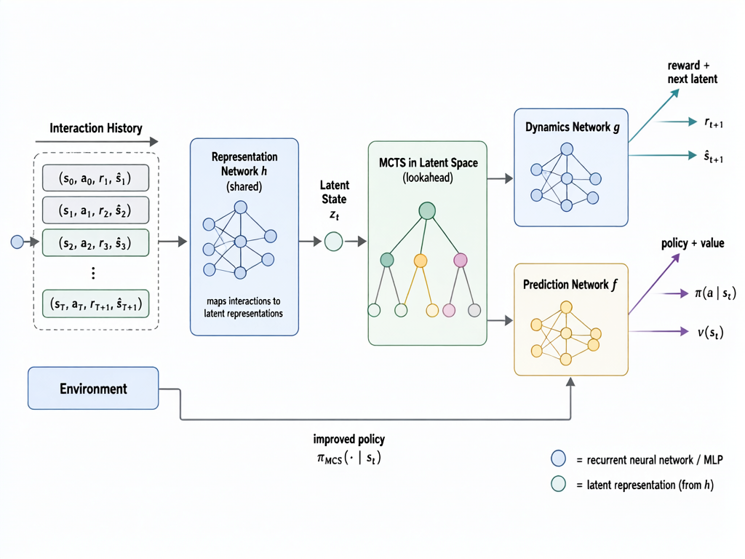
Figure 2-4 MuZero architecture: representation network encodes history into a latent state; dynamics and prediction networks drive MCTS planning in latent space
where p_t^k is a softmax-normalized policy prior over actions and v_t^k is the value estimate of the latent state. We emphasize that MuZero does not predict raw sonar waveforms; its latent state carries no physical interpretation — it learns latent dynamics that are useful for predicting rewards and for planning, which is precisely why it can plan under conditions where the acoustic channel is hard to model exactly.
Table 3-2 MuZero three-network architecture (adopted from Table 3 of the proposal)
Module | Input dim | Hidden structure | Output dim | Activation | Function
Representation h_θ | 2N+3 | FC(256)→GRU(256)→FC(128) | 128 (latent) | ReLU | history→latent
Dynamics g_θ | 128+N (action embed.) | FC(256)→FC(256) | 128+1 (reward) | ReLU | latent transition
Prediction f_θ | 128 | FC(256)→FC(256) | N+1 | ReLU+Softmax | policy prior + value
Policy head (f_θ) | 256 | FC(N) | N | Softmax | action prob.
Value/reward head | 128 | FC(1) | 1 | Linear | scalar regression

2.5 MuZero training objective
The training target uses an n-step bootstrapped return:
$z_t = Σ_\{i=0\}^\{n−1\} γ^i r_\{t+i\} + γ^n v_\{t+n\}$ (20)
where z_t is the value target at time t, n is the bootstrap horizon, and v_{t+n} is the value predicted by the network at time t+n. The equivalent immediate-reward target is obtained by difference:
$u_t = z_t − γ z_\{t+1\}$ (21)
The three networks are jointly trained with a multi-objective loss:
$\sum_{k=0}^{K}{ ( l_r(r_t^k, u_\{t+k\}) + l_v(v_t^k, z_\{t+k\}) + l_p(p_t^k, π_\{t+k\}) ) } + c‖θ‖²$ (22)
where K is the unroll depth, θ is all network parameters, c is the L2 coefficient, and the three loss terms are:
$l_r = (r − u)², l_v = (v − z)², l_p = −Σ_a π(a) ln p(a)$ (23)
where π is the improved policy from MCTS (see (26)) and the policy term is cross-entropy distillation — the network prior is pushed toward the search result, depositing the search gain into the network parameters. For implementation simplicity, value and reward use scalar regression rather than the support-set distribution of the original MuZero; if scalar regression proves unstable, a distributional value representation will be considered (a trade-off documented in the experiments).

2.6 MCTS planning with PUCT
At each decision step, Monte-Carlo Tree Search is performed from the current latent state as the root. Node selection follows the PUCT rule:
$a* = arg max_a ( Q(s,a) + U(s,a) )$ (24)
$U(s,a) = c(s) · P(s,a) · √N_b(s) / (1 + N(s,a)), c(s) = c₁ + ln(N_b(s)+c_base)/c_base$ (24)
where Q(s,a) is the action value, P(s,a) is the policy prior from the prediction network, N(s,a) is the visit count, N_b(s) is the parent total visit count, c(s) is a slowly growing exploration coefficient, and c₁, c_base are exploration constants.
The search cycles through four phases: (1) selection — descend the tree by (24) to a leaf; (2) expansion — generate the child latent state with the dynamics network; (3) evaluation — obtain the leaf's value and prior from the prediction network; (4) backup — propagate the leaf value up the search path, updating statistics with the n-step discounted return:
$G^k = Σ_τ γ^τ r^\{k+1+τ\} + γ^\{l−k\} v^l, Q(s,a) = W(s,a)/N(s,a)$ (25)
where l is the depth reached in the simulation, and r and v are the network's reward and value outputs on the imagined trajectory; W(s,a) is the cumulative value sum, and Q is the mean estimate. After the search, the root visit counts are tempered into the improved policy:
$\frac{N(s,a)^\{1/τ\}}{Σ_b N(s,b)^\{1/τ\}}$ (26)
where τ is a temperature annealed from 1.0 to 0.25 during training; at evaluation τ = 0 (argmax over visit counts). The root prior is perturbed with Dirichlet noise during training to maintain exploration diversity. The default configuration uses 100 simulations and planning depth 5 (selected on the validation split); we treat simulation count (25/50/100/200) and planning depth (1/3/5/10) as ablation variables to analyze the performance-computation tradeoff.

2.7 Baselines
We compare MuZero against eight baselines spanning three families: heuristic policies (Sequential, Random, Belief-Greedy), a known-model POMDP planner (POMCP), and model-free learned policies with and without memory (DQN, PPO, DQN-GRU, PPO-Stack). Sequential scans sectors in fixed cyclic order. Random samples uniformly at each step. Belief-Greedy picks the sector with the highest current posterior probability:
$a_t = arg max_\{i∈S\} b_t(i)$ (27)
Belief-Greedy explicitly exploits belief information and is the most direct single-step-greedy-vs-multi-step-planning control. DQN [4] receives the same observation vector as MuZero and outputs Q-values per action, trained with experience replay, a target network, and ε-greedy exploration:
$L_DQN = E[ ( r_t + γ max_\{a′\} Q⁻(s_\{t+1\},a′) − Q(s_t,a_t) )² ]$ (28)
where Q⁻ is the target network. PPO [5] is a model-free policy-gradient method with clipped objectives:
$r_t(θ) = π_θ(a_t|s_t) / π_\{θ_old\}(a_t|s_t)$ (29)
$L^CLIP(θ) = E_t[ min( r_t(θ) A_t, clip(r_t(θ), 1−ε, 1+ε) A_t ) ]$ (30)
where A_t is the advantage estimate and ε is the clip parameter.
To isolate the contribution of memory from that of planning, we additionally evaluate two memory-augmented variants of the learned baselines. DQN-GRU replaces the feed-forward Q-network with a GRU [35] (256 units) over the per-step raw observation (action one-hot, detection, normalized time), followed by a Q-head, in the spirit of Deep Recurrent Q-Learning [36] — it receives the same raw observation stream as MuZero and must integrate detection history through its recurrent state. PPO-Stack stacks the last K = 8 raw frames into a 1552-dimensional vector for the actor-critic, the standard frame-stacking remedy for partial observability. Both are trained with the same 2×10⁶ environment-step budget, the same validation-based model selection, and the same five seeds as all other learned methods.
Finally, we include POMCP [34], a dedicated online POMDP planner, as a known-model reference. POMCP maintains a particle filter (500 particles) over the target sector and plans at each step with PUCT tree search (200 simulations, depth 10, γ = 0.99 — the same selection rule and discount as MuZero's MCTS) using the true observation model, i.e., the exact per-episode detection probability PD and false-alarm probability PFA. POMCP therefore requires information that is unavailable in practice and is never given to any learned method; it serves as an oracle-model upper bound that quantifies the headroom left by model-free and learned-model approaches. We deliberately do not handicap it: if a known-model planner dominates everywhere, that is the honest answer.
Table 3-3 Method comparison (extended from Table 5 of the proposal)
Method | Env. model | Lookahead | Belief use | Param. learning | Multi-step
Sequential | None | None | No | No | No
Random | None | None | No | No | No
Belief-Greedy | None | Greedy (1-step) | Yes (filter output) | No | No
POMCP | True (oracle) | Explicit (PUCT) | Yes (particles) | No | Yes
DQN | None | Implicit (value fn.) | No (raw hist.) | Yes | No
PPO | None | Implicit (policy grad.) | No (raw hist.) | Yes | No
DQN-GRU | None | Implicit (value fn.) | Implicit (GRU state) | Yes | No
PPO-Stack | None | Implicit (policy grad.) | Implicit (frame stack) | Yes | No
MuZero (ours) | Learned latent | Explicit (MCTS) | Implicit (GRU state) | Yes | Yes

2.8 Fair comparison protocol
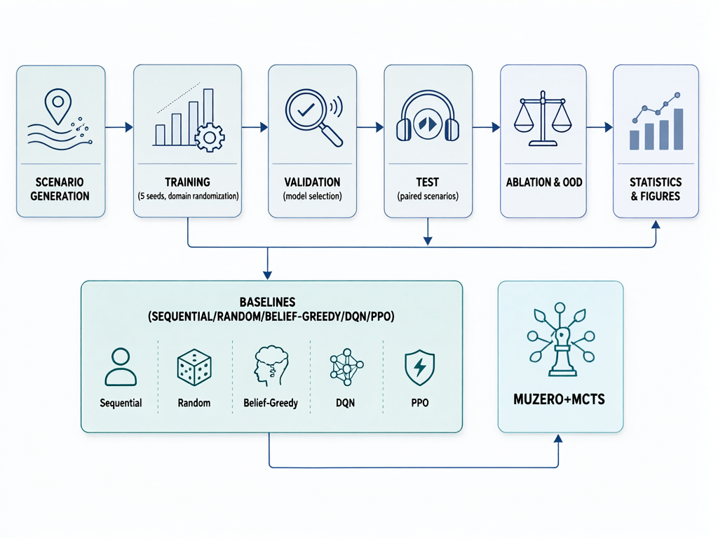
Figure 2-5 Experimental pipeline: scenario generation, training, validation-based model selection, paired testing, ablation and OOD evaluation, statistics and figures
All methods use identical training environment distribution, identical maximum episode length, identical reward function, identical observable information, identical test scenario set, and identical random seed set. For learned methods, the total environment-interaction budget is unified (1×10⁶ steps for V1, 2×10⁶ steps for V2/V3). MuZero's internal MCTS latent rollouts do not count as environment interactions, but we separately report its compute cost (training wall-clock, per-step decision latency, simulation count) so that performance and cost are presented together.

2.9 Evaluation metrics
We report: success rate SR (fraction of episodes detecting the target within budget); average detection steps ADS (successful episodes only); censored expected detection cost EDC = (1/N)Σ C_i where C_i = T_D·1{s=1} + (T_max+C_pen)·1{s=0}; false-alarm rate FAR = N_FA/N_neg (fraction of emissions outside the target's coverage that produced a detection); expected return J(π) from (1); and decision latency (mean per-step action-selection time). Relative degradation under a difficulty condition d is Drop(d) = (P_nom − P_d)/P_nom, where P_nom and P_d are nominal and difficult-condition performance.

2.10 Statistical tests
Each method is trained and evaluated with five independent seeds. Method comparisons use paired designs (identical scenario sets). Depending on the distribution of differences, we use paired t-test or Wilcoxon signed-rank test at α = 0.05, report effect sizes alongside p-values, and apply Holm-Bonferroni correction across the comparison family. All statistics are computed from per-episode raw records (results/raw/) by an automated pipeline.

3. Results

3.1 Main comparison across three observation regimes
Table 3-1 Success rate (SR) and average detection steps (ADS) across three observation regimes (5 seeds, 1000 paired episodes per condition). Memory-augmented baselines and POMCP were evaluated in the blind-search regime, the paper's main setting.
Regime | Method | SR (Easy) | SR (Medium) | SR (Hard) | ADS (Med.)
R1 belief-fed | Sequential | 0.999 | 0.899 | 0.432 | 8.8
 | Random | 0.914 | 0.663 | 0.364 | 8.7
 | Belief-Greedy | 1.000 | 0.959 | 0.000 | 2.2
 | DQN | 0.997 | 0.920 | 0.174 | 3.3
 | PPO | 0.744 | 0.473 | 0.113 | 9.0
 | MuZero | 0.674 | 0.612 | 0.175 | 8.2
R3 blind | Sequential | 0.999 | 0.899 | 0.432 | 8.8
 | Random | 0.914 | 0.663 | 0.364 | 8.7
 | Belief-Greedy | 0.999 | 0.960 | 0.000 | 2.1
 | POMCP (known model) | 0.998 | 0.911 | 0.173 | 5.8
 | DQN | 0.478 | 0.335 | 0.132 | 6.7
 | PPO | 0.471 | 0.303 | 0.108 | 11.3
 | DQN-GRU (memory) | 0.820 | 0.448 | 0.099 | 9.0
 | PPO-Stack (memory) | 0.448 | 0.339 | 0.131 | 6.6
 | MuZero | 0.725 | 0.679 | 0.278 | 8.9

Under Regime 1 (belief-informed), reactive methods dominate: Belief-Greedy achieves SR = 0.96 on Medium and DQN SR = 0.92, while MuZero reaches only SR = 0.61. This confirms that when the Bayesian belief is directly observable, the task is nearly Markov and simple reactive exploitation is sufficient. Under Regime 3 (blind search), the picture reverses for learned methods: MuZero reaches SR = 0.679 on Medium, significantly outperforming DQN (0.335), PPO (0.303), and — critically — the memory-augmented variants DQN-GRU (0.448) and PPO-Stack (0.339) that share MuZero's raw observation stream. The oracle-model POMCP planner reaches 0.911, setting the ceiling for any method that must infer state from raw interactions. On Easy, MuZero (0.725) trails Belief-Greedy (0.999), Sequential (0.999) and POMCP (0.998), because the correct concentrated prior makes greedy exploitation essentially optimal; DQN-GRU (0.820) also edges past MuZero here, though with high seed variance (±0.121).
The memory-versus-planning decomposition is informative. Adding recurrence to DQN (DQN → DQN-GRU) raises Medium SR from 0.335 to 0.448 (+0.113), and adding frame stacking to PPO (PPO → PPO-Stack) raises it from 0.303 to 0.339 (+0.036): memory alone recovers roughly one-third of MuZero's advantage over the feed-forward baselines. The remaining two-thirds comes from search over the learned model — consistent with the ablation in Section 3.3, where removing MCTS from MuZero costs −0.18 SR. Under the biased prior of Hard, the ordering inverts in MuZero's favor: Belief-Greedy collapses to 0.000, and the oracle-model POMCP drops to 0.173 because its particle filter is initialized from the wrong prior, while MuZero — trained under domain randomization with biased priors — retains SR = 0.278, significantly above POMCP (+0.104, p < 0.001) and every other learned baseline. Only the information-free Sequential scan (0.432) is more robust, at the cost of ranking below belief-informed methods on Easy/Medium.
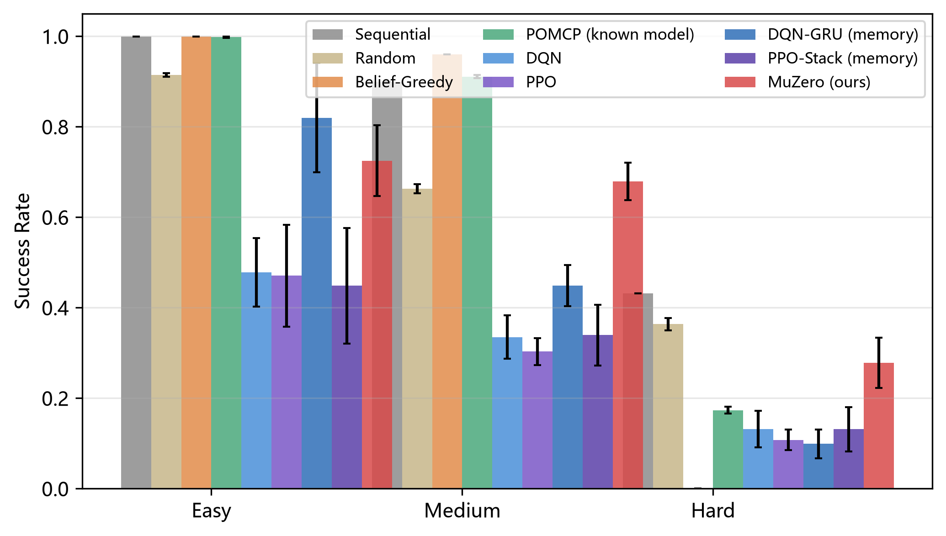
Figure 3-1 Success rate comparison across Easy/Medium/Hard difficulties (blind search regime, V3)
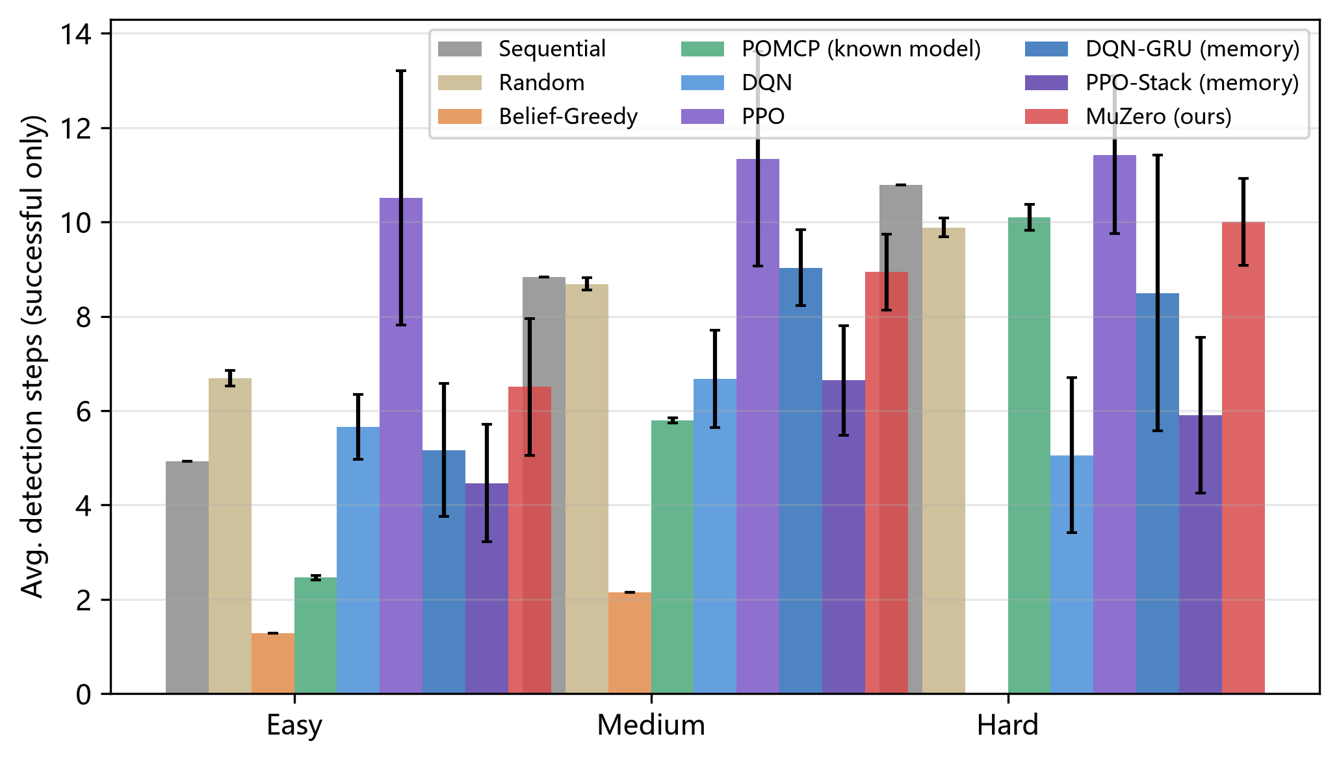
Figure 3-2 Average detection steps comparison across difficulties (successful episodes only)

3.2 Statistical significance
Paired statistical tests (Holm-corrected, α=0.05, 1000 paired scenarios per condition) on the blind-search regime (V3) confirm the picture (Table 3-2). MuZero's advantage over all four model-free learned baselines (DQN, PPO, DQN-GRU, PPO-Stack) is significant on Medium and Hard, with large effect sizes (Cohen's dz = 0.58–1.07). Against the oracle-model POMCP, MuZero is significantly behind on Easy/Medium (−0.273/−0.232) but significantly ahead on Hard (+0.104) — the biased prior poisons POMCP's particle filter, whereas MuZero's policy, trained under prior randomization, is robust to the misspecification. Against Belief-Greedy the same inversion appears (−0.281 on Medium, +0.278 on Hard). The Sequential scan remains significantly above MuZero on all difficulties, and Random ties MuZero on Medium (p = 0.14, n.s.) — both information-free policies set a robustness floor that learned planning does not yet cross.
Table 3-2 Paired statistical tests (Holm-corrected) for MuZero vs baselines in blind search (V3); full 8-comparison family in the released statistical_tests.csv
Comparison (V3) | Difficulty | ΔSR | p (Holm) | Cohen's dz
MuZero vs DQN | Easy | +0.247 | <0.001 | +0.857
 | Medium | +0.344 | <0.001 | +1.045
 | Hard | +0.146 | <0.001 | +0.594
MuZero vs PPO | Easy | +0.254 | <0.001 | +1.079
 | Medium | +0.376 | <0.001 | +1.074
 | Hard | +0.170 | <0.001 | +0.592
MuZero vs DQN-GRU | Easy | −0.095 | <0.001 | −0.404
 | Medium | +0.230 | <0.001 | +0.587
 | Hard | +0.179 | <0.001 | +0.745
MuZero vs PPO-Stack | Easy | +0.277 | <0.001 | +0.802
 | Medium | +0.340 | <0.001 | +0.929
 | Hard | +0.146 | <0.001 | +0.582
MuZero vs POMCP (oracle) | Easy | −0.273 | <0.001 | −1.087
 | Medium | −0.232 | <0.001 | −0.803
 | Hard | +0.104 | <0.001 | +0.393
MuZero vs Belief-Greedy | Medium | −0.281 | <0.001 | −0.882
 | Hard | +0.278 | <0.001 | +1.398
MuZero vs Random | Medium | +0.016 | 0.142 (n.s.) | +0.046
MuZero vs Sequential | Medium | −0.220 | <0.001 | −0.602
 | Hard | −0.154 | <0.001 | −0.315

3.3 Ablation studies
Table 3-3 MuZero ablation results in blind search (Medium difficulty, V3)
Variant | SR (Medium) | Δ vs full
MuZero (full) | 0.679 | —
w/o MCTS (policy only) | 0.499 | −0.180
w/o GRU memory | 0.608 | −0.071
w/o domain randomization | 0.642 | −0.037
Shaped reward | 0.654 | −0.024

Removing MCTS (using only the policy head without search) degrades MuZero from SR = 0.679 to 0.499 (−0.180, Holm p < 0.001), confirming that tree search is the primary contributor to MuZero's advantage (ablation A). Removing GRU memory reduces SR to 0.608 (−0.071, p < 0.001), and removing domain randomization reduces it to 0.642 (−0.037, p < 0.001). Shaped (potential-based) rewards produce no significant change (−0.024, p = 0.11, n.s.), suggesting the sparse task reward is already well-shaped by the detection objective.
Table 3-4 MCTS simulation count vs performance and latency (ablation B, Medium)
MCTS sims | SR (Medium) | Latency (ms)
25 | 0.227 | 1.6
50 | 0.536 | 3.3
100 | 0.679 | 6.7
200 | 0.608 | 13.8

MCTS simulation count shows a clear performance-compute tradeoff (Table 3-4, all at depth 5): dropping to 25 simulations collapses SR to 0.227 (−0.452 vs the 100-simulation default, p < 0.001), and 50 simulations reach only 0.536 (−0.142, p < 0.001). Interestingly, 200 simulations are significantly worse than 100 (0.608, −0.070, p < 0.001) at more than double the latency — over-searching an imperfect learned model amplifies its errors, an instance of search-model mismatch. The chosen default of 100 simulations at depth 5 is the empirical optimum. Planning depth (Table 3-5, at 100 simulations) saturates quickly: depth 1 costs −0.129 SR (p < 0.001), while depths 3, 5, and 10 are indistinguishable (paired tests vs the full model: p = 1.0), because the 20-step episode rarely rewards lookahead beyond 3 steps.
Table 3-5 MCTS planning depth vs performance (ablation C, Medium)
Planning depth | SR (Medium)
1 | 0.614
3 | 0.679
5 | 0.679
10 | 0.679

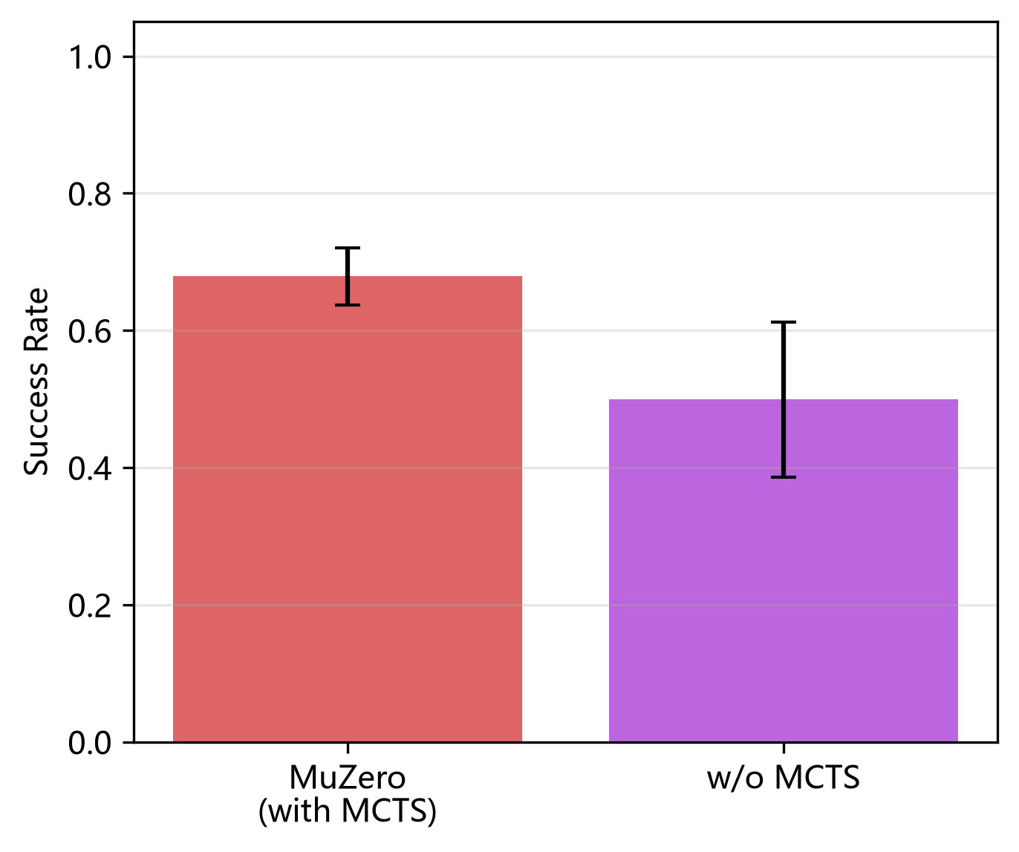
Figure 3-3 MuZero with vs without MCTS (ablation A) — MCTS contributes +0.18 SR
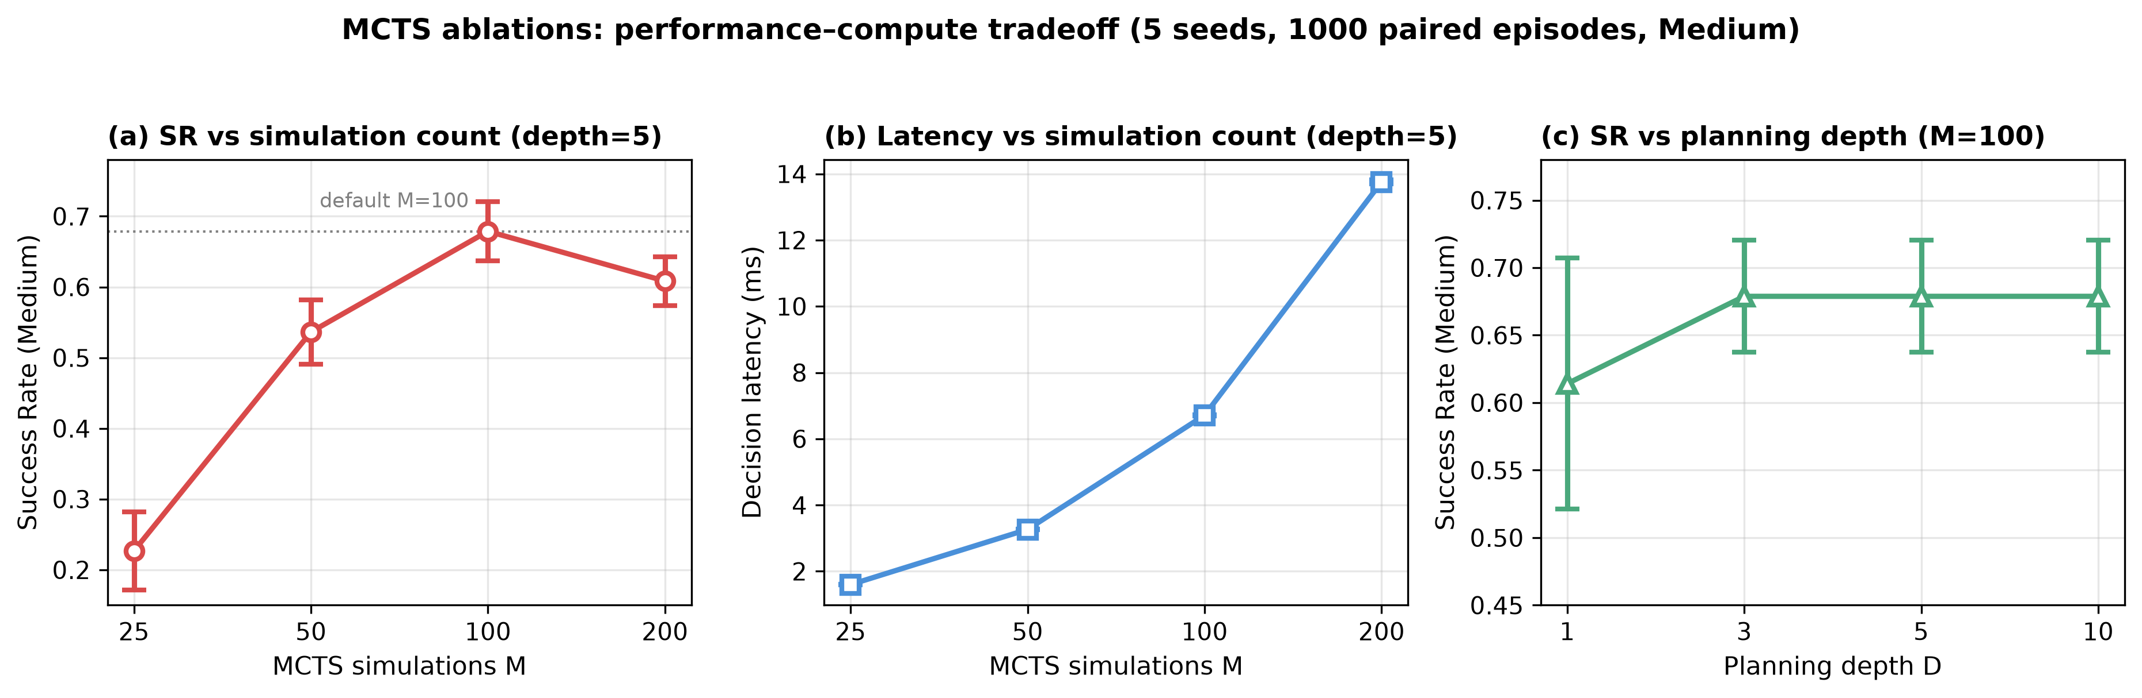
Figure 3-4 MCTS ablations: (a) simulation count vs SR, (b) simulation count vs latency, (c) planning depth vs SR
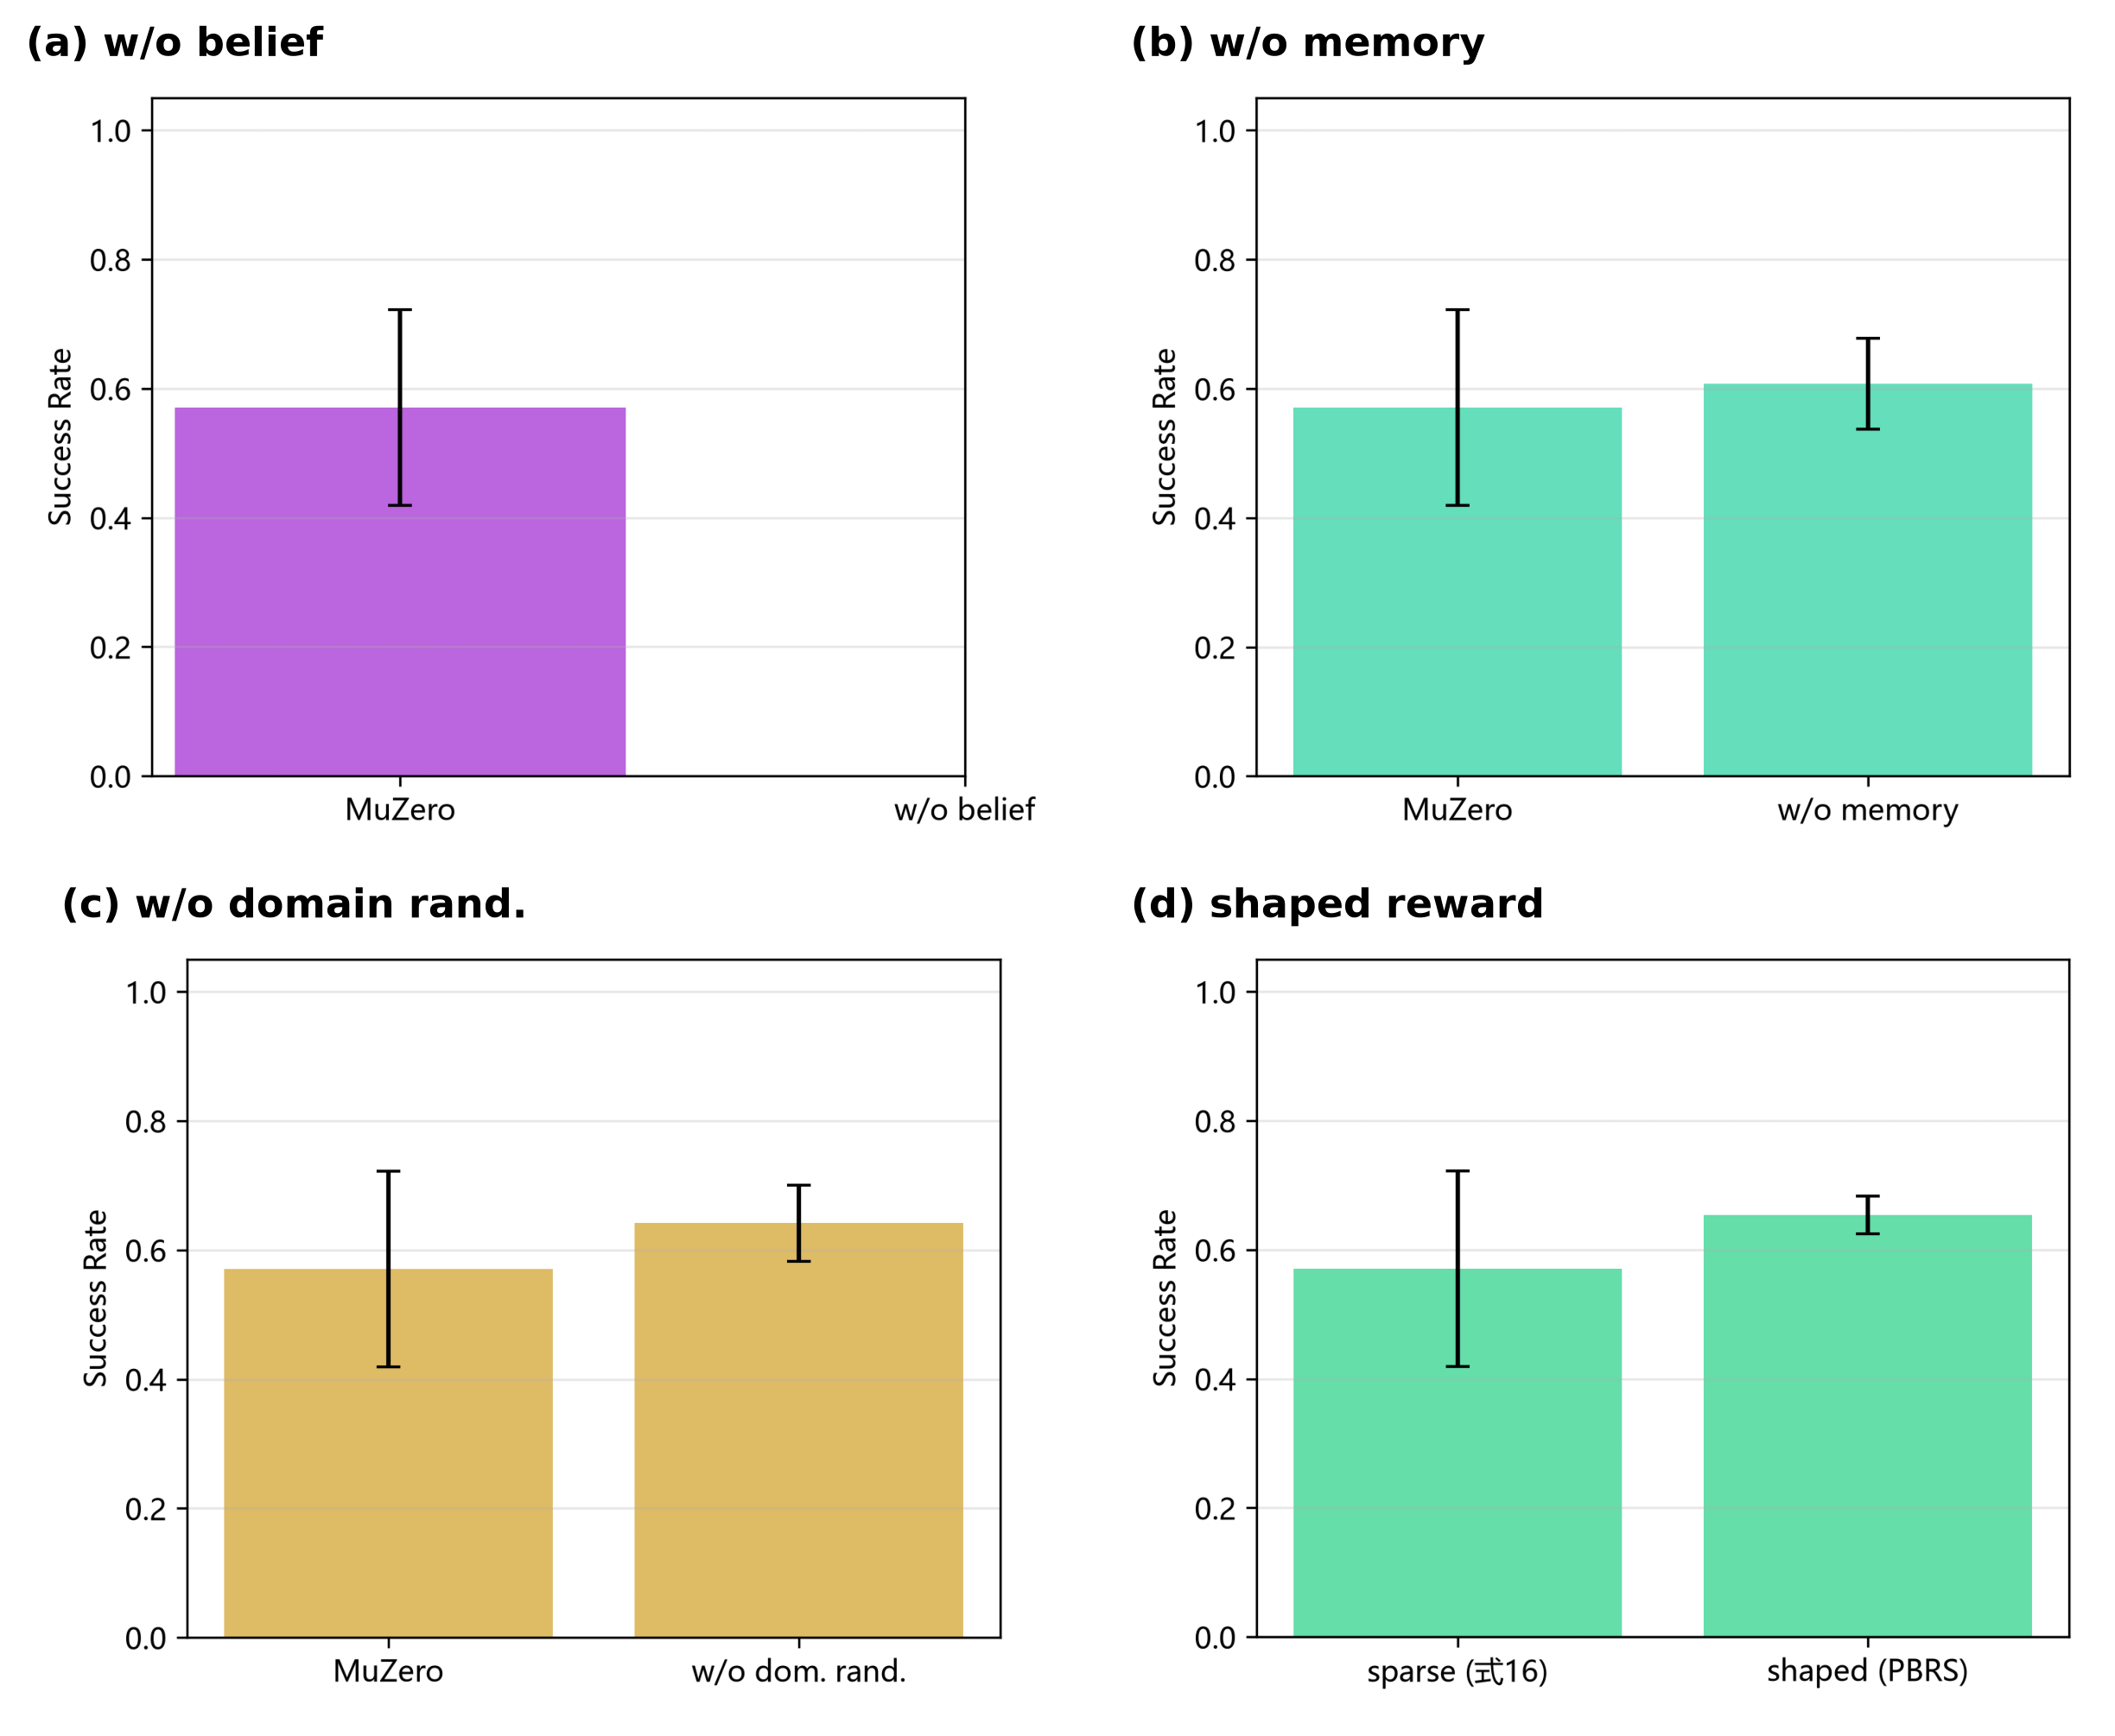
Figure 3-5 Component ablations: (a) w/o belief, (b) w/o memory, (c) w/o domain randomization, (d) shaped reward

3.4 Out-of-distribution robustness
Table 3-6 OOD robustness across all methods (blind search, V3; SR per condition, 5 seeds, paired scenarios)
Method | ID | OOD-SNR | OOD-PFA | OOD-N | OOD-Prior | OOD-Reverb
Sequential | 0.882 | 0.974 | 0.872 | 0.338 | 0.874 | 0.880
Random | 0.660 | 0.716 | 0.644 | 0.288 | 0.665 | 0.656
Belief-Greedy | 0.970 | 1.000 | 0.946 | 0.968 | 0.000 | 0.952
POMCP (known model) | 0.921 | 0.980 | 0.879 | 0.867 | 0.315 | 0.904
DQN | 0.331 | 0.354 | 0.333 | 0.063 | 0.340 | 0.334
PPO | 0.333 | 0.316 | 0.262 | 0.040 | 0.302 | 0.298
DQN-GRU (memory) | 0.470 | 0.480 | 0.454 | 0.078 | 0.452 | 0.469
PPO-Stack (memory) | 0.358 | 0.359 | 0.343 | 0.055 | 0.342 | 0.355
MuZero (ours) | 0.675 | 0.738 | 0.646 | 0.181 | 0.686 | 0.665

Under OOD-SNR (unseen +8 dB shift), MuZero's SR rises to 0.738 (better-than-ID, as expected from easier detection). Under OOD-PFA (higher false-alarm rate), SR drops slightly to 0.646. Under OOD-Prior (adversarial prior), SR holds at 0.686 — MuZero is robust to prior deception because its policy does not consume the belief; Table 3-6 shows the same structural immunity for the other blind-search learners, while belief-consuming methods degrade. The critical failure is OOD-N (48 sectors beyond the training maximum of 32): every method degrades sharply (MuZero to 0.181, Drop ≈ −73%), indicating that problem-size generalization remains a common limitation.
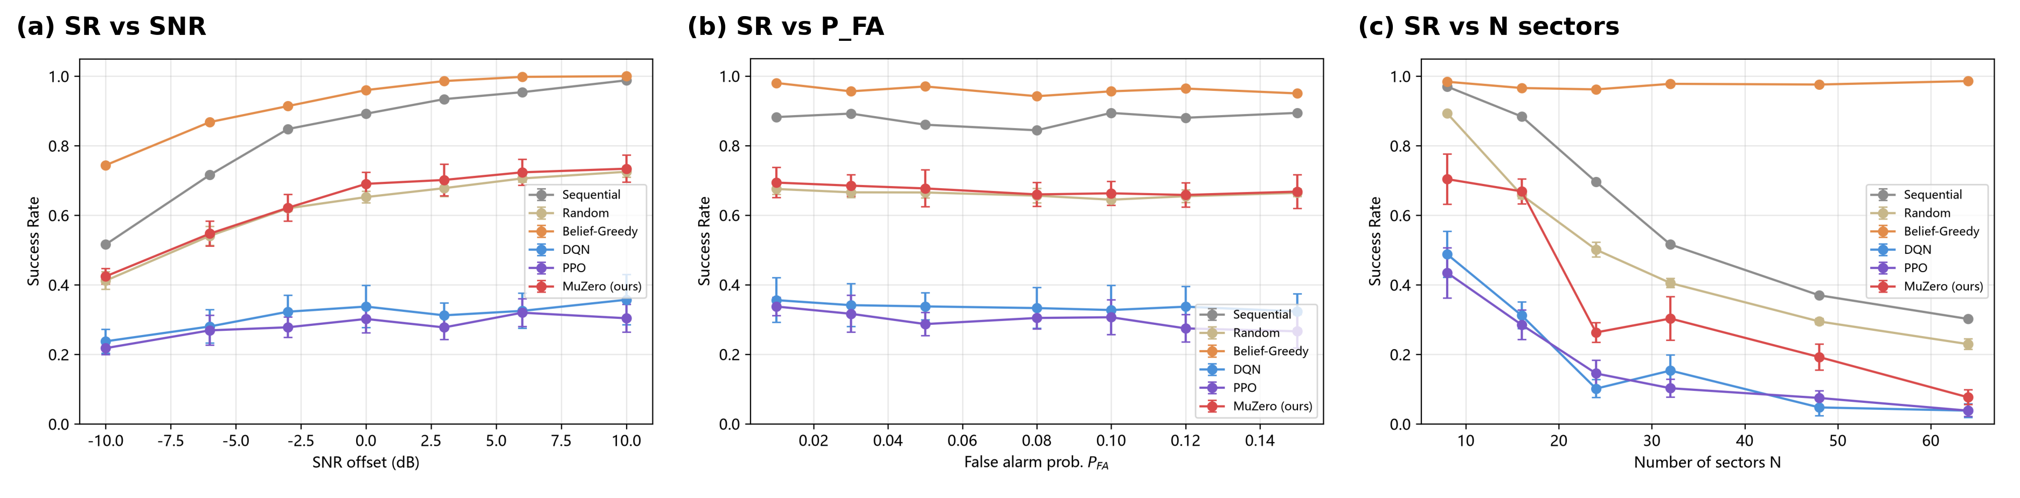
Figure 3-6 Continuous difficulty sweeps: (a) SR vs SNR, (b) SR vs P_FA, (c) SR vs number of sectors
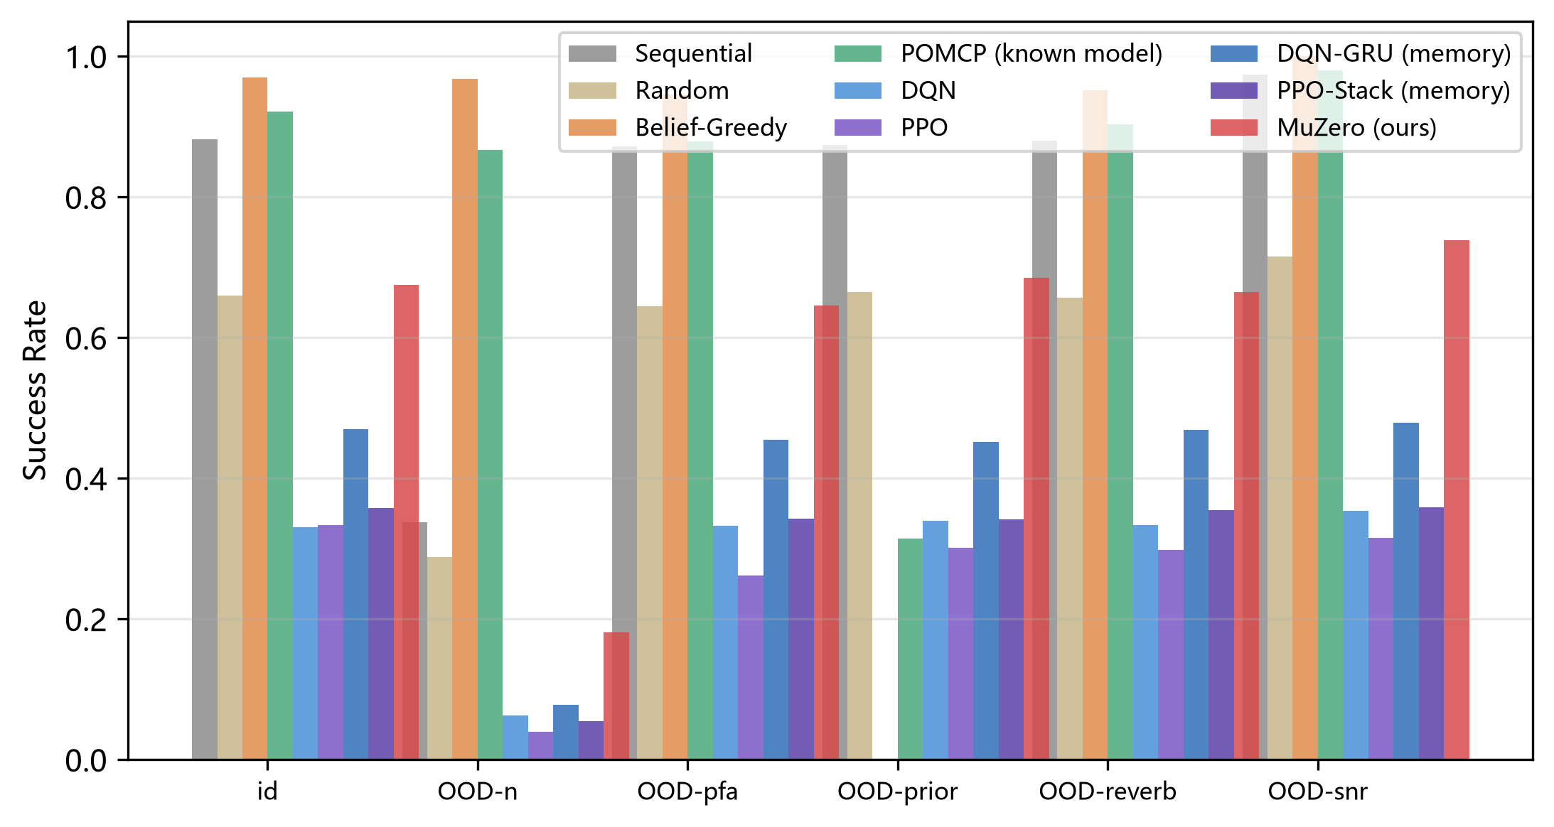
Figure 3-7 ID vs OOD performance comparison across all methods (blind search)

3.5 Prior-bias robustness
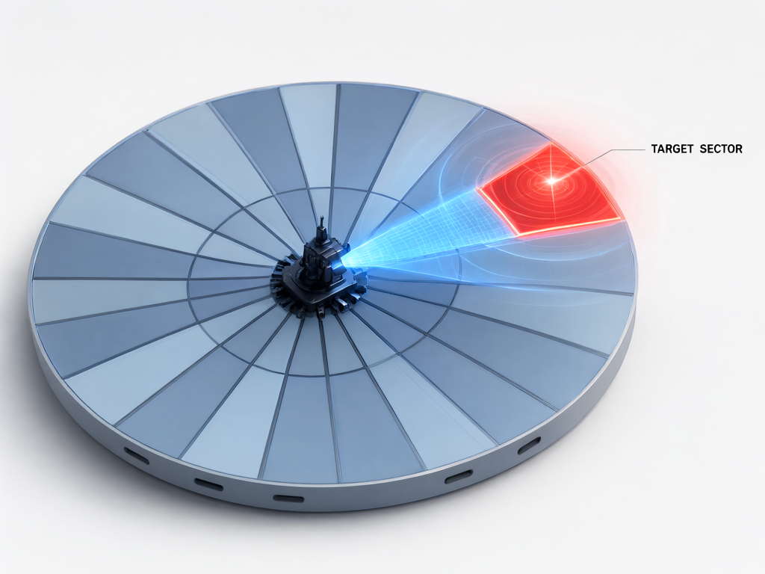
Figure 3-8 The sonar sector grid: a circular search area divided into angular sectors, with the target sector highlighted (3D rendering)
Table 3-2b Success rate under four prior types (Medium base scenarios, 1000 episodes per cell, 5 seeds for stochastic methods). Only methods that consume the prior (Belief-Greedy, POMCP) are affected by prior poisoning; blind-search learned policies are structurally prior-invariant.
Method | Uniform | Correct | Biased | Adversarial | Prior-sensitive?
Sequential | 0.878 | 0.878 | 0.878 | 0.878 | No (prior-free)
Random | 0.654 | 0.654 | 0.654 | 0.654 | No (prior-free)
Belief-Greedy | 0.847 | 0.962 | 0.422 | 0.000 | Yes — collapses
POMCP (known model) | 0.771 | 0.909 | 0.547 | 0.317 | Yes — degrades
DQN | 0.336 | 0.336 | 0.336 | 0.336 | No (blind)
PPO | 0.295 | 0.295 | 0.295 | 0.295 | No (blind)
DQN-GRU (memory) | 0.449 | 0.449 | 0.449 | 0.449 | No (blind)
PPO-Stack (memory) | 0.334 | 0.334 | 0.334 | 0.334 | No (blind)
MuZero (ours) | 0.683 | 0.683 | 0.683 | 0.683 | No (blind)

The prior-bias sweep separates the nine methods into two structurally distinct classes (Table 3-2b). Methods that consume the prior degrade as the prior worsens: Belief-Greedy falls from 0.962 (correct) to 0.000 (adversarial), and even POMCP — despite planning on the true observation model — falls from 0.909 to 0.317, because its particle filter is initialized from the poisoned prior and 20 pings are insufficient to wash it out. Blind-search learned policies (DQN, PPO, DQN-GRU, PPO-Stack, MuZero) are structurally prior-invariant: their observation stream contains no belief, so the prior cannot mislead them, and their success rate is unchanged across the four conditions. On the Hard difficulty (biased prior by construction), this structural immunity is exactly what lets MuZero (0.278) surpass both Belief-Greedy (0.000) and POMCP (0.173). The KL-divergence trajectories (Figure 3-9e) show that the belief filter itself does recover within a few pings — the failure of belief-consuming methods is therefore not a filtering failure but a decision-level one: greedy and short-horizon exploitation of a wrong posterior cannot afford the exploration needed to correct it.
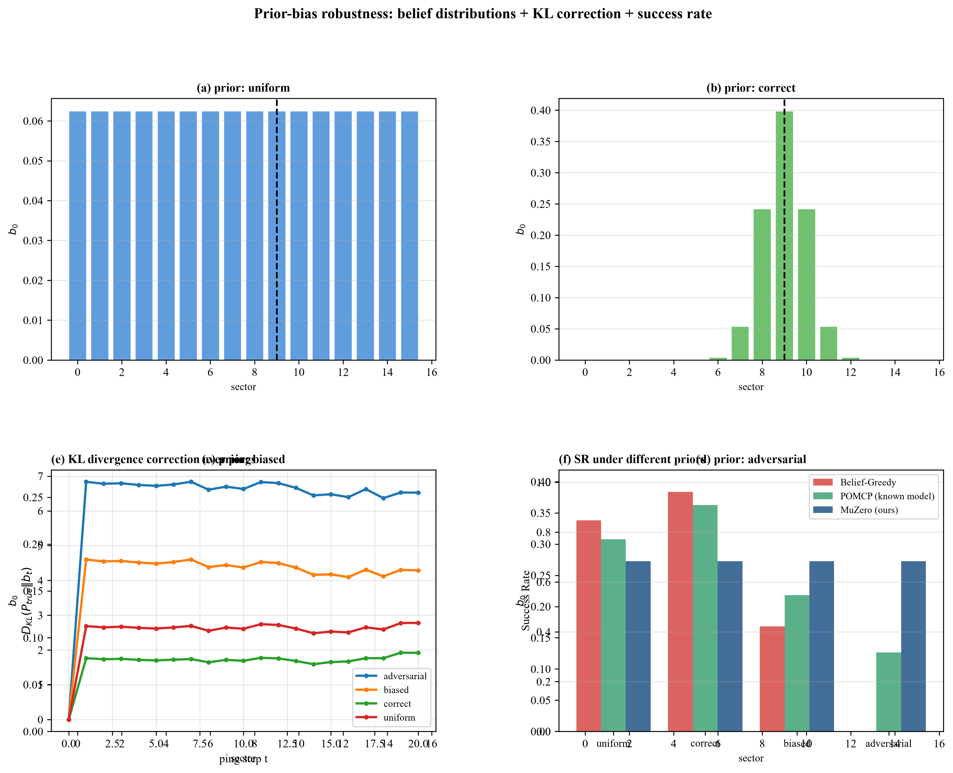
Figure 3-9 Prior-bias robustness: (a)-(d) four initial belief types over 16 sectors, (e) KL divergence correction over pings, (f) success rate under different priors
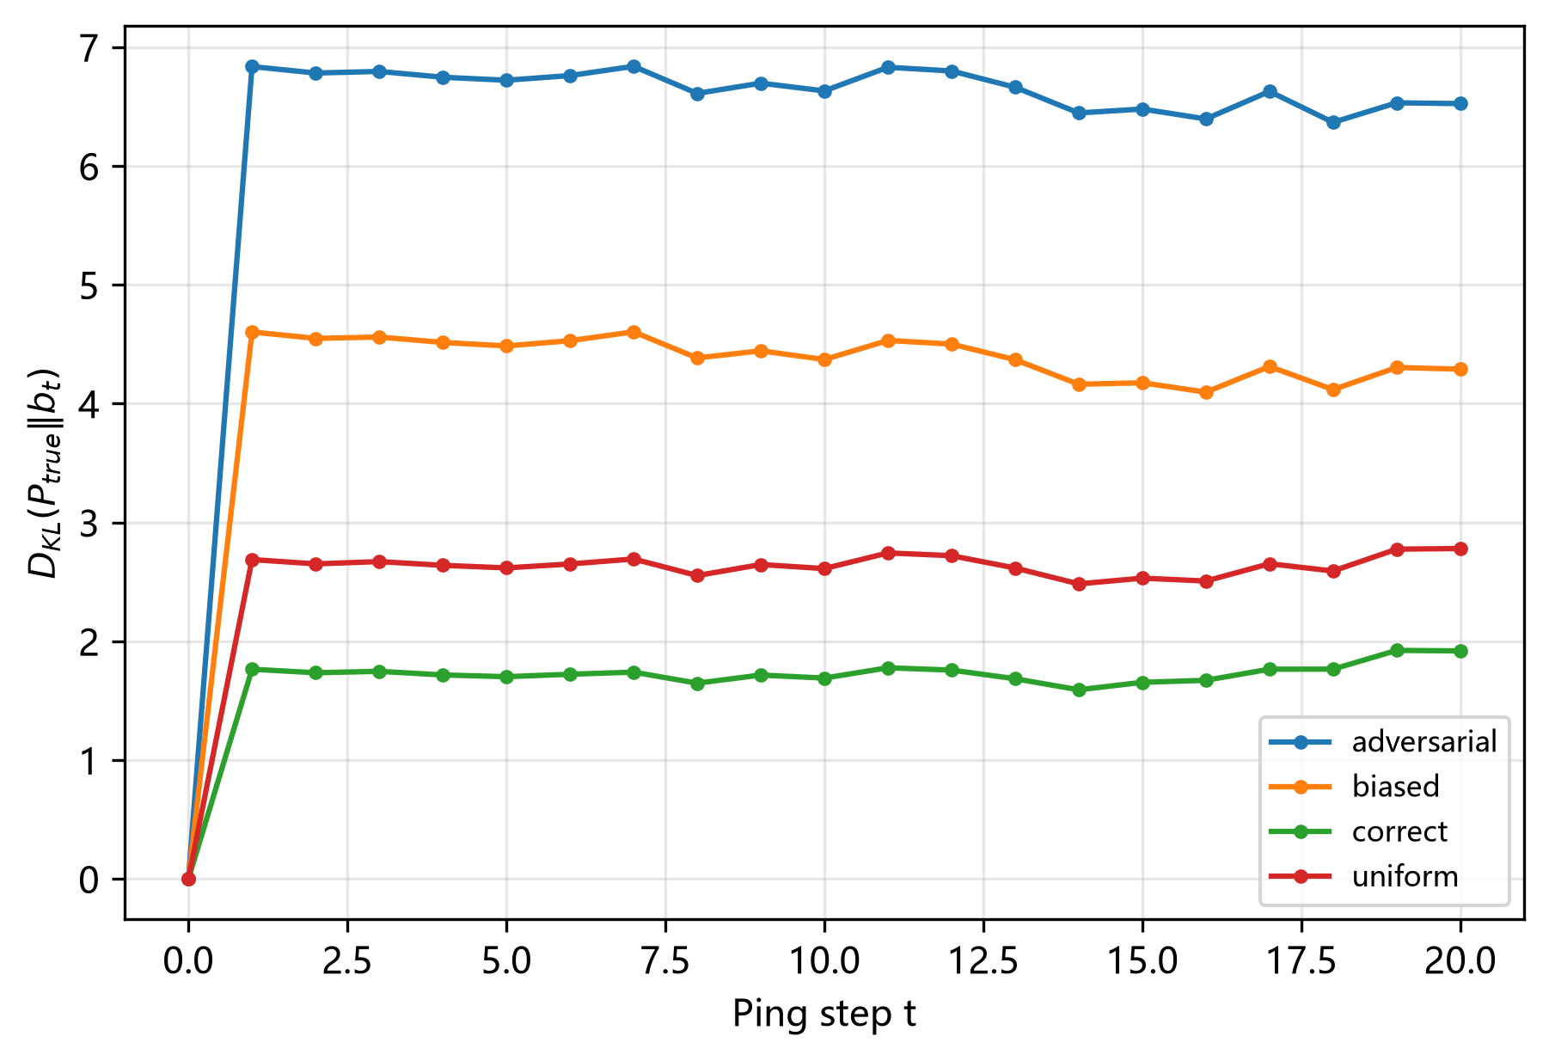
Figure 3-10 Belief correction over pings: KL divergence from true target under different initial priors
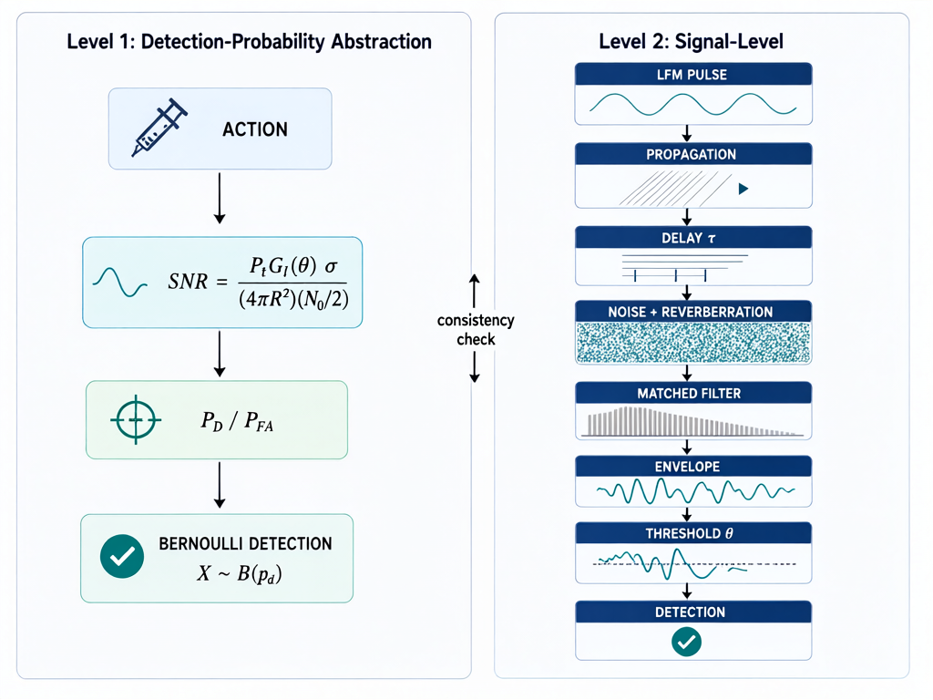
Figure 2-3 The two-level sonar simulation environment: Level 1 detection-probability abstraction vs Level 2 signal-level simulation

3.6 Level-1 vs Level-2 consistency
The signal-level environment (Level 2) produces the same method rankings as the abstract Level-1 environment: Spearman rank correlation ρ = 0.949 (Easy), 1.000 (Medium), 1.000 (Hard). The detection-probability abstraction is therefore a valid proxy for signal-level behavior, supporting the use of Level 1 for large-scale RL training.
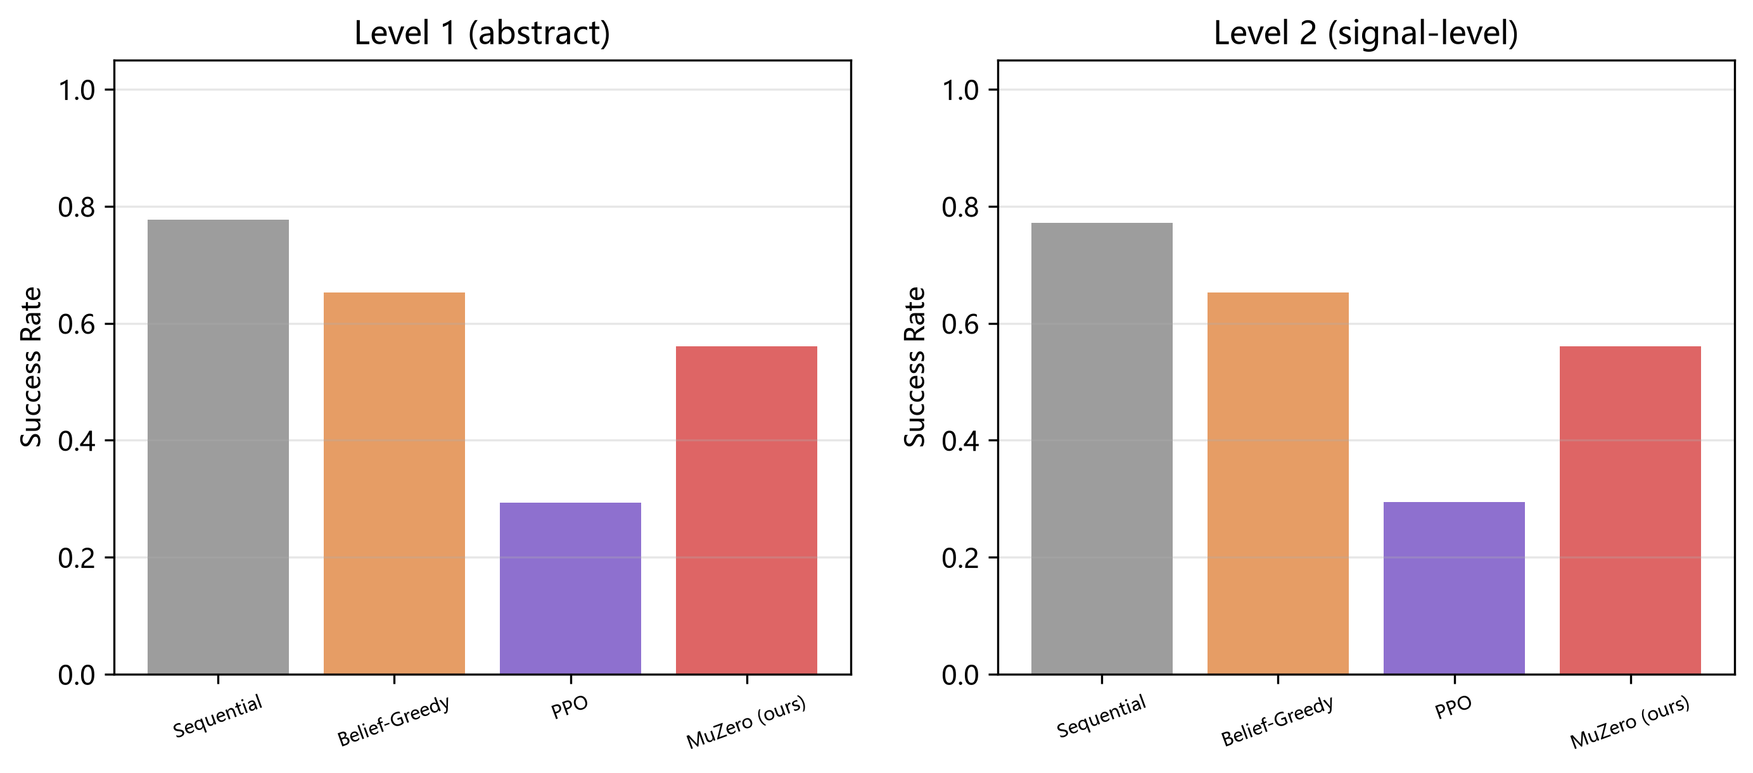
Figure 3-11 Level-1 vs Level-2 environment comparison (method rankings consistent)

3.7 Mechanism analysis
Comparing the raw network policy prior p(a|s) against the MCTS-improved policy π(a|s) shows that tree search sharpens the distribution toward higher-value sectors, confirming that the search is not merely noise (Figure 3-13). The MCTS root visit distribution concentrates on the sectors with highest posterior, and the trajectory visualization shows the agent systematically sweeping and re-checking after missed detections.
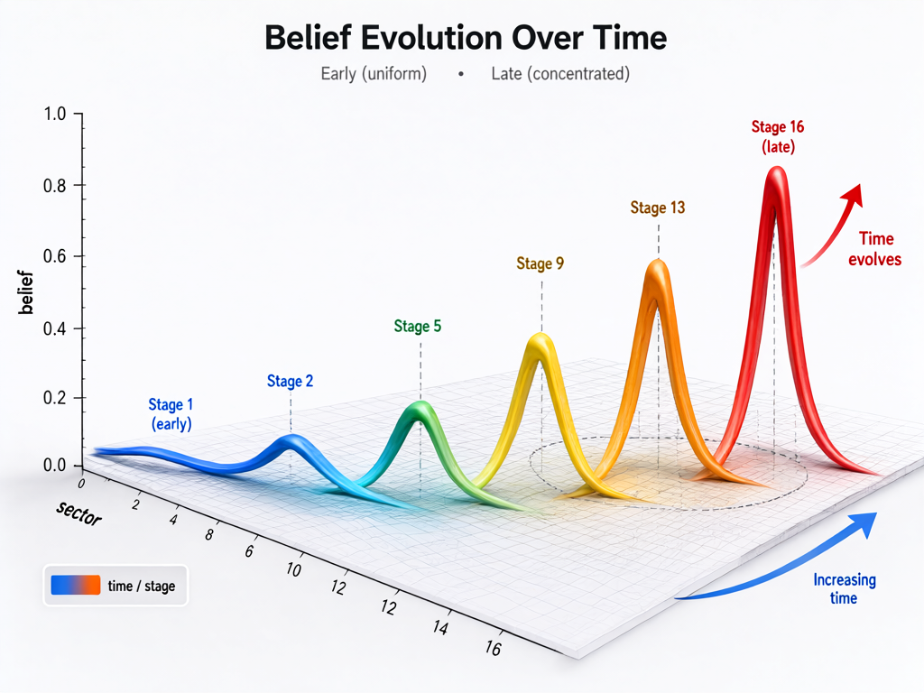
Figure 3-12 Belief evolution over pings: the belief distribution sharpens from uniform to a single peak as evidence accumulates (3D rendering)
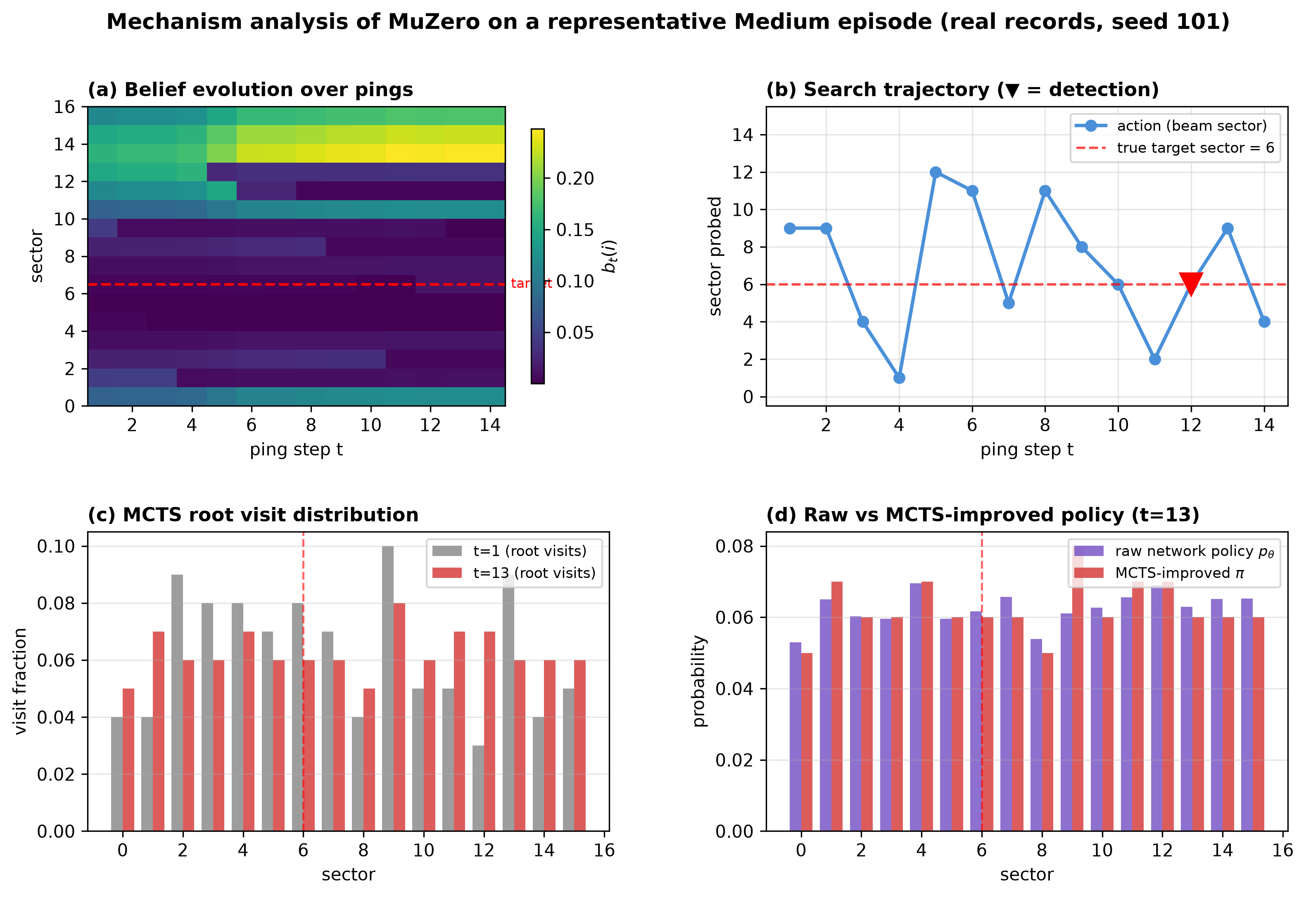
Figure 3-13 Mechanism analysis: (a) belief evolution heatmap, (b) search trajectory, (c) MCTS root visit distribution, (d) raw network policy vs MCTS-improved policy

3.8 Computational cost
Table 3-7 Computational cost comparison (Medium difficulty; latency = per-step action-selection time; wall-clock = cumulative training time per seed, 2×10⁶ env steps)
Method | Decision latency (ms) | Training wall-clock (h/seed)
Sequential | <0.05 | —
Random | <0.05 | —
Belief-Greedy | <0.05 | —
POMCP (known model) | 4.50 | — (planner)
DQN | <0.05 | 0.16
PPO | <0.05 | 0.11
DQN-GRU (memory) | <0.05 | 0.10
PPO-Stack (memory) | <0.05 | 0.15
MuZero (ours) | 6.75 | 3.09

MuZero's advantage comes at a cost: its per-step decision latency is 6.7 ms versus <0.05 ms for the feed-forward baselines (a factor of ~200), driven by MCTS with 100 simulations and depth-5 planning; training wall-clock is 3.1 h/seed versus 0.10–0.16 h/seed for the model-free methods. POMCP, the other search-based method, shows the same cost profile (4.5 ms/step), confirming that lookahead planning — not the learned model per se — is the source of the latency. This performance-compute tradeoff is the price of planning and must be weighed against the detection gain.
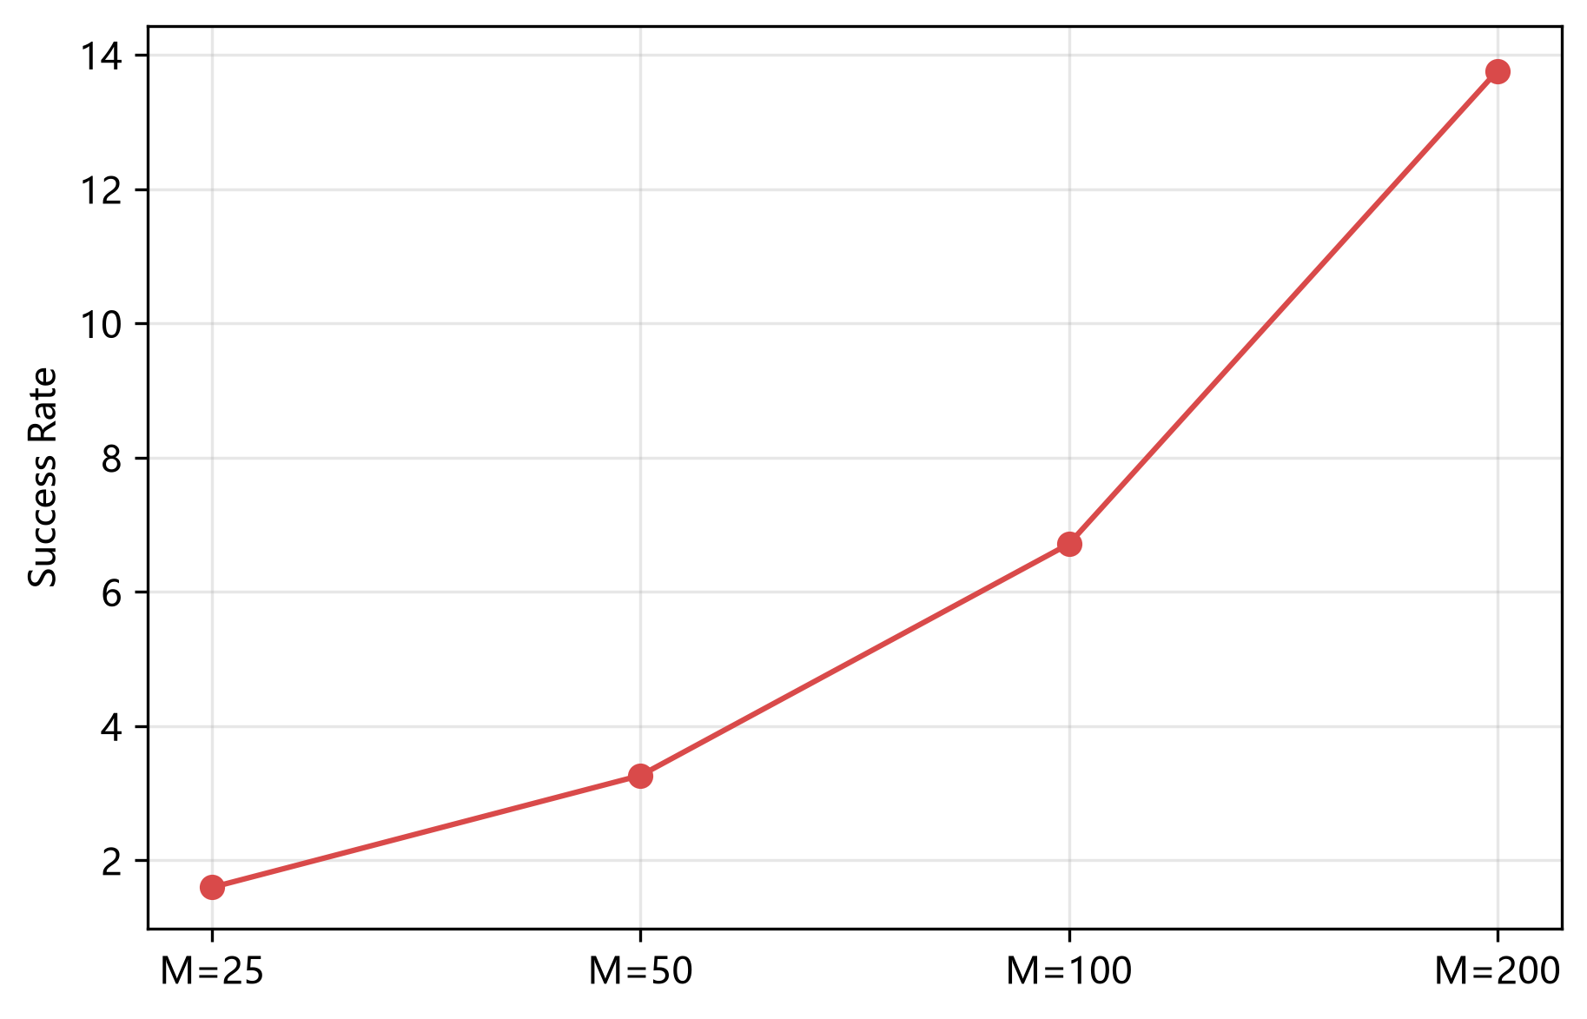
Figure 3-14 MCTS simulation count vs decision latency (performance-compute tradeoff)
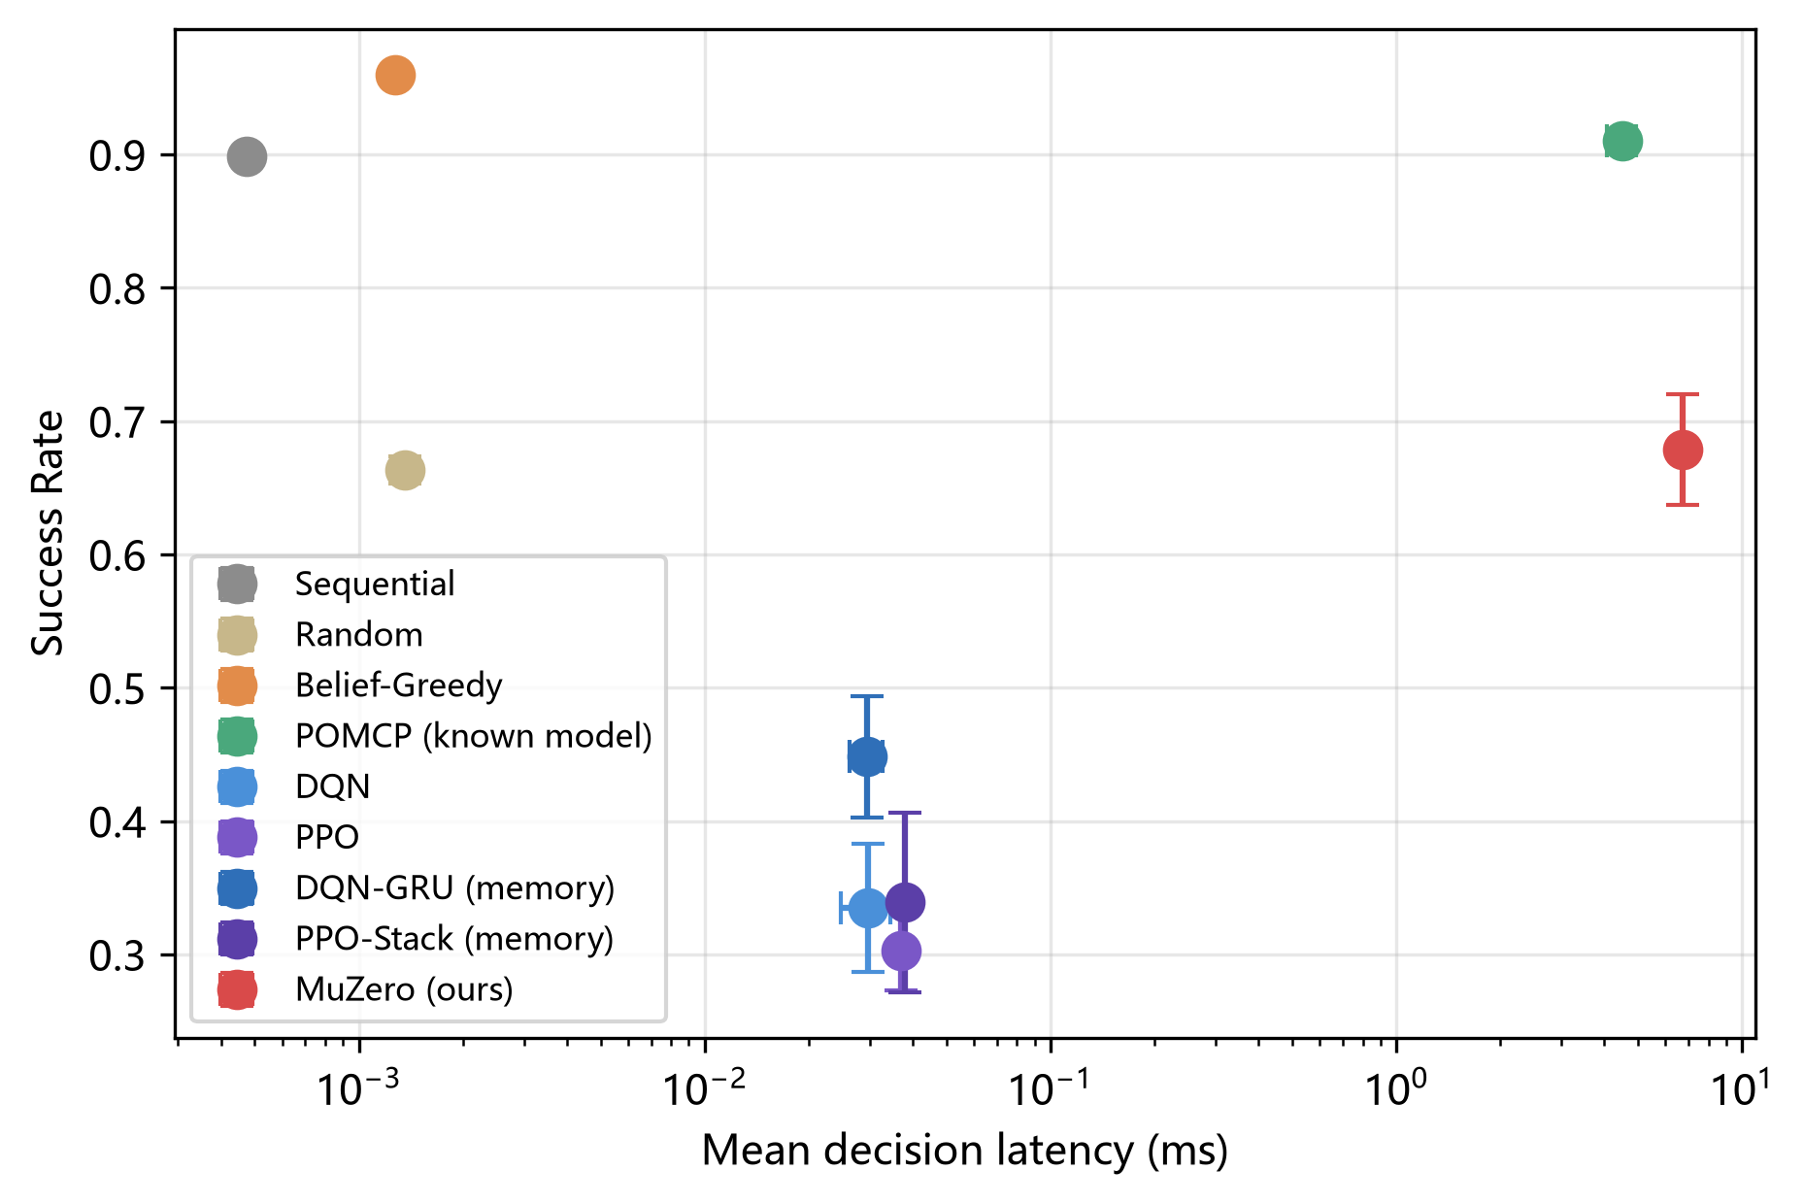
Figure 3-15 Success rate vs decision latency tradeoff across methods

3.9 Training dynamics
Training curves (Figure 3-16) show the learning dynamics of the five learned methods over 2×10⁶ environment steps. DQN converges fastest and most stably in the belief-fed regime; PPO improves slowly; MuZero's validation success rate climbs steadily but does not plateau within the budget, indicating that longer training may close part of the gap in Regime 1. In Regime 3 (blind search), MuZero converges to the highest validation success rate, followed by DQN-GRU and PPO-Stack — the recurrent and frame-stacked variants clearly surpass their feed-forward counterparts but remain well below MuZero, mirroring the test-time ordering.
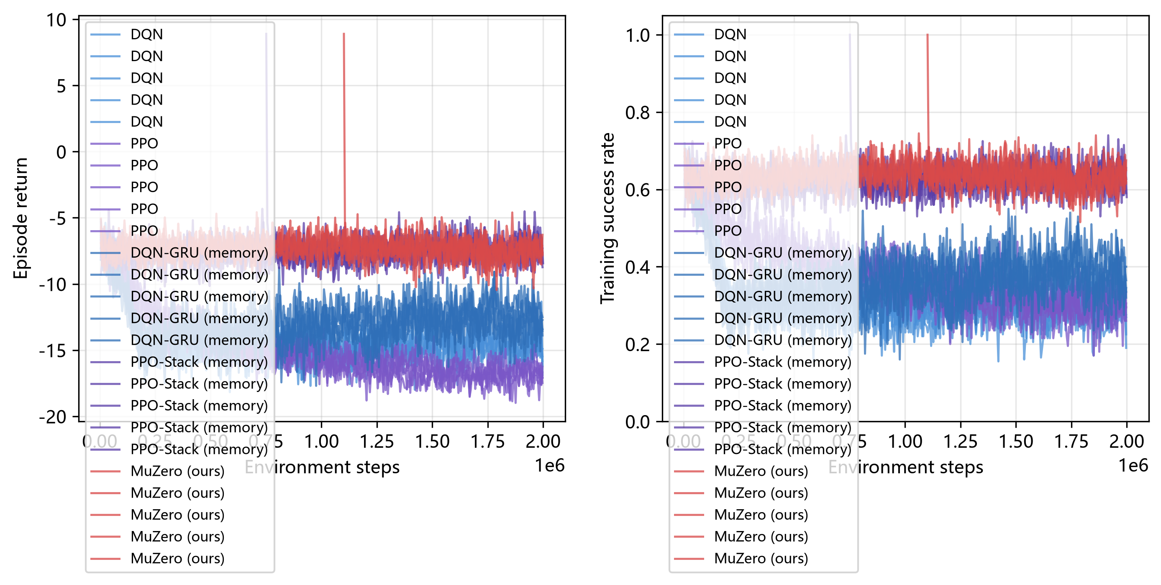
Figure 3-16 Training curves (episode return and training success rate vs environment steps)

3.10 Case studies
We examine four representative episodes: (Case 1) correct prior + low noise, where all methods detect quickly; (Case 2) wrong prior + high noise, where MuZero recovers through observation while Belief-Greedy fails; (Case 3) consecutive misses, where the agent persists and re-checks; and (Case 4) a false alarm, where the policy correctly revisits and re-evaluates. The belief heatmaps and search trajectories (Figure 3-17) show how each policy's probing logic differs.
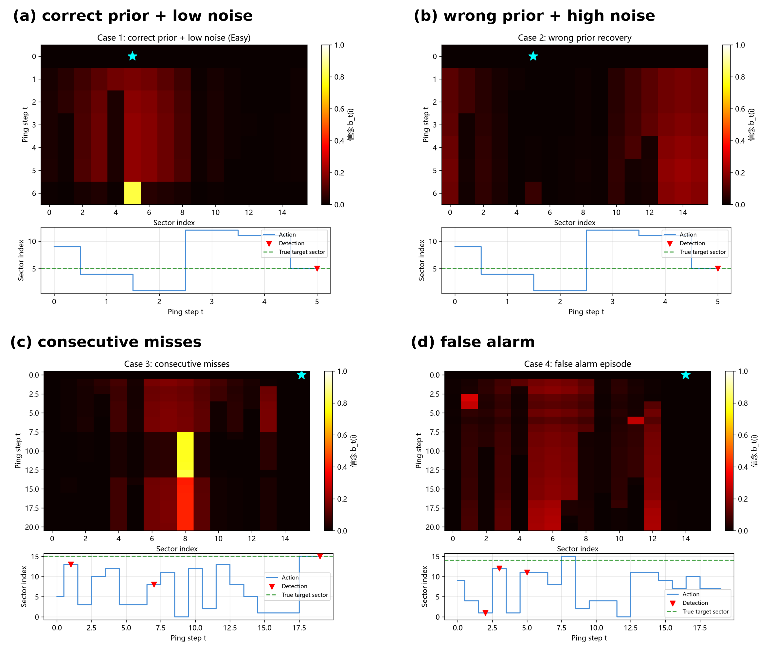
Figure 3-17 Four case studies: (a) correct prior + low noise, (b) wrong prior + high noise, (c) consecutive misses, (d) false alarm

4. Discussion

4.1 When does planning pay off?
The central finding is that observation structure determines which decision approach dominates. When the belief is directly observable (Regime 1), the task collapses to a nearly Markov problem and reactive methods (Belief-Greedy, DQN) achieve near-optimal performance with zero planning overhead. MuZero's latent dynamics model and MCTS then act as an expensive solution to a problem that does not need it. When the belief is not observable (Regime 3), the task becomes a genuine partially-observable sequential decision problem, and MuZero's combination of GRU-based history encoding, learned world model, and MCTS lookahead delivers a decisive advantage — roughly doubling the success rate of DQN and PPO.

4.2 Why does DQN dominate in Regime 1?
DQN wins Regime 1 because the belief vector is a sufficient statistic for this POMDP, so Q-learning on the belief is directly optimal. MuZero, by contrast, must learn to reconstruct the same information implicitly through its latent dynamics — a strictly harder learning problem with the same data budget. The lesson is that belief-informed observation is itself a powerful inductive bias; when available, simpler methods win.

4.3 The role of MCTS and memory
Two independent lines of evidence decompose MuZero's advantage into memory and planning. Within MuZero itself, ablation A (removing MCTS at evaluation) costs −0.18 SR and ablation E (removing GRU memory) costs −0.07 SR in blind search. Across methods, the memory-augmented baselines bound the value of memory without planning: DQN-GRU recovers +0.11 SR over DQN on Medium, and PPO-Stack +0.04 over PPO — together roughly one-third of MuZero's +0.34 advantage over the feed-forward baselines. The remaining two-thirds is attributable to lookahead over the learned model. The agreement between the within-agent ablation and the cross-agent comparison strengthens the causal attribution: it is the combination of recurrent state and tree search, not either alone, that closes the gap to the oracle planner.
The POMCP comparison further clarifies the value of model knowledge. With the true observation model, POMCP reaches SR = 0.911 on Medium — the effective ceiling — while the best model-free method reaches only 0.448 and MuZero reaches 0.679. In other words, MuZero's learned model recovers about two-thirds of the oracle gap between DQN and POMCP ((0.679−0.335)/(0.911−0.335) ≈ 0.60) without ever observing the model. When the prior is misspecified (Hard), the direction reverses: exact particle-filter inference over a wrong prior (POMCP 0.173, Belief-Greedy 0.000) is brittle, whereas the learned policy — exposed to prior bias during domain-randomized training — degrades gracefully (0.278). Learned robustness and oracle accuracy are complementary strengths; the choice between them is a deployment decision about which assumption is safer: an approximately known model, or a distributionally robust policy.

4.4 Limitations
Several limitations must be noted. First, the environment is a stylized two-level abstraction with parameterized acoustic models — it does not simulate real ocean bathymetry or full waveform physics. Second, the action space is discrete sector selection; continuous beam steering and waveform parameter optimization are left as future work. Third, all methods degrade sharply at N = 48 (OOD-N), indicating limited generalization to larger problem scales. Fourth, MuZero's compute cost (6.7 ms per decision, ~220× DQN) may be prohibitive for real-time sonar without engineering optimization. Fifth, the initial priors are synthetic; field priors from sonar operators may differ in shape. Sixth, our planner comparison uses POMCP as the representative online POMDP solver; anytime planners with stronger sample efficiency (e.g., DESPOT, PFT-DPW) might close more of the oracle gap, although we stress that POMCP already had access to the true observation model — an advantage no deployable method possesses. The memory-augmented baselines (DQN-GRU, PPO-Stack) received one hyperparameter pass inherited from their feed-forward counterparts; per-method tuning could shift individual numbers, but the qualitative ordering was stable across five seeds and three difficulties.

4.5 Implications for adaptive sonar design
The practical implication is a conditional design rule. Use reactive policies (Belief-Greedy) when a well-calibrated belief filter is available and the prior is trustworthy; if the observation model itself is known precisely, an online POMDP planner such as POMCP is near-optimal and training-free. Switch to MuZero-style learned planning when belief sufficiency is degraded — when the detection probability is unknown or drifting, when priors may be biased or adversarial, or when the sensor cannot maintain a reliable filter. Finally, keep the sequential scan in the toolbox: being information-free, it is immune to prior poisoning and sets a robust floor (Hard SR = 0.432) that no learned method in our study crossed.

5. Conclusion
We have presented the first systematic application of MuZero to active sonar target detection, with a complete POMDP formulation, a two-level simulation environment, and a rigorous evaluation protocol (eight baselines including a known-model POMDP planner and memory-augmented RL, five seeds, paired scenarios, Holm-corrected statistical tests). Our results show that MuZero's advantage is conditional on the observation regime and prior quality: when belief is directly observable, reactive methods win; when the agent must infer target state from raw interaction history, MuZero significantly outperforms all learned baselines (Medium ΔSR = +0.23 to +0.38 over the strongest learned competitors, p < 0.001), recovers about 60% of the oracle gap to a true-model POMCP planner, and is uniquely robust to biased priors among non-trivial policies (Hard SR = 0.278 vs POMCP 0.173, Belief-Greedy 0.000). The contribution is not a new algorithm but a boundary characterization — a map of when learned planning pays off in active sonar search — together with an open, reproducible benchmark. Future work will extend to continuous beam steering, waveform parameter adaptation, moving targets, multi-target scenarios, and real sea trials.

Declarations
Funding: Not applicable.
Competing interests: The authors declare no competing interests.
Data availability: All raw experimental data, trained checkpoints, and analysis code are publicly available at https://github.com/94346hddjna/muzero-adaptive-sonar (including Release v1.0-full-data with raw JSONL and checkpoints).
Author contributions: R.T. designed and implemented the system, ran experiments, and wrote the draft. F.H. supervised the research.

References
[1] Urick R J. Principles of Underwater Sound. 3rd ed. New York: McGraw-Hill, 1983.
[2] Schrittwieser J, Antonoglou I, Hubert T, et al. Mastering Atari, Go, chess and shogi by planning with a learned model. Nature, 2020, 588(7839): 604-609.
[3] Kocsis L, Szepesvári C. Bandit based Monte-Carlo planning. In: Proc. 17th European Conference on Machine Learning. Berlin: Springer, 2006: 282-293.
[4] Mnih V, Kavukcuoglu K, Silver D, et al. Human-level control through deep reinforcement learning. Nature, 2015, 518(7540): 529-533.
[5] Schulman J, Wolski F, Dhariwal P, et al. Proximal policy optimization algorithms. arXiv preprint arXiv:1707.06347, 2017.
[6] Haykin S. Cognitive radar: a way of the future. IEEE Signal Processing Magazine, 2006, 23(1): 30-40.
[7] Li X H, Li Y A, Cui L, et al. Research of new concept sonar—cognitive sonar. Journal of Marine Science and Application, 2011, 10(4): 502-509.
[8] Wenz G M. Acoustic ambient noise in the ocean: spectra and sources. The Journal of the Acoustical Society of America, 1962, 34(12): 1936-1956.
[9] Silver D, Schrittwieser J, Simonyan K, et al. Mastering the game of Go without human knowledge. Nature, 2017, 550(7676): 354-359.
[10] Hafner D, Lillicrap T, Fischer I, et al. Learning latent dynamics for planning from pixels. In: Proc. 36th International Conference on Machine Learning. PMLR, 2019: 2555-2565.
[11] van Hasselt H, Guez A, Silver D. Deep reinforcement learning with double Q-learning. In: Proc. 30th AAAI Conference on Artificial Intelligence. 2016: 2094-2100.
[12] Lillicrap T P, Hunt J J, Pritzel A, et al. Continuous control with deep reinforcement learning. arXiv preprint arXiv:1509.02971, 2015.
[13] Haarnoja T, Zhou A, Abbeel P, et al. Soft actor-critic: Off-policy maximum entropy deep reinforcement learning with a stochastic actor. In: Proc. 35th International Conference on Machine Learning. PMLR, 2018: 1861-1870.
[14] Deisenroth M, Rasmussen C E. PILCO: A model-based and data-efficient approach to policy search. In: Proc. 28th International Conference on Machine Learning. 2011: 465-472.
[15] Chua K, Calandra R, McAllister R, et al. Deep reinforcement learning in a handful of trials using probabilistic dynamics models. In: Advances in Neural Information Processing Systems. 2018, 31: 4754-4765.
[16] Hafner D, Lillicrap T, Ba J, et al. Dream to control: Learning behaviors by latent imagination. In: International Conference on Learning Representations. 2020.
[17] Moerland T M, Brokens J, Plaat A. Model-based reinforcement learning: A survey. Foundations and Trends in Machine Learning, 2023, 16(1): 1-118.
[18] Browne C B, Powley E, Whitehouse D, et al. A survey of Monte Carlo tree search methods. IEEE Transactions on Computational Intelligence and AI in Games, 2012, 4(1): 1-43.
[19] Silver D, Huang A, Maddison C J, et al. Mastering the game of Go with deep neural networks and tree search. Nature, 2016, 529(7587): 484-489.
[20] Silver D, Hubert T, Schrittwieser J, et al. A general reinforcement learning algorithm that masters chess, shogi, and Go through self-play. Science, 2018, 362(6419): 1140-1144.
[21] Hubert T, Schrittwieser J, Antonoglou I, et al. Learning and planning in complex action spaces. In: Proc. 38th International Conference on Machine Learning. PMLR, 2021: 4476-4486.
[22] Antonoglou I, Schrittwieser J, Ozair S, et al. Planning in stochastic environments with a learned model. In: International Conference on Learning Representations. 2022.
[23] Danihelka I, Guez A, Schrittwieser J, et al. Policy improvement by planning with Gumbel. In: International Conference on Learning Representations. 2022.
[24] Ye W, Liu S, Kurutach T, et al. Mastering Atari games with limited data. In: International Conference on Learning Representations. 2022.
[25] Wang S, Liu S, Ye W, et al. EfficientZero V2: Mastering discrete and continuous control with limited data. arXiv preprint arXiv:2403.00564, 2024.
[26] Schrittwieser J, Hubert T, Mandhane A, et al. Online and offline reinforcement learning by planning with a learned model. arXiv preprint arXiv:2104.06294, 2021.
[27] Hao X, Hao J, Xiao C, et al. Multiagent Gumbel MuZero: Efficient planning in combinatorial action spaces. In: Proc. AAAI Conference on Artificial Intelligence. 2024, 38(11): 12304-12312.
[28] Wu T R, Guei H, Peng P C, et al. MiniZero: Comparative analysis of AlphaZero and MuZero on Go, Othello, and Atari games. IEEE Transactions on Games, 2025, 17(1): 125-137.
[29] Fang B, Chen X, Pan Z, et al. SLAMuZero: Plan and learn to map for joint SLAM and navigation. In: Proc. 34th International Conference on Automated Planning and Scheduling. 2024, 34(1): 196-200.
[30] Cao X, Sun C. Target search control of AUV in underwater environment with deep reinforcement learning. IEEE Access, 2019, 7: 96349-96359.
[31] Chu Z, Wang F, Lei T, et al. Path planning based on deep reinforcement learning for autonomous underwater vehicles under ocean current disturbance. IEEE Transactions on Intelligent Vehicles, 2023, 8(1): 108-120.
[32] Masmitjà I, Martin M, O'Reilly T, et al. Dynamic robotic tracking of underwater targets using reinforcement learning. Science Robotics, 2023, 8(80): eade7811.
[33] Gulcehre C, Wang Z, Novikov A, et al. RL Unplugged: A suite of benchmarks for offline reinforcement learning. In: Advances in Neural Information Processing Systems. 2020, 33: 7248-7265.
[34] Silver D, Veness J. Monte-Carlo planning in large POMDPs. In: Advances in Neural Information Processing Systems. 2010, 23: 2164-2172.
[35] Cho K, van Merriënboer B, Gulcehre C, et al. Learning phrase representations using RNN encoder-decoder for statistical machine translation. In: Proc. Conference on Empirical Methods in Natural Language Processing. 2014: 1724-1734.
[36] Hausknecht M, Stone P. Deep recurrent Q-learning for partially observable MDPs. In: AAAI Fall Symposium Series. 2015: 29-37.

