ONLINE STUDENT ATTACHMENT ACTIVITIES INFORMATION MANAGEMENT SYSTEM FOR STRATHMORE UNIVERSITY

By

094694

An Information System Project 1 documentation submitted to the Faculty of Information Technology in partial fulfilment of the requirements for the award of Bachelor’s Degree in Business Information Technology

STRATHMORE UNIVERSITY

November 2017

DECLARATION
I declare that this work has not been previously submitted and approved for the award of a Bachelor’s degree by this or any other University. To the best of my knowledge and belief, the documentation contains no material previously published or written by another person except where due reference is made in the documentation itself.

Student’s signature:
………………………………….………….. [Signature]
………………………………….………….. [Date]

Approval
The Information System Project 1 documentation of Serah Mwangi here was reviewed and approved (for examination) by:

Supervisor’s signature:
………………………………….………….. [Signature]
………………………………….………….. [Date]

ABSTRACT
Strathmore University requires that every student undertakes a community based attachment and industrial attachment as a prerequisite to graduation. At the end of the attachments, students are required to submit a report of all their activities during attachment. This includes a record of all daily activities for the 200+ hours for each attachment type. A problem arises when students write their reports as majority do not have all records of their daily activities. In addition to this, there has been reported instances where student reports are misplaced and students discover that they lack attachment marks a month later. Often, the students are forced to rewrite their reports. However, by this time, the students mostly have no record of their attachment activities which becomes a complex case as students cannot graduate without attachment marks.
The web-based information system for online attachment record addresses the shortcomings of the current system in use. The web based information system will enable students to keep track of all their daily attachment activities. This is the main objective of this system. Additionally, the system will make attachment report writing a continuous activity by providing a means for the students to continuously record all details required to write the final report thus significantly reduce the time required to write the report. The online records will also solve the problem of missing reports as students can rewrite their reports in an hour should they be reported missing.
In developing the system, JavaScript, PHP, HTML, CSS programming languages were used. MySQL database was used in implementing the database due to its stability, reliability and flexibility. The system will mainly be accessed via the internet as it spans large geographical areas. Object Oriented Analysis and Design (OOAD) was used in analyzing and designing the entire system. The preference of this approach was because conducted in an iterative and incremental way hence allowing analysis model and design models evolve continuously being driven by key factors which include risk and business value.

List of Figures

Chapter 1: Introduction

1.1 Background
Information is a critical success factor for any enterprise today. Organizations are increasingly leveraging on information technology to obtain competitive advantage in the present technology. Technology is the main cause of large-scale transformations that has occurred across different operations in organizations today. Even though digital technology will transform most organizations, there are a number of shortcomings that need to be understood. These include factors such as the pace of changing client anticipations, cultural evolution, and out-of-date regulation, recognizing and gaining access to the exact capabilities (Weinelt, 2016).
Learning institutions are among organizations that have embraced technology the most. Strathmore University being one of the learning institutions that has embraced technology has aggressively computerized its operations. Among the operations Strathmore University has computerized is eLearning platforms, students’ academic management system and accessing the past papers examinations, eBooks and journals in the university library. These computerized operations making it easier to access them and saves a lot of time to the user.
In the modern world, terms attachment, information and information system are very common words. The term attachment refers to an extra part or extension that is or may be attached to something to perform a particular function (Oxford Dictionary, 2017) while information refers to facts about a state of affairs, place or occurrence (Cambridge Oxford Dictionaries, 2017) and finally the term information system refers to a software system to capture, transmit, store, retrieve, manipulate, or display information thus supporting people, organizations or other software systems(Alter ,2002).The above defined words are the keywords of this project that has been proposed.
Every student in Strathmore must undertake a community based attachment and an internship attachment as one of the requirements of graduation. Currently, the system that is the system being used has no platform where the students can store the records of their daily activities online this being a major challenge for the students for the manual records are subject to the risk of getting lost. The first two weeks of school after the long holiday become hectic for the students for they are required to write a report of the entire attachment period and they do not have all the necessary information. After writing the report, they are supposed to print it and take it to the respective.
Faculty offices. Another challenge occurs here for there is congestion of students in the two bookshops with students queuing to print the reports hence wasting a lot of time. There is also congestion of students in the faculty’s offices while handing in the reports. After a month, one gets frustrated for having no marks in the academic management system reason being misplacement of the report and the remedy of this is repeating the entire report.
This research aimed at developing a web based information system that would resolve the above shortcomings of the current system being used.

1.2 Problem Statement
Strathmore University requires that every student undertakes a community based attachment and industrial attachment as a prerequisite graduation. At the end of the attachments, students are required to submit a report of all their activities for the 200+ hours for each attachment type. A problem arises when students write their reports as a majority do not have all records of their daily activities. In addition to this, there has been reported instances where student’s reports are misplaced and students discover that they lack attachment marks a month later. Often, the students are forced to rewrite their reports. However, by this time, the students mostly have no record of their attachment activities which becomes a complex case as students cannot graduate without attachment marks.

1.3 Aim
The general objective of this project was to design and develop a web-based information system that will enable student’s login in the system using their accounts, update their day to day activities in the entire attachment period and also upload their reports online before the due date of submission like it is done while uploading assignments on the eLearning platform.

1.4 Specific objectives
The project’s specific objectives:
- To investigate factors relating to an online information management system
- To analyze the existing systems of managing student attachment records.
- To design the proposed online student attachment activities information management system
- To develop the proposed online student attachment activities information management system
- To test the functionality of the proposed system.

1.5 Justification
The web-based information system will help to solve the shortcomings of the current system in use. The system will enable students to keep track of all their daily attachment activities and to upload their final report entailing all the activities. Additionally, the system will make attachment report writing a continuous activity by providing a means for the students to continuously record all details required to write the final report thus significantly reduce the time required to write the report. The online records will also solve the problem of missing reports which costs students a lot of time when required to rewrite the entire report having misplaced the activities.

1.6 Scope and limitation

1.6.1 Scope
This System only enables Strathmore students to enroll in the system once they provide credentials and are declared valid. When a student logs in the system during the attachment session he/she can update the daily activities. The supervisor on the other end will monitor the student and have a rough idea on the progress. After writing the report and uploading it, the system can recognize the submission of a particular student based on the credentials used to log in the system.

1.6.2 Limitation
This systems functionality is only limited to Strathmore University students for one is required to log in with the provided credentials. Any other student from other institutions will not find the system relevant because their credentials will not be retrieved from the Strathmore database management system.

Chapter 2: Literature Review

2.1 Introduction
Information technology has rapidly changed the world in a major way. Education sector is a major beneficiary of the substantial growth in IT (Deb, 2014). In education, IT enables more students to affordably access learning content and motivates an individual (Punie, 2007).
This transformation has highly been implemented in our campuses today. Strathmore being one of the campuses has turned its services into online. One of the services that is conducted online is that of the student attachment system which a major focus in this review is. These online services are because of development of the web technologies. The future of web based technologies is very promising as many organizations are moving their services online.

2.2 Factors relating to an online information management system
Behind any success of an organization, there is an information system behind it (Anagbo, 2017). The three main factors that lead to an organization adapting online information systems are as follows: information systems provide business processes and operations for example in a hotel the check-ins and the checkouts of a certain customer are done online outdating the traditional means which was to record it using a pen and paper. Information system also helps different departments in an organization to work together making it smoother to conduct their operations.
Information systems aid in making informed well-informed decisions. An information system analyzes information which has been collected either within an organization or from an external source into useful information that will help the employees and managers to make decisions. Finally, information systems also support strategies for competitive advantage. Competition in today’s business is keen and the added advantage is how quickly companies can convert their reams of information they collect into knowledge so that they can provide services and products that are ahead of their competitors.

2.3 Existing systems of the student attachment records
- Nanyang Technological University Attachment and Internship Management System
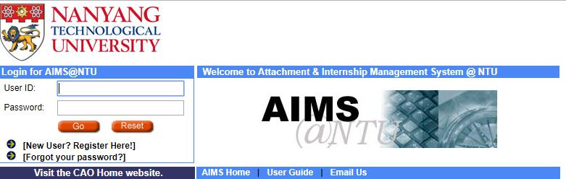

Figure 2.2 Attachment & internship management system for Nanyang Technological University
The system above is the platform where organizations can coordinate the process of providing the attachment and internship placements to the students. It also serves as a platform for organizational supervisors to enquire necessary details of the attachment and perform their specific tasks throughout the entire period. Currently, the system allows the organizational coordinator to update the organizations information online, access information on past attachments, register the organization supervisor who wants to give a placement to the students, and access information of the assigned students. The organization supervisor uses the system to register as a supervisor for a specific program and to submit the available attachment program to the coordinator. The system has its shortcomings which are to be corrected soon. After the upgrade, it should allow the supervisors to access the resume applicants, submit assessment and receive system generated message to prompt oneself complete a task. It helps the coordinator to supervise the submission of assessments by the supervisor and administering the selection of students in case a certain organization wants to select students it wants for their attachment programs.

Chapter 3: Methodology
3.1 Approach to be used by the proposed system
Object oriented analysis design approach uses an object-oriented perspective rather than the structured system analysis design which uses the functional perspective in the structural system analysis design (Pefkaros, 2008). Object-oriented analysis is the process of developing an object-oriented model of the problem domain where the initial objects represent the entities and methods related to the problem that needs to be resolved (Pefkaros, 2008). The preference of OOAD approach to that of SSAD is because systems developed using the OOAD have reduced maintenance.
Reduced maintenance is the primary goal of the object-oriented development for there is assurance the system will have a long-time span with low maintenance costs. This is as a result of encapsulation of the processes used in the system (Donald, 2016). Object oriented systems tend to model the real world in a realistic way than the traditional method. The model is based on objects rather than data processing (Donald, 2016). There is high code reusability due to inheritance principle. When a new object is created it will inherit the data attributes from the class it was spawned. New objects also inherit the data and behavior from super classes in which it participates (Donald, 2016).
3.2 System Development Methodology
Methodology refers to a step to step approach of solving limitations of an existing system or rather for development of a new system (Pefkaros, 2008). Design and development of the information systems has many methodologies but in the development of this information system the iterative methodology will be used. The iterative methodology breaks the overall project into a series of versions developed sequentially. The basic and fundamental requirements are bundled in the first version (Dennis, Wixom & Roth, 2012). This version is developed quickly by a mini-waterfall process, and once it is implemented, the users can provide valuable feedback which is to be incorporated into the next version of system. Below is the figure of the iterative development methodology.

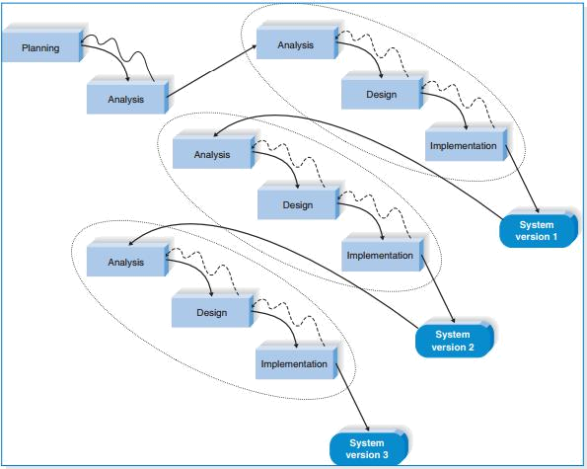

Figure 3. 1: Iterative development methodology (Source: Dennis et al., 2012)
3.3 Requirement Analysis
System requirements will be gathered by visiting the attachment office in the University and by reviewing the already existing systems of the proposed system.
3.4 Proposed design diagram
- Use case diagram
This is a diagram that defines set of actions that a system can perform while collaborating with the external users of the system. A use case helps to make sure that the precise system has been developed by picking up necessities from the user’s point of view. They are easy to understand and hence provide an excellent way for communicating with users and finally they help to manage the complexity of large projects by decomposing the project into a major problem (Firesmith, 2004).
- Class diagram
This is a diagram that describes the systems structure by showing the system’s class, attributes, operations and the relationship among them. A class diagram is a very important for it models the statistic view of an application
Important diagram that shows the sequence of flow of activities in the system.
Database Schema

Mockup Diagram

3.5 Proposed development tools

In developing the system, PHP, JAVASCRIPT, HTML, CSS programming languages will be used. This is because the project will be a web-based application information system. The project will also use MYSQL in implementing the database due to its stability, reliability and flexibility.

3.6 Proposed Domain of Execution

The domain of execution will be a web-based application for it is accessible from any location provided the user has access to an internet connection and web browser. Web-based information system only requires to be installed in a company’s server rather than separately installed at the end user workstation.

  - Proposed modules
Login module

This module allows a Strathmore student to access the system if the credentials are
Valid.
Registration module
This module enables an admin to register students undertaking the attachment.

Student attachment record module

This module enables students to record their daily activities of the 200+ hour’s attachment.

Report submission module

This module enables the students to submit their reports before a proposed deadline is met.

Chapter 4: Analysis and Design

4.1 System Analysis
System analysis refers to the process of understanding the current system, pinpointing improvements and outlining requirements for the new system. A system requirement refers to what a certain system must do or rather the features that it must have .In types of system requirements that need to be defined in this phase include the business requirements- requirements that specifically describe the needs of a business, user requirements- description of what users need to do ,functional requirements- a description of the characteristics of what users need to do and non-functional requirements – a description of how the proposed system need to be built(Dennis et al.,2008).

4.1.1 Functional Requirements
System functional requirements stems from a determination of the ways in which the proposed information system needs to support user needs. Table below shows the functional requirements of the online student attachment activities information management system for Strathmore University.
ID | Description
FRQ1 | The system should allow the users to login provided the credentials are valid.
FRQ2 | The system should allow the admin to register students, admins and supervisors to the attachment system
FRQ3 | The system should allow students to record their daily activities during the entire attachment period.
FRQ4 | The system should allow students to upload the report in the system before the submission link expires.
FRQ5 | The system should enable the admin assign students their supervisors.
FRQ6 | The system should enable the user logout once an entire session expires.

4.1.2 Non-Functional Requirements

ID | CATEGORY | DESCRIPTION
NFRQ1 | Usability | The system should only allow Strathmore Students whose
NFRQ2 | Reliability | The system should
NFRQ3 | Performance | The system should be fast enough when using fast internet and also should be available 24 hours a day, 7 days a week.
NFRQ4 | Supportability | The system should

CHAPTER 5: IMPLEMENTATION AND TESTING

CHAPTER 6: Conclusion and Recommendations for Future Work
In conclusion, the system comes in handy to help the Strathmore students have an easy time during the attachment period and during the final submission of the report .I recommend this system for use to help improve the existing system

References
Anagbo, S. (2017). Role of information systems in an organization. Retrieved from Academia.edu:
http://www.academia.edu/4433329/Role_of_Information_System_in_an_Organization
DENNIS, W. (n. d.). System analysis & design (5th edition Ed.). (B. L. Golub, Ed.) Don Fowley.
Retrieved from
http://www.saigontech.edu.vn/faculty/huynq/SAD/Systems_Analysis_Design_UML_5th %20ed.pdf
Donald, B. (2016). Advantages and Disadvantages of Object-Oriented Approach. Retrieved from
Oracle Consulting: http://www.dba-oracle.com/t_object_oriented_approach.htm
Pefkaros, K. (2008, March). Object-oriented programming (Analysis). International Journal of Business Research, 8
Donald G. Firesmith. (2004). Usecases:Pros and Cons. Retrieved from Knowledge System Corporation: https://www.cs.hmc.edu/~mike/courses/mike121/readings/reqsModeling/firesmith.htm
Wikipedia. (2017, October). Class diagram. Retrieved from Wikipedia: https://en.wikipedia.org/wiki/Class_diagram

Appendix A: Gantt Chart

Appendix B: Turnitin Report

Appendix C: User Manual

PART A: Technical Guide
System Installation
This system is a web-based application. To run the information system, one needs to upload it to a live web server or use a local server such as xampp local server. Xampp server is a local server (run offline) that mimics a live web server and is used for testing and deployment of web based applications. In this documentation, installation of the web application on a local web server is explained.
To install the attachment web application, follow the following instructions:
Installing Xampp Local Web Server
- Download Xampp from Apache Friends website. Be sure to download a version compatible with your computer’s Operating System e.g. xampp for Linux, Windows, or OS X for Apple
- This guide assumes you are using Windows environment
- Unzip the downloaded xampp file to your disk C:\xampp
- Note: You may unzip to a different disk with adequate space. For purposes of this project, disk C:\ is preferred
- Open the xampp folder in C:\xampp and run the executable file C:\xampp\xampp-control.exe
- Start Apache and MySQL services from the xampp control-panel
- Click on Admin option of Apache service.
- From the window that opens, click phpmyadmin to access the database.
- Create a new database and call it suattachments
- While on the suattachments database, click on import and then choose file from the window that opens.
- Locate the database file ‘suattachment.sql’ in the attachments project folder on the storage containing the project. If this is successful, then your database is set up and ready
- Once the database is setup, copy the folder that contains the project i.e. attachment from storage and paste it in C:\xampp\htdocs\
- Your project setup is now complete.
- To run the project, open a browser (Chrome, Firefox and Opera preferred) and type ‘localhost/attachment’ without the closing tags. A login page is loaded where users enter their login credentials

PART B: User Guide
User Login
The login page allows students, supervisors and the administrator to login. It provides for the different user access levels. The figure below shows the login page.
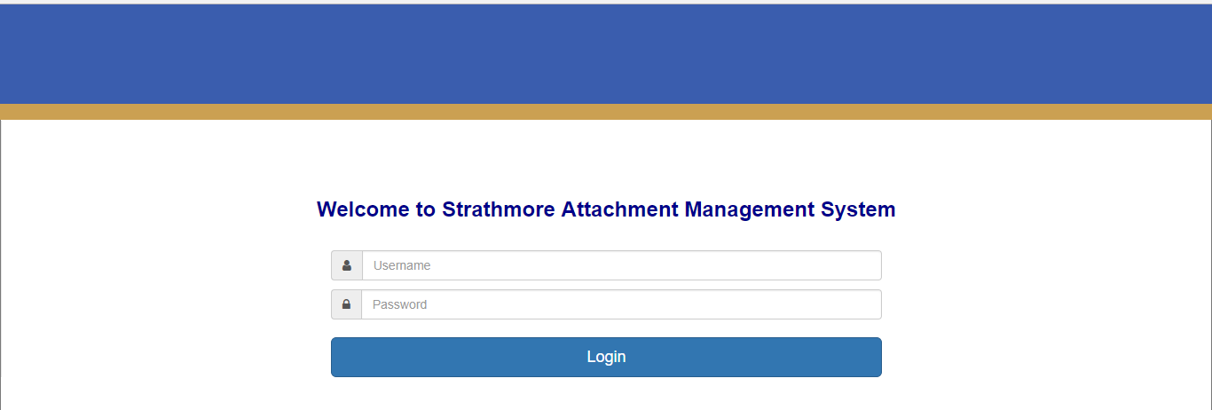
User login page
Below are the existing user login credentials
User | Username | Password
Administrator | 1002 | 12345
Supervisor | 1003 | 1003
Student | 94694 | 94694

Admin Functionalities
The system admin is responsible for adding users i.e. other admins, supervisors and students. S/he is also responsible for assigning students supervisors. The following screen captions indicate how to carry out admin functionalities:
Once logged in as admin, the user sees the below admin control page.
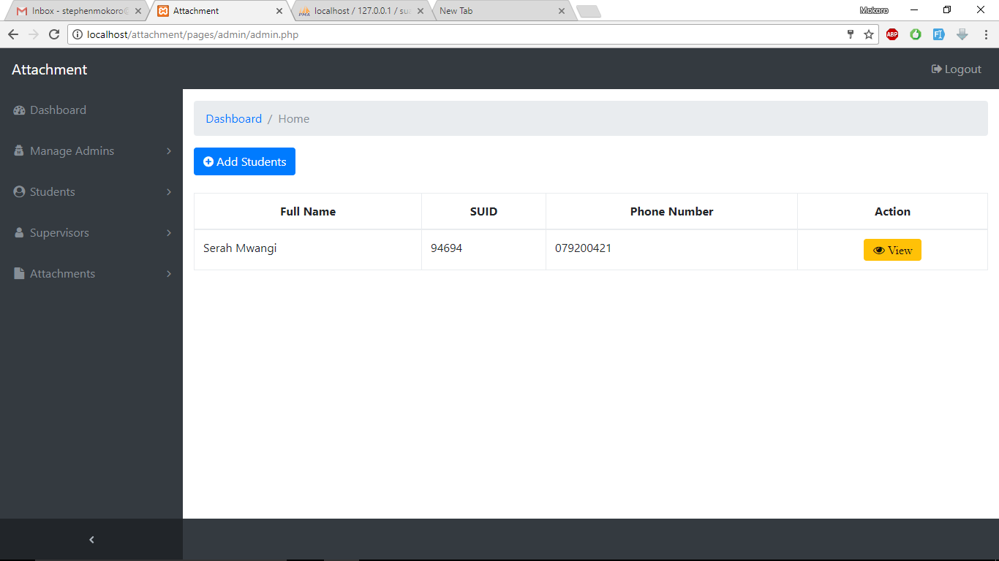
System admin control page

To add a student, click on Students>New Student. This loads the page below for adding a student.
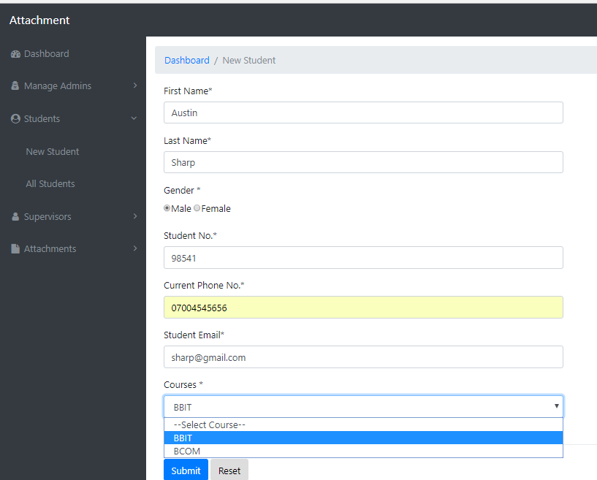
New student registration

Fill in the details and click Submit button. The success message below is displayed.
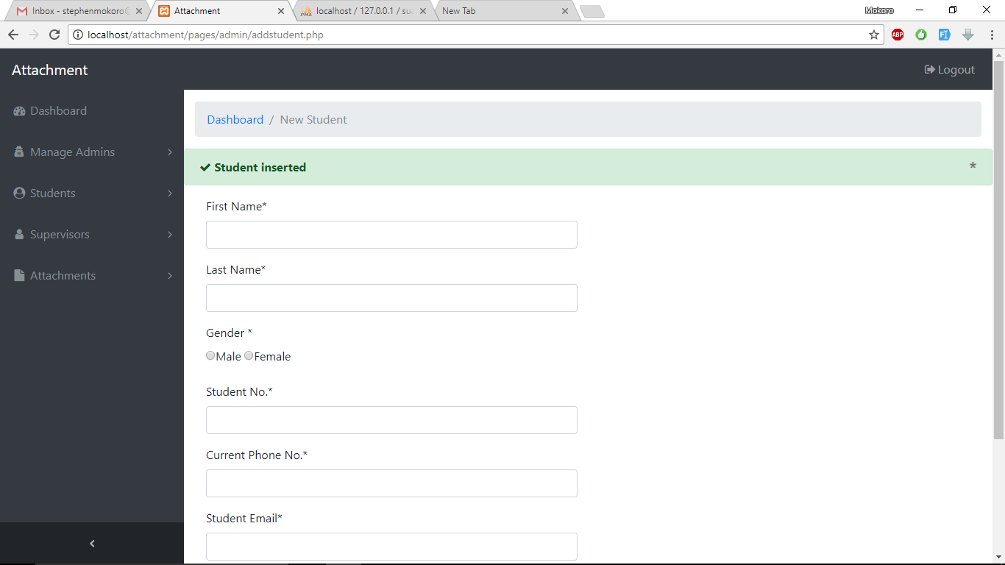
Student registration success message
To see a list of all registered students, click on Students>All students from the navigation menu on the left. The page below is loaded.

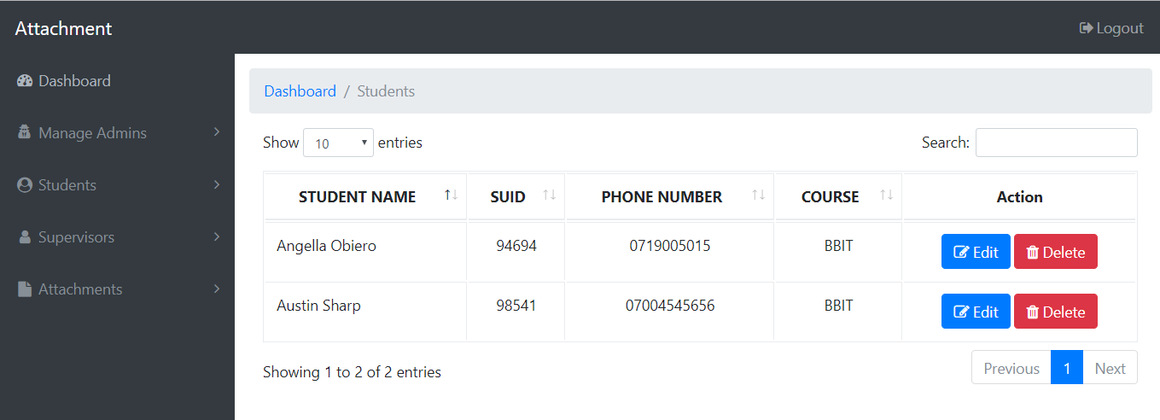
List of registered students

Registering supervisors
Admin can also register supervisors. To register a new supervisor, from the navigation menu on the left, click on: Supervisors>New supervisor. The supervisor registration page below is loaded.
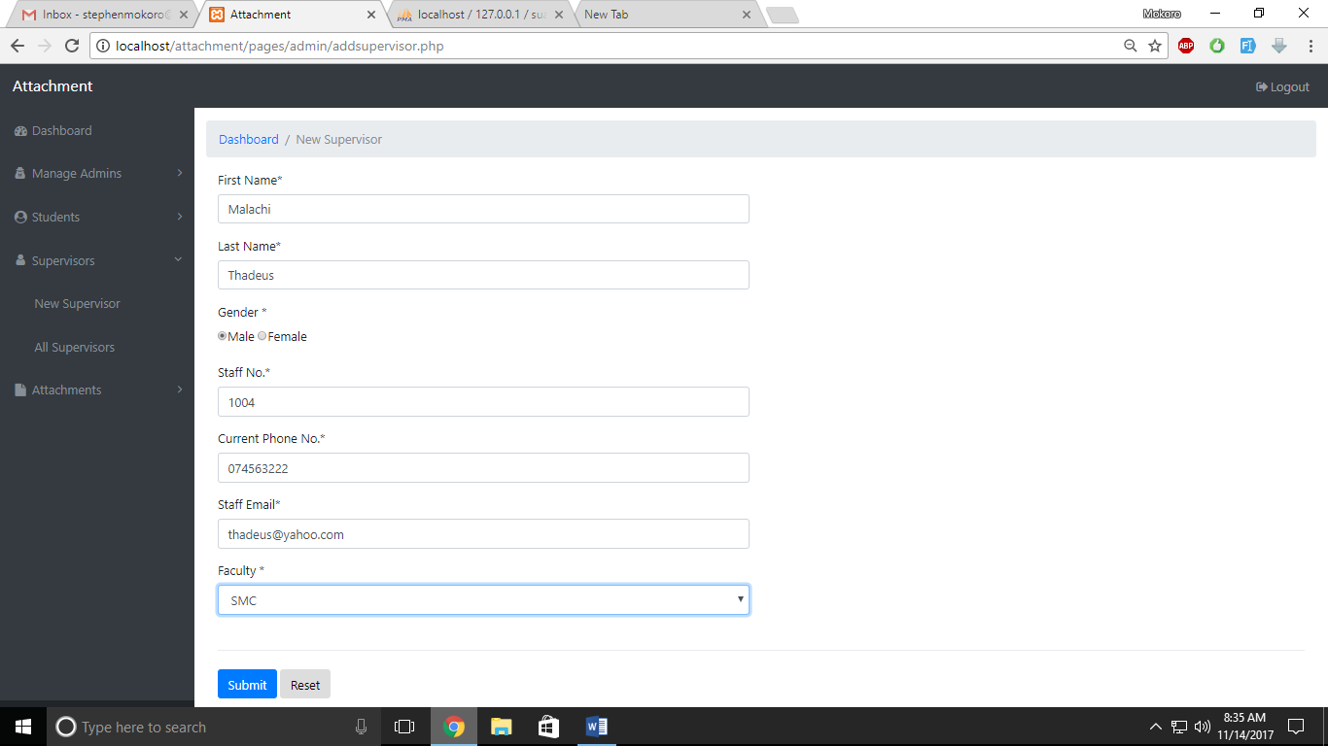
Supervisor registration page

Fill in the supervisor details and click on Submit button. The success message below is displayed.
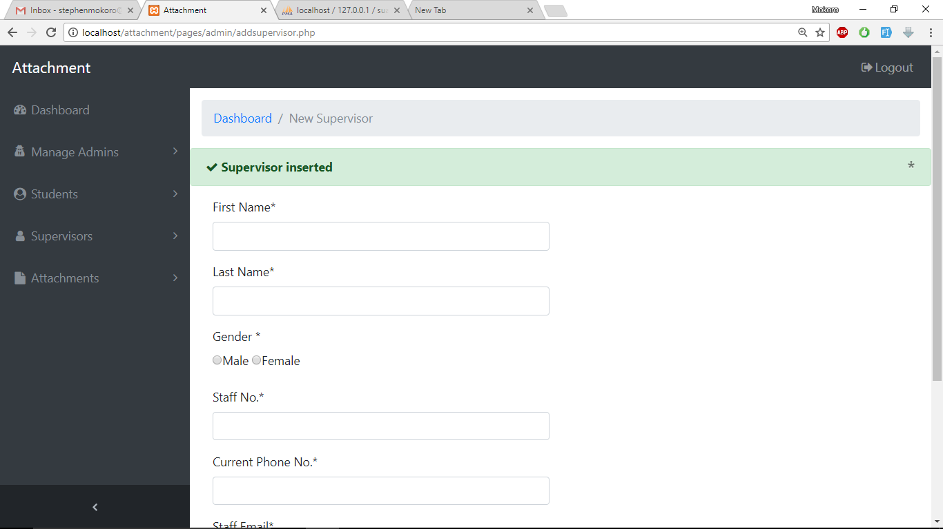
Supervisor registration success message

To see the list of registered supervisors, click on Supervisors>All Supervisors from the navigation menu on the left. The list of supervisors below is loaded.

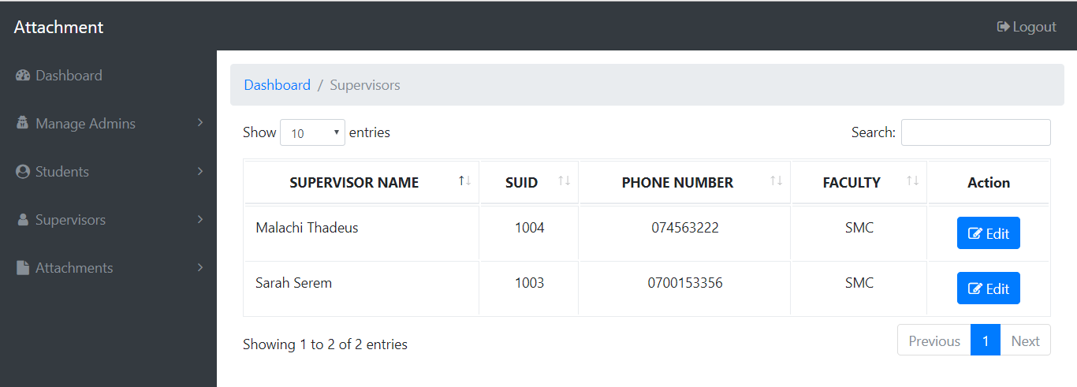
List of registered supervisors

Assigning a supervisor to a student
The admin is able to assign supervisors to students. To assign a student a supervisor, click on Attachments>Assign Supervisor from the left navigation bar. The page below is loaded.
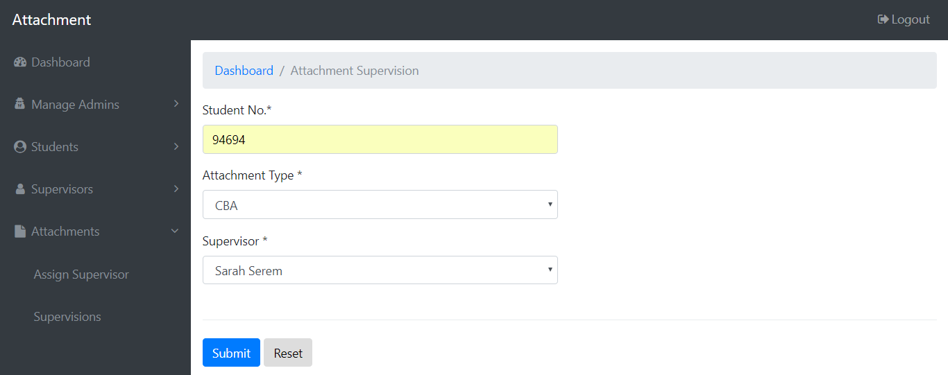
Supervisor assignment page
Input the student number to whom you are assigning a supervisor, select the type of attachment and the supervisor. Note: A student cannot be assigned a supervisor twice for the same attachment type. However, a student can be assigned another supervisor for a different attachment type. Once filled the form, click on Submit. The below success message appears.
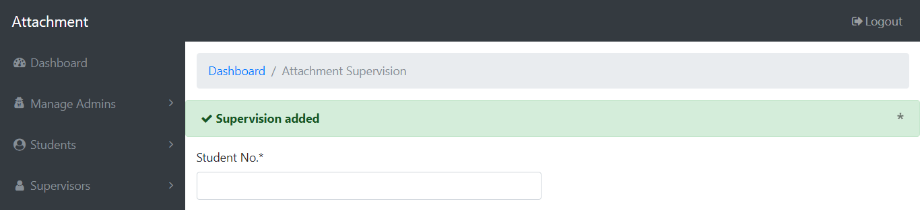
Supervisor assignment
To view a list of supervisions, click on Attachments>Supervisions. The list below is loaded.

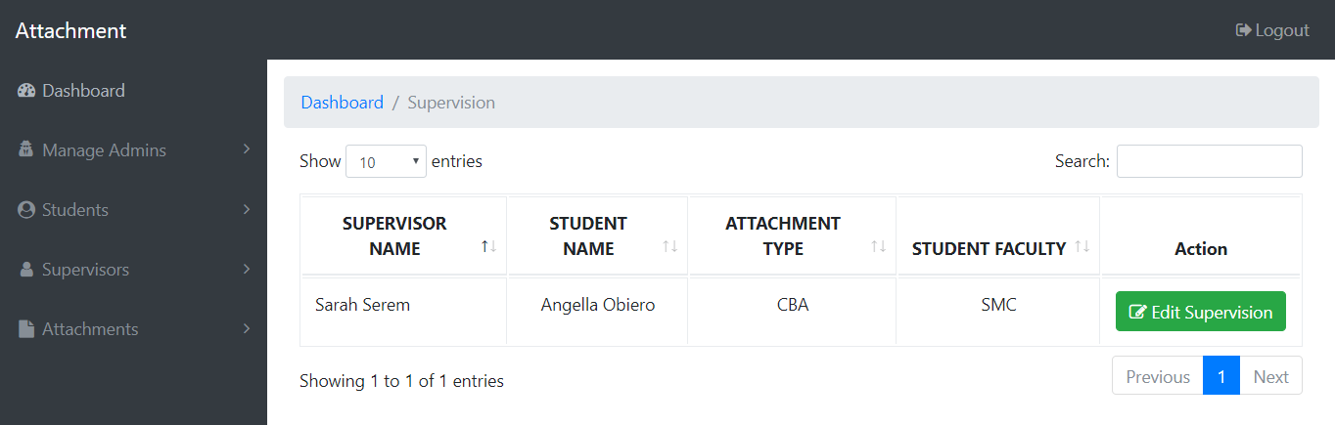
List of assigned supervisions

Editing Information
To edit user information, access the list of users (supervisors for example) as explained earlier. At the rightmost column of each user row, there is a button named Edit. Click on the button. In the case of editing supervisors, the supervisor edit page below is loaded.
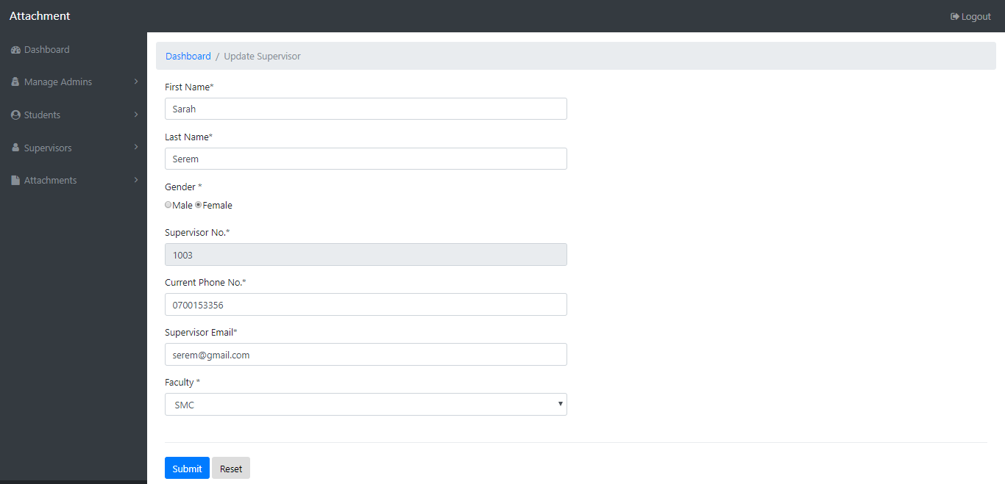
Supervisor profile editing page
Edit the information as necessary and click Submit. The message below is displayed if Faculty, for example, is changed from SMC to FIT and submitted.
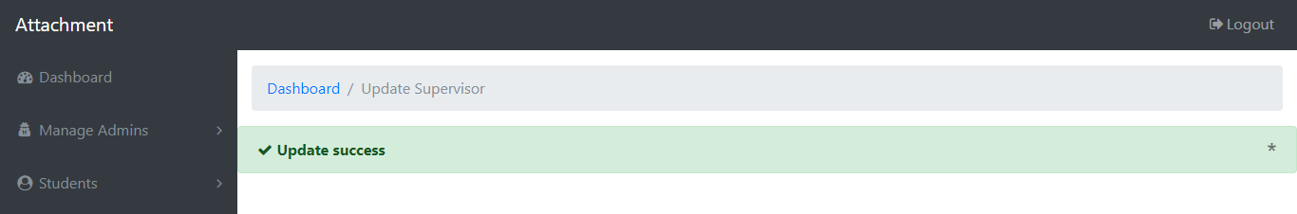

Deleting data
For one to delete data such as student, access the list of students and click on the Delete button at the rightmost column of each student. If the students table does not have any depedent child rows via a foreign key constraint, then it is success. Otherwise, it fails. Consider the list of students below.
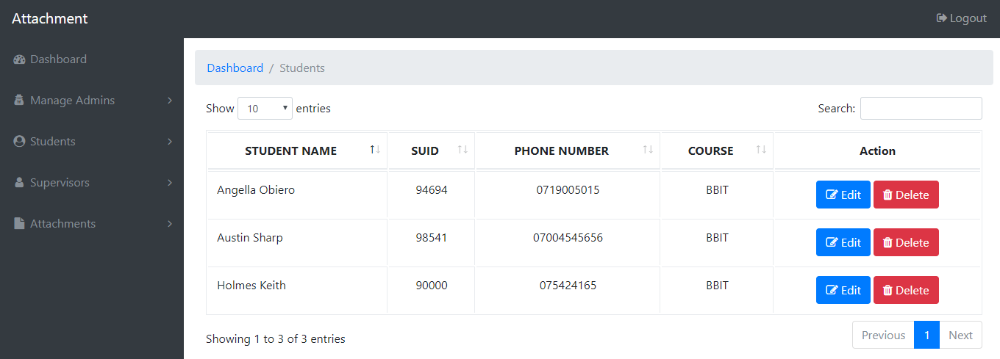
List of students
It is not possible to delete Angella because she has been assigned a supervisor hence has a foreign key relationship with table studentsupervisors. However, Austin and Holmes are deletable as they do not have any depended child row in any other relation. The figures below show results of attempt to delete Angella and Austin respectively.
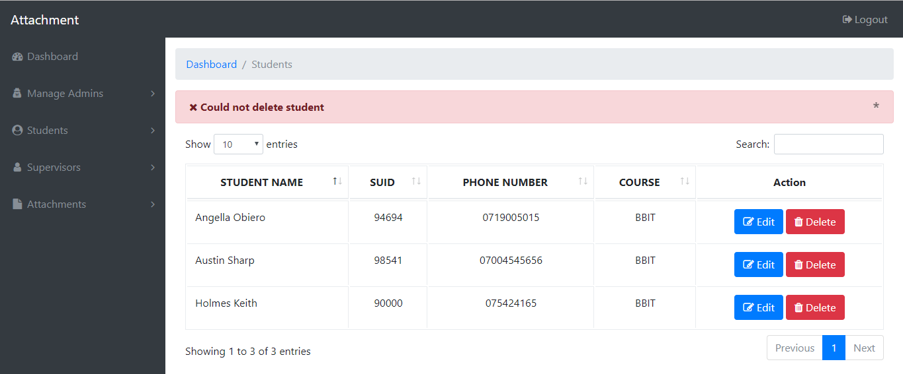
Attempt to delete Angella who is assigned a supervisor for CBA
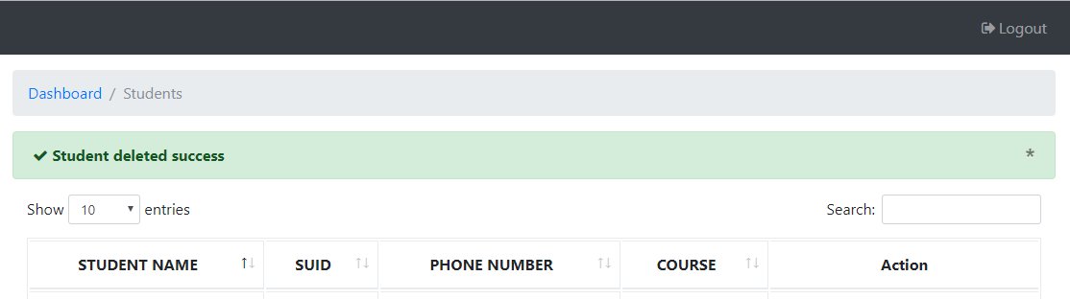
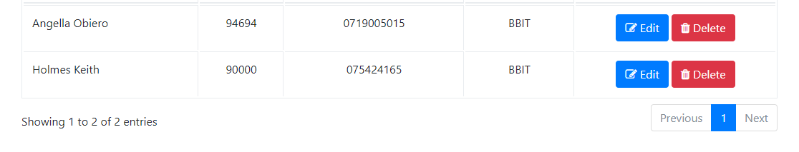
Attempt to delete Austin

Student Portal Functionalities
When a student is logged in, s/he is able to update their profile, upload an attachment report and add daily activities.
Updating Student Profile
For a student to update his/her profile, s/he needs to be logged in. Once logged in, the profile is loaded first. Also, clicking on the My Profile Option on the left navigation will load the profile. Click on Edit button and update the profile as shown below:
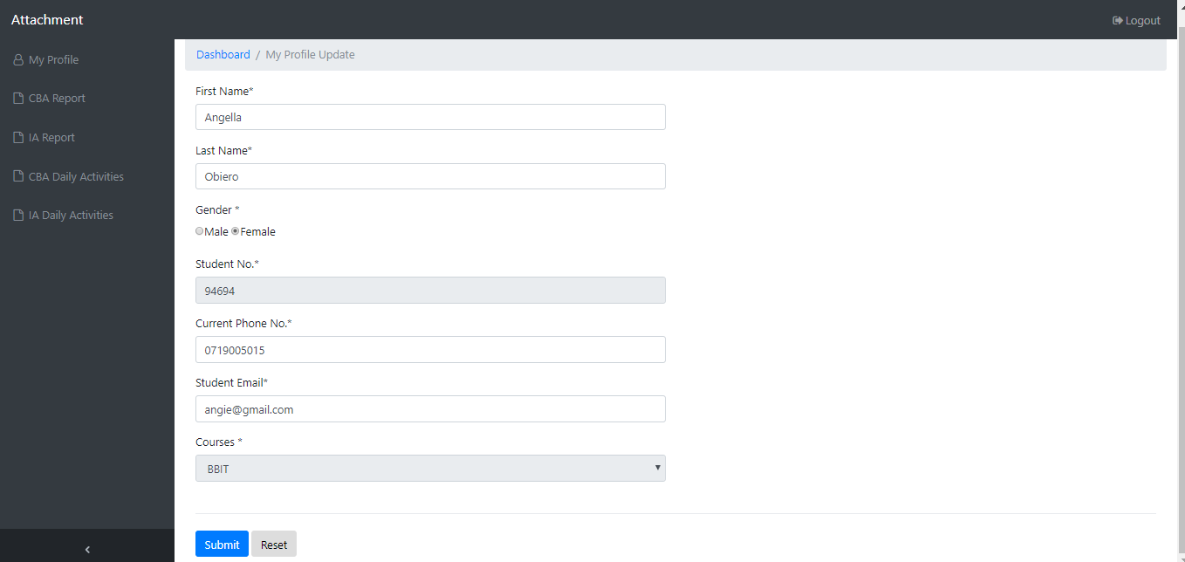
Student updating own profile. Course and Student No unchangeable

The message below appears on successful profile update

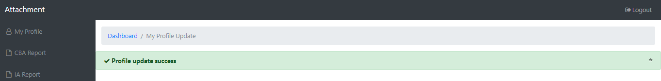
Successful profile update by student

Uploading CBA Report
For a student to upload a CBA report, click on CBA Report option on the left navigation menu. The page below is loaded.

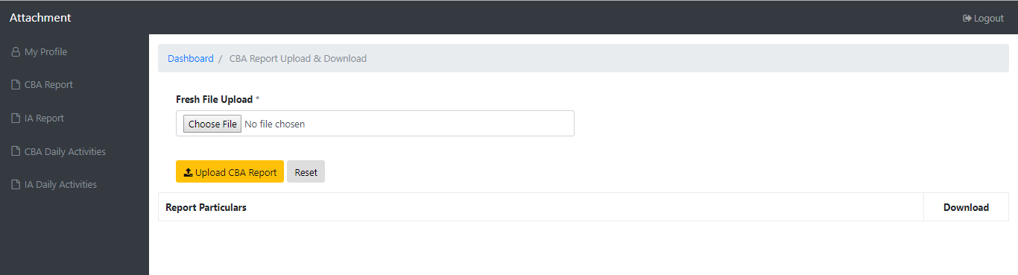
CBA Report upload page
Click on Choose File to select the file to upload. Please do upload allowed types (.doc or .docx). Once the file is selected, click on Upload CBA Report. A success message is displayed. Note: Users can only upload one file. In future, file overwriting will be enabled.

