# Appendix C: User Manual

## PART A: Technical Guide

**System Installation**

This system is a web-based application. To run the information system, one needs to upload it to a live web server or use a local server such as xampp local server. Xampp server is a local server (run offline) that mimics a live web server and is used for testing and deployment of web based applications. In this documentation, installation of the web application on a local web server is explained.

To install the attachment web application, follow the following instructions:

***Installing Xampp Local Web Server***

1. Download Xampp from Apache Friends website. Be sure to download a version compatible with your computer’s Operating System e.g. xampp for Linux, Windows, or OS X for Apple
2. This guide assumes you are using Windows environment
3. Unzip the downloaded xampp file to your disk *C:\xampp*
4. **Note:** You may unzip to a different disk with adequate space. For purposes of this project, disk **C:\** is preferred
5. Open the xampp folder in *C:\xampp* and run the executable file *C:\xampp\xampp-control.exe*
6. Start *Apache* and *MySQL* services from the xampp control-panel
7. Click on Admin option of *Apache service.*
8. From the window that opens, click *phpmyadmin* to access the database.
9. Create a new database and call it *suattachments*
10. While on the *suattachments* database, click on *import* and then c*hoose file* from the window that opens.
11. Locate the database file ‘*suattachment.sql’* in the *attachments* project folder on the storage containing the project. If this is successful, then your database is set up and ready
12. Once the database is setup, copy the folder that contains the project i.e. *attachment*  from storage and paste it in *C:\xampp\htdocs*
13. Your project setup is now complete.
14. To run the project, open a browser (*Chrome, Firefox and Opera preferred)* and type ‘*localhost/attachment’* without the closing tags. A login page is loaded where users enter their login credentials

## PART B: User Guide

**User Login**

The login page allows students, supervisors and the administrator to login. It provides for the different user access levels. The figure below shows the login page.

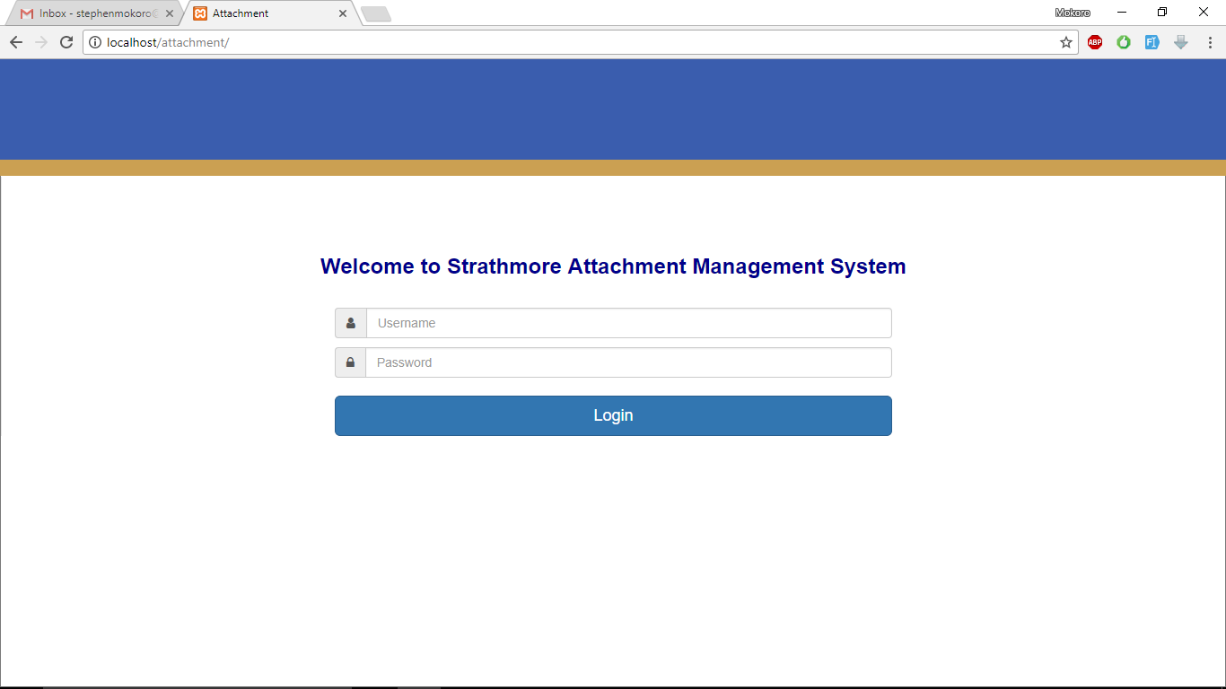

*User login page*

Below are the existing user login credentials

|  |  |  |
| --- | --- | --- |
| **User** | **Username** | **Password** |
| Administrator | 1002 | 12345 |
| Supervisor | 1003 | 1003 |
| Student | 94694 | 94694 |

**Admin Functionalities**

The system admin is responsible for adding users i.e. other admins, supervisors and students. S/he is also responsible for assigning students supervisors. The following screen captions indicate how to carry out admin functionalities:

Once logged in as admin, the user sees the below admin control page.

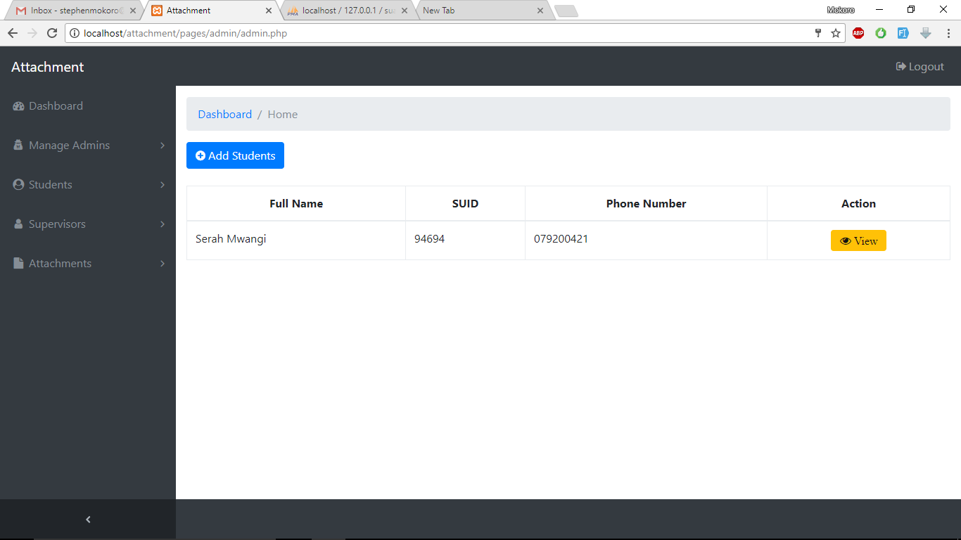

*System admin control page*

To add a student, click on **Students>New Student.** This loads the page below for adding a student.

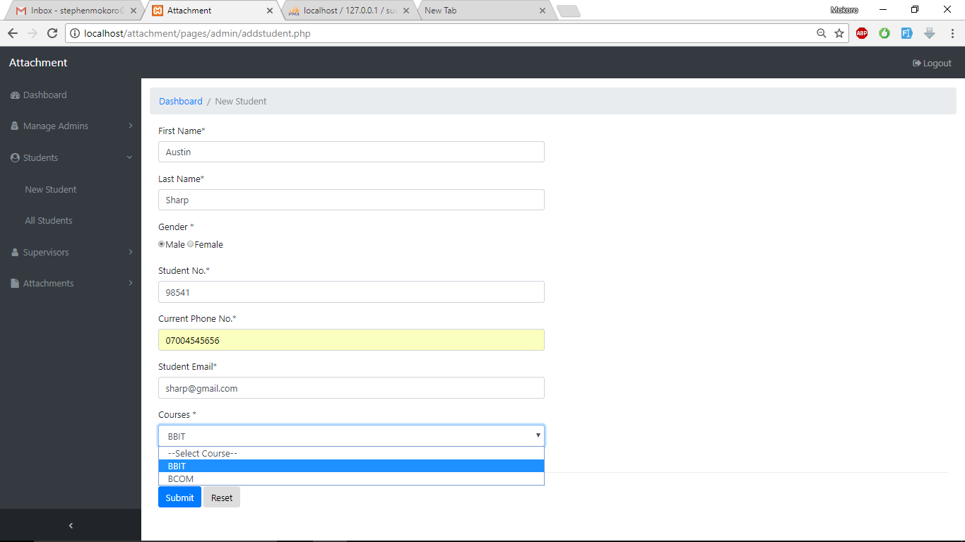

*New student registration*

Fill in the details and click ***Submit*** *button.* The success message below is displayed.

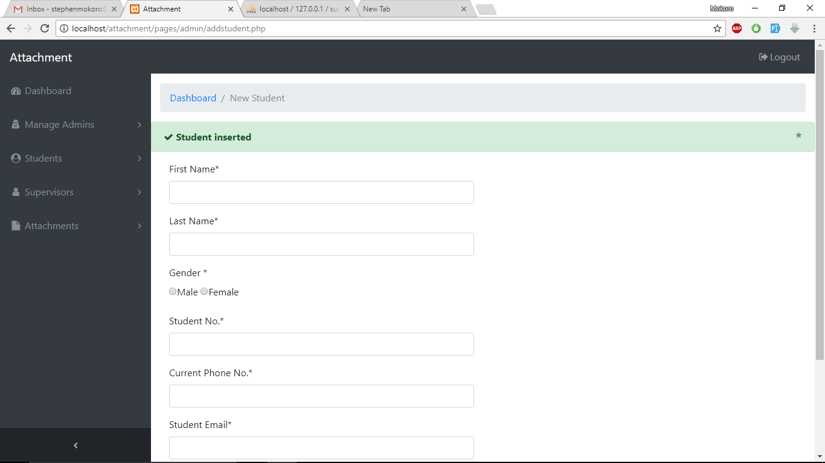

*Student registration success message*

To see a list of all registered students, click on **Students>All students** from the navigation menu on the left. The page below is loaded.

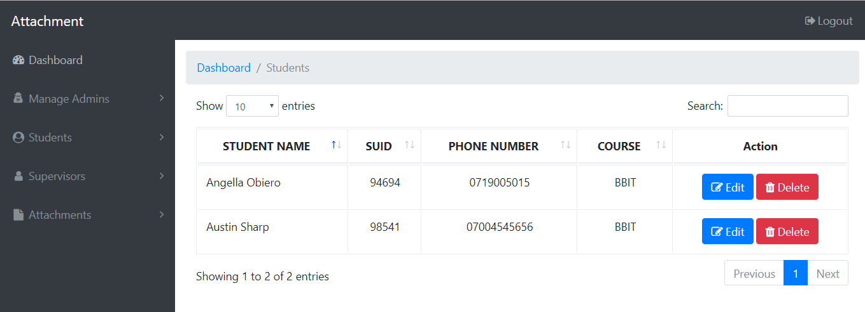

*List of registered students*

**Registering supervisors**

Admin can also register supervisors. To register a new supervisor, from the navigation menu on the left, click on: **Supervisors>New supervisor**. The supervisor registration page below is loaded.

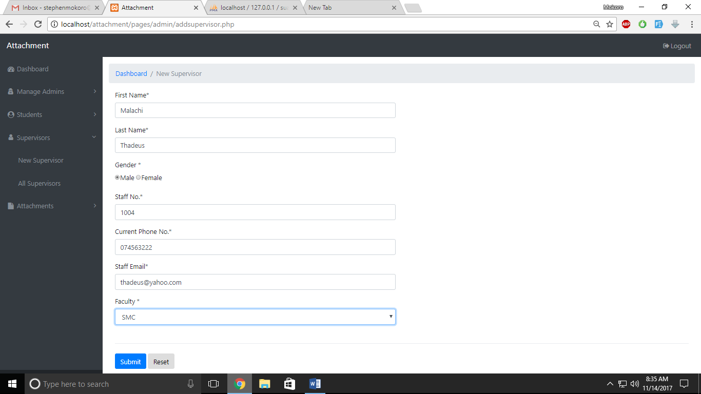

*Supervisor registration page*

Fill in the supervisor details and click on ***Submit*** *button.* The success message below is displayed.

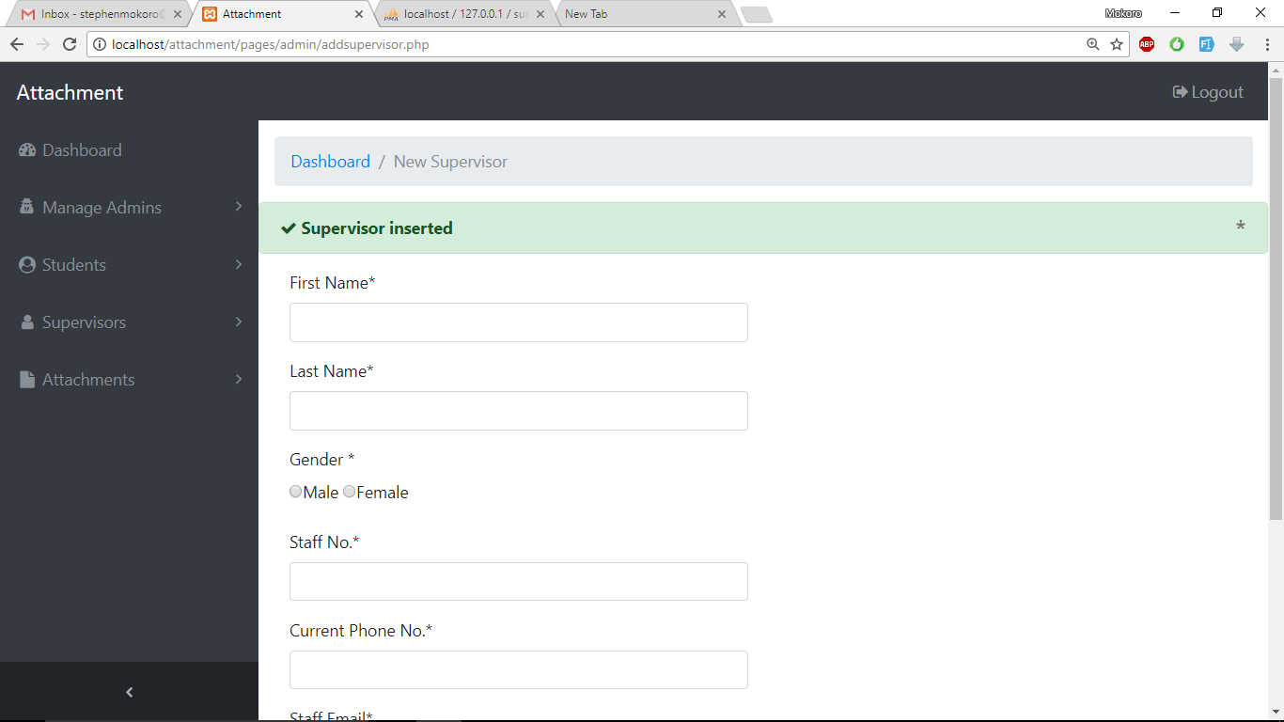

*Supervisor registration success message*

To see the list of registered supervisors, click on **Supervisors>All Supervisors** from the navigation menu on the left. The list of supervisors below is loaded.

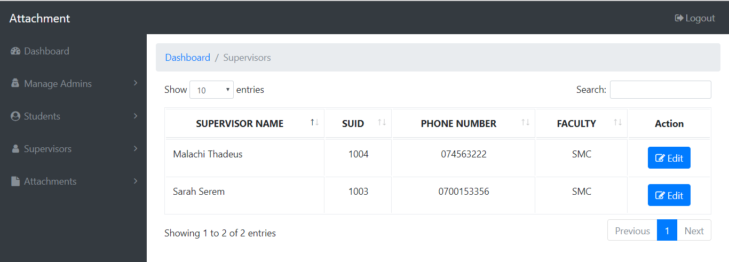

*List of registered supervisors*

**Assigning a supervisor to a student**

The admin is able to assign supervisors to students. To assign a student a supervisor, click on ***Attachments>Assign Supervisor***from the left navigation bar. The page below is loaded.

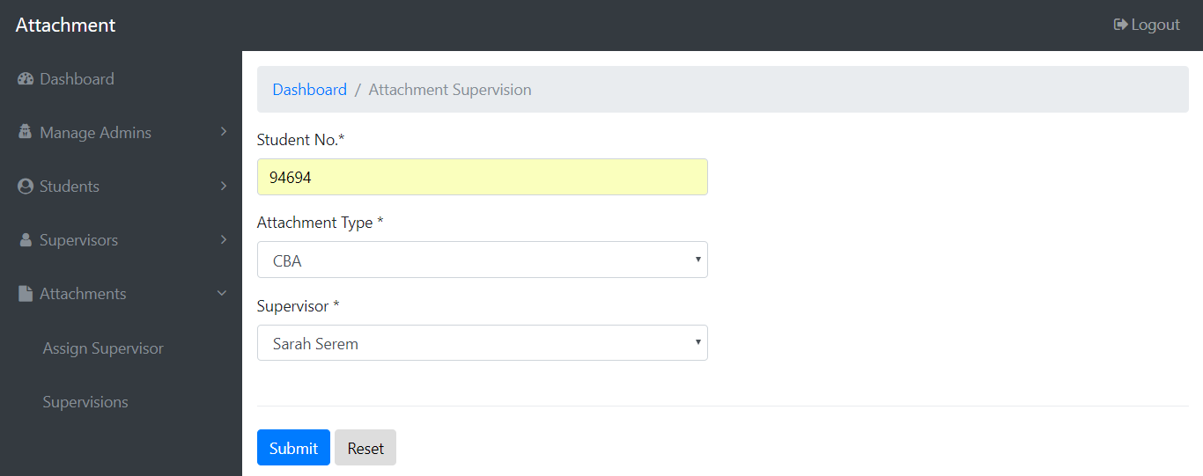

*Supervisor assignment page*

Input the student number to whom you are assigning a supervisor, select the type of attachment and the supervisor. **Note:** A student cannot be assigned a supervisor twice for the same attachment type. However, a student can be assigned another supervisor for a different attachment type. Once filled the form, click on ***Submit*.** The below success message appears.

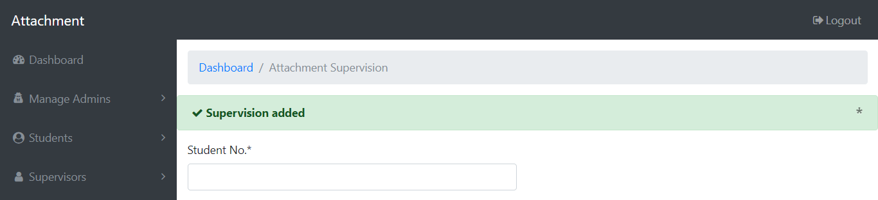

*Supervisor assignment*

To view a list of supervisions, click on ***Attachments>Supervisions.*** The list below is loaded.

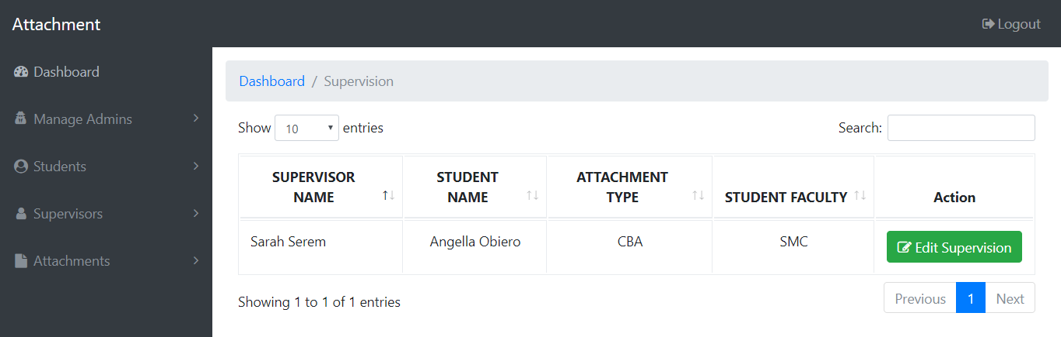

*List of assigned supervisions*

**Editing Information**

To edit user information, access the list of users (**supervisors for example)** as explained earlier. At the rightmost column of each user row, there is a button named ***Edit****.*Click on the button. In the case of editing supervisors, the supervisor edit page below is loaded.

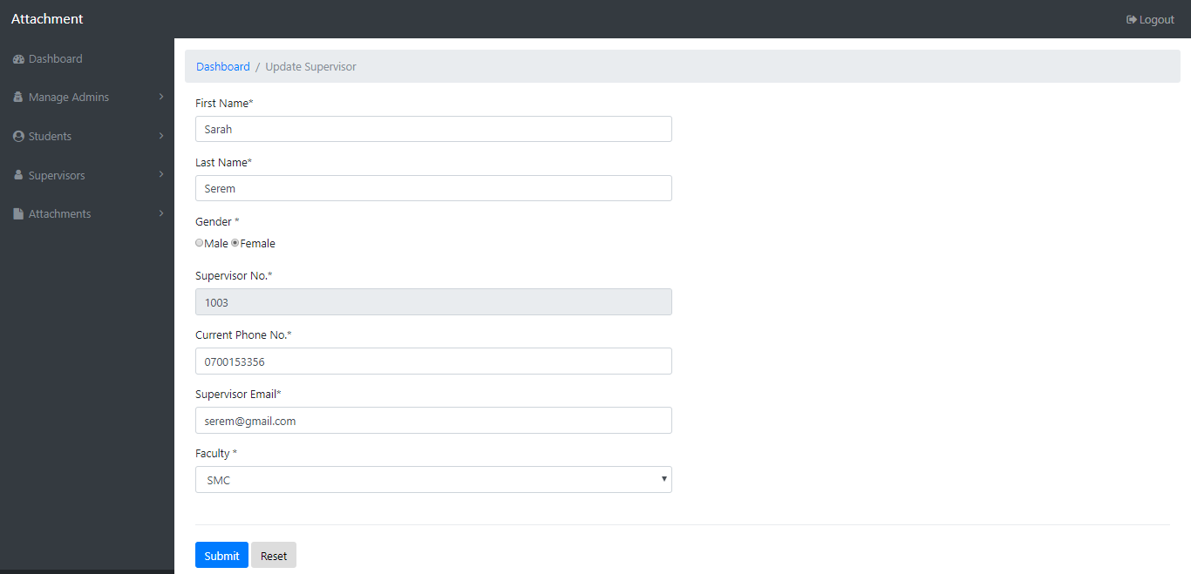

*Supervisor profile editing page*

Edit the information as necessary and click **Submit.** The message below is displayed if Faculty, for example, is changed from SMC to FIT and submitted.

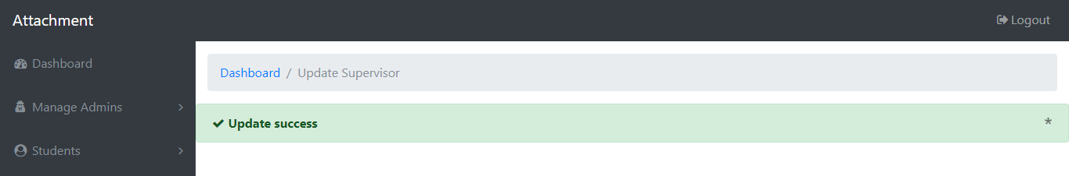

**Deleting data**

For one to delete data such as student, access the list of students and click on the ***Delete*** button at the rightmost column of each student. If the students table does not have any depedent child rows via a foreign key constraint, then it is success. Otherwise, it fails. Consider the list of students below.

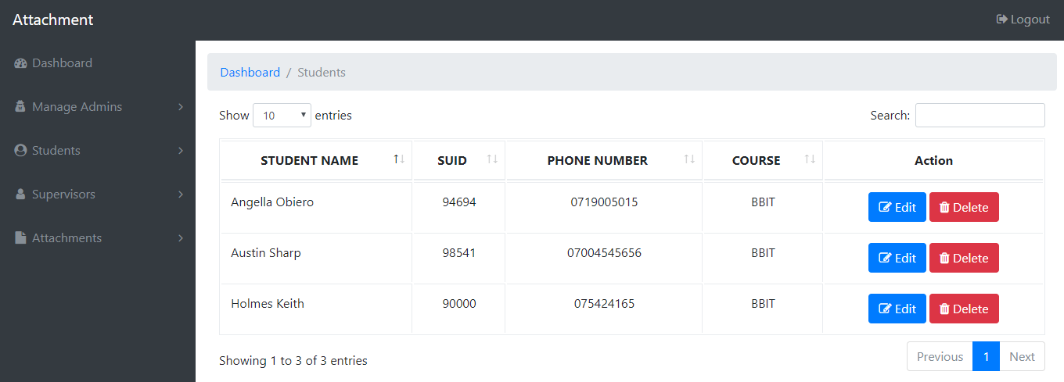

*List of students*

It is not possible to delete Angella because she has been assigned a supervisor hence has a foreign key relationship with table *studentsupervisors.* However, *Austin* and *Holmes* are deletable as they do not have any depended child row in any other relation. The figures below show results of attempt to delete *Angella* and *Austin* respectively.

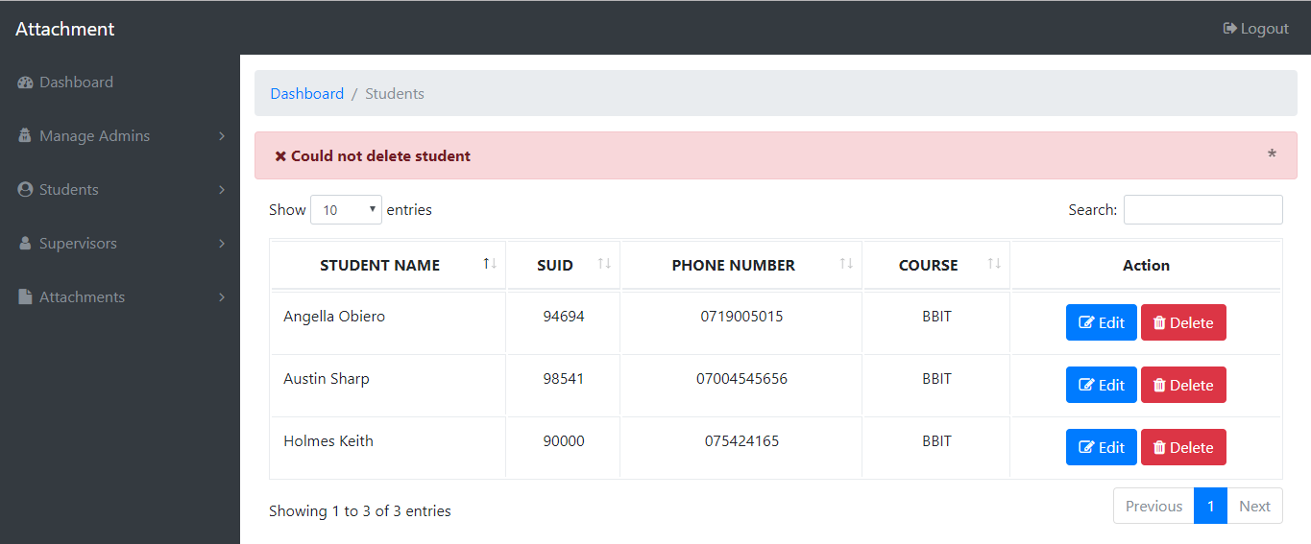

*Attempt to delete Angella who is assigned a supervisor for CBA*

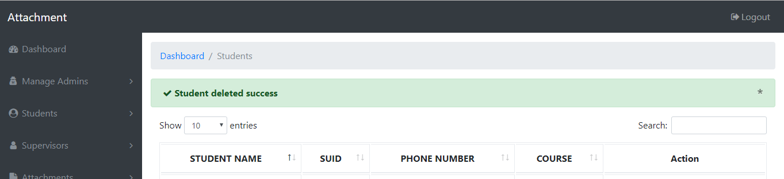

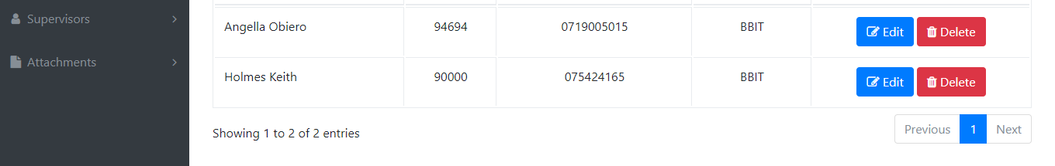

*Attempt to delete Austin*

**Student Portal Functionalities**

When a student is logged in, s/he is able to update their profile, upload an attachment report and add daily activities.