**NCC-TemplateMatching**

**with Four-level Pyramid and Angle Output**

范声思 涂锋

[fanshengsi@stu.hit.edu.cn](mailto:fanshengsi@stu.hit.edu.cn) [tufeng@stu.hit.edu.cn](mailto:tufeng@stu.hit.edu.cn)

1. **Introduction**

**Background** Normalized Cross-Correlation(NCC) is a method of template matching which based on gray level. During the previous lessons, we have done a homework to write a code to of single-level NCC template matching, without angle measurement. However, it will be so much calculating work when the image is big, because you need to calculate every pixel’s NCC value to find out the biggest one. What’s more? When there is a angle between template and the target image, the result could be incorrect. So we have to figure out a way to solve these two problems.

**State-of-the-art** To solve the problems above, we have googled them. To our surprise, there’s no such algorithm of NCC with angle output. So up to now, there might be few people who have thought about it. We must have a try!

**Applications** Maybe we can applicate the algorithm to the product lines, logistics, face recognition and so on.

1. **Description of the Algorithm**

First, we build a Four-level pyramid, so we [downsampling](javascript:;) the template image and target image for three times. On the top level of the pyramid, we divided -30°~ 30°to 12 equal part(5°for each part), then every time we rotate the template for 5°, and calculate the mean and variance for them with the formula below:

For every angle we rotated, we calculate the correlation between the new template with target image on every pixel which is the so-called NCC value with the formula below:

and find out the bigget one, and the biggest one among all angles.Then, we have the most matched pixel and angle.

Then we move to the next level. This time we need not calculate every pixels and angles, but the pixels and angles around the most matched one we just get. Then we find the most matched one and move to the next level.

And we do this one by one level until we reach the bottom of the pyramid. So that we have had a more accurate coordinate and angle of the interested object.

1. **Experiment Results**

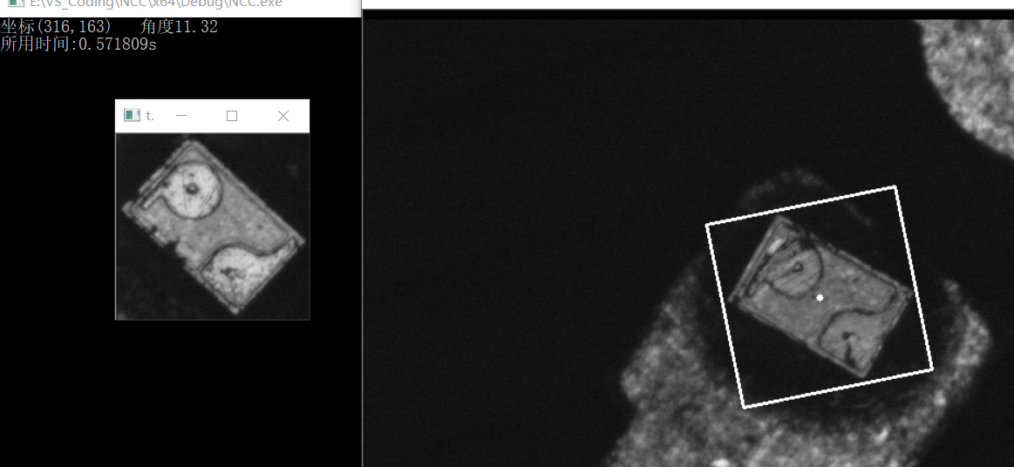

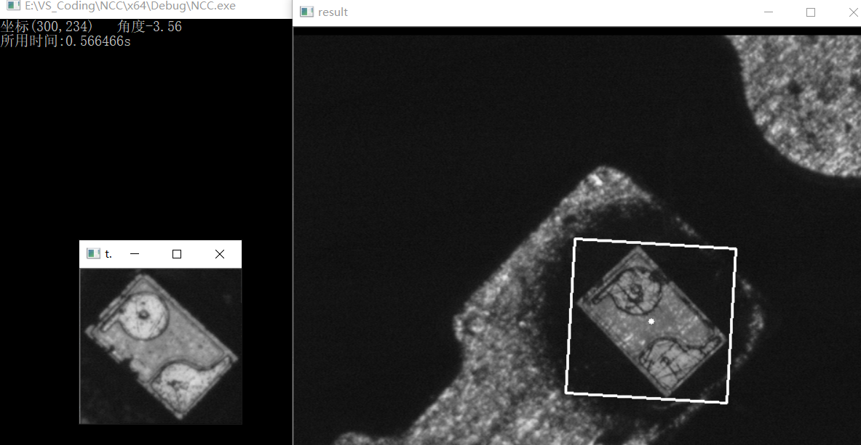

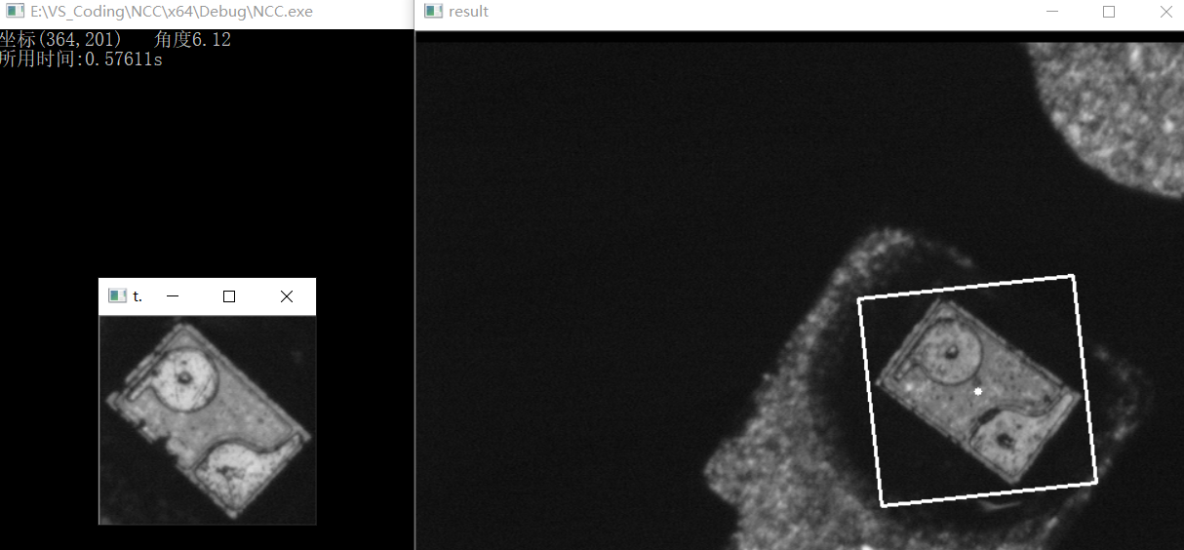

From the results above, we can see the performance of this algorithm is good, we can get the coordinate and angle of the interested object in the target image accurately within 0.5s.

1. **Conclusions and Discussions**

Using image pyramid can reduce the calculating work efficiently because we need not calculate so many pixels. And by rotating the template, we can increase the accuracy of the result. In some occasions, we may need to know the angle of the object, by using this algorithm we get this data.

There’s a problem in this algorithm that when we rotate the template image, there will be four black zones in the four corner which the gray level is 0. But in the target image, the background is not absolutely black, in other word, the gray level is not 0 but a small value, this will influence the accuracy of the result.

**Reference**

1. Lesson9-NCC handout-new