# Start with the TPC-DS Dataset from Snowflake. Design a dashboard that will leverage queries from Snowflake to build the dashboard.

Query:

query31.tpl List counties where the percentage growth in web sales is consistently higher compared to the percentage growth in store sales in the first three consecutive quarters for a given year.

with ss as

(select ca_county,d_qoy, d_year,sum(ss_ext_sales_price) as store_sales

from store_sales,date_dim,customer_address

where ss_sold_date_sk = d_date_sk

and ss_addr_sk=ca_address_sk

group by ca_county,d_qoy, d_year),

ws as

(select ca_county,d_qoy, d_year,sum(ws_ext_sales_price) as web_sales

from web_sales,date_dim,customer_address

where ws_sold_date_sk = d_date_sk

and ws_bill_addr_sk=ca_address_sk

group by ca_county,d_qoy, d_year)

select

ss1.ca_county

,ss1.d_year

,ws2.web_sales/ws1.web_sales web_q1_q2_increase

,ss2.store_sales/ss1.store_sales store_q1_q2_increase

,ws3.web_sales/ws2.web_sales web_q2_q3_increase

,ss3.store_sales/ss2.store_sales store_q2_q3_increase

from

ss ss1

,ss ss2

,ss ss3

,ws ws1

,ws ws2

,ws ws3

where

ss1.d_qoy = 1

and ss1.d_year = 2001

and ss1.ca_county = ss2.ca_county

and ss2.d_qoy = 2

and ss2.d_year = 2001

and ss2.ca_county = ss3.ca_county

and ss3.d_qoy = 3

and ss3.d_year = 2001

and ss1.ca_county = ws1.ca_county

and ws1.d_qoy = 1

and ws1.d_year = 2001

and ws1.ca_county = ws2.ca_county

and ws2.d_qoy = 2

and ws2.d_year = 2001

and ws1.ca_county = ws3.ca_county

and ws3.d_qoy = 3

and ws3.d_year =2001

and case when ws1.web_sales > 0 then ws2.web_sales/ws1.web_sales else null end

> case when ss1.store_sales > 0 then ss2.store_sales/ss1.store_sales else null end

and case when ws2.web_sales > 0 then ws3.web_sales/ws2.web_sales else null end

> case when ss2.store_sales > 0 then ss3.store_sales/ss2.store_sales else null end

order by web_q2_q3_increase;

List of counties for percentage growth in web sales is consistently higher compared to the percentage growth in store sales in the first three consecutive quarters for a given year:

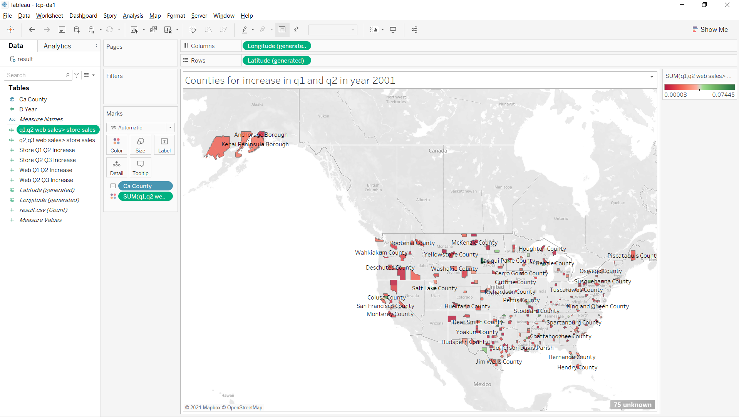

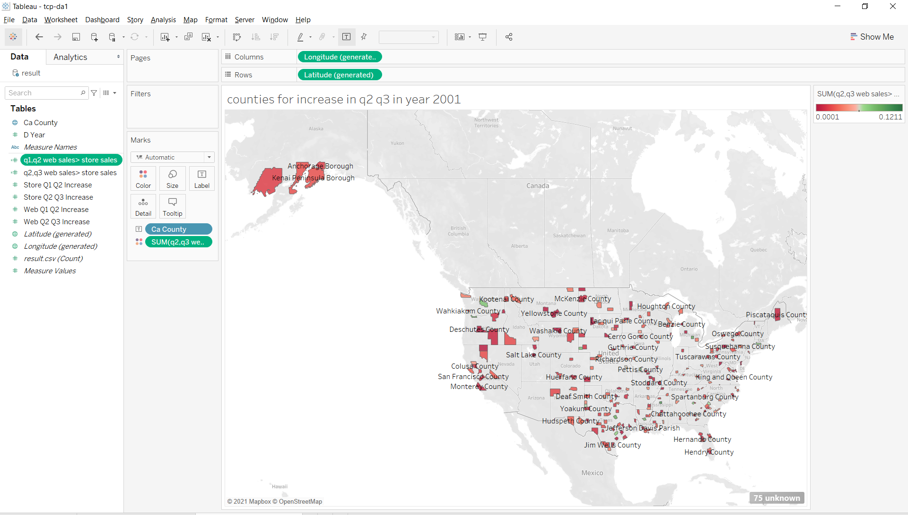

# Discuss who is this dashboard targeted towards and the use cases you will accomplish with it:

Dashboard is designed for Sales optimization, using which we can distribute the products across stores accordingly. The following are the use cases with this kind of optimization:

* Suggestions on discounts on store specific products.
* Promotions based on the sales data of web and store.
* Proposal for store closures which are in a negative revenue generation state.
* Promotions and appreciation for the employees based on the store specific performance.
* Transfer of products from one store to another if the other is doing good sales and again it depends on logistics.

# Describe your design on how would you onboard the dataset

Warehouse database schema on table created. Through snowflake python connector by using

pandas connector package inserted data into table which we already created with the same

column names as we are on-boarding the dataset through pandas.

# Describe what tools (xsv, Python) will be used for data cleanup:

We used python (pandas, NumPy) to data cleaning:

* Handling missing values
* Converting Data types
* Dealing with duplicates
* Dropping unnecessary columns

# Prototype your application

1. Have used adventureworks DW: Dim date, dim geography, factResellerSales, factInternetSales.
2. Colab link for pre processing steps:https://colab.research.google.com/drive/1x-hH49VAAPlCtzL0NiDoGC3ErNJ964Aa#scrollTo=isFBWNHy3oFX
3. Inserting data to snowflake through python and pandas.

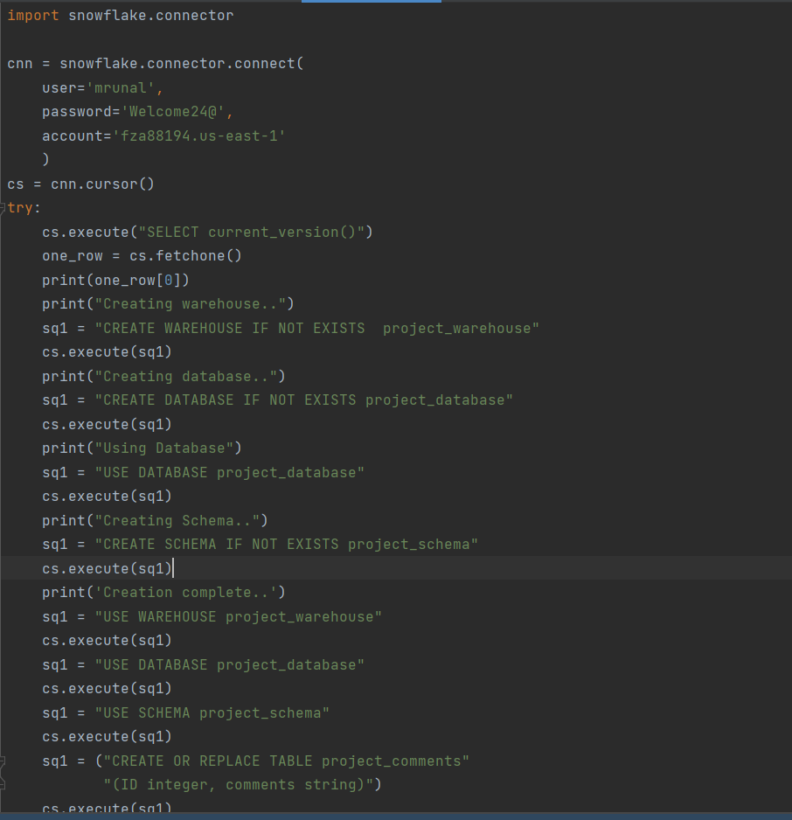

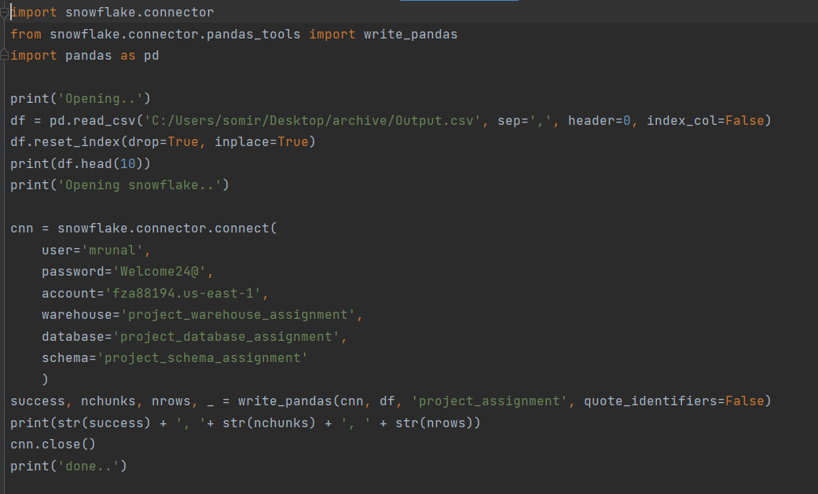

iv.

Show how this data can be visualized in an analytics tool of your choice.

Found out List cities where reseller sales is consistently higher compared to the internet sales

for a given year.

