**Source/Layout Organization**

Key:

* Package
* Folder

Class

Layout

- Description

**Source Organization**

* Login

LoginActivity - Controls all login activity, package communicator. No action bar.

LoginFragment - First screen upon opening program, login, create user, recover account buttons.

CreateAccountFragment - When create account button is pressed go here. Allows user to create an account. Auto-login.

RecoverAccountFragment - Allows user to recover lost passwords.

RecoveryHandler - Handles emails regarding recovering lost passwords.

* Main

MainActivity - Controls all main activity, package communicator.

* + Party

PartyFragment - Contains list of parties, clicking them leads to PartyDetailFragment

CreatePartyFragment - Accessed by clicking + on action bar while viewing PartyFragment

PartyDetailFragment - Shows friends at party, party address, open in maps button, attendees, general details

* + Friend

FriendFragment - Contains list of friends, clicking them leads to FriendDetailFragment

CreateFriendFragment - Accessed by clicking + on action bar while viewing FriendFragment

FriendDetailFragment - Shows details about clicked friend

* + Map

MapFragment - Displays google map

MapController - Controls map view, populates parties, handles clicks

GoogleMaps - Handles querying google maps and ta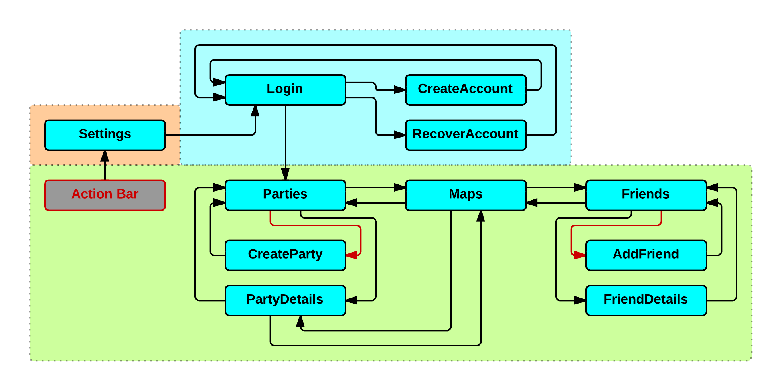lking to google play library

* Settings

SettingsActivity - Controls all settings activity, package communicator

SettingsFragment - Allows user to change personal settings, logout

* Database
  + TokenVendingMachine

TVMClasses… - Classes to handle all TVM functions

DatabaseHandler - Package communicator. One instance on each activity will allow database interaction.

* UserData

UserAccount - Package Communicator, Holds all user data, friends, parties, created parties, etc.

Friend - Template for a friend object

Party - Template for a party object

* Program

Program - Package communicator, allows retrieval and writing to constants and shared preference file.

Constants - Contains all program constants. All constants now in resources

SharedPreferenceHandler - Allows reading and writing to local data

Activities: Package Communicators, Communicate With Other Package Communicators and Child Fragments

Fragments: Inflate UI, Handle Local Methods, Communicate With Parent Package

**Layout Organization**

* login

**activity_login**

fragment_login

fragment_createaccount

fragment_recoveraccount

* main

**activity_main**

* + party

fragment_party

fragment_createparty

fragment_partydetail

* + friend

fragment_friend

fragment_createfriend

fragment_frienddetail

* + map

fragment_map

* settings

**activity_settings**

fragment_settings