September 19, 2014

Dear Sir or Madam,

This study constitutes the first study directly comparing brain extraction in CT images to a gold standard manual segmentation.

I believe that it is appropriate for NeuroImage because we have provided a validation study based on manual segmentation for procedures previously discussed in NeuroImage (doi:10.1016/j.neuroimage.2012.03.020) using CT images acquired on different scanners, at different sites and in different studies. We also discuss the sensitivity of the previously proposed procedure to smoothing and choice of parameters. In particular, we identify that the procedure can be substantially improved by pre-smoothing the CT images and by a careful choice of parameters. We provide a fundamental processing step in extracting quantitative information from brain tissue in a CT scan using existing, open-source, free software (FSL) and provide the code for readers.

Thank you for your consideration.

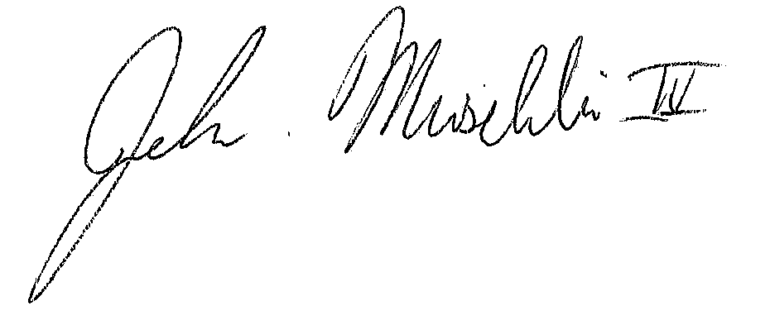

John Muschelli, ScM

PhD Student

Department of Biostatistics

Johns Hopkins Bloomberg School of Public Health